Laboratory work 5
Graph visualization

Task
Construct a graph including files and directories starting at a certain level (directory). Build its visualization, taking into account the feature according to the number in the student’s list. Files and directories are visualized in different colors. Features to realize (one per student):
6. The color of the node depends on the number of folders and files in the directory;
For options with color (2, 3, 4, 6, 7), add a legend to the plots.

The goal of this work was to create a Python program that visualizes the structure of a file system as a graph. For this purpose, the NetworkX library was used to represent directories and files as graph nodes, while Matplotlib was applied to display the graphs using various layout algorithms.
The function is_hidden_dir() is responsible for detecting hidden directories. On Windows systems, it calls the attrib command via subprocess to check whether a directory has the hidden attribute. This function ensures that hidden system folders are excluded from the visualization.
The function get_tree() builds the graph of the directory tree recursively. It accepts a starting node (the root directory) and traverses its subdirectories and files. Each node is marked as either a file or a directory, and corresponding edges are added to the graph. To avoid infinite recursion, the function limits both the maximum recursion depth and the number of iterations. In this way, a clear and structured representation of the file system is generated.
The function assign_colors() assigns colors to nodes depending on their type. Files are always colored in blue. Directories are colored in shades of green, where the intensity depends on the number of items inside the folder: the more contents, the brighter the green. If a node cannot be processed or its type is unknown, it is colored gray. This color scheme improves the readability of the visualization and helps distinguish different types of nodes.
The function main() controls the program’s workflow. It first checks whether the root directory exists and whether it is accessible. Then, it calls get_tree() to build the graph and assign_colors() to generate the coloring. Depending on the size of the graph, different layout algorithms are selected. If the graph contains fewer than 500 nodes, four layouts are drawn: Kamada-Kawai, Circular, Spectral, and Spring. For very large graphs, only the spring layout is used to improve performance.
The program successfully visualizes the structure of a file system, representing it as a graph with clear distinctions between files and directories. The implemented coloring and legend system provide additional clarity, making the visualization easy to interpret.

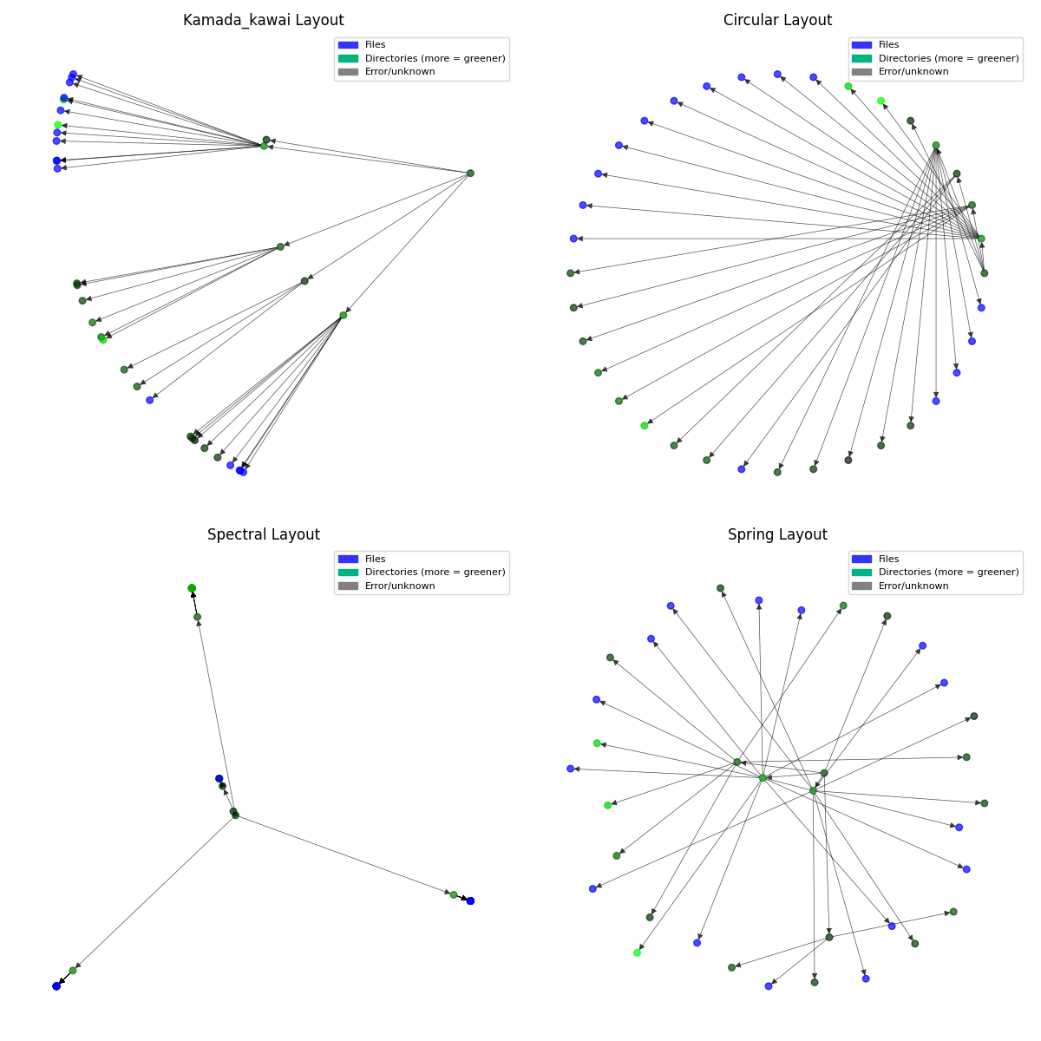
Figure 1 – The result of visualization of the file system structure by various algorithms.

