Laboratory work 6
Gephi for Graphs Vizualization

Task
According to the option, visualize the dataset (student number – dataset number) at the link in two ways: Using gephi; Using networkx.
Datasets: Web and Internet: Internet

1. Using gephi.
The dataset “internet_routers-22july06.gml” was loaded using NetworkX (Figure 1).
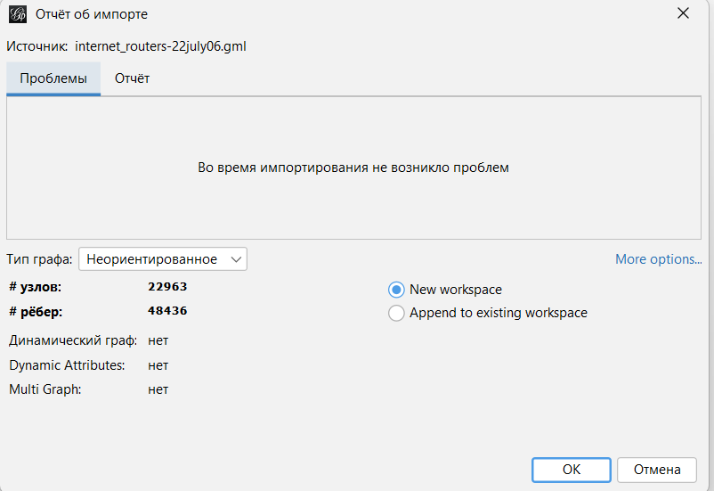
Figure 1 – Import Results Report.

The initial graph representation is displayed on the screen (Figure 2).

Figure 2 – Graph representation in Gephi

To improve visualization, the OpenOrd layout was applied (Figure 3), with node labels colored pink.
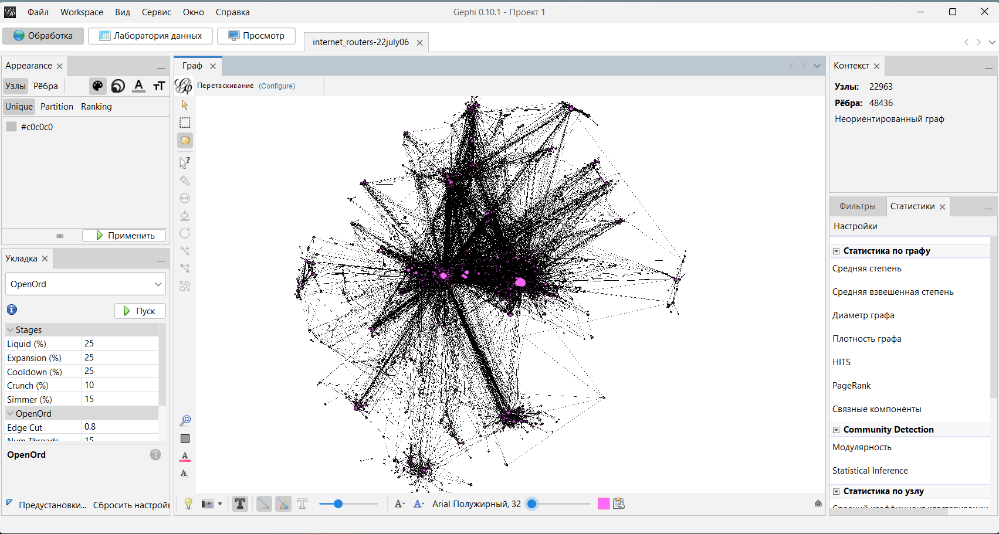
Figure 3 – Results of plotting the graph using the OpenOrd method (node labels are colored pink)

The graph's average path length is 3.8424, calculated using the Network Diameter statistics (Figure 4).
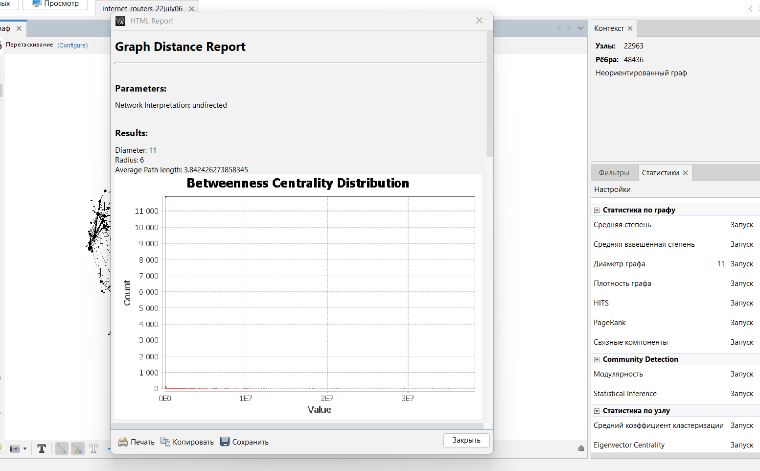
Figure 4 – Grapth path length statistics.
Node size and color were adjusted to reflect connectivity (Figure 5).
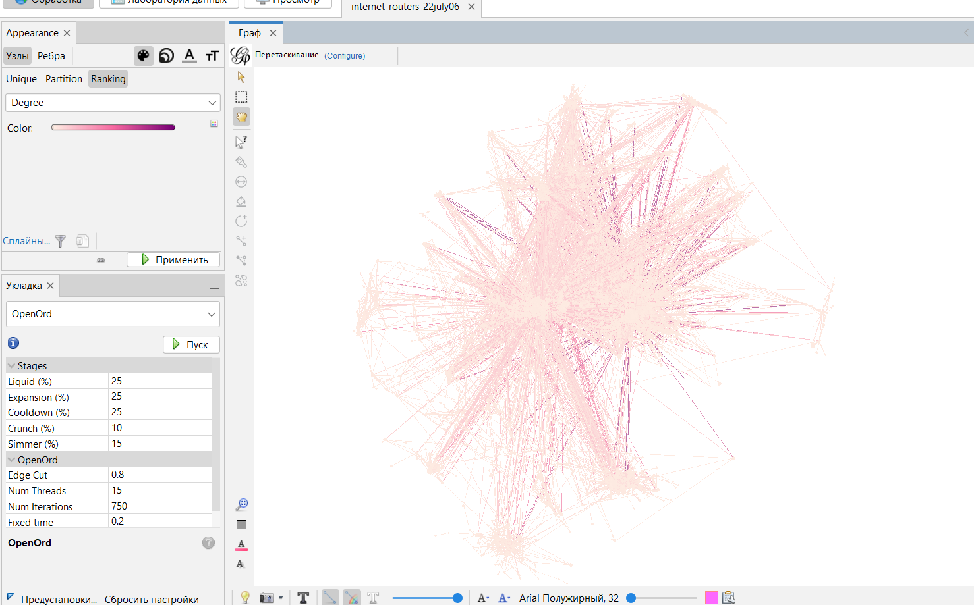
Figure 5 – The result of setting the size and color of the nodes

Under the Preview Settings, the Black Background preset was applied, and the final rendering was exported as an image (Figures 6–7).

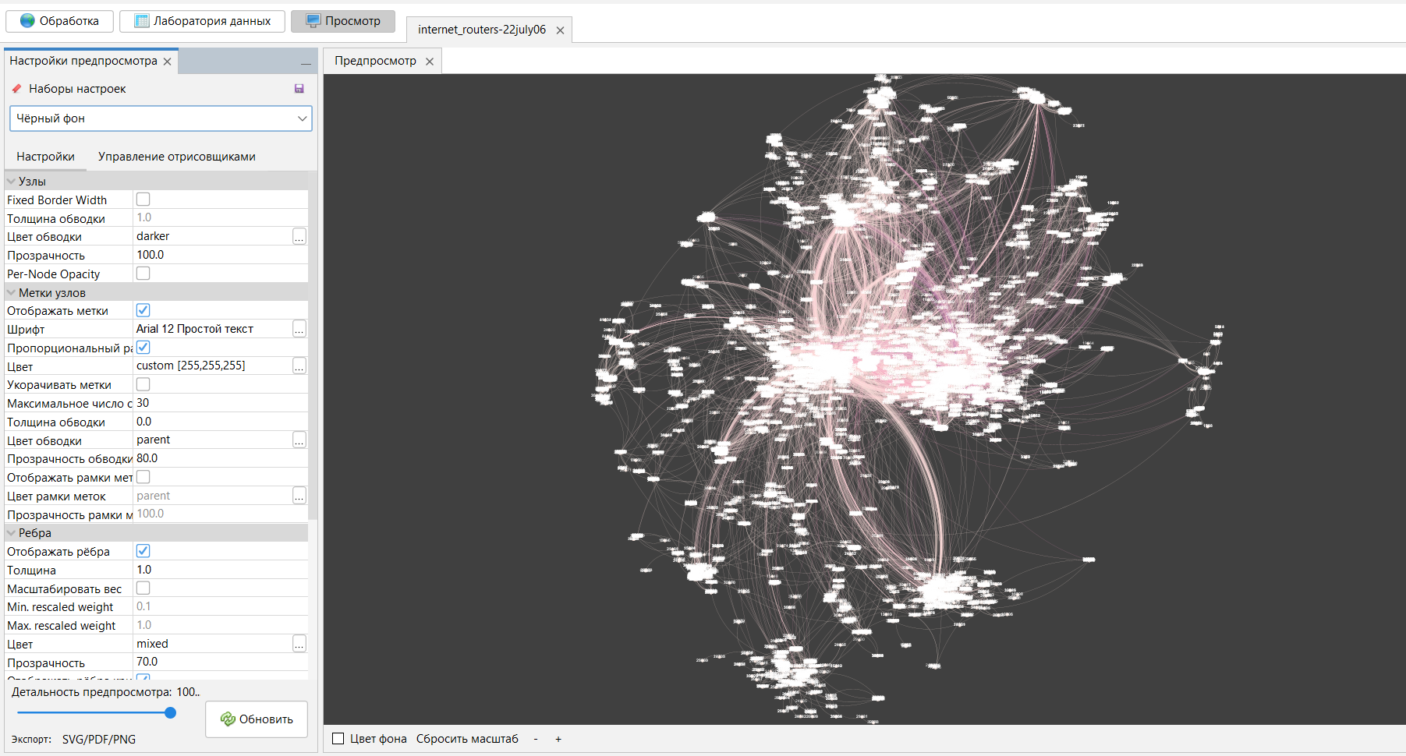
Figure 6 – The graph visualization result

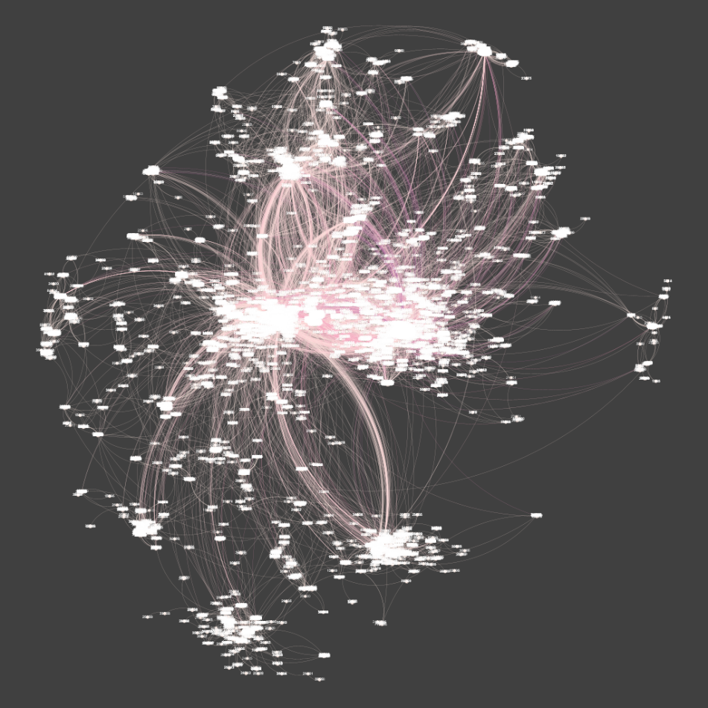
Figure 7 – graph.png

2. Using networkx.
The dataset represents a large-scale internet router graph loaded using networkx. It contains 22,963 nodes and 48,436 edges, with an average degree of 4.22, indicating each node connects to roughly four others (Figure 7).
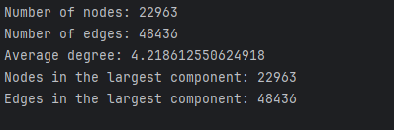
Figure 7 – Statistic

The largest connected component includes all nodes and edges, showing the graph is almost entirely connected.
For visualization, the full component was drawn with a random layout, which is fast for large graphs but does not show detailed structure (Figure 8). To inspect connections more clearly, a sample of 500 nodes was visualized using a spring layout, revealing clusters and node interconnections (Figure 9)
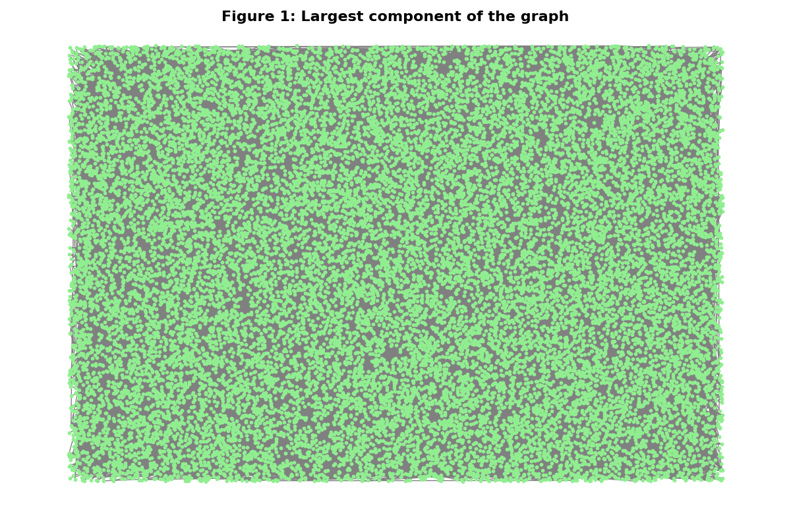
Figure 8 – Visualization using random layout

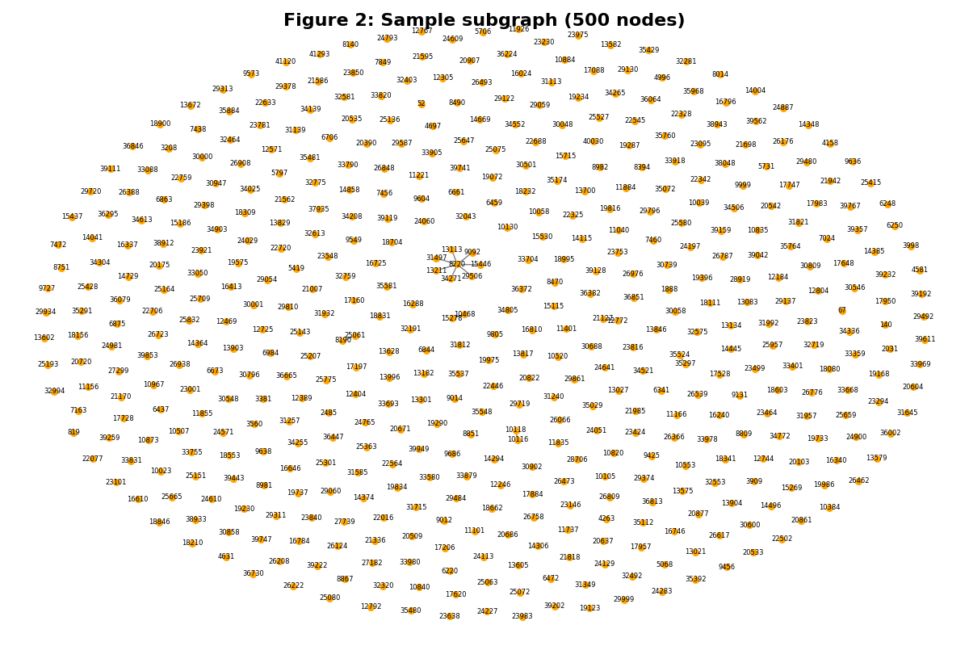
Figure 9 – Sample subgraph (500 nodes) using spring layout

