Laboratory work 7
Visualize social connections in your Instagram profile

Task
Build a graph of your followers on the social network Instagram. Visualize the graph using the networkx and gephi libraries. Also, determine the characteristics according to the variant using networkx or gephi: 6. Average clustering coefficient.

The Instagram followers graph was constructed using the instagrapi API and visualized with networkx. Nodes represent the user and their followings, while edges represent mutual connections between them. The graph was also saved in GEXF format for further analysis in Gephi.
The network provides insight into the connectivity of the user’s social circle. Using networkx, the average clustering coefficient was calculated to be 0.7074, indicating a high tendency for the user’s followings to form tightly connected groups or clusters (Figure 1).
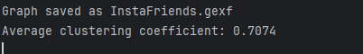
Figure 1 – Average clustering coefficient.

Visualization of the graph using a spring layout shows the structure of the social network, highlighting clusters of interconnected followings and the central position of the user within their network. This approach allows both quantitative and qualitative analysis of social connections (Figure 2).

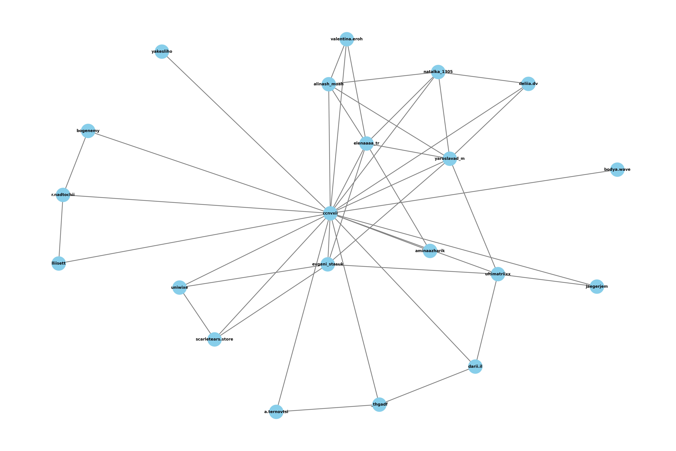
Figure 2 – Graph visualization

The Instagram followers graph was visualized in Gephi. This visualization highlights the central position of the user and the tight clustering of their followings, making the network structure clearly observable (Figure 3).

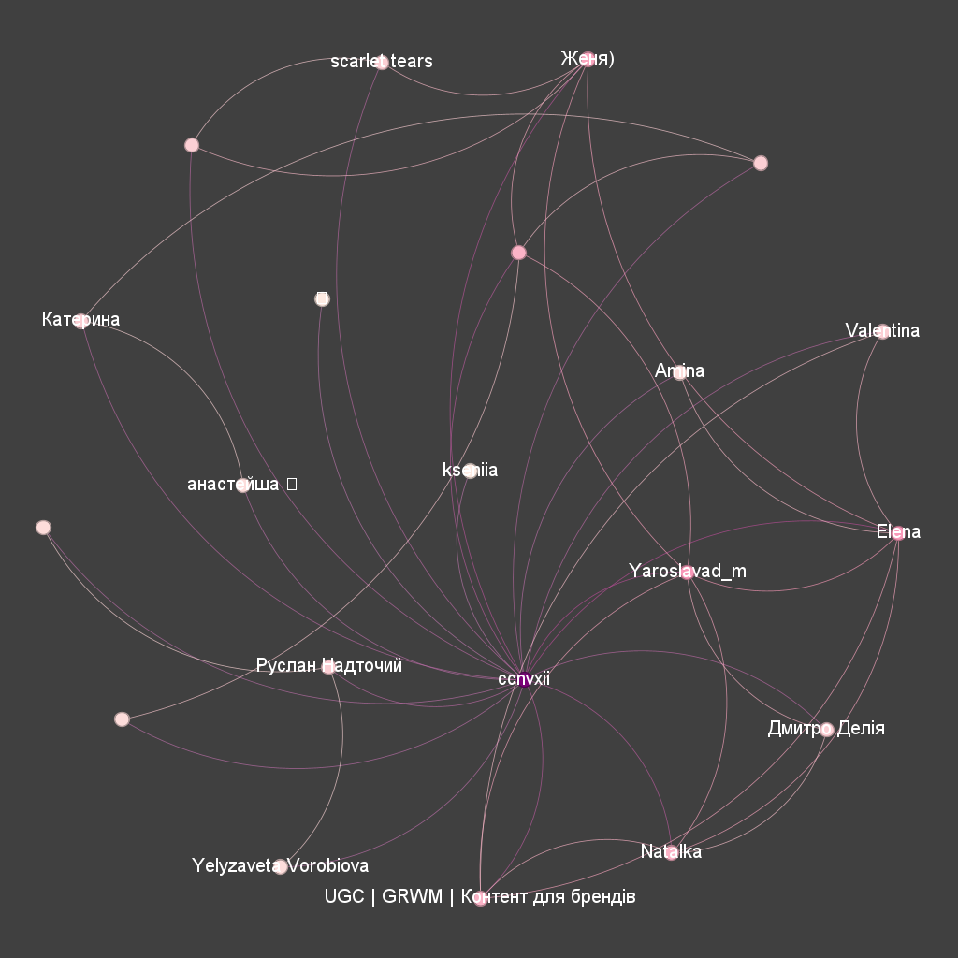
Figure 2 – Graph visualization result using gephi

