MSDS 7330

File Organization and Database Management

Final Exam

Due 23 April 2019

Name: Che’ Cobb

Final Exam: Directions

This is a final exam for MSDS 7330, File Organization and Database Management. This document contains the questions for the exam. Follow the question directions and submit the requested information by 23 April 2019.

Final Exam: Questions

Use MongoDB as a database to store the eCommerce Database that we used in class. Use Python to connect to the MongoDB database and insert, update, and query data from MongoDB.

Submit the code and screenshots of your execution.
I installed pymongo then connected to the MongoDB database
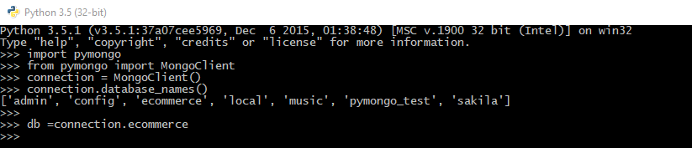
I made an ecommerce database and a column called addresses first and did a import many to do around 3 addresses at once to put in the column
dddresses=db.addresses

address = [
{
"AddressId": 2,
"HouseNumber": 810,
"SteetName": "FallCreek",
"City": "Austin",
"State": "TX",
"Zip": 75827
},
{
"AddressId": 3,
"HouseNumber": 364,
"SteetName": "Airport blvd",
"City": "Houston",
"State": "TX",
"Zip": 75699
},
{
"AddressId": 4,
"HouseNumber": 798,
"SteetName": "Lovers Lane",
"City": "Austin",
"State": "TX",
"Zip": 75419
}
]

result=addresses.insert_many(address)
print(result)

You can see the result in MongoDB environment
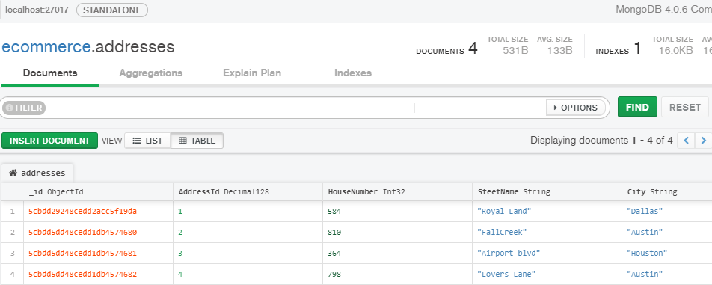
Used update function to change HouseNumber and State in Address 5 which were inputted wrong.
address = {
"AddressId": 5,
"HouseNumber": 777,
"SteetName": "JFK Dr",
"City": "Houston",
"State": "Fl",
"Zip": 75876
}

db.addresses.update_one(
{"AddressId": 5},
{
"$set": {
"HouseNumber": 198,
"State":"TX"
}
})

Next just do a simple query to see what is in the address columns
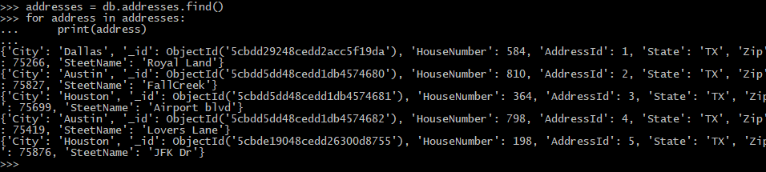

In 1-2 pages, compare and contrast the suitability of MySQL and MongoDB for the eCommerce database. Be sure to identify both advantages and disadvantages of each database.

I like SQL better since not use to going through terminal and being precise with functions for pymongo. Ecommerce database seems harder setting up with MongoDB, also mongo not the best with complex transactions that an Ecommerce database entails. MongoDB doesn't support "multi-document" transactions. Instead you should go with a relational DB like MySQL to support transactions/rollbacks etc.

MongoDB (and other NoSQL databases) are designed specifically for high load websites, map reducing. Fetching a complete record by a single key is much, much faster than trying to fetch data from multiple tables like in SQL. A document is a key value query, not a relational query. Key value query is much faster than relational query but can require higher memory usage. It is also schema-less while makes it easy to edit.

