**Universal Task Documentation**

Universal Automation Center support for Ansible

UAC-Ansible Integration

Associated Activities:

Date: 04 Aug 2020

Author: Ravi Kumar Murugesan

Revision: 01

CONFIDENTIALITY INFORMATION

Distribution list: Stonebranch Customer

|  |  |  |  |
| --- | --- | --- | --- |
| **Version** | **Date** | **Author** | **Changes** |
| 0.1 | 04-Aug-2020 | Ravi Kumar M | Draft |
|  |  |  |  |

**Abstract:**

UAC-Ansible Integration allow you to execute Ansible playbook and run other ansible modules or commands .

Contents

1 Disclaimer 3

2 Scope 3

3 Introduction 3

3.1 Ansible – UAC Integration Overview 3

3.2 Implementation Details 4

4 Installation 4

4.1 Software Requirements for Linux Agent 4

4.2 Installation Steps 4

5 Universal Task Configuration 5

6 Universal Tasks for Ansible-Exec-Playbook 5

6.1 Ansible Universal Task Fields 5

7 Document References 6

# Disclaimer

No support and no warranty are provided by Stonebranch GmbH for this document and the related Universal Task. The use of this document and the related Universal Task is on your own risk.

Before using this task in a production system, please perform extensive testing.

Stonebranch GmbH assumes no liability for damage caused by the performance of the Universal Tasks

# Scope

This document provides a documentation how to install and use the Universal Tasks for Ansible. If more Task will be created in the future this document will be updated accordingly.

**High Level UAC-Ansible Integration View:**

Ansible



Universal controller



Execute Ansible Runbook

Other Ansible Utility command

Universal Agent

Ansible Playbook scripts

<

REST-API Call to Universal controller

# Introduction

## Ansible – UAC Integration Overview

Ansible is and opensource tool and primarily used for application deployment, updates on workstations and servers, cloud provisioning, configuration management & intra-service orchestration. Ansible does not depend on agent software and has no additional security infrastructure.

Universal controller can be integrated easily with Ansible through the Linux/Unix universal agent as Ansible software can only be installed in Unix/Linux machines. So universal controller can manage all ansible task execution through an intuitive user interface controlling ansible playbook execution/host inventory details / other ansible utility.

## Implementation Details

Details about the universal tasks for Ansible as below:

* Accepts input parameters like Ansible utility, Ansible playbook path, Ansible host inventory, Script library (Yaml)
* Universal agent should be installed in the Ansible hosted machine and register to a universal controller.
* The Universal Task supports only Universal Agent for Linux.

# Installation

## Software Requirements for Linux Agent

**Universal Task name:**  Ansible-Exec-Playbook

Requirements:

* Universal Agent V6.5.0.0 or higher installed on a Linux/unix

## Installation Steps

The following describes the installation steps:

1. **Import Ansible-Exec-Playbook Universal Task including the Universal Template to your Controller**

Go to “All Tasks” and load via the Import functionality the Universal Tasks configuration into the Controller.

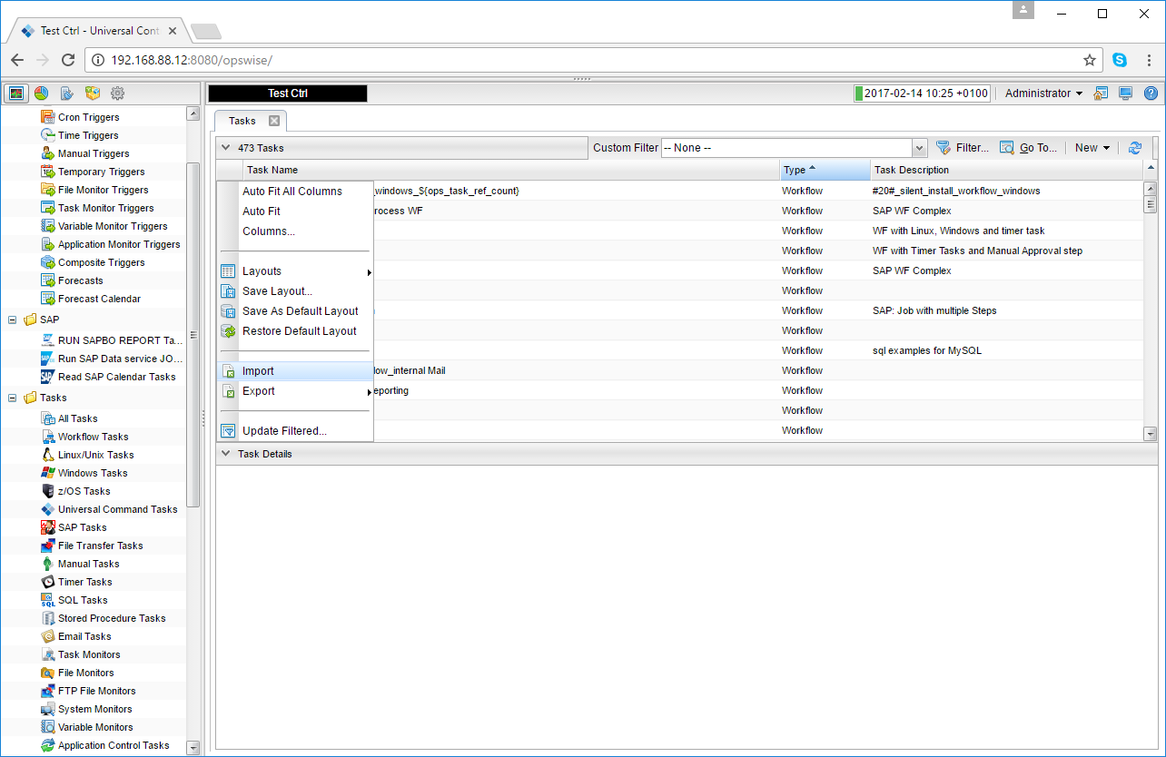 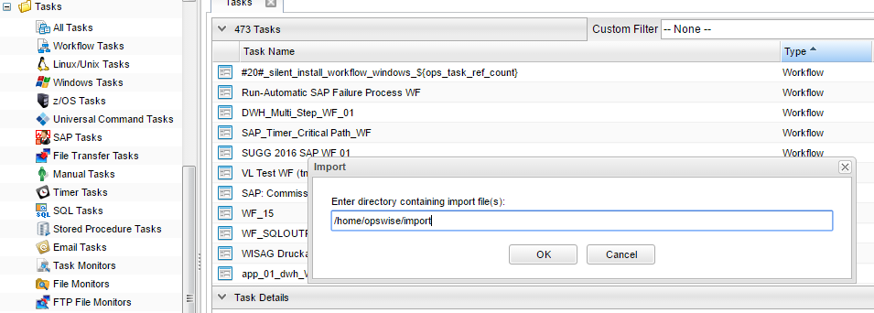

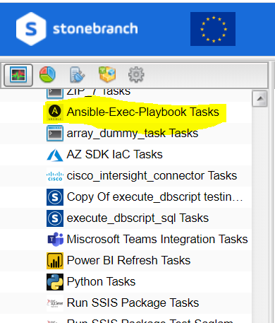

# Universal Task Configuration

**1.1 Invoke a playbook residing in Ansible Host**

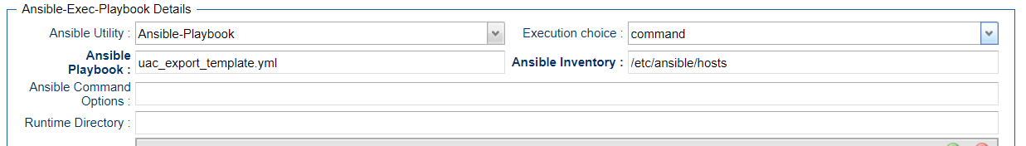

**1.2 Creating and executing a Ansible playbook from Controller**

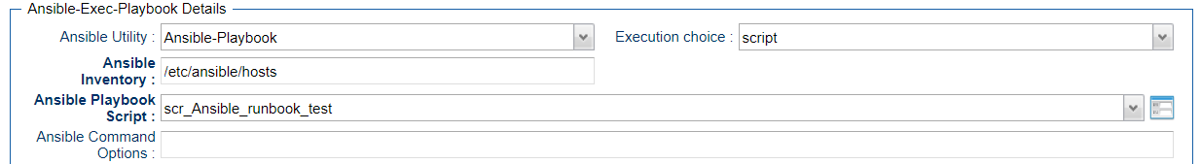

# Universal Tasks for Ansible-Exec-Playbook

The following contents describes the Ansible notifications through the universal task.

| UT Name | Description |
| --- | --- |
| Ansible-Exec-Playbook | Execute Ansible Playbook &other Ansible utility |

## Ansible Universal Task Fields

**Field Description:**

|  |  |
| --- | --- |
| Field | Description |
| Agent | Universal agent where ansible is installed |
| Credentials | Credentials of the Ansible installed machine(optional) to execute playbook, Default is agent userid credential(ubroker) |
| Ansible utility | 1. Ansible-Playbook (select to execute Ansible playbook) 2. Other-Ansible-Utility(Other Ansible commands) |
| Execution Choice | * Command 🡺 provide Ansible command that will be used to execute in Ansible machine where playbook and inventory is stored in Ansible host * Script 🡺 Select this option if you want to store the Ansible playbook in controller script library |
| Ansible Inventory | Provide the Ansible Inventory source from the Ansible host |
| Ansible Playbook Script | Provide a universal controller script name where you have the Ansible playbook (YAML) |
| Ansible command options | any additional commands if needed in playbook execution |

# Document References

This document references the following documents:

|  |  |
| --- | --- |
| Ref# | Description |
| 1. Ansible | <https://docs.ansible.com/ansible/latest/user_guide/playbooks.html> |