

**MDB**

MDB Test System

Technical Manual

**Document version** 01.00

**Release date** 15. March. 2018

**Software Rev.** 01

﻿© 2018 Quibixx

Table of Contents

Table of Contents 2

General information 3

About this document 3

System Overview 3

Organization of the Manual 3

System Summary 4

System Configuration 4

User Access Levels 4

Getting Started 5

Installation 5

System Menu 5

Settings 5

Help 5

Exit System 5

Using the System 6

Basic system usage 6

Unit testing 7

USB Type B and LEDs 8

Relay test 8

Serial test 8

Device Current and USB Type A 8

Appendix A 10

General information

|  |  |  |
| --- | --- | --- |
| About this document |  | This Technical Manual aims at giving insight to detailed technical aspects of the **MDB Test System** and general terms of the system and the purpose for which it is intended. |
| System Overview |  | **MDB Test System** software is an application which allows for automated testing of mdb boards. The application provides visual feedback of the testing status and stores it’s result in a database. MDB test system works in Windows 10 operating system. |
| Organization of the Manual |  | The user’s manual consists of 4 sections:   * General information * System summary * Getting started * Using the system |

System Summary

|  |  |  |
| --- | --- | --- |
|  |  | System Summary section provides a general overview of the system. The summary outlines the uses of the system’s hardware and software requirements, system’s configuration, user access levels and system’s behavior in case of any contingencies. |
| System Configuration |  | **MDB Test System** works on Windows 10 operating system with .NET framework 6 or higher. The application requires a valid database connection to be able to store data and several connection to the mdb board that will be explained later in this document. After installation the MDB test system can be used immediately without any further configuration. |
| User Access Levels |  | The application doesn’t require any specific privileges to allow the correct functionality of the program. |

Getting Started

|  |  |  |
| --- | --- | --- |
|  |  | Getting Started section explains how to install **MDB Test System** on the computer. The section presents briefly system menu. |
| Installation |  | The user must run **MDBTestSystemSetup.msi** or **setup.exe** provided in the distribution package. |
| System Menu |  | MDB test system has a very simple menu. Settings After clicking in **“settings”** (1), it will be displayed the following above window with 4 input fields that should contain the basic information of access to the database. A valid database connection is necessary to use the software.  **Server IP Address:** input the correct server IP address or URL of the database.  **Server Username:** input the database user name.  **Server Password:** input the database password.  (2)  (1)  **Database Name:** input the database name.  C:\Users\Inês Carvalho\Desktop\1.png Help Clicking in the **“help”** (2) will open this document. |
| Exit System |  | Click on Exit. |

Using the System

|  |  |  |  |  |
| --- | --- | --- | --- | --- |
|  |  | | This section provides a detailed description of system functions | |
| Basic system usage |  | | Correctly connect the **MDB** board using as reference the image in Appendix(A) open the software. After correctly configuring the database the user must fill the **form** (1) in the main window. The form consists of four input fields, **“Operator”**, where the user must input his name without numbers of special characters, **“Work Station”**, where the user must choose his working station, **“RS232 Port”,** where the user must select the COM Port associated with the RS232 cable and finally, **“Nucleo Port”**, where the user must select the COM Port associated with the Nucleo board. After filling correctly, the main window form, to start testing the user must press **“Start Test”** button (2).  C:\Users\Inês Carvalho\Desktop\1.png  The software will try to establish a connection to the database and to the Nucleo board, if it’s not possible to software will alert the user and stop, to continue the user must obtain a valid database connection and/or reselect the correct COM Ports.    When the database connection is established, the software will try to connect to the mdb board and if all the connection are correctly establish the software will start to perform several test to the board.  C:\Users\Inês Carvalho\Desktop\2.png | |
| Unit testing |  | | Every time a new test starts the user must input its serial number (only 10 digits and all must be numbers) and press **“Ok”** button for the automated tests to start by the following order.  C:\Users\Inês Carvalho\Desktop\3.png | |
| USB Type B and LEDs | |  | | This test will be performed by attempting to establish a connection to the MDB board, prompt the user that the LED test is about to start and after the user confirms the test will attempt to light all leds in a sequence. During testing, it will be asked to the user if the LEDs lighted up and down. If the user inputs a negative answer or if any failure occurs (e.g. no board communication) the software will consider it as a failed test and store the test result in the database. |
| Relay test | |  | | This test will attempt to activate and deactivate the relays on board. During testing, a valid connection between MDB board and the Nucleo board is mandatory, because the Nucleo board will validate the correct activation and deactivation of the relays. The proper function of the relays will be validated by the Nucleo board and if any failure occurs the software will consider the test as a failed test and store the test result in the database. |
| Serial test | |  | | This test will perform a read and write operation using the serial port. If any failure occurs the software will consider it as a failed test and store the test result in the database. |
| Device Current and USB Type A | |  | | This test will perform a measurement of the board current consumption and switch the power supply from USB to MDB Mode, read the power supply on the USB Type A Connector and perform all test described above, again. If any failure occurs the software will consider it as a failed test and store the test result in the database. |

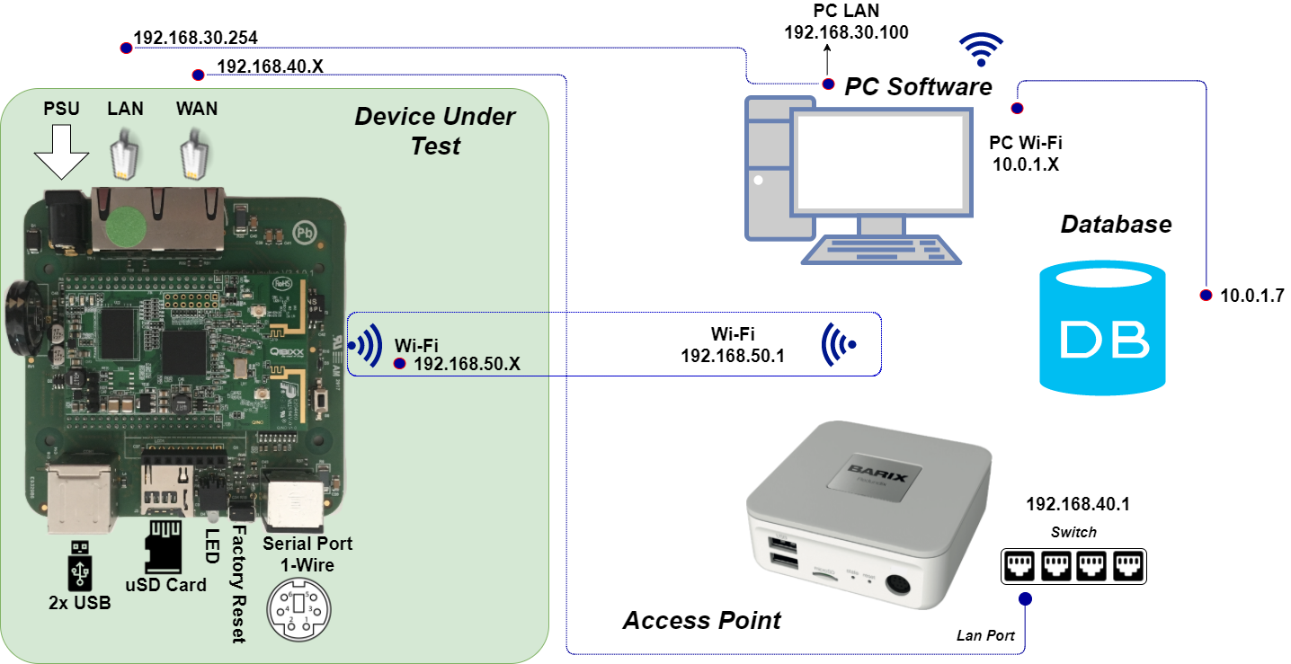

Appendix A

|  |  |  |  |  |  |  |
| --- | --- | --- | --- | --- | --- | --- |
| |  |  |  | | --- | --- | --- | | **MDB Board Connections** |  | **1** Open the Control Panel |  |  |  |  | | --- | --- | --- | |  |  |  | |