Assignment 1, Web Development with SpringMVC and JPA

Use Case Scenario:

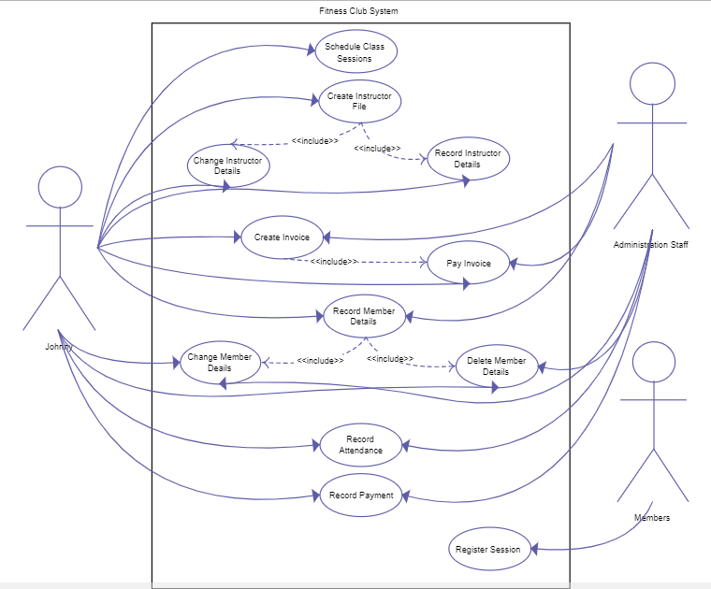

This semester’s assignments will focus on the gym club application system with use case scenarios demonstrated above.

**In this assignment, you are asked to develop a web app with SpringMVC and JPA.**

**Requirements:**

1, Be noticed that it is not necessary to provide complete functions for the development, providing 2-3 functions such as sign-in, sign-up and browsing gym location and private trainers will be fine; Also the web pages are not important part of our assignment, we are focused on server side implementation anyway.

2, Basic requirements (70%) :You are required to use SpringMVC, JPA and DBMS to develop the 3-tiers.

3,Credit to Spring Data JPA implementation(15%): query to multiple tables, pagination, multi datasources, auditing and so on.

4, Creadit to Web Caching (15%): providing cache to speed up the web response.

**Hand-in:**

1, Due date: 2019-4-30

2, Deliverables: source code, design report.

**Assessment criteria:**

|  |  |  |  |
| --- | --- | --- | --- |
|  | Basic-70% | JPA featues-15% | Web Cache-15% |
| >90 | a | a | a |
| 80~90 | b+ to a- | b+ to a- | b+ to a- |
| 70~80 | b | b | b |
| 60~70 | c- to c+ | c- to c+ | c- to c+ |
| Poor | f | f | f |