Chris Cole

BUS 440 Project 1

Business Rules

* NTC managed by Conner B Johnson (555) 637-9192
* CSF managed by Mary B. Carter and has a number of (555) 637-9045
* An item may only have 1 number, and each has a quantity on hand and on order
* Each vendor has 1 ID
* A building can have multiple rooms and a room number can correspond to different buildings
* A building can contain 1 or more items
* A building can have multiple vendors
* Items can be kept in multiple rooms of a building
* Item quantities can be ordered from a vendor

AllData

AllData (Item_Number, Name, Item_Quantity_On_Hand, Item_Quantity_On_Order, Room_Number, VendorID, Vendor_Name, Building_Name, Manager, Phone_Number )

Transitive dependencies:

VendorID: VendorName

BuildingID: BuildingName, Manager, Phone number

FNF

Item(Item_Number, Name,Item_Quantity_On_Order, VendorID, Vendor_Name, Building_Name, Manager, Phone_Number)

Room(BuildingID, RoomNumber)

Inventory(Item_Number, Room_Number, BuildingID, QuantityOnHand)

Second Normal Form

Already in 2NF

Item(Item_Number, Name, Item_Quantity_On_Order, VendorID, Vendor_Name, Building_Name, Manager, Phone_Number)

Room(BuildingID, RoomNumber)

Inventory(Item_Number, Room_Number, BuildingID, QuantityOnHand)

Third Normal Form and Additions

Item (ItemNumber, Name, VendorID, ItemQOO)

Vendor (VendorID, VendorName, Vendor Street_Address, Vendor_City, Vendor_State, Vendor_Zip, Vendor_Email_Addresss,)

Room(RoomNumber,BuildingID, NumberofItems, StorageCapacity)

Inventory (ItemNumber, BuildingID, ItemQuantityOnHand,RoomNumber)

Manager(ManagerFirstName, ManagerLastName, ManagerCellphone, ManagerEmail, ManagerID)

Building (*BuildingID*, Name, *ManagerID*, PhoneNumber)

Data Import

Questions

1)

select item.Item_Name, vendor.vendor_ID, vendor.Vendor_Name

from item, vendor

where Item_Quantity_On_Order > 0

And item.Vendor_ID = vendor.vendor_ID;

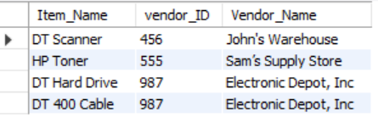

2) 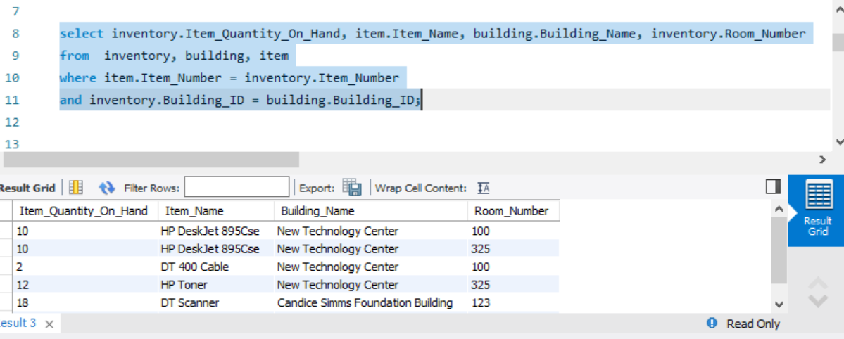

3)

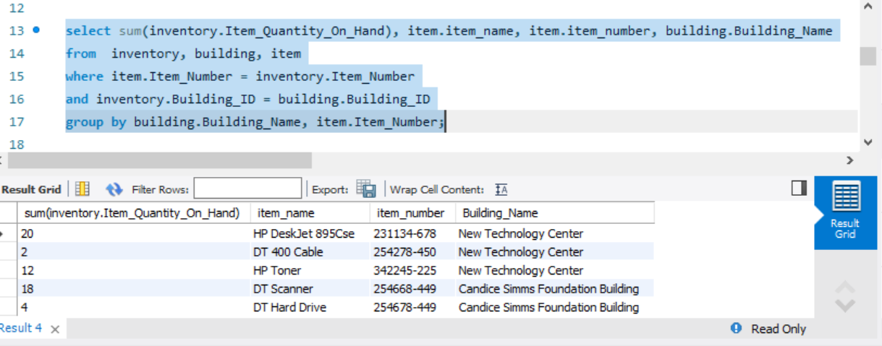4)

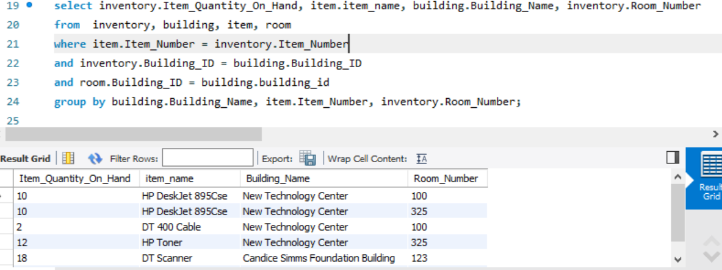

5)

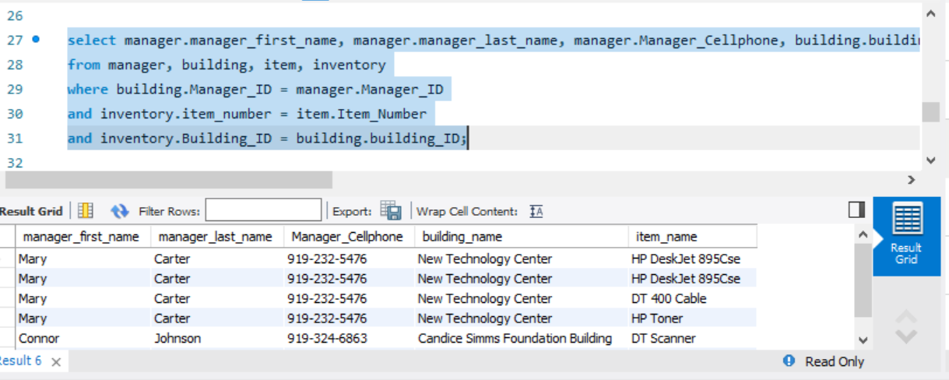

6)

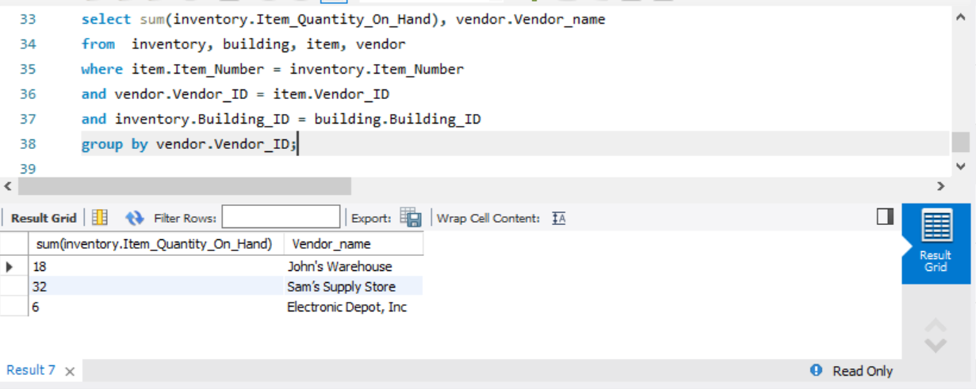

7) What is the average storage capacity for the rooms of both buildings?

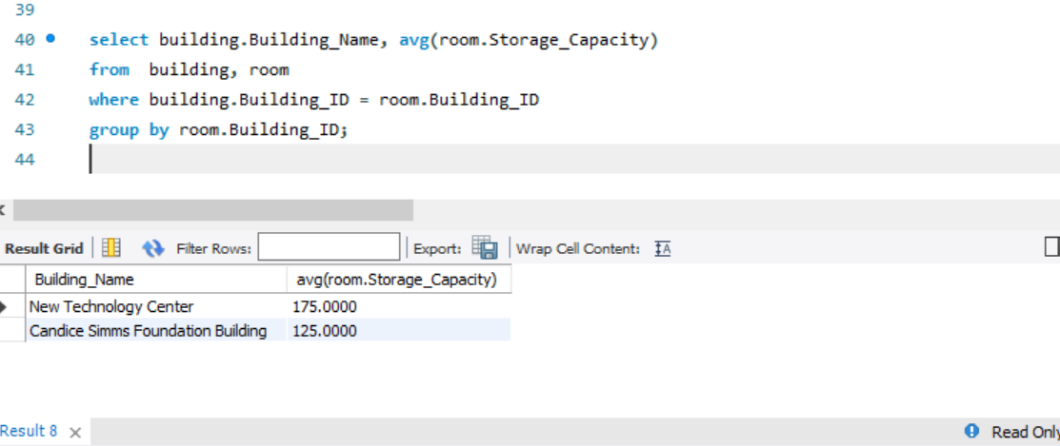

Based ond data below

