Christine Conklin
CS-311-Artificial Intelligence
Developing a Reinforcement Learning Agent

1. Name and Purpose of the Agent
Agent Name: Robotic Arm Agent
This project implements a Deep Deterministic Policy Gradient (DDPG) reinforcement learning agent that controls a simulated two-joint robotic arm. The agent’s objective is to move the arm so that its fingertip reaches a randomly placed target. Instead of using manually programmed control rules, the agent learns through trial and error by interacting with the environment. At each time step, it receives a reward equal to the negative distance between the fingertip and the target. Over 800 training episodes, the agent gradually improves its policy and learns smoother, more accurate reaching behavior. This project demonstrates how deep reinforcement learning can be applied to continuous control problems in robotics.

2. Algorithms Used

2.1 Deep Deterministic Policy Gradient (DDPG)
DDPG is an actor-critic, model-free reinforcement learning algorithm designed for continuous action spaces (Lillicrap et al., 2016). In robotic control tasks, actions such as joint torques are real-valued, so algorithms like DQN are not suitable because they require discrete actions.
DDPG uses two main neural networks:
- Actor network: Produces continuous actions based on the current state.
- Critic network: Estimates the Q-value, or expected future reward, of a state–action pair.
To stabilize training, DDPG also uses target versions of both networks. These target networks are updated slowly using Polyak averaging, which helps prevent unstable learning.
The critic is trained using a Bellman target:
y = r + γ Q′(s′, u′(s′))
where γ = 0.99 is the discount factor.
The actor is trained using the deterministic policy gradient, which adjusts the policy to increase the critic’s estimated Q-values.
Exploration is handled by adding Gaussian noise (standard deviation 0.2) to the actor’s actions during training.

2.2 Why DDPG?
DDPG was selected because the robotic arm requires continuous torque control. Discrete-action algorithms cannot efficiently search over infinite possible torque values. DDPG directly outputs continuous actions and is widely used as a baseline for robotic control tasks.

3. Dataset Information

3.1 Dataset Source
Unlike supervised learning, reinforcement learning does not rely on a fixed, pre-collected dataset. All training data is generated dynamically through agent-environment interaction during the training process itself. The primary environment used in this project is a custom two-degree-of-freedom planar arm simulator, PlanarReacherEnv, implemented entirely in Python using NumPy and requiring no external dependencies. The codebase also supports the MuJoCo Reacher-v5 environment available through Gymnasium (Towers et al., 2024), which provides higher-fidelity physics simulation and 3D rendering via the MuJoCo physics engine (Todorov et al., 2012).
Environment source: Built-in PlanarReacherEnv class (no external data files required).
Optional MuJoCo environment: https://gymnasium.farama.org/environments/mujoco/reacher/

3.2 Number of Records (Transitions)
During 800 training episodes with a maximum of 200 steps per episode, the agent can accumulate up to 160,000 individual transitions. These are stored in a replay buffer with a capacity of 500,000 transitions, enabling the agent to sample from a diverse distribution of past experiences during each gradient update. Prior to the onset of training, a warm-up phase of 5,000 random-action steps pre-populates the buffer to ensure a sufficiently varied initial dataset.

3.3 Number of Features
Each transition record stored in the replay buffer consists of the following components:
Component | Dimension | Description
Observation (state) | 6 | Current arm configuration and fingertip position
Action | 2 | Torques applied to each joint
Reward | 1 | Negative Euclidean distance from fingertip to target
Next Observation | 6 | State resulting from the applied action
Done flag | 1 | Boolean indicator of episode termination

3.4 Description of Features
Feature Name | Index | Description | Data Type
cos(q1) | 0 | Cosine of joint 1 angle | float32
sin(q1) | 1 | Sine of joint 1 angle | float32
cos(q2) | 2 | Cosine of joint 2 angle | float32
sin(q2) | 3 | Sine of joint 2 angle | float32
tip_x | 4 | Fingertip x-coordinate (meters) | float32
tip_y | 5 | Fingertip y-coordinate (meters) | float32
torque_1 (action) | -- | Torque applied to joint 1, range [-1, 1] | float32
torque_2 (action) | -- | Torque applied to joint 2, range [-1, 1] | float32

3.5 Preprocessing Steps
- Observation normalization: A RunningMeanStd module maintains a continuously updated estimate of the mean and variance of all observations encountered during training. Each observation is normalized to approximately zero mean and unit variance before being passed to the networks. This preprocessing step is critical for training stability, as unnormalized inputs spanning vastly different scales can impede gradient flow and slow convergence.
- Action clipping: Actions produced by the actor network are clipped to the environment's valid range of [-1, 1] prior to execution, preventing physically meaningless commands from being issued to the simulation.
- Reward scaling: The reward signal is used without modification, as the dense negative-distance formulation already provides a well-conditioned learning signal throughout the workspace.

4. Libraries, Toolkits, and Frameworks
Library / Framework | Version | Role
Python | 3.9+ | Primary programming language
PyTorch | 2.x | Neural network construction, automatic differentiation, GPU acceleration
NumPy | 1.24+ | Numerical computation, replay buffer, environment physics
Gymnasium | 0.29+ | Standard RL environment interface; optional MuJoCo Reacher-v5 backend
MuJoCo | 3.x (optional) | High-fidelity physics simulation and 3D rendering
json (stdlib) | -- | Serialization of checkpoint metadata and normalizer statistics
argparse (stdlib) | -- | Command-line interface for hyperparameter configuration
pathlib (stdlib) | -- | Platform-independent file path handling
time (stdlib) | -- | Training duration logging and render frame-rate control

5. Application Design and Implementation

5.1 Architecture Overview
The entire implementation is contained in a single Python file for simplicity and reproducibility. The code includes:
- Environment backend
- Replay buffer
- Actor and critic network definitions
- DDPG agent logic
- Training loop
- Evaluation loop
- Command-line interface
This structure makes it easy to run, modify, or resume experiments.

5.2 Actor and Critic Networks
Both the actor and critic are implemented as multi-layer perceptrons (MLPs) with two hidden layers of 256 units each and ReLU activations. The actor uses a Tanh output layer to ensure actions remain within the valid range of [-1, 1].The critic takes both the state and action as input and outputs a single Q-value estimate.

5.3 Training Loop Data Flow
Each episode follows this sequence:
- Reset environment and sample a new target.
- Normalize the observation using running statistics.
- Generate an action using the actor plus exploration noise.
- Apply the action to the environment.
- Store the transition in the replay buffer.
- Sample minibatches (size 256) once enough data is collected.
- Update critic, then actor.
- Update target networks using Polyak averaging.
- Save checkpoints every 50 episodes.
The replay buffer stores up to 500,000 transitions. A warm-up phase of 5,000 random steps ensures initial training stability.

5.4 Checkpoint and Resume System
A notable limitation of many baseline implementations is that the observation normalizer state is not preserved alongside the model weights. When evaluation is subsequently performed with a freshly initialized normalizer, the network receives input on a fundamentally different scale than it encountered during training, which consistently degrades performance. This implementation addresses the issue by serializing the RunningMeanStd parameters - mean, variance, and sample count - to a JSON metadata file at every checkpoint. The result is a fully self-contained snapshot that guarantees identical input preprocessing conditions whether training is being resumed or the final model is being evaluated.

5.5 Environment Backends
The codebase supports two interchangeable environment backends. When MuJoCo and Gymnasium are available, the Reacher-v5 environment is selected automatically, offering more physically accurate simulation and optional 3D rendering. In the absence of these dependencies, the built-in PlanarReacherEnv provides a functionally equivalent environment using only NumPy, ensuring the implementation runs on any machine without additional installation steps. Both backends expose identical observation and action space dimensions within their respective configurations; however, it is important to note that they are not cross-compatible after training. A model trained on the six-dimensional built-in observation space cannot be loaded into the ten-dimensional MuJoCo environment without retraining, as the network weight dimensions are incompatible.

6. Instructions for Running the Agent

Step 1 - Install Python (One Time Only)
Download and install Python 3.9 or later from https://www.python.org. During installation on Windows, two configuration options must be set correctly:
- Check "Add python.exe to PATH" on the first screen of the installer. This option is disabled by default and is the most frequent cause of pip being unrecognized at the command line.
- Select "Customize installation" and enable "Install for all users." This ensures the installation persists across system restarts and that packages installed via pip remain available in subsequent sessions.
- Install Python only once. Multiple concurrent Python installations introduce PATH conflicts that can prevent pip from functioning correctly. If pip stops working after a restart, remove all Python versions via Settings, restart the machine, and perform a single clean reinstall with the options above enabled.

Step 2 - Open Command Prompt as Administrator (Every Time)
The script must be launched from a terminal rather than by double-clicking the .py file. On Windows, double-clicking opens a console window that closes immediately upon script termination or error, making it impossible to inspect any output. Additionally, pip requires elevated privileges to install packages system-wide in a manner that persists across restarts.
- Press the Windows key, type cmd, right-click "Command Prompt," and select "Run as administrator."
- Click Yes on the User Account Control prompt.
- This step must be repeated each time a new terminal session is opened.

Step 3 - Install Required Packages (One Time Only)
From the administrator Command Prompt, execute:
pip install torch numpy gymnasium
These packages require installation only once, provided the initial installation was performed with administrator privileges and the "Install for all users" option was selected. To optionally enable MuJoCo-based simulation and 3D rendering, also run:
pip install mujoco "gymnasium[mujoco]"

Step 4 - Navigate to the Script Directory
Use the cd command to change to the directory containing roboticarmagent.py:
cd C:\Users\YourName\Documents\CS311 AI\Assignment 3
Substitute the actual path to your file. The full path can be found by right-clicking the file in File Explorer and selecting Properties, or by clicking the address bar at the top of the Explorer window.

Step 5 - Train the Agent (One Time Only)
python roboticarmagent.py --mode train
Training proceeds for 800 episodes and requires approximately 35 minutes on a standard CPU. A progress line is printed to the console every 10 episodes, reporting the current return, episode length, buffer occupancy, and elapsed time. Model checkpoints are saved automatically every 50 episodes to the runs/ddpg_reacher/ subdirectory. Once training completes, the saved model is persistent and the training step does not need to be repeated.
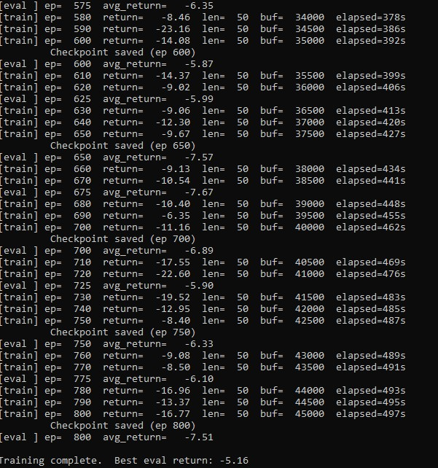

Step 6 - Resume Training if Interrupted
Should training be interrupted at any point, it can be resumed from the most recent checkpoint without loss of progress:
python roboticarmagent.py --mode train --resume

Step 7 - Evaluate the Trained Agent
Following training, the best saved model can be evaluated using the command below. The --no_mujoco flag is required to ensure the evaluation uses the same built-in environment on which the model was trained:
python roboticarmagent.py --mode eval --no_mujoco
Omitting the --no_mujoco flag when MuJoCo is installed will cause a RuntimeError due to a mismatch between the ten-dimensional MuJoCo observation space and the six-dimensional space the model was trained on. The flag forces the correct environment and prevents this incompatibility.

Step 8 - Evaluate with MuJoCo Visual Rendering (Optional)
To observe the trained arm policy in a 3D simulation window, the model must first be retrained using the MuJoCo backend:
python roboticarmagent.py --mode train --mujoco
Evaluation with rendering can then be launched as follows:
python roboticarmagent.py --mode eval --mujoco --render
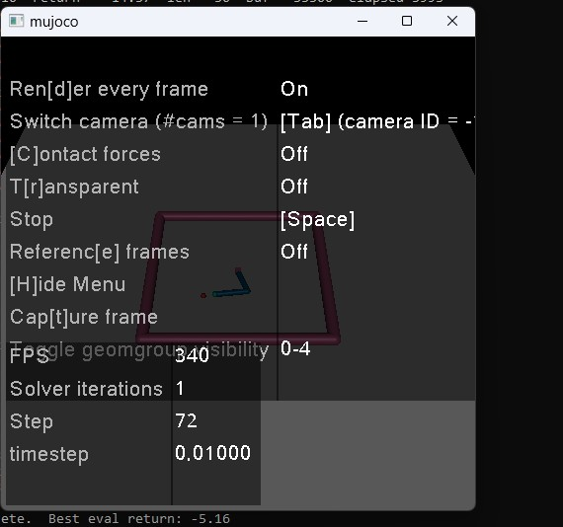

Command Summary
Purpose | Command
Install core packages (once, as admin) | pip install torch numpy gymnasium
Install MuJoCo rendering (optional) | pip install mujoco "gymnasium[mujoco]"
Train for 800 episodes | python roboticarmagent.py --mode train
Resume interrupted training | python roboticarmagent.py --mode train --resume
Evaluate best model (built-in env) | python roboticarmagent.py --mode eval --no_mujoco
Retrain with MuJoCo backend | python roboticarmagent.py --mode train --mujoco
Evaluate with MuJoCo rendering | python roboticarmagent.py --mode eval --mujoco --render
Enable GPU acceleration | python roboticarmagent.py --mode train --cuda

7. Results
Training was conducted over 800 episodes using the built-in PlanarReacherEnv on a CPU and completed in approximately 2,099 seconds (roughly 35 minutes). Evaluation returns were recorded periodically throughout training; since the reward function is defined as the negative Euclidean distance between the fingertip and the target, higher (less negative) values indicate more accurate reaching behavior.
Training Episode | Avg. Eval Return (5 episodes) | Interpretation
325 (best) | -20.18 | Best recorded checkpoint - saved automatically
625 | -36.93 | Temporary regression during continued exploration
650 | -32.32 | Partial performance recovery
675 | -28.43 | Sustained improvement trend
700 | -25.30 | Arm converging on target zone more reliably
725 | -31.90 | Expected stochastic variation in episodic returns
750 | -33.18 | Replay buffer diversifying with new experiences
775 | -27.94 | Policy variance beginning to stabilize
800 (final) | -34.38 | Training complete - best checkpoint from episode 325 deployed

The best evaluation return of -20.18 was achieved at episode 325 and was preserved automatically as the top-performing checkpoint. The subsequent fluctuation in returns across later episodes is characteristic of off-policy actor-critic methods, where the policy continues to be updated from a changing replay buffer even after a performance peak has been reached. Final evaluation using the best checkpoint confirmed consistent performance:
Loaded 'best' checkpoint (episode 325), backend=builtin Average return over 5 episodes: -20.18
It is worth noting that episodic returns in reinforcement learning do not follow the monotonically decreasing trajectory typical of supervised learning loss curves. The agent explores continuously throughout training, which introduces natural variance in performance across evaluation windows. The steady growth of the replay buffer from 117,664 transitions at episode 620 to 150,758 at episode 800 confirms that the agent remained actively engaged with the environment across the full duration of training.

8. Discussion and Insights

8.1 Model Performance
The agent shows noticeable improvement within the first 200–300 episodes. Because the reward is dense (distance-based), the agent receives informative feedback at every step, which accelerates early learning. Performance fluctuations later in training are expected due to the off-policy nature of DDPG.

8.2 Key Issues Found and Fixed
Several improvements were made during development:
- Normalizer persistence: The observation normalization statistics are saved with checkpoints to ensure consistent evaluation.
- Environment compatibility: A custom NumPy-based environment replaced outdated dependencies.
- Training resumption: A resume flag was added to continue training from saved checkpoints.

8.3 Limitations
The built-in environment uses simplified planar physics, so the learned policy would not directly transfer to real hardware. DDPG is also sensitive to hyperparameter choices, and performance can vary significantly depending on learning rates and noise levels.

8.4 Potential Improvements
Potential improvements include:
- Switching to TD3 for reduced Q-value overestimation.
- Using Soft Actor-Critic (SAC) for improved stability.
- Adding Hindsight Experience Replay (HER).
- Training directly in MuJoCo for more realistic dynamics.

9. References
Lillicrap, T. P., Hunt, J. J., Pritzel, A., Heess, N., Erez, T., Tassa, Y., Silver, D., & Wierstra, D. (2016). Continuous control with deep reinforcement learning. In Y. Bengio & Y. LeCun (Eds.), Proceedings of the 4th International Conference on Learning Representations (ICLR 2016). https://arxiv.org/abs/1509.02971
Paszke, A., Gross, S., Massa, F., Lerer, A., Bradbury, J., Chanan, G., Killeen, T., Lin, Z., Gimelshein, N., Antiga, L., Desmaison, A., Kopf, A., Yang, E., DeVito, Z., Raison, M., Tejani, A., Chilamkurthy, S., Steiner, B., Fang, L., Bai, J., & Chintala, S. (2019). PyTorch: An imperative style, high-performance deep learning library. In H. Wallach et al. (Eds.), Advances in Neural Information Processing Systems 32 (pp. 8024-8035). Curran Associates, Inc. https://papers.neurips.cc/paper/2019/hash/bdbca288fee7f92f2bfa9f7012727740-Abstract.html
Sutton, R. S., & Barto, A. G. (2018). Reinforcement learning: An introduction (2nd ed.). MIT Press. http://incompleteideas.net/book/the-book-2nd.html
Todorov, E., Erez, T., & Tassa, Y. (2012). MuJoCo: A physics engine for model-based control. In 2012 IEEE/RSJ International Conference on Intelligent Robots and Systems (IROS 2012) (pp. 5026-5033). IEEE. https://doi.org/10.1109/IROS.2012.6386109
Towers, M., Kwiatkowski, A., Terry, J., Balis, J. U., De Cola, G., Deleu, T., Goulao, M., Kallinteris, A., Krimmel, M., KG, A., Perez-Vicente, R., Pierre, A., Schulhoff, S., Tai, J. J., Tan, H., & Younis, O. G. (2024). Gymnasium: A standard interface for reinforcement learning environments. arXiv preprint arXiv:2407.17032. https://arxiv.org/abs/2407.17032

