**Analysis of Team NBA Stats (2000 – 2019)**

*Caleb Conner, CSCE 567*

**Introduction/Background**

One of the most interesting things to look at when it comes to NBA basketball is the statistics. More specifically, how certain stats may or may not affect the performance of a given team. Advanced analysis of statistics is something that people have been looking at across all sports for a while. While it is a common thing to look at and reference, it is not always the easiest thing to visualize. “Player X had the highest PPG average in the league in season Y, leading him to the highest number of win shares by a player in 15 seasons with a 3-point percentage less than Z%” is a sentence that is completely meaningless unless you know exactly what all of those things mean.

For the purpose of this project, there are only a few statistics to be aware of: points per game, 2-point percentage, 3-point percentage, field goal percentage, and free throw percentage. Points per game is just the average points that team scored each game that season. On a basketball court, the outer arc is referred to as the “3-point line.” Any made shot within the arc counts as 2 points and any behind it count as 3 points. 2-point and 3-point percentage just refers to the percentage of made shots out of the ones attempted. Field goal percentage refers to the total percentage of shots made (2 and 3 point). A free throw is a shot after a foul occurs that only counts for 1 point. It is a shot taken without moving and without any defense, so most players tend to have a higher free throw percentage.

**Audience/Purpose of work**

The ideal audience for this work would be someone who is interested in NBA basketball or just likes looking at statistics as a whole. The purpose is to throw together some simple stats and be able to compare two teams side by side. This will allow people to draw their own conclusions as to what stats they believe have the biggest impact. Instead of just saying “the best teams in the league tend to be better at X,” people can look at this visualization and determine what they think is the most important stat. It will also be useful for showing how the best teams of each year compare side by side. This will make more sense after looking at the mockups for the visualization (below).

**Dataset(s)**

Every stat needed can be found on basketball-reference, here: <https://www.basketball-reference.com/leagues/NBA_2019.html>. That link is just the 2018-2019 season summary, but the website has that for each of the seasons needed for this visualization (2000-2019). The 2020 season is still not complete (postponed because of the virus season). Also, there was a “lockout” which delayed the start of the 2011-2012 season, so it was shortened to 50 regular season games instead of the normal 82. This should not affect any of the stats since they are all per game/ average based. Below is an example of how the table will be laid out:

Column Descriptions

|  |  |
| --- | --- |
| **Column Name** | **Description** |
| Team | Team Name (ex. Charlotte Hornets) |
| Season | Years that season spans, starts in the fall and ends in the spring so it spans 2 years (ex. 2000-2001, 2001-2002, etc.) |
| Total Points | The total amount of points that the team scored throughout the whole season |
| 2 Point Percentage | Percentage of 2-point shots made |
| 3 Point Percentage | Percentage of 3-point shots made |
| Field Goal Percentage | Percentage of total shots made |
| Free Throw Percentage | Percentage of free throws made |

Example Table

|  |  |  |  |  |  |  |
| --- | --- | --- | --- | --- | --- | --- |
| **Team** | **Season** | **FG** | **threeP** | **twoP** | **FT** | **PTS** |
| Milwaukee Bucks | 2018-2019 | 0.476 | 0.353 | 0.565 | 0.773 | 118.1 |
| Golden State Warriors | 2018-2019 | 0.491 | 0.385 | 0.557 | 0.801 | 117.7 |

Obviously this is only 2 rows, and there are 30 teams and 19 seasons, as well as league averages per season. In total, it is 584 rows. All of these stats can be found on the link above. A little bit of navigation is needed to get to the rest of the seasons, but it is all there.

**Visualization Method**

For my visualization, I chose to go with an interactive basketball court rather than just a standard chart. I created an HTML webpage that displays 2 teams and their stats side by side. The left half of the court is one team, and the right half of the court is another. I felt as if this was a much more interesting display than just throwing a couple of graphs on there. Graphs are sometimes much more difficult to look at an interpret, plus they are much more boring. I used HTML, CSS, jQuery, D3 JS, and some Bootstrap HTML/CSS elements.

Also, I built my CSS basketball court by referencing this codepen: <https://codepen.io/vinicius5581/pen/xZgxvz>. I changed it up a lot to match what I needed, but the court itself was built around that. Below is a screenshot of the final product.

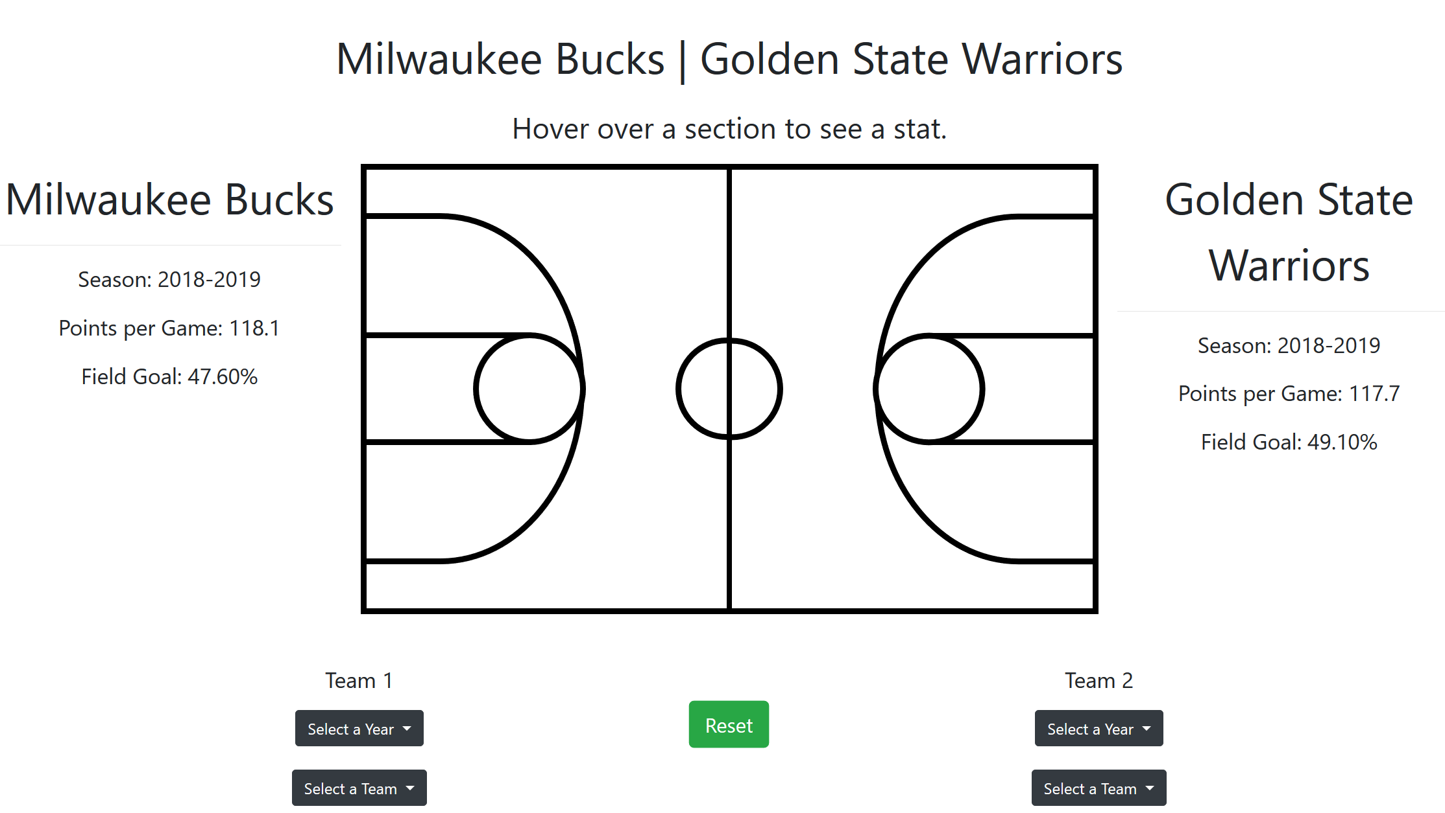

**Results**

My visualization is very simple to use, and I will attach the source code for it to my blackboard submission. Apart from starting a local server, there are no special setup instructions. I ran everything on a local server on my Windows machine using Firefox. Whenever I tested it in Chrome, it was not as smooth of an experience (the display kept on shifting). By default, the website will load comparing the 2018-2019 Milwaukee Bucks to the 2018-2019 Golden State Warriors (the first 2 elements in the data set).

To the left of the court, the first team is displayed along with some stats (points per game, season, and total field goal percentage). The same thing is displayed on the right side of the court for the second team. Hovering over sections of the court displays a stat above the court corresponding to that section. For example, if you hover your mouse outside the 3-point arc on the left side, it will display the first team’s 3-point percentage above the court. Note: the color that fills in the section that you are hovering corresponds to that team’s color.

To change the teams/seasons, there are 2 sets of dropdown menus below the court. The set on the left corresponds to what team will show on the left half of the court, and the set on the right corresponds to what team will show on the right half of the court. You must select the year for the team dropdown to populate. The reason for this is because over the past 20 seasons, there have been a few franchise changes, so not every season has the same 30 teams. For example, the 2000-2001 dataset has a team called the Vancouver Grizzlies. This team is a part of no other season. Once you have selected a season/team for each side, press the “reset” button to reload the webpage with the new data. If a selection is not complete, it will go back to the default value (ie. If you pick a season but no team).

**Discussion/Future Work/Complications**

I think that the most disappointing aspect of my visualization is the fact that it wasn’t feasible to include the win percentage stat, like I proposed in my midterm. The website that I used had a table that included all the stats that I needed (plus a few extra). There were separate tables that showed the number of wins and losses for each team. The problem was that these tables were sorted differently than the table that included all the other stats. This meant, to get all of the win percentages, I would have had to do each calculation by hand and type the result into the table. I got about halfway through the first season before I decided to give up. It was just too much effort for just one extra statistic.

Other than that, I am very happy with the way that my project turned out. I created a very interesting and clean looking visualization. It is easy to use and includes almost every stat that I wanted. Also, initially in my proposal, I said that I was just going to display the 3 stats (3P%, 2P%, and FT%) in plain text on the court. I ended up going with the hover aspect because I felt as though the extra interaction made it much more interesting. I also learned a great deal about front-end web development in the process of doing this project, so that was pretty cool too.

In the future, I would find an easier way to grab all of the win% stats for each team. I probably could have found a way to do it in excel, but I am not good enough at excel to even attempt that. Also, I could expand the data set to include more stats (such as assists, rebounds, etc.).

**Works Cited**

Stats: <https://www.basketball-reference.com/>

CSS Court: <https://codepen.io/vinicius5581/pen/xZgxvz>

Bootstrap Docs: <https://getbootstrap.com/docs/4.4/getting-started/introduction/>

My GitHub Repo: <https://github.com/cconn0803/basketball-stats>