Model Description

# Overview

## Purpose

The purpose of this model is to explore the dynamics of a human foraging system including the exploration of decision making rules for camps and foragers. The landscape and food resources relate to the Middle Stone Age of coastal South Africa during an inter-glacial phase such as MIS 5e. Several specific research questions will be addressed with the model including maximum sustainable population size, role of inter-tidal foraging in the diet and its impact on mobility patterns, and the impact of future planning. In addition, the process of model development is closely linked to complementary research on the impact of climatic and ecological changes on past human populations.

## Entities, state variables, and scales

There are three types of entities in the model: cells and two types of agents. Cells each represent one hectare of a foraging landscape. A georeferenced raster map of a section of South Africa is imported with values representing one of 14 terrestrial and coastal habitat types. Each cell is assigned associated variables relating to the caloric return rates of harvesting, time required to harvest, current state of depletion, and time until replenishment based on its type. The total landscape is 60,000 hectares, with a fraction of that representing inaccessible ocean.

The return rates of these coastal cells cycle between two values, one for regular and Neap tides which last for 10 days, and one for Spring tides which last 5 days. The spatial and temporal distribution of resource abundance over the landscape influences the pattern of mobility and the proportions of resources collected.

There are two types of agents, namely foragers and camps. Camps may move at the beginning of each day but have a limited mobility range. Camps make mobility decisions designed to maximize caloric returns for the group over a given number of days. Foragers are individual people, each a member of specific camp, who have a time budget in hours that are available each day. Foragers make their own mobility and resource harvesting decisions designed to maximize their caloric returns during the time they have left in their day. Foragers’ time budgets are reduced by fractions of hours during harvesting and while walking between cells. Camp and forager variables are used to keep track of time left and kilocalories collected.

## Process overview and scheduling

Each time step (tick) represents one day. At the beginning of the day, cells and camps are updated. A 15 day tidal cycle advances by one day and if in the last 5 days of this, return rates are updated to reflect Spring tide resource availability even if it had been harvested during the previous 10 days. Depleted terrestrial cells decrease their time until regrowth by one day and if at zero, their return rate is replenished. The camps then use a decision making algorithm to decide on their location for the end of the day. The maximum range of this move is 75% of a days’ walk from their previous location but may be a much shorter distance. If the selected cell is within range they will move to it, if it is beyond their range they will move as far as they can in the direction of that cell.

Foragers then begin a loop where they make mobility and harvesting decisions with the time they have left in their day. During each iteration of the loop, foragers in random order estimate the time required to walk directly to their assigned camp. If their time left is greater, they make a mobility decision designed to maximize their daily caloric return. After moving to a cell, they subtract their travel time. They harvest 20% of the resources of that cell, reflecting a linear 100m transect with 10 m visible on either side, and subtract the time expended in harvesting that resource. We assume that foragers are able to observe a previous forager’s transect and thus, the return rate of each cell remains constant until it is completely depleted (Fig. S1). If their travel time to camp is less than or equal to their time left, they move one cell towards their camp and do not harvest resources. Foragers repeat this loop until they run out of foraging time. As harvest times are different per habitat, foragers are asynchronous during each day. When all foragers have used up their time and returned to camp average caloric returns are calculated by each camp.

Upon being fully harvested, terrestrial cells set a counter to 365 days. This counter is decreased each day to simulate plant regrowth and as cells reach zero, their resources are replenished. More detailed plant surveys are underway in South Africa and additional details regarding seasonal plant cycles or differing regrowth rates will be incorporated into a future model.

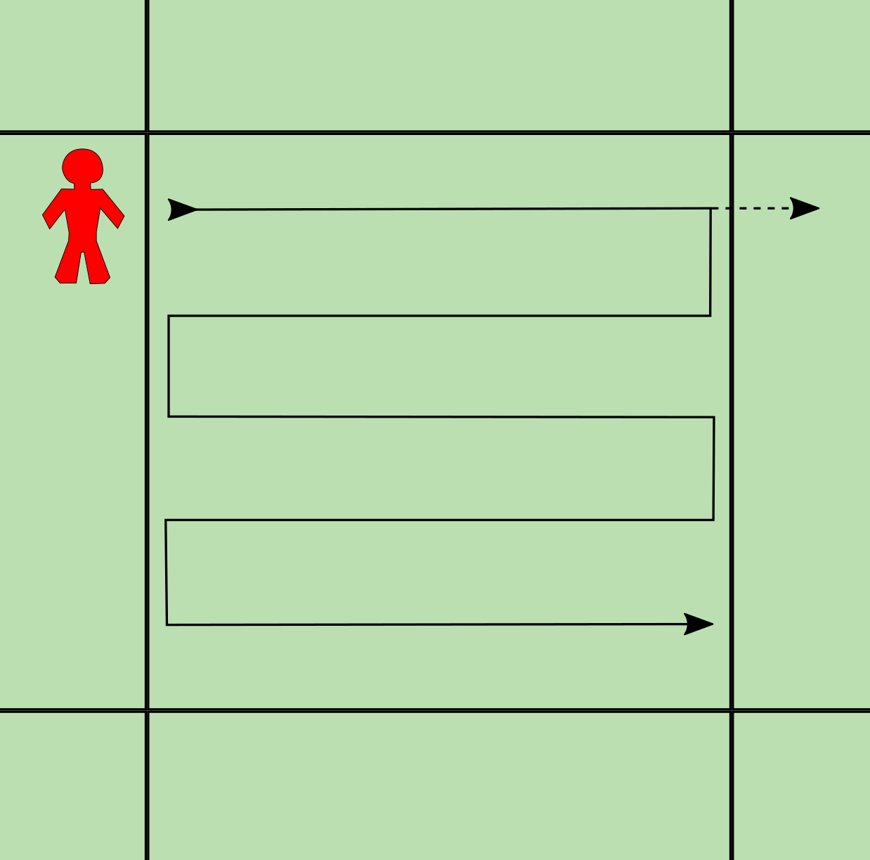

Fig. 1: Schematic of a forager agent systematically searching a single cell (solid arrow). By not overlapping the swaths (we assume they are able to recognize previous foragers’ harvesting activities) they maintain a constant return rate over five passes across the cell. Alternatively, the forager could decide after the first pass that the neighboring cell has a higher return rate and move there (dashed arrow). That would leave the cell with the same return rate but 20% less harvestable time available to future foragers.

# Design concepts

## Theoretical and empirical background­

The model design is based on Optimal Foraging Theory (OFT) and implemented according to OFT’s definitions of habitats, patches, and prey (Stephens and Krebs, 1986; Janssen and Hill, 2014; 2016). Habitats are geographical regions with consistent characteristics such that a statistically constant pattern of food resources will be encountered. This leads to an average expected return rate for individuals searching that habitat. Patches are smaller units of habitat with a finite number of resources. On the time scale relevant to daily foraging, patches may be depleted as their return rate relative to other patches drops. In our model we assume a systematic search per patch, which means that the return rate per patch remains constant until that cell’s resources have been completely exhausted at which point no other resources are available. While our field research has shown that certain plant resources do appear in concentrated clumps only a few meters across, at the scale of a hectare an individual forager has a reasonably consistent return rate given a habitat specific amount of searching and processing time. In the current implementation, there are no prey species.

While the broad framework of the model is based on OFT and ethnographic observations, some model details have been incorporated that are specific to South Africa. For example, water availability has not been included as a constraint on camp location decisions. A paper on this subject is in preparation, but preliminary data suggests that water sources are relatively well distributed across the landscape and therefore would not have been as important a constraint in most habitats as in some other regions (Cowling and Mars, personal communications). We have worked closely with a variety of researchers with knowledge of South African archaeology, ethnography, ecology, botany, and marine biology to ensure the relevant factors are being considered in the decision making framework of camps and foragers.

## Individual Decision Making

Camps and foragers make similar decisions designed to maximize their caloric return given their available time. In each case, the agent assesses individual patches with the assumption that its neighbouring patches will be similar. That is, the return rate of a cell is multiplied by up to several days of foraging time even though that patch may be fully exploited in a fraction of that time. This is a reasonable, though not strictly accurate, heuristic that we use for computational efficiency. This heuristic introduces some uncertainty into the estimated return for camps and foragers since the neighboring cells may not have the same return rate or may be depleted. We assume that camps and foragers have prior experience in this landscape and thus know the condition of cells in the landscape. No partial memory aspect is included. See below for details.

## Learning

Camps and foragers do not learn or adapt their decision making strategies in this version of the model.

## Individual sensing

In their decision making algorithm, camps use the daily foraging budget, distances to assessed cells, return rate of all cells, and whether a cell is depleted or not. In assessing the return rate, camps also understand the impact of the tidal cycles on return rates, and may forecast the high return Spring tides several days in advance. Although not explicitly modeled, camps are assumed to have global knowledge of current return rates through information exchange and experience.

Foragers keep track of how much time they have left in their day, the distance to their camp and how much time it will take to travel there, how many kilocalories they have collected so far that day, and the current return rate of patches within a specified radius and coastal patches even if they are outside of the radius.

## Individual prediction

Although not explicitly modeled, camps and foragers are assumed to have knowledge of the tidally affected coastal return rates through the observation of lunar phases. This also allows camps to anticipate the arrival of the Spring tide. A future version of the model will incorporate data from seasonal plant phenology for predicting the availability of plant resources as well.

## Interaction

Camp and forager interaction is indirect as their mobility decisions are affected by other foragers’ depletion of resources. However, the location of other foragers and camps are not factored into mobility decisions.

## Collectives

Camps consist of a number of foragers who begin their day at the previous day’s camp location, and end their day at the new camp site. Average caloric returns are calculated both for individual foragers as well as for camps under an assumption of food sharing. Foragers are assigned a camp on initialization of the model and do not change camps.

## Heterogeneity (agents)

Agents are not heterogeneous in their state variables or processes. All agents use the same decision algorithm.

## Stochasticity

The order in which camps move, and foragers move and forage, is randomized. Since each forager is indirectly affected by the distribution of available resources, there is a minimal impact of this randomization. In certain rare circumstances, a forager is not able to move to or towards the cell they determine to have the highest net return due to an uninhabitable cell being in the way (such as an ocean). In these cases, foragers move to a randomly selected cell in their immediate 8-cell neighbourhood to help them continue moving.

## Observation

Output variables will vary based on the specific research question being evaluated. The model accounts for time spent and calories collected per forager, per camp, and per cell. These may then be aggregated into average caloric returns, days without food, and ratios of different food types (e.g. plant vs marine, or per habitat type). Mobility characteristics such as frequency of camp movement, distance traveled per camp or forager, and time spent in proximity to the coast may also be measured.

# Details

## Implementation details

The model is implemented in Netlogo 5.3.1

## Initialization

During the setup procedure, variable settings are read from the user interface to determine which landscape will be used, and how many camps and foragers there will be. Setup assigns return rates and harvesting times to all cells based on their habitat type. Several other accounting variables are set to zero such as calories collected and distance traveled. Additionally, if a number of days of foresight are being used, a temporal multiplier is calculated using the hyperbolic time-discounting formula. All terrestrial cells are set to be full of resources which results in the first year of the simulation being more productive than subsequent years.

## Input data

### Habitat data

The habitat map consists of two data sources. Vector GIS layers of terrestrial habitats were taken from a digital appendix to Mucina and Rutherford (2006) and converted into raster format at one hectare resolution.

The coastline of the study region were walked in order to sample underlying geology. De Vynck et al. (2016a) found that shellfish return rates varied consistently with underlying geology and used this as the basis for differentiating returns rates among other variables. We used GPS data from this coastline survey and combined it with the terrestrial data to create a raster model of all habitats at 1 hectare resolution divided into 14 distinct habitat types.

Details of field experiments in coastal shellfish foraging are documented in De Vynck et al. (2016a), and in plant foraging in De Vynck et al. (2016b;c) with some additional caloric data from Singels et al. (2016). Note that the values in the table are estimated given currently available data, but that more rigorous estimates are underway.

|  |  |  |  |
| --- | --- | --- | --- |
| Habitat ID | Habitat Name | Return rate (kcal/hr) | Harvest time (hours/ha) |
| 1 | Freshwater wetlands | 2000 | 17.9 |
| 2 | Alluvial vegetation | 1160 | 13.4 |
| 3 | Strandveld | 1200 | 1.17 |
| 4 | Saline vegetation | 0 | 0.83 |
| 5 | Renosterveld | 100 | 0.67 |
| 6 | Sand Fynbos | 1020 | 0.72 |
| 8 | Albany Thicket | 100 | 0.65 |
| 9 | Limestone Fynbos | 470 | 0.70 |
| 10 | Aeolianite | 1450(l)/250(h) | 1.5 |
| 11 | Sandy beach | 150(l)/250(h) | 1.5 |
| 12 | TMS Boulders | 1100(l)/250(h) | 1.5 |
| 13 | TMS Rocky Headlands | 1100(l)/250(h) | 1.5 |
| 14 | TMS Wave Cut Platforms | 1100(l)/250(h) | 1.5 |

Table S1: Return rates and harvest times per habitat type. Habitat IDs 10 or more are coastal habitats which have different return rates for the lowest (l) two hours of tide vs. the rest of the day (h).

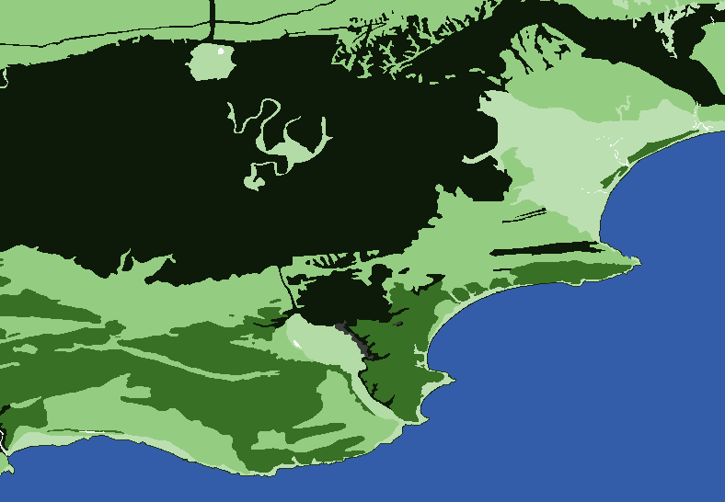

Fig S2: Screenshot of the Netlogo raster landscape where habitats are colour scaled according to their caloric return rates (lighter shades = higher returns). This view is during a neap tide when coastal returns rates are low (black).

### Parameter values

Other parameter values are either estimated from ethnographic sources or are actively being derived from fieldwork in South Africa. For example, walking speeds through different habitats are being recorded during the process of plant surveying. The amount of harvesting time available to foragers is estimated from ethnographic sources including Hill’s work with Ache foragers of Paraguay (Janssen and Hill, 2014; 2016) and this is consistent with Hadza foragers in nearby Tanzania (Hawkes et al., 1997). One exception to these two sources is the camp mobility distance which is calculated as a percentage of a day’s walk (Eq. S3).

|  |  |  |  |
| --- | --- | --- | --- |
| Parameter | Description | Default value | Value range |
| nragents | Number of foragers per camp | 7 | 1-30 |
| nrcamps | Number of camps | 3 | 1-30 |
| Walk-speed (km/hr) | Speed foragers will walk when not harvesting resources | 2 | 1-5 |
| Camp-mobility | Maximum distance a camp may travel per day | Eq. S3 | n/a |
| Vision-forager (cells) | Distance in hectare cells that a forager sees when making a mobility choice | 10 | 5-75 |
| Vision-camp (cells) | Distance in cells that a camp sees when making a mobility choice (if global-knowledge is off) | 50 | 1-50 |
| Global-knowledge? | Switch to determine if camps have knowledge of all cells, or only ones within the vision-camp radius | True | True/False |
| Map-zone | Selects the full region or different sub-zones of the study area | z2 (Pinnacle Point) | z1 (Vleesbaai), z2, or full |
| Max-kcal-collect (kcal) | Maximum number of resources a forager will collect in a day | 5000 | 1000-5000 |
| Days-of-foresight | Number of days camps will forecast return rates over | 1 | 1-5 |
| Discount-rate | *k* in Eq. S2. Controls the steepness of the fall-off in value with days of foresight | 0.1 | 0.01, 0.1, 0.25 |

Table S2: Default values and ranges for other parameters used in the model.

## Submodels

Here we discuss the details of the forager and camp mobility decisions, the tidal cycle, and including our implementation of forecasting return rates over several days.

### Camp decision algorithm

Camps assess all cells then select the cell which has the maximum net caloric return determined by Eq. S1. If the cell is a coastal cell, an adjustment is made as the return rate is different for the two hours of lowest tide at the beginning of the day versus the remaining hours. In this case, the first two hours (minus travel time) are multiplied by the low tide return rate, followed by the remaining hours multiplied by a randomly selected adjacent terrestrial cell (which are generally higher than the high tide return rate).

Available time may also be multiplied over a specified number of days of foresight to reflect future planning. In these cases, the caloric returns of future days are discounted according to a hyperbolic time discounting formula (Eq. S2). The discount rate parameter (*k*) determines the fall-off rate of value with number of days in the future.

*Net caloric return = ((discounted_return) * hours_per_day – (distance /* *camp_mobility * hours_per_day * current_return_rate)*

(S1)

where *camp_mobility* is defined by Eq. S3 and *discounted_return* represents the summed returns over a defined number of days of foresight ($d_{f}$) $$discounted_return=\sum_{D=0}^{d_{f}}{\frac{A}{(1+kD)}}$$

(S2)

where *A* is the caloric return after a delay of *D* (in days), and *k* is the discount rate parameter and

*camp_moblility = daily_time_budget * walk_speed * 10 * 0.75*

(S3)

which assumes that the maximum distance the camp can move in one day is 75% of a day’s constant walking.

### Forager decision algorithm

Like camps, foragers assess cells (within a visual range) and select the cell with the maximum net caloric return (Eq. S4). The algorithm similarly subtracts travel time and adjusts for the low and high tides. The only difference is that foragers’ available time is based on how much time they have left in their day and no future days are accounted for.

*Net_caloric_return = (current_return_rate * time_left) – (distance \** *time_walk_cell)*

(S4)

where *time_walk_cell* is the time in hours needed to walk 100 m as calculated from the *walk_speed*.

### Lunar tidal cycle and forecasting

The ~15 day lunar cycle has a dramatic effect on the return rates of inter-tidal shellfish availability such that only around the Spring tides, are foragers able to get a sufficiently high caloric return to justify the risk of acquiring the resource. De Vynck et al. (2016a) demonstrated that under the best combination of conditions return rates could exceed 3000 kcal/hr. However, waves along this coastline can be powerful and could sweep foragers off slippery rocks into the ocean making the lower return rates during non-Spring tides much less attractive. Our intertidal foraging experiments during different parts of the lunar cycle and under a variety of weather and forager characteristics have led us to determine that only 5 days out of each 15 day cycle have high return rates, with the other 10 being much lower.

A tidal-cycle procedure updates the return rates of coastal cells at the beginning of each model day. If a coastal cell is fully depleted during a non-Spring day, it will be replenished to the full return rate on the first Spring tide day to reflect foraging lower in the inter-tidal zone. If a cell is fully depleted during a Spring tide day, that cell will not be replenished until the beginning of the next Spring tide (i.e. will remain at zero return rate during the 10 days of non-Spring tides). Although this replenishment rate may seem surprising, our fieldwork has demonstrated that inter-tidal return rates are sustainable at this rate (De Vynck, personal communication).

To allow for forecasting return rates over a number of days of foresight, a list of return rates over the 15 day cycle is first established based on whether or not the cell is currently depleted. The position in the list is determined by where on the tidal cycle the current day rests. We calculate the discounted sum of returns for the next number of days of foresight. We use different return rates for Spring tides and non-Spring tides instead of a fixed return rate.

# Bibliography

De Vynck, J.C., Anderson, R., Atwater, C., Cowling, R.M., Fisher, E.C., Marean, C.W., Walker, R.S., Hill, K., (2016a). Return rates from intertidal foraging from Blombos Cave to Pinnacle Point: Understanding early human economies. Journal of Human Evolution 92, 101–115. doi:10.1016/j.jhevol.2016.01.008

De Vynck, J.C., Cowling, R.M., Potts, A.J., Marean, C.W., (2016b). Seasonal availability of edible underground and aboveground carbohydrate resources to human foragers on the Cape south coast, South Africa. PeerJ 4, e1679. doi:10.7717/peerj.1679

De Vynck, J.C., Van Wyk, B.-E., Cowling, R.M., (2016c). Indigenous edible plant use by contemporary Khoe-San descendants of South Africa’s Cape South Coast. South African Journal of Botany 102, 60–69. doi:10.1016/j.sajb.2015.09.002

Grimm, V., Berger, U., Bastiansen, F., Eliassen, S., Ginot, V., Giske, J., Goss-Custard, J., Grand, T., Heinz, S.K., Huse, G., Huth, A., Jepsen, J.U., Jørgensen, C., Mooij, W.M., Müller, B., Pe’er, G., Piou, C., Railsback, S.F., Robbins, A.M., Robbins, M.M., Rossmanith, E., Rüger, N., Strand, E., Souissi, S., Stillman, R.A., Vabø, R., Visser, U., DeAngelis, D.L., (2006). A standard protocol for describing individual-based and agent-based models. Ecological Modelling 198, 115–126. doi:10.1016/j.ecolmodel.2006.04.023

Grimm, V., Berger, U., DeAngelis, D.L., Polhill, J.G., Giske, J., Railsback, S.F., (2010). The ODD protocol: A review and first update. Ecological Modelling 221, 2760–2768. doi:10.1016/j.ecolmodel.2010.08.019

Hawkes, K., O’Connell, J.F., Blurton Jones, N.G., (1997). Hadza women’s time allocation, offspring provisioning, and the evolution of long postmenopausal life spans. Current Anthropology 38, 551–577.

Janssen, M.A., Hill, K., (2016). An agent-based model of resource distribution on hunter-gatherer foraging strategies: clumped habitats favor lower mobility, but result in higher foraging returns, in: Barceló, J.A., Castillo, F. del (Eds.), Simulating Prehistoric and Ancient Worlds. Springer.

Janssen, M.A., Hill, K., (2014). Benefits of Grouping and Cooperative Hunting Among Ache Hunter–Gatherers: Insights from an Agent-Based Foraging Model. Hum Ecol 42, 823–835. doi:10.1007/s10745-014-9693-1

Lake, M.W., (2001). The use of pedestrian modelling in archaeology, with an example from the study of cultural learning. Environment and Planning B 28, 385–404.

Lake, M.W., (2000). MAGICAL Computer Simulation of Mesolithic Foraging, in: Kohler, T.A., Gumerman, G.J. (Eds.), Dynamics in Human and Primate Societies: Agent-Based Modeling of Social and Spatial Processes. Oxford University Press, New York, pp. 107–143.

Mucina, L., Rutherford, M.C., (2006). The vegetation of South Africa, Lesoto and Swaziland. Strelitzia 19. South African National Biodiversity Institute, Pretoria. Memoirs of the Botanical Survey of South Africa.

Müller, B., Bohn, F., Dreßler, G., Groeneveld, J., Klassert, C., Martin, R., Schlüter, M., Schulze, J., Weise, H., Schwarz, N., (2013). Describing human decisions in agent-based models – ODD + D, an extension of the ODD protocol. Environmental Modelling & Software 48, 37–48. doi:10.1016/j.envsoft.2013.06.003

Singels, E., Esler, K.J., Cowling, R.M., Potts, A.J., de Vynck, J., 2016. The role of geophytes in stone-age hunter-–gatherer diets. Quaternary International, The African Quaternary: environments, ecology and humans Inaugural AFQUA conference 404, Part B, 210–211. doi:10.1016/j.quaint.2015.08.208