Christopher Cornejo

Evan Dorn

Brad Kennedy

App Title: Five words or less

**Bring your Daughter to Clemson**

Project Description:

Target audience (who is the app for?) Be specific but comprehensive.

**This app is for a 3-day Clemson event called “Bring your Daughter to Clemson”. This is a fundraising scholarship event that Clemson holds each year. The target audience will be the girls that attend this event ranging from ages 6-16 as well as their parents.**

Target device (iPhone, iPad, iPod Touch, two of the three, all three?)

**Target Devices will be iPhone and iPod Touch**

Brief description of what your app will do. May be prose (paragraph format) or itemized (bullet list). Be specific and comprehensive.

**This app will have the following functions:**

* **List of events (pulled from external database)**
* **User specific agenda (items selected by user from events, stored in internal database)**
* **Map of campus with current location and locations of events.**
* **Scavenger hunt (ability to save photos to the internal and external database)**
* **Contact info for the BYDTC event staff.**

Benefits. What benefits will this app provide? Who will it benefit? Why this app is worth developing? Should be clear and explicit. May be prose or itemized list.

**The app will benefit the students and their parents attending the conference. The app will allow for a better organization of the conference and contain features that will enhance overall experience.**

What artifacts (documents, images, video, etc.) resides on the device?

**Photos**

**short videos (sub-2 minutes)**

**event schedule (documents)**

What additional devices does the app require (Estimote beacons, Nix sensors, other)?

**N/A**

Brief description of local database, i.e., database on the device. What does the database contain? May be prose or itemized list. (Need not include a schema, but if you include a schema, so much the better.)

**The database on the device will contain the events, hunts, and staff tables pulled from the external database . It will contain 2 additional tables, the first will list the events selected by the user to attend, and the second will contain a list of images of the found scavenger hunt items. See schema below.** 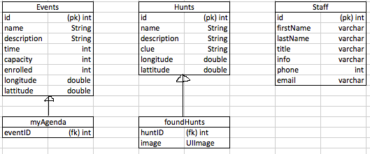

If applicable, brief description of other artifacts (images, audio, video, text) residing on the device. May be prose or itemized list.

**Photos taken for the scavenger hunt.**

Brief description of external database, i.e., database on a server accessed through the web. What does the database contain? Does the app upload artifacts to the database? Does the app download artifacts from the database? May be prose or itemized list. (Need not include a schema.)

**The external database contains all of the the event, attendee, scavenger hunt, and staff member data. See schema below. There will currently not be any artifacts uploaded to the external database.**

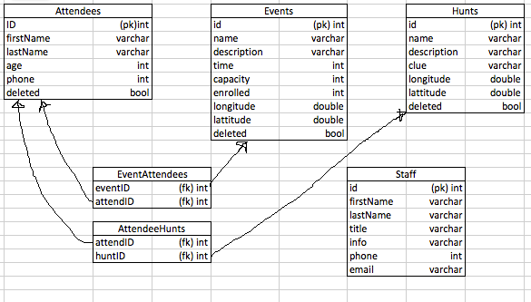

**The authoring tool will be used with PHP myAdmin to allow the author to edit the external databases. The author will be able to add, edit, or delete any item in any table of the external database. The method for deletion of events, hunts, or attendees however will be to mark them as deleted with the ‘deleted’ bool in the events table.**

Storyboard (May be pencil sketch, FluidUI, or other)

Storyboard: <https://www.fluidui.com/editor/live/preview/p_ovsbJDrHJdsTd2upFmUEMC3V5ETPEHn8.1446686444765>