Evan Dorn

Chris Cornejo

Bradley Kennedy

P2.techref.manual

Technical Reference Manual

Database Info

The database on the device will contain the events, hunts, and staff tables pulled from the external database . It will contain 2 additional tables, the first will list the events selected by the user to attend, and the second will contain a list of images of the found scavenger hunt items. See schema below.

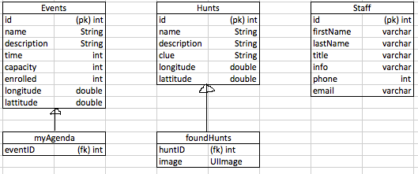

If applicable, brief description of other artifacts (images, audio, video, text) residing on the device. May be prose or itemized list.

Photos taken for the scavenger hunt.

Brief description of external database, i.e., database on a server accessed through the web. What does the database contain? Does the app upload artifacts to the database? Does the app download artifacts from the database? May be prose or itemized list. (Need not include a schema.)

The external database contains all of the the event, attendee, scavenger hunt, and staff member data. See schema below. There will currently not be any artifacts uploaded to the external database.

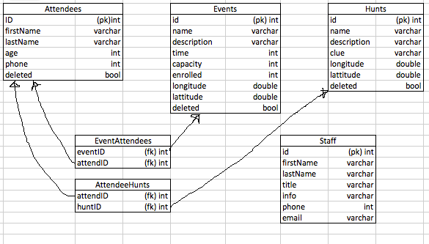

The authoring tool will be used with PHP myAdmin to allow the author to edit the external databases. The author will be able to add, edit, or delete any item in any table of the external database. The method for deletion of events, hunts, or attendees however will be to mark them as deleted with the ‘deleted’ bool in the events table.

Storyboard: <https://www.fluidui.com/editor/live/preview/p_ovsbJDrHJdsTd2upFmUEMC3V5ETPEHn8.1446686444765>