OSCAR McMaster

**User Manual**

|  |  |
| --- | --- |
| Version: | 0.1 |
| Released: | August 20, 2013 |
| Author: | *Nick Goupinets* |

Release

|  |  |  |  |  |
| --- | --- | --- | --- | --- |
| Version | Date | Changes | Areas Affected | Comments |
| 0.1 | Aug. 20, 2014 | Initial Release |  |  |

Distribution

|  |  |  |
| --- | --- | --- |
| Name | Organisation | Title |
|  |  |  |

# Objectives

This manual overviews the necessary OSCAR user interface components and operational elements that are required for proper operation of OSCAR

# Scope

*This training covers only the Electron Asthma Action Plan components related to OSCAR, including encounter chart widget, notification popup and study data functionality.*

# Strategy

*Target audience includes people who will utilize Electron Asthma Action Plan in OSCAR on the daily basis including administrator, service providers and doctors. It is also an good starting point for the people responsible for the support and maintenance of OSCAR, such as OSCAR service providers, developers, testers and system administrators. For the latter group, it's also avisable to review the deployment manual document.*

# Overview

eAAPs is a project dedicated to development of a research module that can work in together with OSCAR helping doctors, nurses and administrators work more effectively by providing up-to-date relevant information to patients. Asthma patients were identified as the initial target-base due to a potentially high impact that this can make in their lives.

When a strategic initiative to operate this project is identified, the module must be enabled in OSCAR. Person responsbile for the technical maintenance must be contacted to carry out this activity. After enabling eAAPS module, it can be used for delivering customized action plans. This involves tree steps: configuring study, exporting patient data, reviewing patient status and action plan.

## *Study Configuration*

OSCAR provides a way to operate online studies. This feature is used by eAAPS. To start with eAAPS, first make sure a study is created on your stystem. This can be done through "Admin" > "Study" entries in the menu

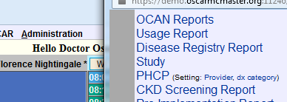

After accessing the "Study" link, you should see "Manage Study" window that shows existing stuies. Click "New Study" button to create a study.

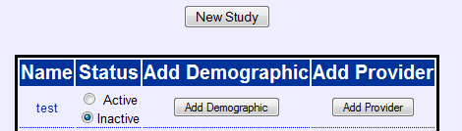

Fill out the appropriate details.

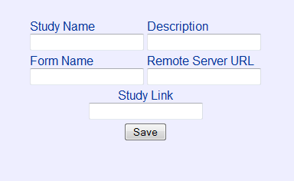

Please enter "eAAPS" into the study name to uniquely identify the study. Other information can be entered arbitrarly, as it's not used by the system.

Once a study has been added, it must be enabled by selecting "Active" radio button beside its name.

## *Adding Patients*

After a study is enabled, new patients can be added to it. Click "Add Demographic" button in the corresponding row for the study to carry this out.

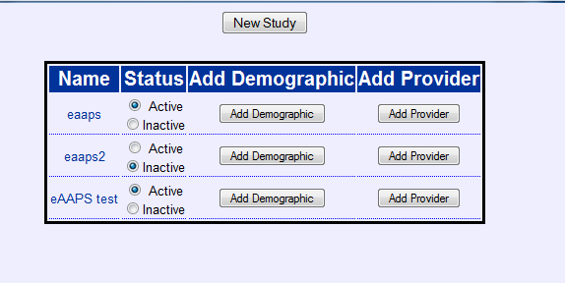

This will display "oscarReport" screen, where demographic selection criteria can be defined. Demographic records can be selected using their corresponding demographic ID numbers, which may be provided as a comma-delimited list. For example: 1, 2, 3, 4, 5, 6, 7, 8, 9, 10

After thse IDs are identified, they can be entered into the “Demographic IDs” field. Please also note to highlight “Demographic #” checkbox in the left column ("Search For"). Now click “Add to Study” button:

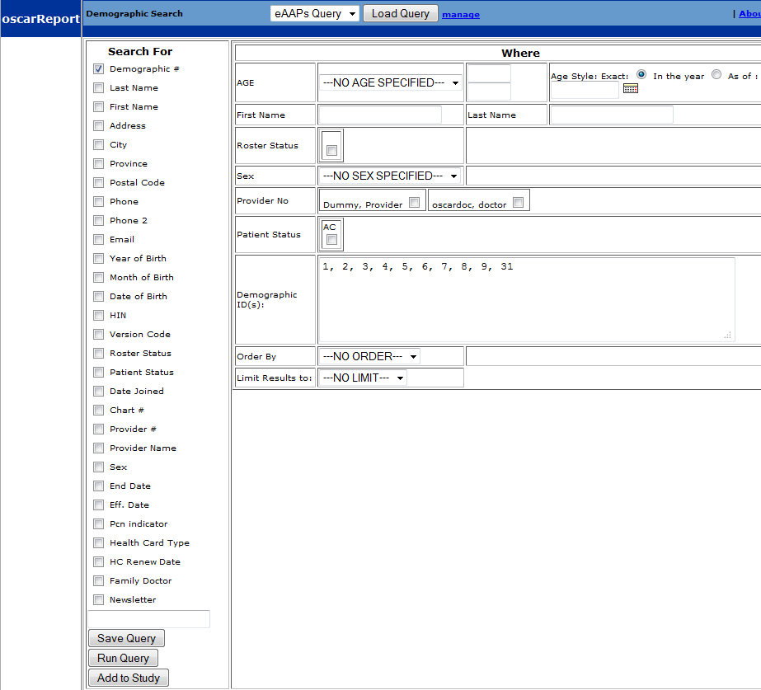

You should now see the selected entries added in the study:

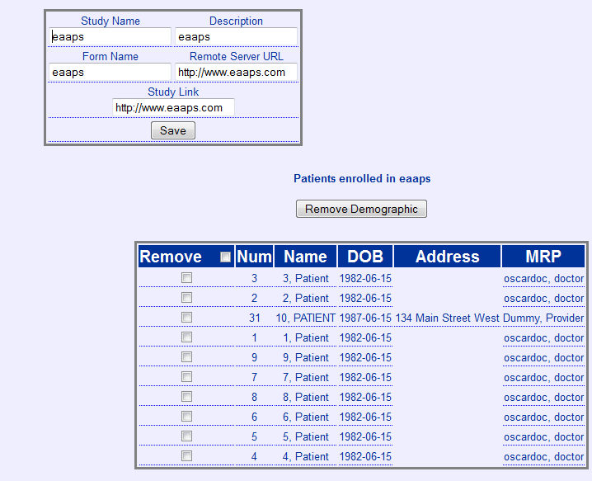

Now go back to the study screen (see step #1) and click “Add Provider” button. It will show the “Select Provider” screen.

Start typing provider name. The system will auto-populate the provider list with the matching providers, so just go ahead and select one

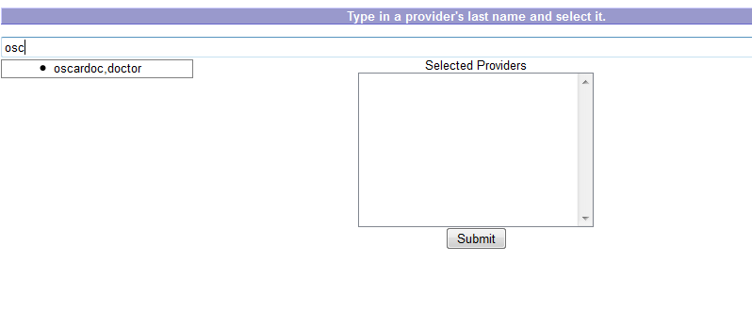

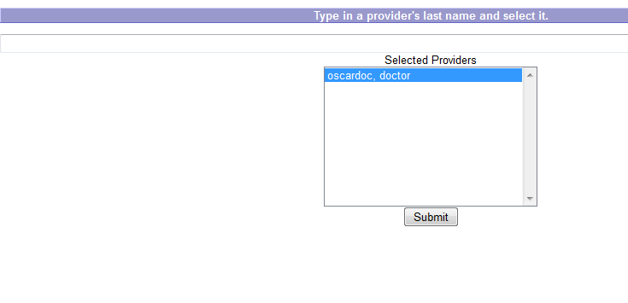

At this step, click the submit button. This should complete the study setup. The resulting screen should look similar to the one below:

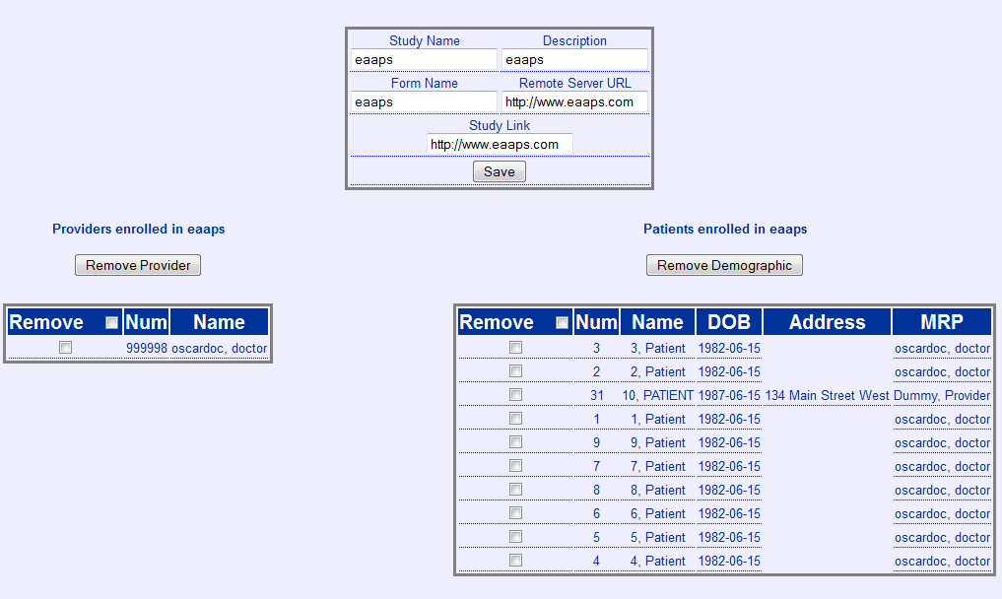

## *Patient data export*

After the study is created, enabled and populated with the correct patients, it is possible to export the study data to the eAAPS server. This is a very important step which is required for the correct operations.

To carry out the export, please go to the Administration Menu and click “Electronic Asthma Action Plan Export” link.

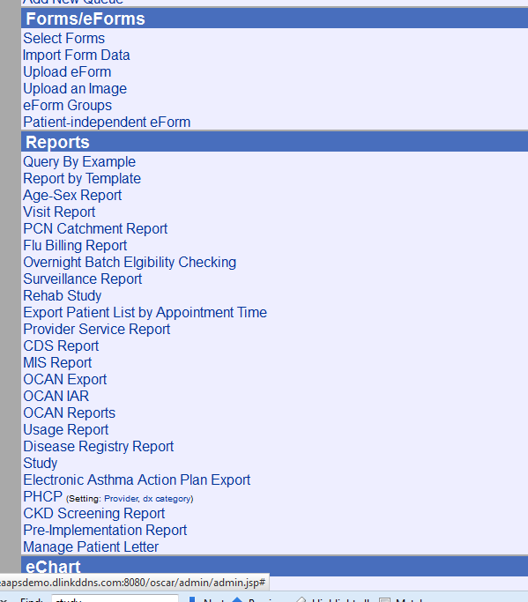

It will display the export window. There, pick the study from the list and check the acknowledgement checkbox, noting the legal and compliance requirements, and hit “Export” button.

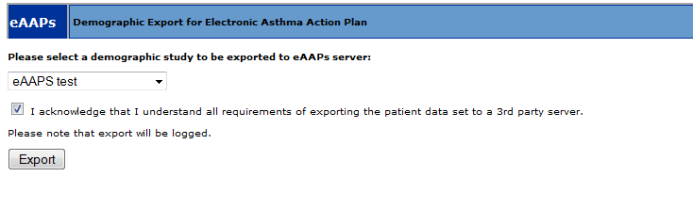

The system may take some time to export the demographic study. It may take up to 20-30 seconds to complete the operation, as export is a very data-intensive operation carried out by the server. Upon the successful completion, you should see a confirmation.

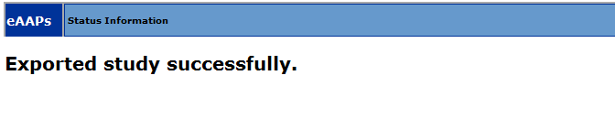

This completes the export.

## *Reviewing status*

The exported patients are now ready for action plan integration. Just access the encounter chart for a patient exported in the previous step to see the eAAPS information. This can be done by clicking "Search" link and then "Search" button.

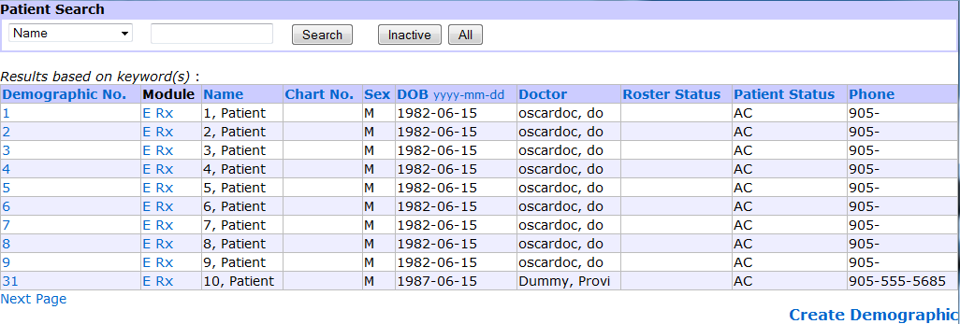

Click on “E” beside patient's name to see his or her encounter chart. The chart should now display the eAAPs widget at the bottom of the left column of the chart as well as the notification popup.

