Gwendolyn Weston
Carl Cota-Robles

ABANDON: THE PROPOSAL

Abandon is a Chinese language-learning app that aims to help users automate and maintain studying vocabulary on their own. Essentially, this app is aimed for the intermediate language learner who has picked up enough grammar patterns to be proficient, but not enough vocabulary to be articulate. Such a user who has hit a plateau in their learning would not need to depend on a textbook, and instead would want to be able to mine words from primary sources, such as tv shows, news articles, song lyrics, etc. However, the act of making study lists, flashcards, test materials can be time-consuming and cumbersome; thus, this app aims to mitigate time wasted on creating self-study materials by offering tools to automate the process.

The idea behind the app assumes that the ideal flashcard of a word stores the Chinese character, the pronunciation, and the English translation, as well as recordings of the Chinese and English in order to help test listening comprehension. Traditionally, making each flashcard by hand would be a time-consuming process--given a user who has a come across an unfamiliar word that he or she would like the learn, the person would have to enter the word in an online dictionary in order to get the pronunciation and english translation, enter each field into the flashcard program by hand. Then, if the user wanted to also test listening comprehension (which is of particular significance when it comes to a tone-based language such as Chinese), the user would have to record each field, splice, export, and attach the file to the flashcard accordingly. For each word the user wanted to learn, this whole process would have to be repeated over and over and would eclipse the amount of the time the user would spend studying.

This app would mitigate these issues by automating the flashcard making--given a list of whitespace-delimited chinese characters, the app would query an in-app database and create the flashcard model for each word without the user having to manually type in each field. Similarly, there would be a recording tool that would handle all the splicing and associate it appropriately to each flashcard, only requiring the user (or some native speaker friend) to speak each word as it comes onto the screen.

With these flashcard data objects, it thus becomes very easy to create tools that help with review and testing. For this particular project, along with the automated flashcard making and the recording tool, we aim to include one mini game, a way for the user to upload photos to assist with studying, and a way to concatenate and export vocabulary recordings to review with on the go.

The mini-game we would aim to develop is a game of concentration/memory. The program would store the last 20 words that the user has learned and each side of a flashcard would be represented by a card in this game, then the user would have to match the English words with the Chinese ones.

Our roles in this project would be as follows: Gwen is responsible for grabbing the list of Chinese characters and their corresponding English words and pronunciations and then storing that information into flashcards that can be used to study with, as well as creating a recording tool that will record the correct pronunciation of each Chinese word as the user speaks it. Carl will implement the mini-games, as well as create a picture-taker that can upload a picture to be paired with the English word/definition.

Additionally, if time allows, or in the coming months after the project, we would aim to develop more mini-games to help with studying.

This is a visual of the main screen,
where new words are introduced. This is a visual of what each flashcard would look like.
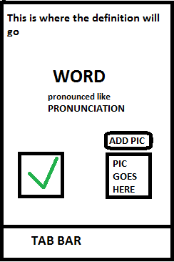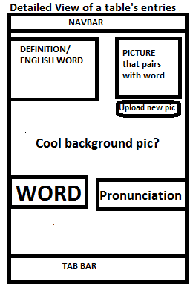

A detailed view of how the concentration/memory mini-game would be laid out:
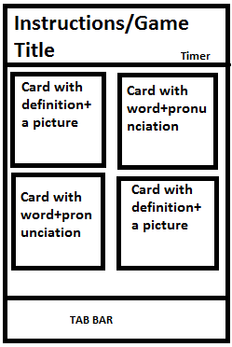

? ¹ Note another issue with this flashcard model. There are three fields for every vocabulary word: the chinese character, the pronunciation, and the english. However, a flashcard traditionally only has two sides. Thus, given a two-sided flashcard, the user would have to choose beforehand where to put the three fields on the two sides of a flashcard. If the user was ever to change his or her mind later, changing the format would be even more time-consuming. ?

