Practice

Chris Coussa

10/3/2018

###### R Code Practice: Week 1 Monday ######  
  
# Get working directory  
getwd()

## [1] "/Users/ccoussa717/Desktop/College Classes/National University/CSC220_AppliedStats/R_Code"

# Simple math operations  
4 / 2

## [1] 2

log(12)

## [1] 2.484907

sqrt(121)

## [1] 11

pi

## [1] 3.141593

sin(pi/2)

## [1] 1

log(1)

## [1] 0

(3 * 9) / (2 * 4)

## [1] 3.375

# assigning variables with "=" or "<-"  
x <- 5 + 9 #you need to exicute this line to load the var into RAM, then you can use the var  
chris = (5 + 9 + 10 - 56) / 32  
x

## [1] 14

y = 45  
z = x + y  
print(z)

## [1] 59

myNumber = z  
rm (myNumber)  
  
# Putting a "?" in front of a function and run it, you will get a help menu  
?print()  
  
# Removing variables from memory  
rm(chris)  
rm(n)

## Warning in rm(n): object 'n' not found

# Generate a sequence of numbers from and to are the range and by is the width between the numbers, a vector is created  
chris = seq(from = 3, to = 20, by =4)  
print(chris)

## [1] 3 7 11 15 19

###### Creating a Histogram: Week 1 Wednesday ######  
  
# Normal Distribution in R - generate some dummy variables  
dummy_data = rnorm(200, 5, 2)  
# Generate a Histogram  
hist(dummy_data, main = "Normal Distribution", breaks = 10, col = "red", xlab = "myData", ylab = "testFreq")

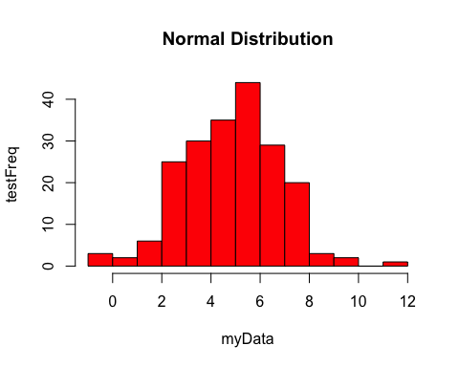

?rnorm  
# Set the seed to generate the same numbers each time the code runs  
set.seed(30)  
rnorm(20, 5, 2)

## [1] 2.422964 4.304621 3.956742 7.546946 8.649041 1.977384 5.221016  
## [8] 3.478408 3.660206 5.549039 2.953456 1.361204 3.664420 4.881404  
## [15] 6.760332 5.537026 4.960841 3.950106 2.181337 1.332022

?set.seed  
  
# Creating a vector from set data points, the c stands for "combine"  
data = c(3, 5, 6, 20, 25, 34, 58, 65)  
print(data)

## [1] 3 5 6 20 25 34 58 65

#Create a plot  
plot(data, col = "#B8472F", main = "My Data plot", xlab = "xIndex", ylab = "yData", pch = 2)

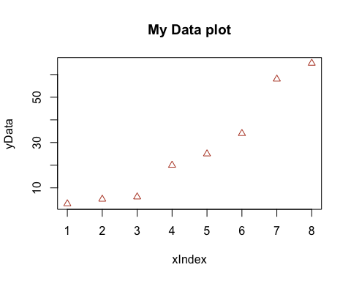

# Calculates the Standard Deviation of the data vector  
mySd = sd(data)  
myVarience = mySd^2  
print(mySd)

## [1] 23.92846

print(myVarience)

## [1] 572.5714

?ada

## No documentation for 'ada' in specified packages and libraries:  
## you could try '??ada'

# install.packages("ada")  
# library(ada)  
# install.packages("neat")  
# library(neat)  
?`knitr-package`