Week2_Practice

ChrisCoussa

10/6/2018

###### Monday 8 Oct 2018 ######  
  
library(DevFarn2)

## Loading required package: qcc

## Package 'qcc' version 2.7

## Type 'citation("qcc")' for citing this R package in publications.

library(qcc)  
  
# Importing Data_sets, click on the "Import Dataset" in the window to the right. It will  
# download the needed packages and you can search for the file you want to import.  
# It will show up in the RStudio enviornment as a seperate file.  
  
# After you install qcc, you can install the DevFarn2 file you downloaded form Bb  
# Go to install package and switch from package repo to archive, and install  
# from there.  
  
data("e1.1")  
# Displays the type of file you're working with. With e1.1, it's "numeric".  
class(e1.1)

## [1] "numeric"

# Example Histogram  
hist(e1.1, main = "My First Histogram", xlab = "Freq", ylab = "yTest",   
border = "blue", col = "yellow", las = 1, breaks = 20)

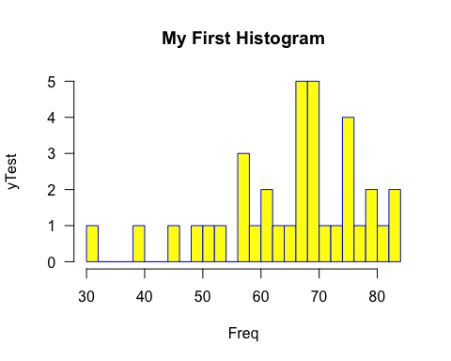

stem(e1.1)

##   
## The decimal point is 1 digit(s) to the right of the |  
##   
## 3 | 1  
## 4 | 059  
## 5 | 23788  
## 6 | 01136777789  
## 7 | 000023556689  
## 8 | 0134

dotchart(e1.1, main = "Example Dot Plot", xlab = "Freq", ylab = "yTest", col = "blue")

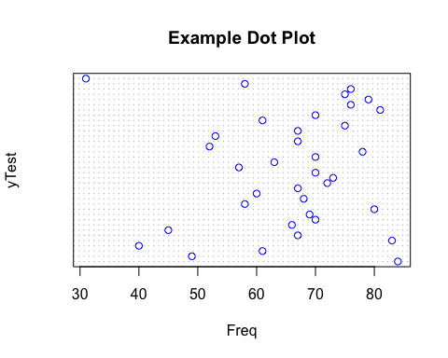

# Importing another dataset from the book  
data("Furnace")  
View(Furnace)  
# Displays the type of file you're working with. With Furnace, it's a "data.frame".  
class(Furnace)

## [1] "data.frame"

dim(Furnace)

## [1] 90 10

head(Furnace)

## Type CH.Area CH.Shape CH.HT CH.Liner House Age BTU.In BTU.Out Damper  
## 1 1 28 1 20 2 3 8 7.87 8.25 1  
## 2 2 144 2 26 0 2 75 9.43 9.66 1  
## 3 1 80 3 30 1 2 44 7.16 8.33 1  
## 4 2 100 2 24 0 2 75 8.67 8.82 1  
## 5 3 168 3 35 1 2 30 12.31 12.06 1  
## 6 3 28 1 17 2 3 4 9.84 9.67 1

tail(Furnace)

## Type CH.Area CH.Shape CH.HT CH.Liner House Age BTU.In BTU.Out Damper  
## 85 1 144 1 30 0 2 85 10.50 10.77 2  
## 86 2 100 2 24 0 2 70 14.35 15.26 2  
## 87 2 96 1 17 0 1 40 13.42 14.53 2  
## 88 1 100 2 20 1 2 99 6.35 6.84 2  
## 89 1 100 2 20 1 1 14 9.83 10.92 2  
## 90 1 28 1 28 1 2 55 12.16 13.05 2

# Histogram of CH.HT column. $CH.HT is the command to tell R to get just the data   
# from the CH.HT column  
hist(Furnace$CH.HT, main = "Practice Histogram", xlab = "xTest", ylab = "yTest",   
 breaks = 50, col = "red")

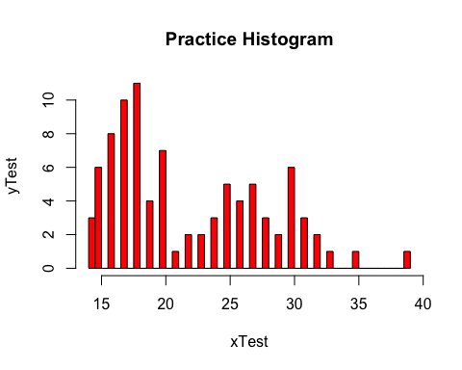

# Create a vector of data  
x = c(12, 7, 3, 4.2, 18, 2, 54, -21, 8, -5)  
  
# Find the mean of the dummy vecotor  
xMean = mean(x)  
print(xMean)

## [1] 8.22

class(x) # Numeric class

## [1] "numeric"

# Get the median  
median(x)

## [1] 5.6

###### Example for Linear Model ######  
x = c(.18, .20, .21, .21, .21, .22, .23, .23, .24, .24, .25, .28, .30, .37)  
y = c(.46, .70, .41, .45, .55, .44, .24, .47, .22, .80, .88, .70, .72, .75)  
mean(x)

## [1] 0.2407143

mean(y)

## [1] 0.5564286

plot(x, y, main = "Scatter Plot Example", xlab = "Hydrogen Content",  
 ylab = "Gas Porosity", pch = 9, col = "red")  
scatter.smooth(x, y, main = "Scatter Plot Example", xlab = "Hydrogen Content",  
 ylab = "Gas Porosity", pch = 9, col = "red")

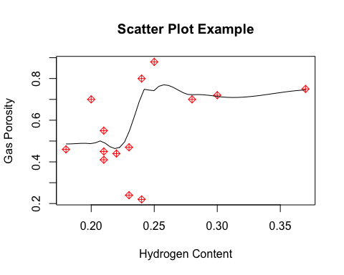

sum(x)

## [1] 3.37

sum(y)

## [1] 7.79

sum(x^2)

## [1] 0.8419

sum(y^2)

## [1] 4.8805

###### Method for finding Correlation Coefficient (R^2) ######  
cor(x, y)

## [1] 0.4491168

###### Building a Linear Model for the Data ######  
# Converting 2 vectors to a dataframe  
dataExample = data.frame(x, y)  
  
# Build a model for linear regression on full dataframe  
# y = mx + b ----> b is y intercept  
linearModel = lm(y ~ x, data = dataExample)  
plot(x, y, main = "Scatter Plot Example", xlab = "Hydrogen Content",  
 ylab = "Gas Porosity", pch = 3, col = "red")  
  
# abline fits the linear line for the dataframe in the scatter plot  
abline(linearModel, col = "red")

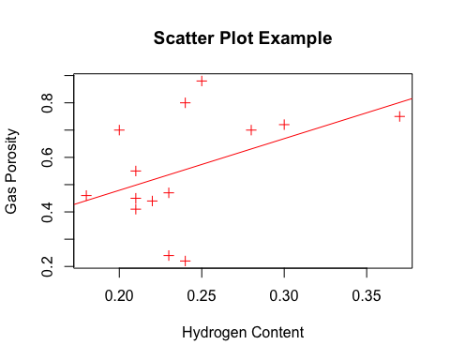

summary(linearModel)

##   
## Call:  
## lm(formula = y ~ x, data = dataExample)  
##   
## Residuals:  
## Min 1Q Median 3Q Max   
## -0.33508 -0.07443 -0.01484 0.06481 0.30598   
##   
## Coefficients:  
## Estimate Std. Error t value Pr(>|t|)  
## (Intercept) 0.1005 0.2667 0.377 0.713  
## x 1.8941 1.0878 1.741 0.107  
##   
## Residual standard error: 0.1906 on 12 degrees of freedom  
## Multiple R-squared: 0.2017, Adjusted R-squared: 0.1352   
## F-statistic: 3.032 on 1 and 12 DF, p-value: 0.1072

# From the table below y = mx + b is  
# y = 1.89x + 0.10  
  
###### Wednesday 10 Oct 2018 ######  
# Multipe Linear Regression with 3 variables  
y = c(226, 250, 180, 205, 200, 215, 200, 180, 180, 182, 248, 260, 210, 225, 205, 195, 175, 220, 195, 210, 195, 200, 210, 220, 185)  
x1 = c(75, 77, 73, 75, 71, 72, 74, 72, 72, 73, 75, 80, 75, 75, 75, 75, 68, 74, 71, 73, 71, 74, 72, 70, 72)  
x2 = c(30, 40, 28, 25, 27, 40, 31, 41, 24, 26, 44, 28, 29, 26, 34, 32, 29, 25, 28, 26, 31, 34, 33, 33, 30)  
  
# Create a dataframe from the 3 vectors  
my_data_frame = data.frame(y, x1, x2)  
View(my_data_frame)  
# Buid the linear regression model on the three var dataframe  
lm_model2 = lm(y ~ x1 + x2, data = my_data_frame)  
summary(lm_model2)$r.squared

## [1] 0.5434694

# R^2 (corrilation coefficient) = 0.5434694  
# y = mx + b from the table summary ----> y = 6.2351x1 = 1.0739x2 -283.8123