Week3_Practice

ChrisCoussa

10/15/2018

###### Week 3 Session 1 ######  
library(qcc)

## Package 'qcc' version 2.7

## Type 'citation("qcc")' for citing this R package in publications.

library(DevFarn2)  
library(readxl)  
  
# Importing a data frame from the DevFarn2 examples  
data(e2.16)  
# Summary of the e2.16 data frame (descriptive analysis of the data, range is max - min)  
summary(e2.16)

## Min. 1st Qu. Median Mean 3rd Qu. Max.   
## 5.30 90.20 94.80 84.86 96.70 113.50

# View the data frame in a separate window  
# View(e2.16)  
  
boxplot(e2.16, main = "Example", col = "red", horizontal = TRUE)

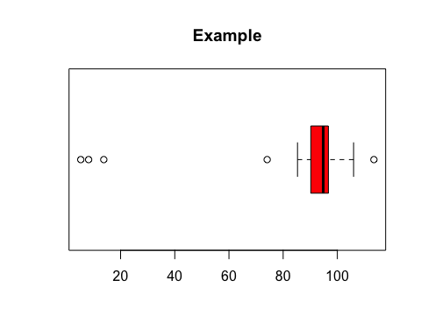

# Boxplot shows 3 possible outliers at the bottom of the plot, under 20.  
  
###### Quantile-Quantile Plots (qq plot) ######  
# If you have a Normal Distribution of variables, take the qq plot of the data it  
# is a straight line. 2 variable dataset  
data(e2.18)   
qqnorm(e2.18$X1) # the $x1 means that you are going into the e2.18 dataset and getting

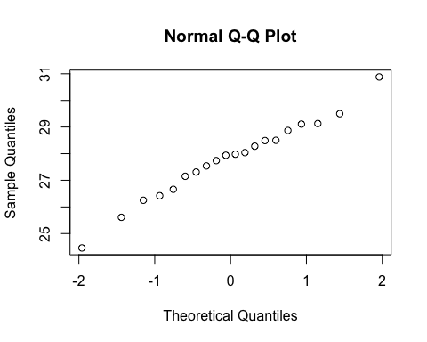

# the data for for the x1 variable  
  
###### Creating a data frame with Normal Distrubution using rnorm() ######  
dataW3s1 = rnorm(30, mean = 50, sd = 20)  
plot(dataW3s1, main = "Normal Distribution", col = "blue")

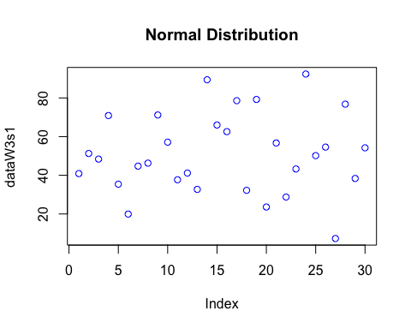

# Given that the data frame dataW2s1 has Normal Distribution, the qq plot should be straight  
qqnorm(dataW3s1)

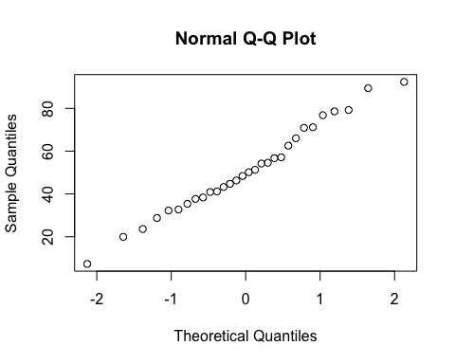

###### Working with data of three variables (x1, x2, and y)  
data(e3.15)  
summary(e3.15)

## x1 x2 y   
## Min. : 61.0 Min. : 13.00 Min. : 4.00   
## 1st Qu.:130.0 1st Qu.: 24.00 1st Qu.:18.00   
## Median :169.0 Median : 39.00 Median :26.00   
## Mean :177.3 Mean : 49.31 Mean :29.85   
## 3rd Qu.:199.0 3rd Qu.: 64.00 3rd Qu.:36.00   
## Max. :333.0 Max. :112.00 Max. :65.00

dim(e3.15)

## [1] 13 3

# Create a scatter matrix for all three data sets of the data frame  
# Use labels to change the labels of the plots  
pairs(e3.15, labels = c("Iron", "Aluminum", "Gold"), col = "gold", pch = 20)

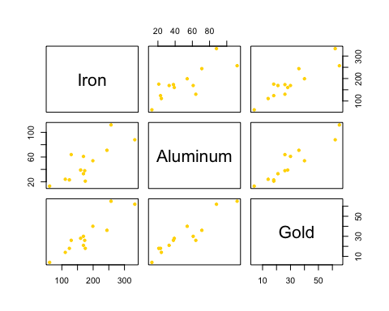

data("Bears")  
# str shows internal structure of the dataset, alternative to summary  
str(Bears)

## 'data.frame': 143 obs. of 12 variables:  
## $ Name : Factor w/ 99 levels "","Abe","Adam",..: 6 9 9 9 9 18 18 24 24 72 ...  
## $ ID : int 39 41 41 41 41 43 43 45 45 48 ...  
## $ Age : int 19 19 20 23 29 19 20 55 67 81 ...  
## $ Month : int 7 7 8 11 5 7 8 7 7 9 ...  
## $ Sex : int 1 2 2 2 2 1 1 1 1 1 ...  
## $ Head.L : num 10 11 12 12.5 12 11 12 16.5 16.5 15.5 ...  
## $ Head.W : num 5 6.5 6 5 6 5.5 5.5 9 9 8 ...  
## $ Neck.G : num 15 20 17 20.5 18 16 17 28 27 31 ...  
## $ Length : num 45 47.5 57 59.5 62 53 56 67.5 78 72 ...  
## $ Chest.G: num 23 24 27 38 31 26 30.5 45 49 54 ...  
## $ Weight : int 65 70 74 142 121 80 108 344 371 416 ...  
## $ Obs.No : int 1 1 2 3 4 1 2 1 2 1 ...

# Create a linear model from the Bears dataframe using 2 variables  
plot(Bears$Weight, Bears$Age, main = "Bear Data", xlab = "ID", ylab = "Age",  
 col = "black")  
# REMEBER: When you created a linear model you have to put your y variable first!  
# So reverse the order from your plot in order for the linear line to be correct.  
lmBears = lm(Bears$Age ~ Bears$Weight, data = Bears)  
summary(lmBears)

##   
## Call:  
## lm(formula = Bears$Age ~ Bears$Weight, data = Bears)  
##   
## Residuals:  
## Min 1Q Median 3Q Max   
## -35.159 -11.751 -3.693 2.373 78.849   
##   
## Coefficients:  
## Estimate Std. Error t value Pr(>|t|)   
## (Intercept) 2.61341 4.40772 0.593 0.555   
## Bears$Weight 0.21912 0.01992 11.001 <2e-16 ***  
## ---  
## Signif. codes: 0 '***' 0.001 '**' 0.01 '*' 0.05 '.' 0.1 ' ' 1  
##   
## Residual standard error: 21.68 on 81 degrees of freedom  
## (60 observations deleted due to missingness)  
## Multiple R-squared: 0.5991, Adjusted R-squared: 0.5941   
## F-statistic: 121 on 1 and 81 DF, p-value: < 2.2e-16

# Yhat = 0.219x + 2.613  
abline(lmBears, col = "red")  
legend(x = 175, y=NULL, legend = "Yhat = 0.219x + 2.613", col = "black", bg = "white")

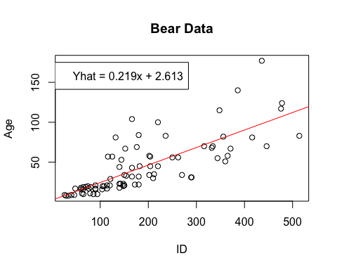

###### Week 3 Day 6 ######  
  
# Working with data imprted from an Excel file  
  
ex01_01 <- read_excel("/Users/ccoussa717/Desktop/College Classes/National University/CSC220_AppliedStats/R_Code/data_sets/EXCEL/Chapter01/ex01-01.xls")  
hist(ex01_01$Percent_expenditures, main = "Example Data From Chapter One", breaks = 20, col = "red")

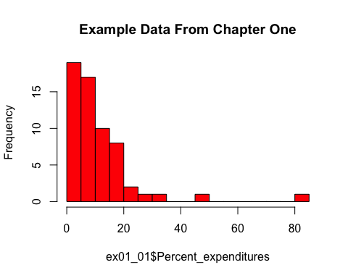

boxplot(ex01_01, main = "Boxplot of Example Data", col = "blue")

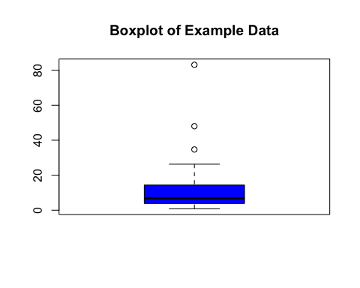

sd(ex01_01$Percent_expenditures) # Standard Deviation is 12.7411

## [1] 12.7411

mean(ex01_01$Percent_expenditures) # Mean is 10.89167

## [1] 10.89167

var(ex01_01$Percent_expenditures) # Variance is 162.3357

## [1] 162.3357

ex01_04 <- read_excel("/Users/ccoussa717/Desktop/College Classes/National University/CSC220_AppliedStats/R_Code/data_sets/EXCEL/Chapter01/ex01-04.xls")  
linearModelEx04 = lm(ex01_04$Luminance ~ ex01_04$Time, data = ex01_04)  
plot(ex01_04, main = "New Example Data")  
summary(linearModelEx04) # Yhat = -8.388x + 22443.468

##   
## Call:  
## lm(formula = ex01_04$Luminance ~ ex01_04$Time, data = ex01_04)  
##   
## Residuals:  
## Min 1Q Median 3Q Max   
## -86.49 -63.06 -29.00 29.42 193.01   
##   
## Coefficients:  
## Estimate Std. Error t value Pr(>|t|)   
## (Intercept) 2627.11066 58.81707 44.666 8.43e-09 ***  
## ex01_04$Time -0.10124 0.01741 -5.814 0.00114 **   
## ---  
## Signif. codes: 0 '***' 0.001 '**' 0.01 '*' 0.05 '.' 0.1 ' ' 1  
##   
## Residual standard error: 99.95 on 6 degrees of freedom  
## Multiple R-squared: 0.8492, Adjusted R-squared: 0.8241   
## F-statistic: 33.8 on 1 and 6 DF, p-value: 0.001137

abline(linearModelEx04, col = "green")

