# Programs:

LIDIA, PHASER, POINTLESS, ACEDRG, REFMAC, RDKIT, COOT

# Scenario

As part of a chemical-probe discovery project, you have established a soakable crystal system into which you have soaked a fragment library. A high resolution structure for “apo” (ligand free) crystals has been solved, and you are confident that ligand soaking will not change the crystal form (AN ASSUMPTION THAT IS NOT WITHOUT DANGER).

You have retrieved your autoprocessed data from the synchrotron and will adopt the unmerged data generated by XIA2 as your start point to find the ligand.

# Task 1: Data import – Import from Xia2

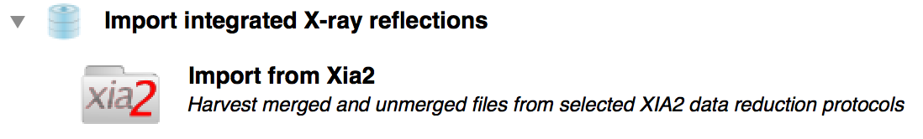

HINT: The “Look in” element of the file browser offers a pull-down of known project directories from which you might set off to find the files you want to import. At the bottom of the list is “CCP4I2_TOP”, which is an alias for the ccp4i2 source code. For the import xia2 task, you need to locate and select the subdirectory “ccp4i2/test/data/baz2b/BAZ2BA_x839.xia2”

Now run the job

Question: locate the elements of the report that explain the selection of spacegroup, and the selection of output resolution

# Task 2: Ligand pipeline



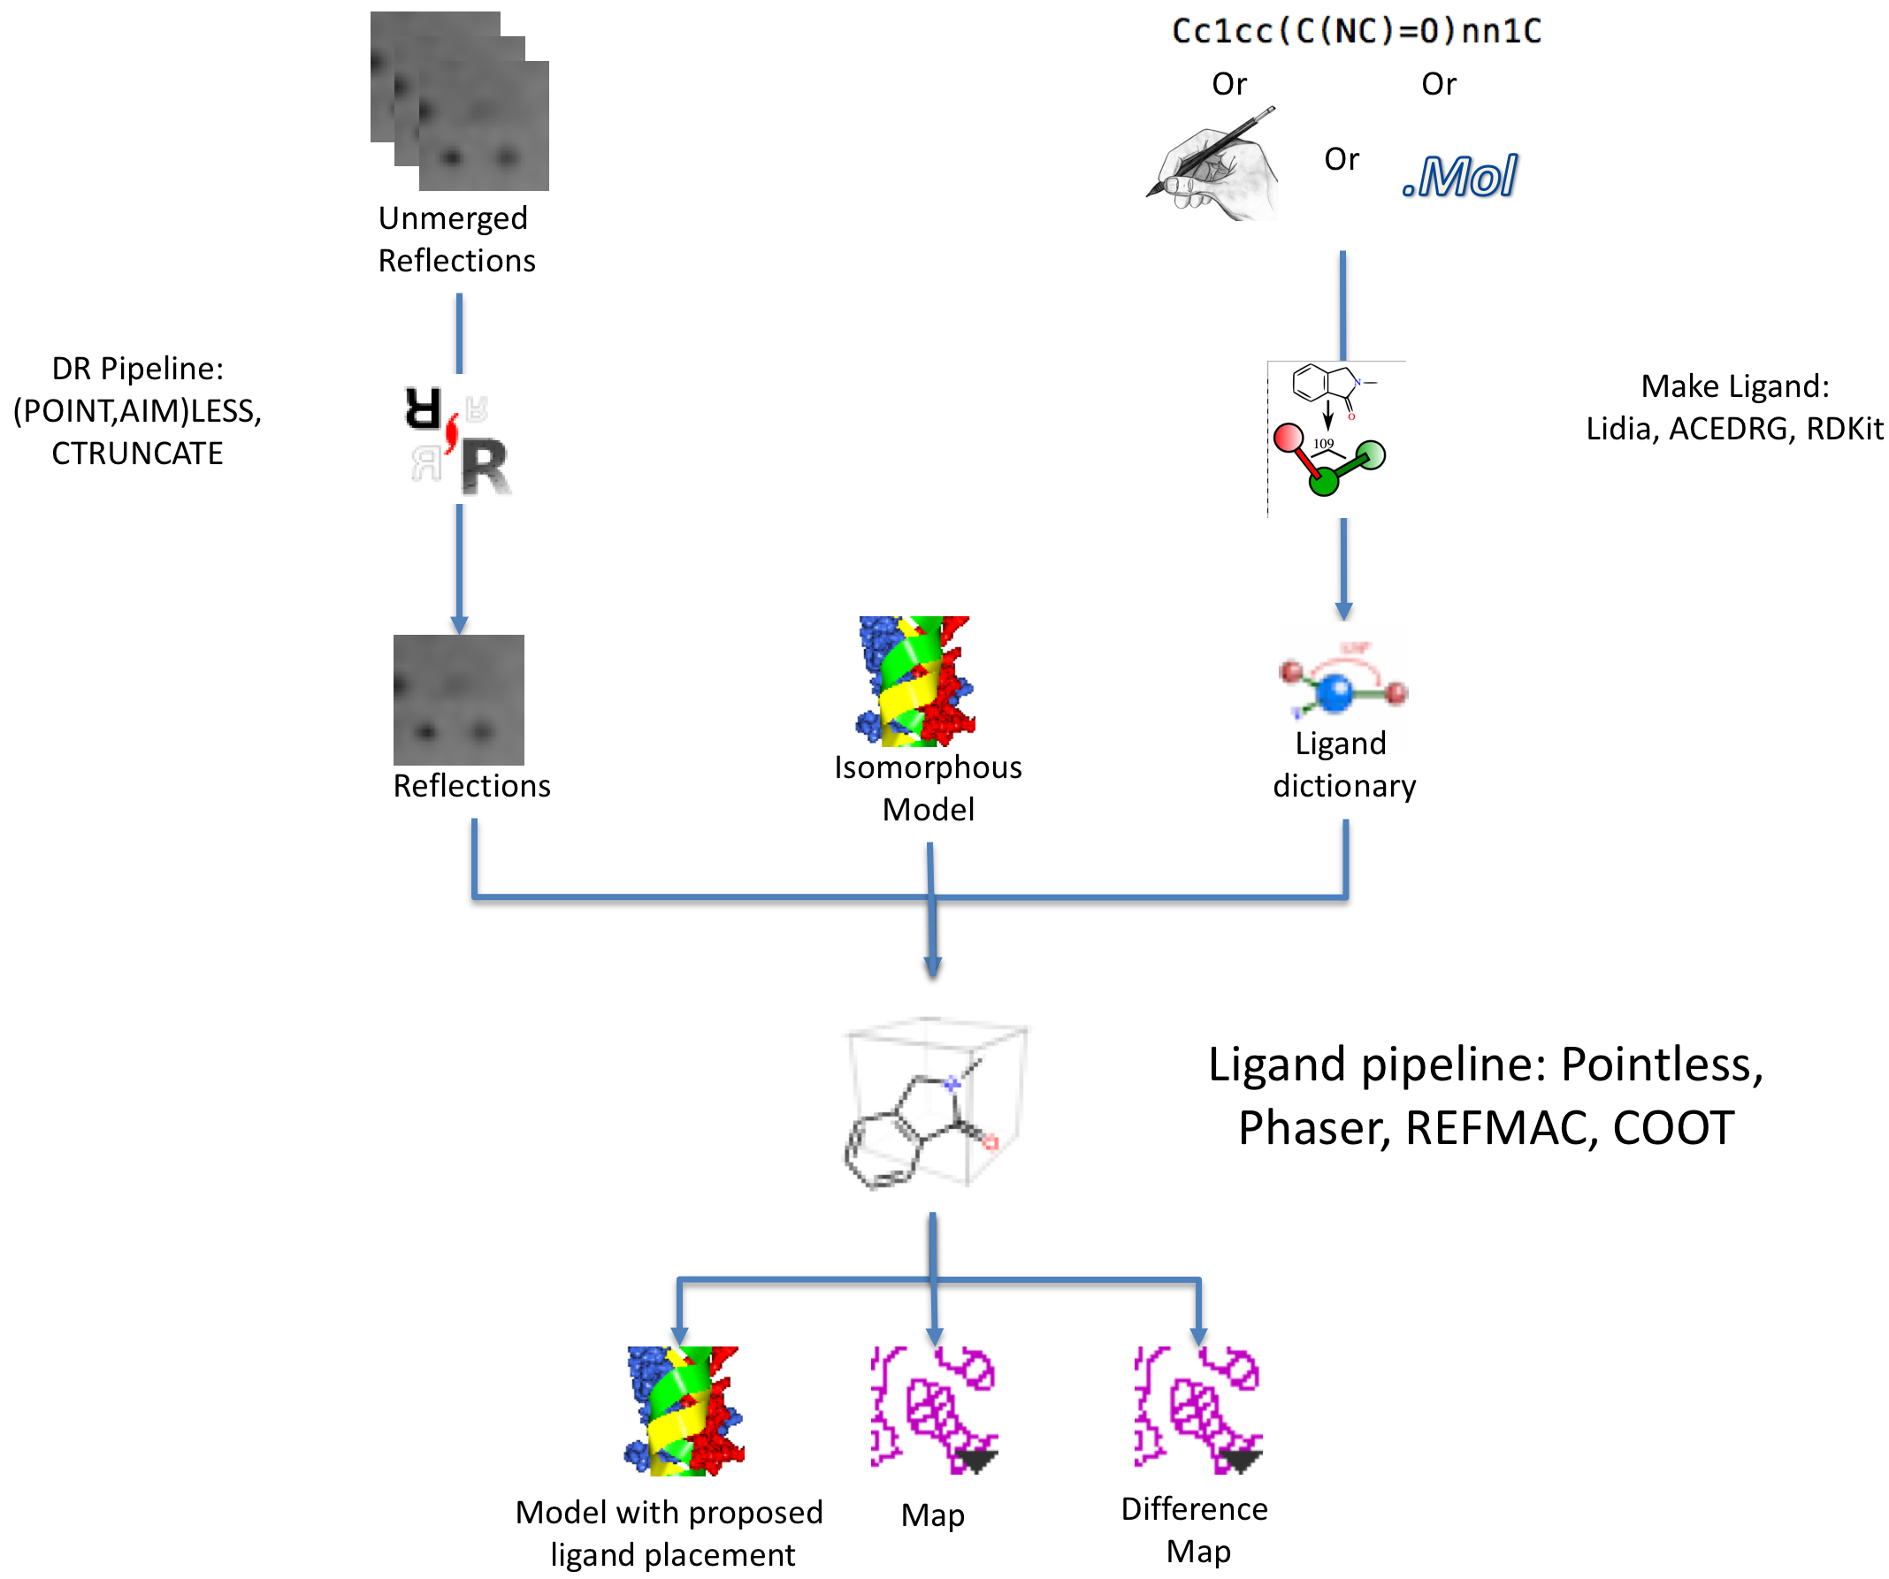

Principle inputs to the Ligand pipeline are reflections, an isomorphous model, and a ligand dictionary. This pipeline, however, also embeds two other pipelines (data reduction and make ligand) to allow it to start further upstream, with unmerged data and a sketch, mol file, or SMILES string.

There is a small advantage to starting from unmerged data here (since the isomorphous model will be used as a reference to ensure consistent assignment of space group and choice of reciprocal space asymmetric unit)

The ligand can be represented with the SMILES string

CN1C(C=Cc2ccccc12)=O

The native PDB file is :

ccp4i2/test/data/baz2b/BAZ2B.pdb

HINT: to make sure no waters are copied across to confuse the ligand placement part of the pipeline, provide the selection:

not (HOH)

# Task 3 - review the results

From the bottom of the report, select “Manual model rebuilding”, and then click the Run icon



Review in turn the proposed ligand binding sites, deleting those that are not supported by the electron density

# For those interested

The ligand pipeline was coded in about half a day, pulling together other pipelines from CCP4i2.

If provided with unmerged data, it will run data reduction once to identify the dataset’s PhilEvans resolution ™, which is where the shellwise correlation coefficient drops to 0.3. It will then run the scaling again to apply that limit.

The starting PDB file is used as a reference in POINTLESS to encourage data reduction in the appropriate space group.

Unless a ligand dictionary is provided, a ligand dictionary is calculated using the Make Ligand pipeline from whatever data are provided (mol, sketch, or smiles)

Instead of full-blown molecular replacement, the pipeline calls a “Molecular replacement by rigid body” pipeline, which uses PHASER to refine the position and orientation of the input PDB file in the unit cell of the new data. The resulting structure is then subject to a few cycles of REFMAC refinement.