# **Lab Report**

1. Your name

劉品枘

1. Lab Log:
   * How long did you work on this lab? 1:30
   * Any problems? How did you resolve the problem? No
2. VM Host information

|  |  |  |  |
| --- | --- | --- | --- |
|  | Physical Interface | MAC Address | IP Address |
| VM host1 (client) |  | 08:00:27:bc:90:7e | 192.168.43.242 |
| VM host2 (hacker) |  | 08:00:27:1c:70:0c | 192.168.43.59 |
| VM host3 (server) |  | 08:00:27:f7:f3:0c | 192.168.43.55 |

Physical Interface:

VM1: 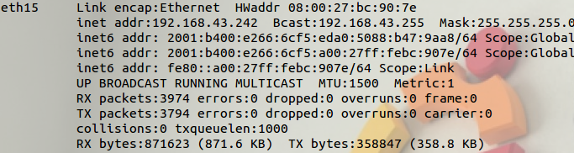

VM2: 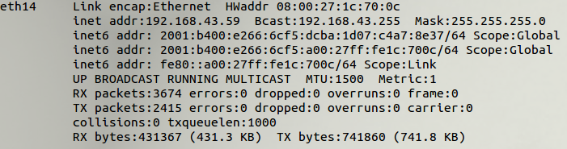

VM3: 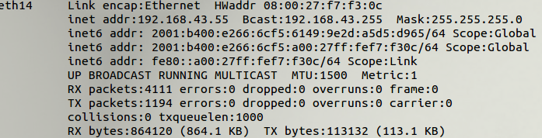

1. Proof of your lab work
2. Screenshot-1: DNS query of [www.example.com](http://www.example.com) (before hacking)

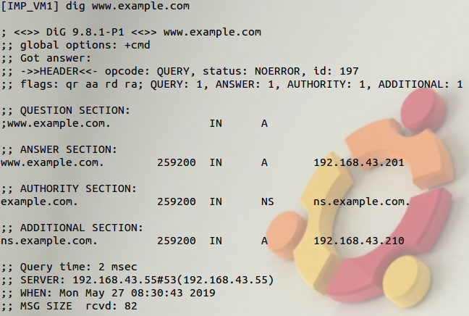

1. Screenshot-2: wireshark of DNS query for [www.example.com](http://www.example.com) (before hacking)

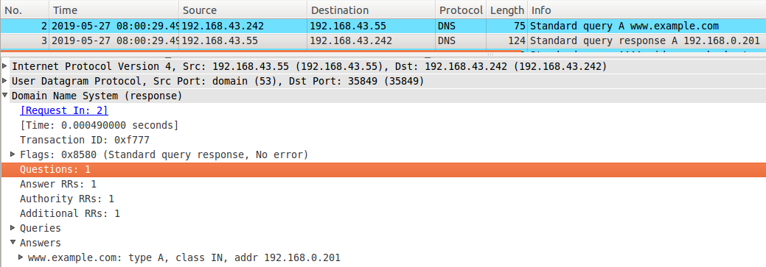

1. Screenshot-3: [www.cnn.com](http://www.cnn.com) of local DNS attack (pharmed IP addresses in /etc/hosts)

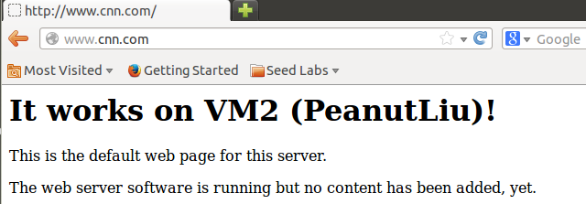

1. Screenshot-4: netwag configuration for DNS Spoofing (client side)

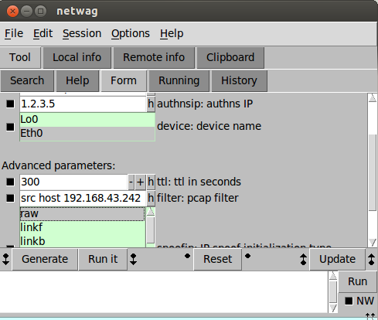

1. Screenshot-5: Proof of DNS hacking ([www.exammple.com](http://www.exammple.com), client side)

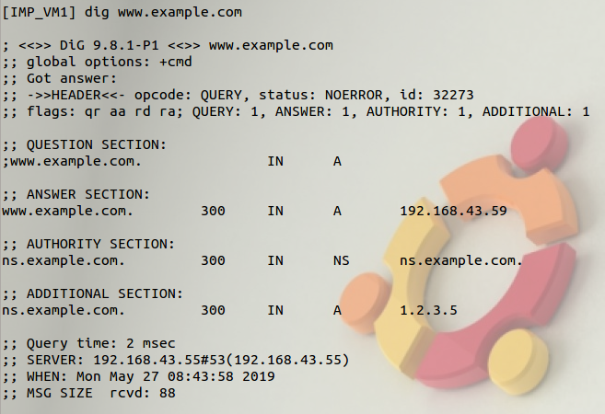

1. Screenshot-6: Wireshark of Hacked DNS Response (client side)



1. Screenshot-7: Proof of DNS hacking ([www.syr.edu](http://www.syr.edu), server side)

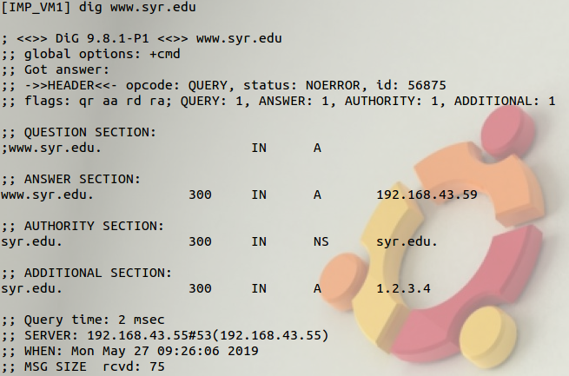

1. Screenshot-8: Wireshark of Hacked DNS Response ( server side)



1. Question:

Comparing Task-3 and Task-4, which DNS attack is more effective? Why?

Effectiveness is defined as the percentage of successful attacks.

1. Lab reflection

Describe if the lab learning goals are met and also any interesting observation from this lab exercise.

It’s interesting to finish DNS cache poisoning. But use tool to complete the task can’t let me fully understand.