AnalysisAssign backbone assignment tutorial

**Version History:**

* beta1 (SS): First version
* beta2 (GWV): Reworked extensively; added Assignment Inspection section

# Table of contents

Table of contents 3

1. Getting started 4

1.1. Setting spectrum path 4

1.2 Changing contour display settings 5

1.3 Setting experiment types 6

1.4 Access to the ‘settings’ of a module 6

2. Picking peaks 8

3. Setting up a starting point for assignment 10

3.1. Assignment and names 10

4. Peak picking and assigning the 3D spectra to NmrAtoms 13

4.1 The “Pick and Assign” settings 14

4.2 Assigning to NmrAtoms using the “Atom Selector” 15

5. Performing the sequential backbone assignment 17

5.1 Sequential backbone assignment in the *i-1* direction 18

5.2 Sequential backbone assignment in the *i+1* direction 21

5.3 Correcting mistakes in connected NmrChains 22

5.4 Inspecting and correcting assignments with Peak Assigner and Assignment Inspector 25

5.5 Checking Assignment using Sequence Graph 28

# 1. Getting started

**This tutorial assumes that the Introductory tutorial has been completed!**

This tutorial will require the spectra and projects located in:

*YourFolder/data/testProjects/CcpnSec5BBTutorial*

where *YourFolder* is the path to the CcpNmr v3 directory. To start, open the first tutorial project; if you have a shell open in the top-level CcpNmr v3 directory, type into the terminal

*bin/assign data/testProjects/CcpnSec5BBTutorial/Sec5Part1.ccpn*

or open AnalysisAssign in your preferred way and drag the project directory onto the main window, either the sidebar or the spectral canvas (Figure 1).

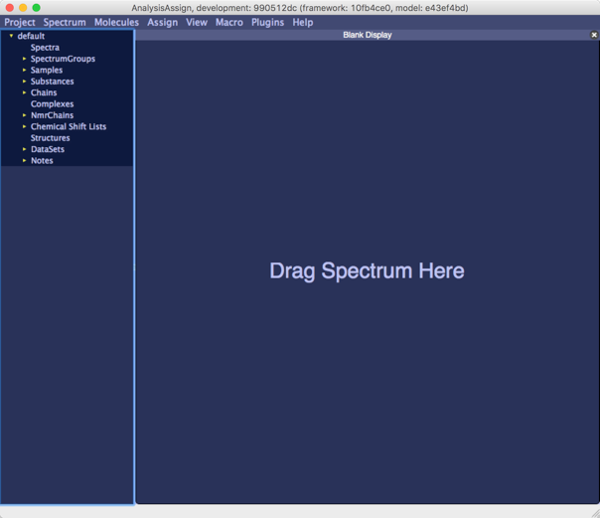

Figure : AnalysisAssign with empty project. Drag any version-3 project onto the sidebar or the canvas.

## 1.1. Setting spectrum path

This project was setup on another computer, so the spectrum paths have changed when you open it. AnalysisAssign tries to establish the new paths starting from the new project path, and for the tutorial projects it should work. The program reports in the terminal window on the reallocation of the spectrum paths.

However, sometimes the program cannot find the spectra. To fix this, double click on each spectrum in the Sidebar and “Spectrum properties” popup will display (Figure 2). The path field in the “General tab” will show the currently specified spectrum path. This text can be manually edited or the button to the right of the text box can be clicked and a popup will appear enabling selection of the spectrum. Once all spectra have the correct path, the contours will be displayed in the spectrum display modules.

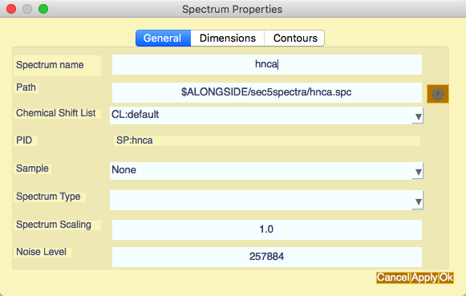

Figure Spectrum path editing.

## 1.2 Changing contour display settings

For this HSQC there are a few peaks with negative contours and peak picking will pick peak using displayed contours as the lower limits. Hence, in this case you may want to hide the negative contours. To do so, double-click on “SP:hsqc” in the sidebar to display the “Spectrum Properties” popup, go to “Contours tab” (Figure 3) and uncheck the box labelled “Show Negative Contours” to hide the negative contours. You may also want to adjust the positive contour levels of this spectrum, which can be done by changing the values in the “Positive Base Level”, “Positive Multiplier” and “Number of positive contours” boxes in the “Spectrum Properties” popup. Changing contour settings can also be achieved by using the toolbar buttons in each spectrum display.

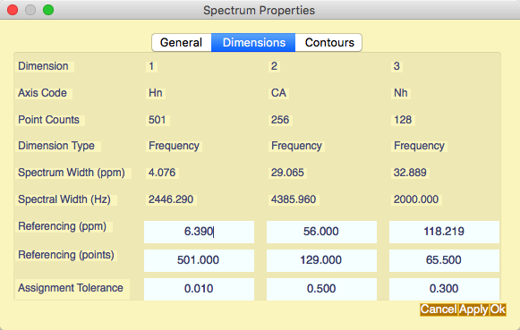 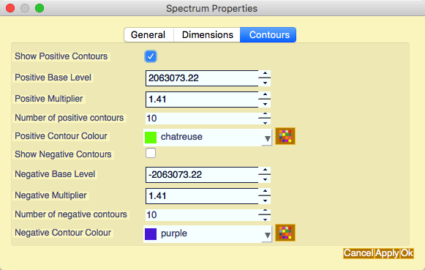

Figure Spectrum Dimensions and Contour settings.

## 1.3 Setting experiment types

It is important to set the experiment types of each spectrum so AnalysisAssign knows how to handle them. This can be done per spectrum using the “General tab” of the “Spectrum Properties” popup (accessed by double clicking the spectrum in the Sidebar;). In of this popup there is a dropdown list labelled “Experiment Type”. Select the appropriate type from this list sets the experiment type.

If you have multiple spectra, it is easier to set the experiment types of all spectra using the “Set Experiment Types" popup (Figure 4) (Menu: Spectrum⟶Set Experiment Types; shortcut ‘et’). Select the appropriate experiment types from the dropdown lists.

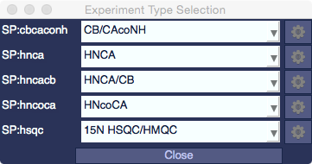

Figure Experiment types popup

Having set all experiment types, close the popup; AnalysisAssign now knows what types of experiments are in the project.

## 1.4 Access to the ‘settings’ of a module

Certain modules have additional setting that modify the behaviour of the module. These settings can be accessed by using the ‘gearbox’ button on the left of the top bar of the module; the settings pane will open Figure 5. Clicking the gearbox again either closes the the settings pane or will make it visible as the sole widget of the module. In the latter case, clicking the gearbox again closes it.

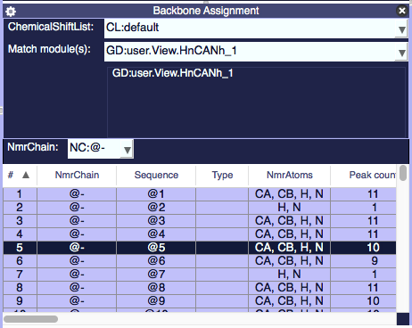

Figure Module with settings window opened.

# 2. Picking peaks

Now that we have the spectra displayed and the contour levels set, we need to pick the peaks of the HSQC spectrum to use it as a reference for backbone assignment. This can be achieved in one of two ways:

1. using the mouse shortcut: CTRL (for Linux)/CMD (for Mac) +SHIFT+Left drag.   
   NB: The graphics sometimes leave the operation hanging if you let go of the SHIFT key before you let go of the mouse button. If this happens, just repeat the action (and next time let go of the mouse first).
2. using the Pick Peaks popup (Menu: Spectrum⟶Pick Peaks; shortcut ‘pp’; Figure 6).

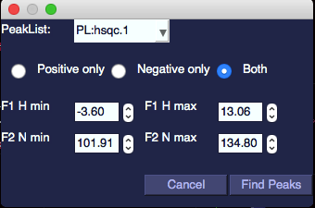

Figure : Peak picking popup.

Using the mouse shortcut will pick all peaks in the region highlighted of both positive and negative contours if they are displayed. The peak picking popup allows you to choose between “Positive only”, “Negative only” or “Both” positive and negative peaks to be picked and more precise control over the peak picking region[[1]](#footnote-1).

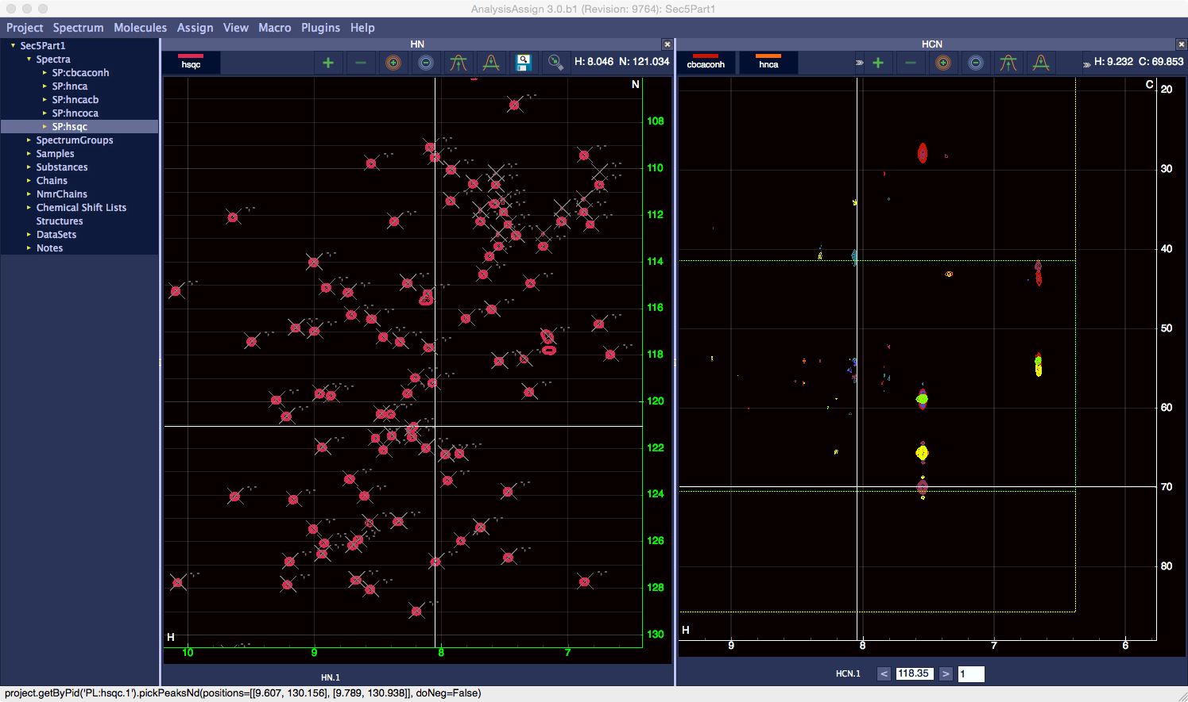

Figure : The peak-picked 15N HSQC spectrum.

The crosses in the 15N-HSQC spectrum (Figure 7) mark the peak positions picked and the two hyphens separated by a comma indicate that the dimensions of these peaks are unassigned.

Some of the peaks picked may be noise and should be deleted prior to proceeding further, which is done by selecting the peaks and hitting the Delete key. Selecting peaks can be done using a rubber band selection CMD/CTRL+drag or individual selection by clicking on a peak, holding CMD/CTRL and clicking on additional peaks.

# 3. Setting up a starting point for assignment

To start the backbone assignment process, we need to define ‘anonymous’ NmrAtoms, i.e. effectively labels, for the two dimensions of the 15N-HSQC peaks, which can subsequently be linked to the 3D spectra and used as placeholders until the actual assignments are obtained.

The “Setup NmrResidues” popup (Figure 8 ) (Menu: Assign⟶Setup NmrResidues; shortcut ‘sn’) performs this task. Selected a peaklist of either an 15N-HSQC or an HNCO spectrum as input (for this tutorial SP:hsqc is the desired choice) and choose an NmrChain for the resulting NmrResidues and NmrAtoms (you can also leave it set to the default for this tutorial). There is also a checkbox to keep existing assignments, but at this point there are none so we can leave this alone.

This procedure should be quick and once it has finished, all the peaks of the HSQC spectrum will have the comma separated dashes replaced with something beginning @-.@, e.g. @-.@1..H, N for the peak at 8.600, 133.28. These annotations are the so-called NmrAtoms; two of these (i.e. for the H and N) are grouped in a so-called NmrResidue. The NmrResidues reside in a NmrChain.

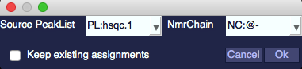

Figure : Setup NmrResidues popup.

## 3.1. Assignment and names

Assignment in AnalysisAssign is simply a matter of setting strings that define the NmrAtoms; we call this the ‘*id*’ (*id*: identifier) of the NmrAtom. If an *id* matches the strings defining a molecular Atom[[2]](#footnote-2), i.e. its *id,* then that is an assignment to the Atom.

If not, the NmrAtom *id* is a placeholder, reflecting its progress towards assignment[[3]](#footnote-3).

At this point, it is appropriate to also consider the relationships between Peak, ChemicalShift and NmrAtom. Each dimension of a Peak is assigned to an NmrAtom. The ChemicalShift (which resides in a ChemicalShiftList) of an NmrAtom, is defined by all the peaks that are assigned to this NmrAtom. Hence, changing an assignment for a Peak (e.g. reassigning a peak from “nmratom\_1“ to another “nmratom\_2”) has an effect on the ChemicalShift of “nmratom\_1”, as it is now no longer defined the Peak. Likewise, it also affects the ChemicalShift of the “nmratom\_2”, as it is now becomes to be (also) defined by the Peak. We will see in section XXX how to inspect and change the assignment(s) of a Peak.

If you change the *id* of an NmrAtom (or its parent NmrResidue or NmrChain), the assignment of all ChemicalShifts and Peaks are updated.

We use NmrChains and NmrResidues to keep track of the NmrAtoms during the assignment process. By default, new NmrResidues are put in NmrChain '@-', and new, temporary NmrChains are given names like '@2'. Initially, NmrChains contain no information about the sequential connections of the NmrResidues, i.e. their ordering. In this case, the NmrChain functions like a simple list with all its NmrResidues.

To store sequential stretches, i.e. lists in which the NmrResidues are ordered, the program uses 'connected' NmrChains, whose names start with '#' instead of '@'. Consequently, names with '@' (and NmrChain names starting with '#') are reserved.

NmrResidues are created with names like '@173' and with no residueType. When you want to create the previous, '*i-1*' residue to a given residue (for backbone assignment) you give it a '-1' suffix, in this case '@173-1'. When you assign the NmrResidue to a real residue, renaming it e,g, 'A.45.GLY', the i-1 residue name updates to 'A.45-1. .

NmrAtom names always start with the nucleus, and default names would be e.g. 'H@31' or 'C@88'. Some names have a special meaning:

* '%' means 'any number', so 'HB%' would be a beta methylene or methyl group. 'H%' would be the backbone NH3 group.
* '\*' means 'any string', so 'H\*' would be 'any proton in the residue'
* Names starting with 'M' and 'Q' are (proton) pseudoatom names
* Number suffixes follow NEF (IUPAC) convention, so serine HB2 or HB3 are *stereospecific* assignments.
* Suffixes 'x' and 'y' are used for non-stereospecific pairs - the normal assignment to serine beta would use HBx and HBy. For e.g. isopropyl groups the x and y assignments match up, so that Leu HDx% are the methyl protons bound to Leu CDx (NEF convention).

# 4. Peak picking and assigning the 3D spectra to NmrAtoms

For this exercise, it is a good idea to assure that the contouring of the ‘hnca’, ‘hncoca’ and ‘cbcaconh’ spectra is set to positive only (i.e. switch off the negative contouring). Use the spectra inspection popups (double click the relevant spectrum in the sidebar, and choose the “contours” tab; see section 1.2). Obviously, contouring for the ‘hncacb’ spectrum should be both the positive and negative levels as we expect both positive and negative peaks. Likewise, the experiment types of each spectrum should be correct (see section 1.3).

To link the 3D spectra to the HSQC spectrum we will use the “Pick and Assign” module (Menu: Assign⟶Pick and Assign; shortcut ‘pa’) and the “Atom Selector” module (Menu: View⟶Atom Selector; shortcut ‘as’). You may want to rearrange the modules since the Atom Selector does not require much screen space and you want to see as much of the 3D module as possible. For example, your layout could look like displayed in Figure 9.

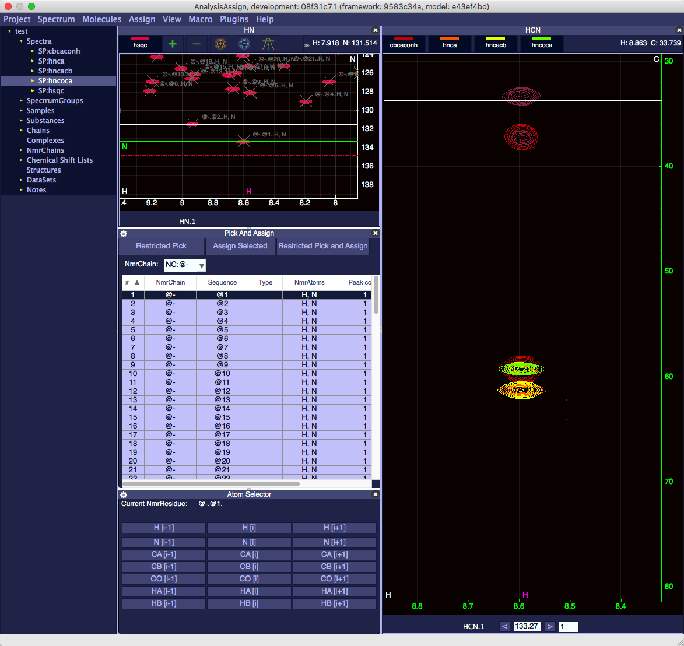

Figure : Setup for Pick and Assign.

In this figure, you can also notice that the toolbar is switched off in the rightmost (HCN) spectral display. You can get to this state by selecting this display clicking in any point of the display (the axes turn green) and toggling the toolbar of with the command “tb” or by using the right-mouse or by Menu: View⟶Current⟶Show/Hide Toolbar.

In the Pick and Assign module you will see a table of NmrResidues, a selector for NmrChain and three buttons labelled “Restricted Peak”, “Assign Selected” and “Restricted Pick and Assign”.

To start the pick and assign procedure double click on a row in the table, e.g. the row for @1. Depending of whether you chose all peaks or positive only peaks for your peak picking, this may be a different peak to that shown in Figure 9. To find the same peak, scroll and zoom with the mouse in the spectrum display to locate the required peak, note its number and select the correct row in the table.

This will cause the module with the HSQC in it to move to the position of the peak labelled @-.@1..H, N and to mark this position with two labelled rulers corresponding to each dimension. Likewise, in the 3D module navigates to the corresponding z (i.e. N) position and marks the appropriate frequency along the proton axis with a labelled ruler. Clicking the “Restricted Pick” button will pick all the peaks along the line in the 3D window and these peaks will be selected.

At this point, you have two choices: either to assign all selected peaks to NmrResidue @-.@1 by clicking “Assign Selected” or to first refine the selection of the peaks and remove any noise peaks or add any peaks. Subsequently, you can select all the relevant peaks and click “Assign Selected”. “Assign Selected” will only assign the dimensions corresponding to the x- and z-axes of the 3D spectrum display(s), where possible.

Often, it is handy to do a “Restricted Pick” and “Assign Selected” in one go, followed by editing later. In this case, use the “Restrict Pick and Assign” button.

## 4.1 The “Pick and Assign” settings

The “Pick and Assign” module has a settings panel (Figure 10) that gives access to the parameters that determine in which spectra and with what tolerances the program tries to pick the peaks, starting from the ‘source’ NmrResidue (i.e. the H,N pair in this example). Click the gearbox to access and close the settings panel.

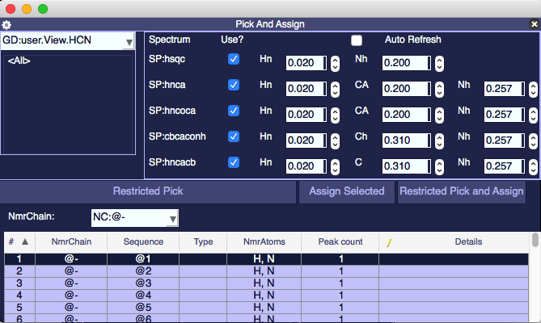

Figure : Pick and Assign settings.

## 4.2 Assigning to NmrAtoms using the “Atom Selector”

Using the “Atom Selector” (Menu: View⟶Atom Selector; shortcut ‘as’), we can set the atom type of the carbon dimension, i.e. the y-axis of the spectrum. In this example, we expect the peaks to be *CA* or *CB*, from residue *i* or *i-1*. Selecting a group of peaks in the 3D window will cause the atom selector to predict the assignment for the carbon dimension, as long as the peaks are close enough within the assignment tolerances and provide that there are no spurious peaks selected as well.

For example, if we select the peaks at 61.3 ppm, the *CA* buttons under *i-1* and *i* in the atom selector change colour, both will be coloured green (Figure 11). The program uses green for likely and orange for less likely assignments, but for a peak in (e.g.) an HNCA experiment, assignments to '*i*' and '*i-1*' are equally likely.

Likewise, selecting the peaks at 59.3 will select only the “*CA [i-1]*” button, as the program detects a peak originating from a sequential-only experiment (i.e. the HN(CO)CA or CBCA(CO)NH experiments in this case).

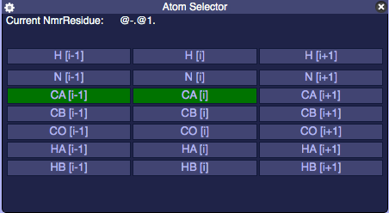

Figure : Atom Selector.

To assign the carbon dimension, click the appropriate button in the atom selector and the carbon dimension of all selected peaks will be assigned.

Repeating this procedure for the other groups of peaks along this line will also yield the *CBi-1* and *CBi* assignments for this NmrResidue.

To use the sequential Backbone Assignment tools in AnalysisAssign, the *i* and *i-1* assignments for all NmrResidues needs to be provided, so the above procedure should be carried out for all NmrResidues listed in the Pick and Assign table, where possible. If you move on to assign NmrResidue @2, after double-clicking you will see no peaks in the “HCN” spectral display; this NmrResidue originates from a Tryptophan side chain NH and hence does not display the triple-resonance peaks. Move on to NmrResidue @3 to continue, and so on for a few more residue to get the hang of it.

Once all the 3D peak dimensions have been assigned to the appropriate NmrAtoms, the backbone assignment can be carried out, but obviously for this tutorial we provide you with a CcpNmr project in which this was already completed.

# 5. Performing the sequential backbone assignment

Sec5Part2.ccpn is a project wherein all the carbon atom type assignments for the NmrResidues have been completed and thus can be used directly for the sequential backbone assignment. The project can be found in:

*YourFolder/data/testProjects/CcpnSec5BBTutorial*

with *YourFolder* as defined in section 1. Open up this project (as you did before for Sec5Part1.ccpn) and (if needed) set the spectrum paths as required (see section 1.1).

You will see a 2D module (HnNh) with the 15N-hsqc displayed and two 3D display modules (i.e. HnCANh and HnCANh\_1 with the cbcaconh, hnca, hncacb and hncoca displayed).

Assign has a dedicated workflow for backbone assignment; the sequence of operations works off the Backbone Assignment module (Menu: Assign⟶Backbone Assignment; shortcut ‘bb’) and the Sequence Graph module (Menu: View⟶Sequence Graph; shortcut ‘sg’). First rearrange the modules to a layout you would like to work with. For example, it could look like those displayed in Figure 12.

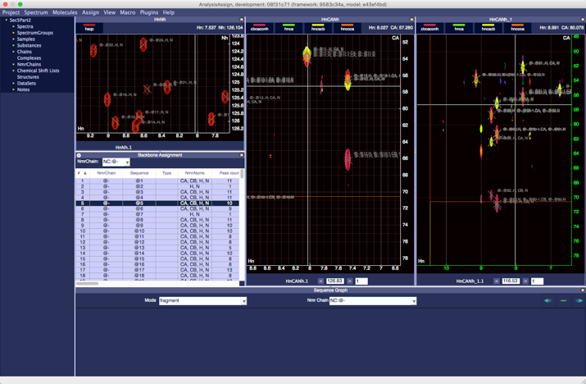 A  B

Figure : Setup for the sequential backbone assignment. A) Overview of the modules. B) Backbone Assignment settings

Before you start the backbone assignment procedure - you need to set the options - click on the gearbox 'Settings' button in the top-left corner of the Backbone Assignment module to do that. In the settings menu, you select the modules that are used to display the strips that match the particular NmrResidue you are trying to connect. The “Match modules” dropdown list shows the module(s) to choose from.

In this exercise, we will select GD:user.View.HnCANh\_1 as the match module. Close the settings menu and you’re ready to start assigning.

## 5.1 Sequential backbone assignment in the *i-1* direction

Let’s start assigning in the *i-1* direction by selecting atom @100-1 in the Backbone Assignment module. This can be found by first selecting NC:@- from the pulldown list ‘nmrChain’. Next, search the table for element ‘@100-1’ in the sequence column and double-click to start the assignment. You will see a series of changes in the GUI. The HnCANh module will navigate to the appropriate plane containing the assignment for the NmrResidue @100; the relevant frequencies of @100 are marked in the spectra. The Sequence Graph will have a schematic residue drawn, labelled with the NmrResidue name (@100) and predictions of the residue type below it. The match module (HnCANh\_1) will display three strips in order (left to right) that the AnalysisAssign algorithm thinks best match the *i-1* chemical shifts of @100 (Figure 13).



Figure . Backbone assignment modules. Matching strips for @100-1 NmrResidue. The best matching strip is highlighted by the green axes.

Upon examination, the first strip in module HnCANh\_1 shows nmrResidue @55; the H, CA and CB marks align with the peaks of this residue, we can therefore see that is the best match for @100-1. To define this strip as the *i-1* nmrResidue of @100, hold **SHIFT** and drag the strip nmrResidue label: NR:@-.@57. (below HnCANh\_1.1) and drop it onto the nmrResidue label: NR:@-.@100. (below the HnNh.1); see Figure 14.







Figure : Drag and drop of strip labels.

At this point @-.@100. and @-.@55. have been put into a so-called connected stretch (cf. section 3.1), which means that their names have changed to #4.@100. and #4.@55. This is also reflected in the labels on the strips and in the “Sequence Graph”, which now also shows another residue C-terminal of @100, with name @55.

When strips are dragged and dropped through this procedure, AnalysisAssign will subsequently look for *i-1* matches for @55. The algorithm thinks that @72 is a good match for @55-1 and on inspection it is a match, so **SHIFT** left dragging HnCANh\_1.1 onto HnCANh.2 will move the assignment on. At this point, we have @72 - @55 - @100 as an assignment stretch, with highly confident predicted residue types Ser – Ala – Ser.

To examine if this could be a match to the sequence, open the “Sequence” module (Menu: View⟶Show Sequence; shortcut ‘sq’). In the “Sequence” module you will see the molecular Chain named ‘Seq5’[[4]](#footnote-4) with its residues SAS highlighted in yellow, indicating that this short stretch matches this part of the sequence.

If you continue assigning in the *i-1* direction, you should end up with a stretch consisting of:

@58 @15 @31 @64 @103 @25 @23 @6 @19 @72 @55 @100

and NCLLTAEWMSAS highlighted in the sequence module (Figure 15).

This is a very confident assignment prediction and therefore we should commit it. To do this, click on any of the residue labels in the stretch in the “Sequence Graph” and a perforated box will appear around it to indicate that it is selected. Then, hold SHIFT and click and drag this box to the N coloured yellow residues in the “Sequence” module and release the mouse. (It does not matter which residue label you pick but you have to drag it to the leftmost residue in the relevant stretch of the sequence module). A popup will ask you to confirm the assignment. Upon acknowledgment, this will cause the sequence highlighted in yellow to become white and bold. This shows that this part of the sequence has been assigned. In addition, the names of the residues on the peak annotations, in the “Sequence Graph” and in the strips will change to reflect the fact that these NmrResidues have now been assigned; i.e. the id’s of the NmrAtom’s matches those of the Atom’s of the “Chain” named ‘Sec5’.

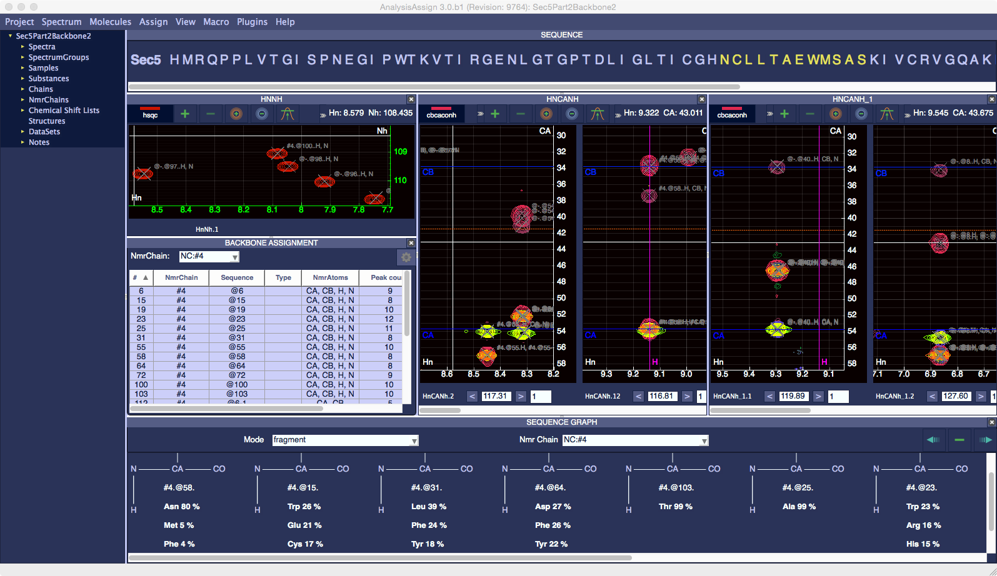

Figure : Matching strips for the sequence @58 @15 @31 @64 @103 @25 @23 @6 @19 @72 @55 @100

## 5.2 Sequential backbone assignment in the *i+1* direction

Sequential backbone assignment in the i+1 direction is fully analogous to the *‘i-1*’ direction; only the starting and matching NmrResidues will be reversed and the drag-and-drop operation will differ. Rather than starting with the *i-1* NmrResidues and finding the *‘i’* NmrResidues, we now start with the *‘i’* NmrResidues and try to match the *‘i-1’* NmrResidues. As an example, double click @18 in the Backbone assignment module and the match module will show the peaks to NmrAtoms of @42-1 as a good match.

To make a connected stretch, drag the HnCANh\_1.1 label onto HnCaNh.1 (**without** using shift) and two residues will now be shown in the “Sequence Graph” with @42 N-terminal of @18. The match module HnCANh\_1.1 displays the five best matches for @42, and @34 appears in the match module as the best match.

Continuing in this direction you should end up with a stretch consisting of:

@18 @42 @34 @22 @106 @29.

This corresponds to LTICGH (displayed in yellow in the “Sequence” module) and can be assigned using drag and drop as done before by selecting one of NmrResidue names in the “Sequence Graph” and dropping it on the beginning of the residues (in the “Sequence” module to be assigned, i.e. on the L. Again, a popup will ask you to confirm the assignment.

## 5.3 Correcting mistakes in connected NmrChains

The sequence graph can be used for more than displaying connected NmrChains and assigning them to the sequence; it can also be used to correct mistakes in these chains. For example, connecting the wrong Gly or Thr and not realising this until you’ve gone a few NmrResidues further. Sec5Part3.ccpn is a project where a central chunk of the protein has been assigned and a couple of connected NmrChains have been formed but not assigned. We will use the project to correct mistakes in NmrChains.

Like before, the project can be found in:

*YourFolder/data/testProjects/CcpnSec3BBTutorial*

with *YourFolder* as defined in section 1. Open up this project (as you did before for Sec5Part1.ccpn and Sec5part2.ccpn) and (if needed) set the spectrum paths as required (see section 1.1).

After opening this project setup the interface as you did for backbone assignment (cf. section 5.2) with the “Backbone Assignment” module, the “Sequence” module and the “Sequence Graph” open. You will need to again specify the match module as HnCANh\_1, using the settings button in the “Backbone Assignment” module. Be sure to also select “Show sequential strips”.

This project contains three NmrChains of connected NmrResidues: NC:#13, NC:#15 and NC:#16. If you select any of these from the NmrChain Pulldown in the “Sequence Graph” you will see the selected NmrChain displayed in the “Sequence Graph” and predicted positions for the selected NmrChain highlighted in yellow in the Sequence Module at the top of the window. N.B. You may have to scroll the Sequence Module to the see the highlighted positions.

Starting with NC:#15, this NmrChain consists of 5 NmrResidues and is predicted to corresponding to the stretch T78 – K79 – S80 – G81- G82. Switching to NC:#16, you will see that this is a stretch of 12 NmrResidues, predicted to encompass K83 to K94 (KGTSTVSFKLLK).

We could go ahead and assign all of these, or even link them together to form a longer stretch, but there is a mistake in NC:#16.

Select NC:#16 in the BackboneAssignment Module. Click on the “index” column to sort the NmrResidues in the table in their logical order (with @71-1 first and @36 last). Also select NmrChain #16 in the SequenceGraph (if you not have already done so).

We can now inspect the sequential assignment: double clicking @71 in the table will show the strips for @71, and @102 in the HnCaNh window, and the best matches for @71: i.e. #16.@102, @-.@63 and A.28.GLY. Only the first match is actually good, so we did ok.

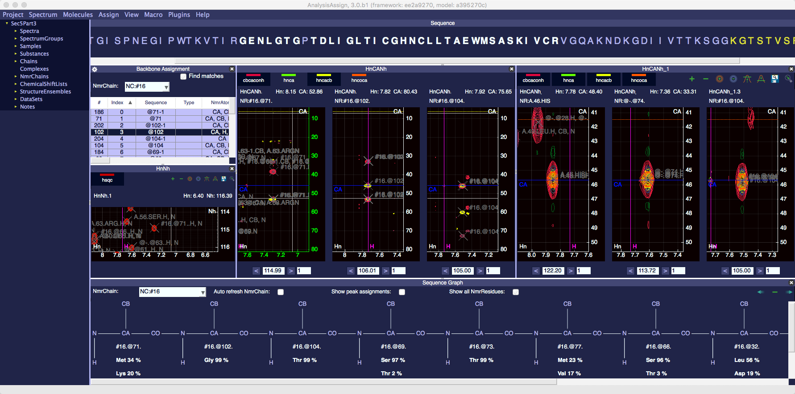

Figure : Inspecting connected stretches using “Backbone Assignment and “Sequence Graph”.

Double clicking @102 in the table will now show the strips for @71, @102 and @104 in the HnCaNh window, and this time the best matches for @102: A.46.HIS, @-.@74 and #16.@104 (Figure 16). The latter is the one that we have it connected to, but this clearly is at least optimistic, as the other two are as good or even slightly better matches. Of course, our problem is caused by the fact that we are dealing with a glycine, which often are degenerate in their match because of the lack of a discriminating second CB nucleus. To rectify this mistake, we need to correct it, disconnecting @102 from @104

In the top right of the “Sequence Graph” in the fragment mode are three buttons, corresponding to **disconnect previous NmrResidue**, **disconnect NmrResidue** and **disconnect next NmrResidue**, respectively (Figure 17).

Macintosh HD:Users:simon1:Library:Application Support:com.yellowmug.SnapNDrag:b5b3e80f0:screenshot_194.png

Figure : Breaking connected stretches in “Sequence Graph”.

These options can also be accessed by right-mouse clicking on an nmrResidue as shown in Figure 18:

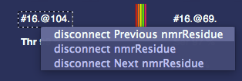

Figure : Breaking connected stretches in “Sequence Graph” using right-mouse menu.

Select an NmrResidue by clicking its label in the “Sequence Graph”. The options are used to break up the NmrChain of the selected NmrResidue in the following ways:

* “disconnect previous NmrResidue” will break the chain in two chains between the previousNmrResidue and the selected NmrResidue. For example, if you selected #16.@104. and click “disconnect previous NmrResidue”, #16.@71. and #16.@102. are removed from NmrChain NC:#16 and put into a new linked NmrChain (e.g. NC:#17 or any higher chain number).
* “disconnect next NmrResidue”, will break the chain into two chains between the selected NmrResidue and the nextNmrResidue. Again, if you selected #16.@104. and click “disconnect next NmrResidue”, #16.@71, #16.@102 and #16.@104 would remain in NmrChain #16, whereas all subsequent NmrResidues, i.e. starting with @104 are moved to another NmrChain (e.g. NC:#17 or any higher chain number) as linked residues.
* “disconnect NmrResidue” breaks links on both sides of the selected NmrResidue and assigns that NmrResidue to the default NmrChain, NC:@-.

In our case, the mistake is the connection of #16.@102. to #16.@104. We want to keep the NmrChain with #16.@104. in it, so we want to disconnect the previous NmrResidue from #16.@104. To do this click on #16.@104. In the sequence graph, a dashed box appears around it to show that it is selected, and click the ‘disconnect previous NmrResidue’ Button (the leftmost), or right-mouse click and select ‘disconnect Previous nmrResidue'. This will cause #16.@71 and #16.@102 to disappear from the Sequence Graph and the left most part of the NmrChain is #16.@104.

We can now continue backbone assignment as we did previously to correct his mistake, by double clicking on @104-1. in the NmrResidue table of the Backbone Assignment Module. @-.@67, appears as the first match in the match module, so we can link that i-1 using shift drag and drop to add it to NC:#16. We can then assign this NmrChain as we did before, by selecting #16.@67. and using shift+left drag to drop it onto the highlighted Gly (G84).

## 5.4 Inspecting and correcting assignments with Peak Assigner and Assignment Inspector

We have previously seen (cf. section 3.1) how the NmrAtoms assigned to the various peaks yield the ChemicalShifts contained in a ChemicalShiftList. We can use a ChemicalShiftTable module (Menu: View⟶ChemicalShift Table; shortcut ‘ct’), together with the Assignment Inspector (Menu: Assign⟶Assignment Inspector; shortcut ‘ai’) and the Peak Assigner (Menu: Assign⟶Peak Assigner; shortcut ‘aa’) to inspect and correct if necessary.

Sec5Part3.ccpn is a project where that contains a rather obvious assignment error. We will use this project to correct this mistake.

Like before, the project can be found in:

*YourFolder/data/testProjects/CcpnSec3BBTutorial*

with *YourFolder* as defined in section 1. Open up this project if you don’t already have it opened (as you did before for Sec5Part1.ccpn and Sec5part2.ccpn) and (if needed) set the spectrum paths as required (see section 1.1).

It is a good idea to close the HnCANh\_1 spectrum display window, and the backbone Assignment module. The final arrangement could look like this (Figure 19):

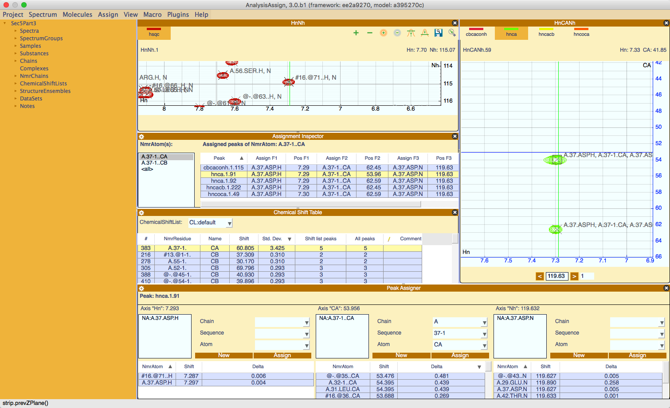

Figure : Layout with Chemical Shift Table, Assignment Inspector and Peak Assigner. See text for discussion

Select CL:default in the Chemical Shift Table dropdown. The table displays all NmrResidues and NmrAtom names, together with their ChemicalShift values, standard deviation, and the number of peaks giving rise to this ChemicalShift

Sort the table on the column “Std Dev” from high to low by clicking twice. Whereas most standard deviations are small (~0.3 or smaller), one NmrAtom (NA:A.37-1.CA) has a 3.425 ppm standard deviation associated with it, which is obviously not correct.

A single click on this row will populate the Assignment Inspector with all peaks that are assigned to NmrAtom NA:A.37-1.CA. The F2 column list all frequencies giving rise to the ChemicalShift value of NA:A.37-1.CA; there is one outlier: peak hnca.1.91.

Now select a strip in the HCaNh display and double click the row of hnca.1.91 in the Assignment Inspector. The spectrum display will focus on the position of peak hnca.1.91. Toggle off all the spectra and display only the hnca spectrum; you can now see clearly what the problem is: both hnca peaks are assigned as the sequential peaks. Comparison with the hncoca or cbcaconh spectrum confirms that PK:hnca.1.91 is miss-assigned and is in-fact the intraresidual CA.

We will use the peak assigner to correct the assignment of PK:hnca.1.91. Selecting the peak (either in the spectrum display or by a single click on PK:hnca.1.91 row in the Assignment Inspector), populates the Peak Assigner module[[5]](#footnote-5). The three boxes show the current assignments of each of the three axes of the peak; the respective tables show possible matches along each dimension[[6]](#footnote-6). Note that each peak dimension can be assigned to multiple NmrAtoms, if so desired.

We first want to remove the wrong assignment of the Carbon axis: right click on NA:A.37-1.CA and choose “delete”. To assign it to the proper NmrAtom, double-click A.37.ASP.CA in the table below (you may have to scroll down a bit). You can limit the selection by selecting “only intra-residual” under the options. Note that after double clicking, the ChemicalShift table will have updated, and the topmost entry will have changed (since we have corrected the error and

An alternative to, first deleting and then assigning (as was done above) is to modify the assignment. So let first restore the error by undoing (Menu: Project⟶Undo; shortcut ‘cmd-z’). Unfortunately, not all our updates are yet perfect, so you have to find and select A.37-1. in the Chemical Shift table and subsequently PK:hnca.1.91 in the Assignment Inspector again.

Rather than deleting the wrong assignment, we now select NA:A.37-1.CA. The Chain, Sequence and Atom fields will populate with A, 37-1, and CA, respectively. We now change 37-1 to 37, and click “Assign” to change the assignment of PK:hnca.1.91 along the Carbon axis. Note that “New” would create a new NmrAtom and assign it to the relevant axis of the peak.

Under the current settings the Chain, Sequence and Atom fields will only populate with those combinations that are available in the associated table. If you wish to see all possible combinations, open the settings from the gearbox icon and deselect ‘Peak Selection from Table’, clicking on NA:A.37-1.CA. again will repopulate the fields. To reverse the change, reselect ‘Peak Selection from Table’.

## 5.5 Checking Assignment using Sequence Graph

Sec5Part4.ccpn is a project containing the completed backbone assignment, but there are a couple of mistakes in the assignment that can be seen by using the Sequence Graph. For the final part of this tutorial we will look at identifying and rectifying these mistakes.

Like before, the project can be found in:

*YourFolder/data/testProjects/CcpnSec3BBTutorial*

with *YourFolder* as defined in section 1. Open up this project if you don’t already have it opened (as you did before for Sec5Part1.ccpn, Sec5part2.ccpn and Sec5Part3.ccpn) and (if needed) set the spectrum paths as required (see section 1.1).

It is a good idea to close the HnCANh\_1 spectrum display window, and the backbone Assignment module. To inspect and correct, we will use the Assignment Inspector (Menu: Assign⟶Assignment Inspector; shortcut ‘ai’), the Peak Assigner (Menu: Assign⟶Peak Assigner; shortcut ‘aa’) and the Sequence Graph (Menu: View⟶Sequence Graph; shortcut ‘sg’) with all options checked. The final arrangement could look like this (Figure 20):

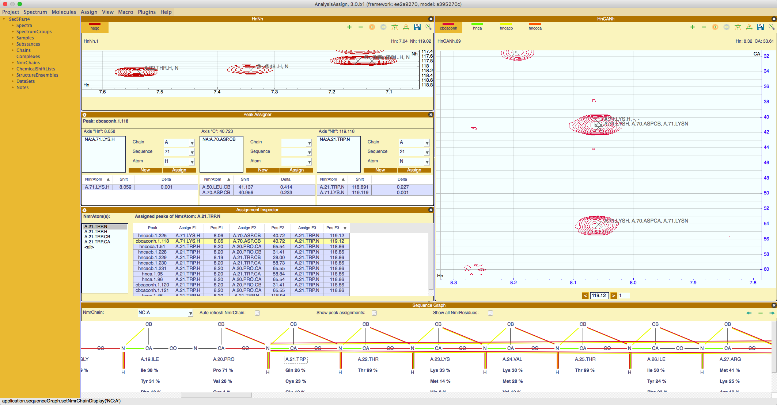

Figure : Layout with Assignment Inspector and Peak Assigner and Sequence Graph. See text for discussion.

Select NmrChain: NC:A on the Sequence Graph. The “show peak assignment” option of the module will display a representation of the sequence with a series of coloured lines connecting the different atoms. The line colours correspond to the positive contours colours of each spectrum and the connections show what atoms are linked by assignment in the experiment.

Scrolling through the sequence, you will notice multiple lines connecting the N atom of A.21.TRP to atoms much further down the sequence; in fact they go to the H of A.71.LYS and the CB of A.70.ASP. These are clearly mistakes in the assignment and should be corrected

Selecting A.21.TRP in the Sequence Graph will populate the Assignment Inspector as discussed before in section 5.4. Two peaks (i.e. hncacb.1.225 and cbcaconh.1.118) for A.21.TRP.N are clearly wrong (try sorting on the “Pos F3” column), as they connect A.71.LYS.H with the A.21.TRP.N. Like in section 5.4, we focus the current spectrum by double clicking and we can select each peak and correct it using the Peak Assigner. Correcting will remove the wrong connections in the Sequence Graph as well.

There is a further error involving A.60.ILE; try correcting that one yourself as well.

After completing these corrections, the backbone of sec5 is now assigned.

**This covers all the tools and workflows currently available for Backbone Assignment.**

1. The “Peak Picking Drop” parameter in the “Preferences” popup (Menu: Project⟶Preferences) affects peak picking. This parameter defines the percentage the intensity must drop from a local maximum (for positive peaks) in each dimension in each direction, in order for the position of the local maximum to be considered to be a peak. If this percentage is too high then some actual peaks might be missed, and if it is too low then too many peaks might be picked. [↑](#footnote-ref-1)
2. Atoms reside in Residues, which reside in Chains; multiple chains can form a Complex. [↑](#footnote-ref-2)
3. The *id* together with the type identifier forms the so-called *pid*, the project-identifier. As an example for an un-assigned amide in the 123rd NmrResidue in the second NmrChain: *NA:@2.@123..H*. For an assigned NmrAtom, all the fields will have been filled, yielding something like NA:A.GLU.14.H. [↑](#footnote-ref-3)
4. The molecular sequence was generated before by us. You can either use Menu:Molecule->Generate Chain or drop a Fasta formatted file onto the Sidebar. [↑](#footnote-ref-4)
5. Selecting any peak, or set of peaks, that you want to assign will populate the module with a section per dimension of the peak. [↑](#footnote-ref-5)
6. The Peak Assigner has a number of options to guide its behaviour. Use the gear box to show/hide these. Crucial parameters are the assignment tolerances along each dimension for the different spectra. These are set to (sensible) default values but can also be modified by using the “dimensions” pane of the spectral properties popups of the respective spectra. [↑](#footnote-ref-6)