Introductory Tutorial

This tutorial will require the spectra located in data/testProjects/CcpnSec5BBTutorial/sec5spectra.

Introduction

When you open the program you will see a large display area, with a sidebar to the left and a menubar at the top. All the displays, tables, etc. go into the display area. The sidebar shows the data in your project and lets you edit data items, create new ones, and drag the items into the display area to activate them. The menubar lets you start actions and action modules. You can also start actions by two-key keyboard shortcuts, using the right mouse button, or from buttons and icons in the application.

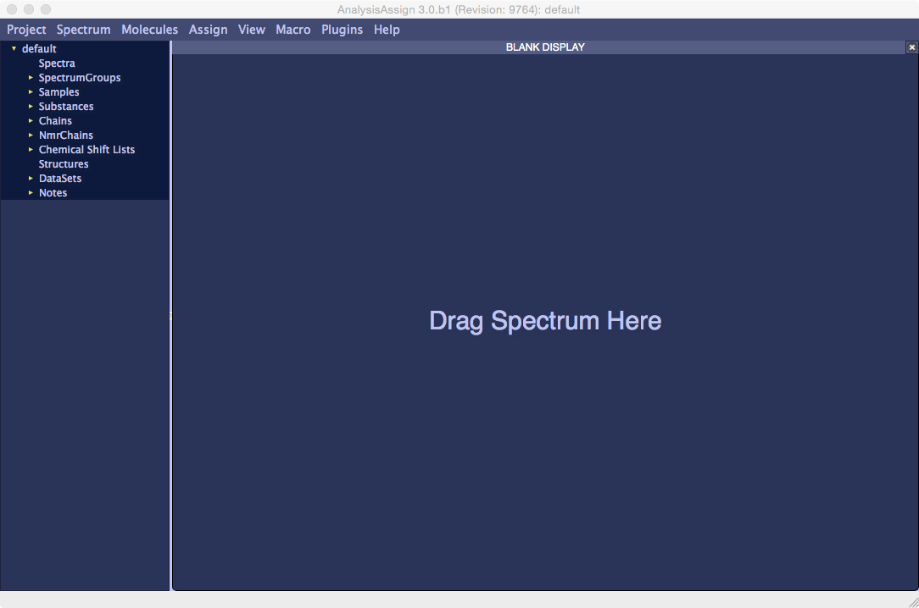

The data are organised into a tree. The top parent is the project, and the objects at the top level of the sidebar are children of the project. They in turn have children that are shown when you open the parent in the sidebar.

Each object has a key that distinguishes it from its siblings; for Spectra, Atoms, NmrAtoms and Samples it is the name, for PeakLists and Peaks it is the serial number. Each object also has a global identifier, or pid. For a Peak, this would be e.g. 'Peak:hnca.2.43' or 'PK:hnca.2.43. The part before the ':' shows the kind of object, either as a full name or a two-letter abbreviation. The rest show the object keys, separated by dots. In this example, the pid would read 'Spectrum:hnca->PeakList:2->Peak:43'. Some objects have multipart keys. A Residue (or NmrResidue) is identified by both the sequenceCode and the residueType, so the pid would look like e.g. 'Residue:A.97.ALA'. And a ChemicalShift is identified by the NmrAtom it belongs to, so that a shift in the default ChemicalShiftList would have a pid like 'CS:default.B.13.GLN.HA'.

Loading spectra

The simplest way to load a series of spectra simultaneously is to select them in Finder and drag them onto the sidebar of the Assign interface. Select hnca.spc, hncacb.spc and cbcaconh.spc and drag them onto the Sidebar. You will see a yellow arrow appear next to the Spectra label in the Sidebar showing that the spectra have been loaded and clicking on this arrow will show you the spectra now in the project.

An alternative way to load spectra, or any data for that matter, is to use the Load Data popup accessed via Project:Load Data (shortcut ld). Open the popup and navigate to where the spectra are stored, select hsqc.spc and click Open. This will load the HSQC spectrum and it will appear under spectra with the other spectra you just loaded.

Displaying Spectra

When v3 is opened without a project, a Blank Display is shown by default with the instruction, “Drag Spectrum Here.” To display one of the loaded spectra, you do just that. Select the hsqc spectrum from the sidebar (SP:hsqc) and drag it onto the Blank Display and it will appear on screen.

Any spectrum with the same dimensions/axes can be dropped onto this display, e.g. another HSQC, however, spectra with different or more dimensions cannot, for example, you can’t drop an HNCACB onto an HSQC spectrum display.

In the 2D spectrum display a button appears at the top, which is used to show or hide the spectrum and a set of buttons for displaying strips and manipulating the display of the spectrum.

To display different types of spectra, different spectrum displays are required. To create a new Blank Display use the menu option View > New Blank Display (shortcut nd). A new display will always appear on the far right of the window.

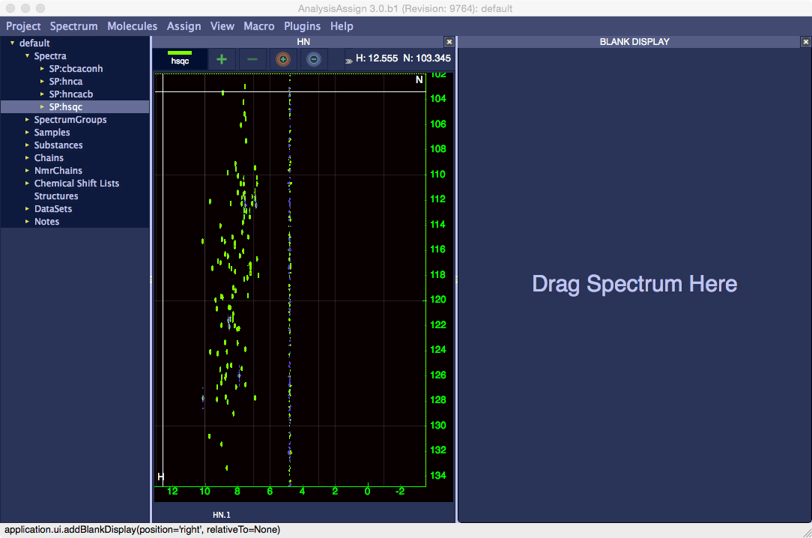

Drag the hnca from the Sidebar onto the new display and it will be displayed as shown below. You will need to adjust the contour base level to see the peaks and this is done using the buttons on the toolbar above. Hovering over a button will display the function it performs. All the functions on the toolbar can also be selected from the right mouse context menu inside a strip.

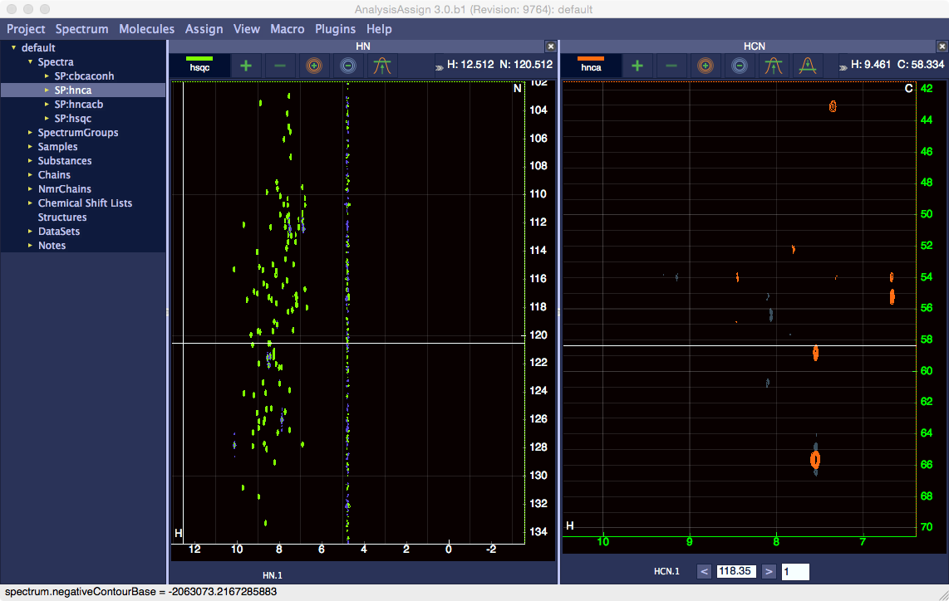

At the bottom of the display is a Z toolbar with a strip label, two buttons for changing planes, a box showing the ppm position of the z axis and a second box which shows how many planes are shown simultaneously.

The two arrows left and right of the z position box moves the spectrum one plane at a time. The number of planes can be changed by editing the plane count manually or by using the mouse wheel while hovering over the box. The z position can also be changed using the mouse wheel in the same way.
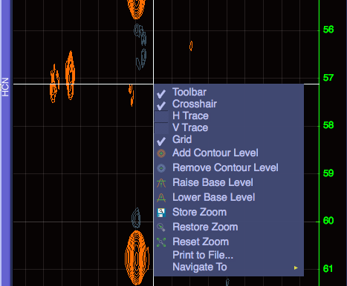
Under the menu there are additional options for hide and showing the grid and crosshair and for putting horizontal and vertical traces on the crosshair.

There is a third way to load spectra into a project, which is dropping a spectrum file onto a spectrum display, for example dropping hncoca.spc onto the display containing the hnca. This will display the spectrum and it will appear in the Sidebar to show it is loaded into the project.

Zooming, panning etc.

Dragging the left mouse button around a spectrum display will pan the spectrum in the direction of movement and the mouse wheel will zoom the x and y axes simultaneously. If you want to zoom into a specific area, using SHIFT+Right Drag or holding down the mouse wheel and dragging it will cause a yellow box to be drawn on the display, which specifies the zoom region.
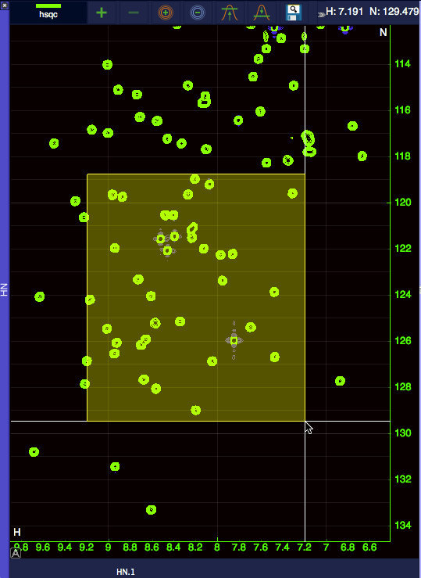

You can also zoom individual axes by hovering over the axis and moving the mouse wheel.

The two buttons on the far right of the toolbar are for storing and restoring zooms, respectively. If you zoom into a particular region and click the store zoom button, this zoom will be stored on a stack. If you move to another part of the spectrum or change the zoom and then hit the restore zoom button, the display will revert to the positions and zoom states stored.

Changing how spectra are displayed

When spectra are displayed, the contour colours are set from a pre-set order hard coded into the software and the positive and negative contour colours are complementary by default. To change the contour colours and other properties of a spectrum, double click its name in the Sidebar and a dialogue box will popup with a series of tabs in it.

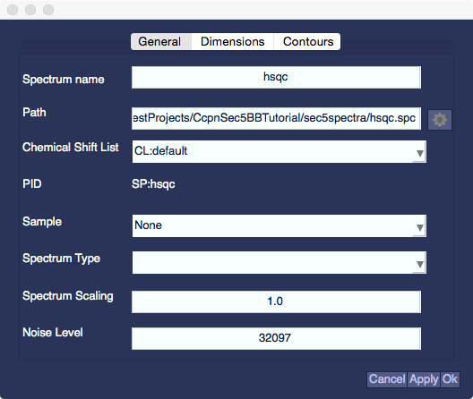

In the first tab, you can set general parameters of the spectrum, such as type, path, name, scaling, spectrum type etc. Changing the values in each box and hitting Apply will change the parameter value. In the Dimensions tab, you can view information on each dimension of the spectrum and change referencing and assignment tolerances for each dimension.
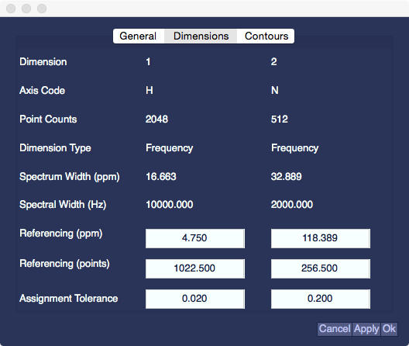

The Contours tab contains values that can be changed to manipulate how the contours are displayed for that spectrum.
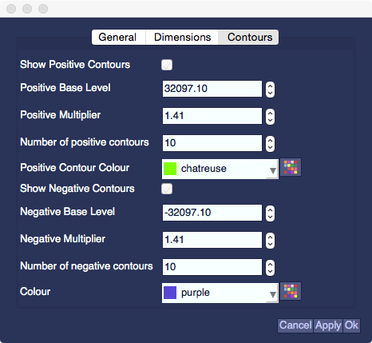

Contour base levels, multipliers and number of contours can be changed by adjusting the value with the mouse wheel or directly writing into the box. Checking and unchecked the check boxes will show or hide the positive/negative contours. To change the colour of the contours, you can either select from the list of standard colours using the drop down list or select one of your own by clicking the Multi-coloured button, which will popup a Colour dialog.

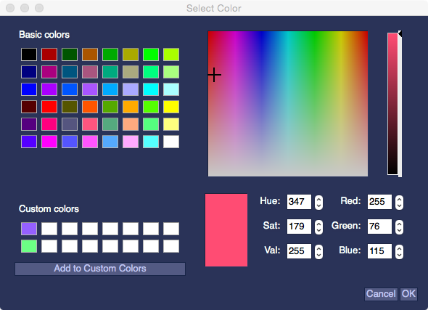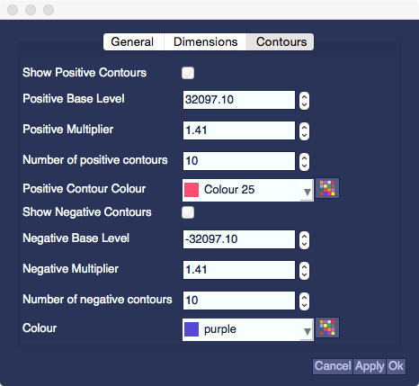

Once you have selected your colour and pressed OK the colour will appear in the drop down list as Colour + a number and will be stored for future use.

Rearranging modules

The two spectrum displays on screen are an example of what we call a module. In general, anything that isn’t a popup is a module and these can be easily rearranged in any way you want. To move a module, hold the left mouse button down on the thin bar at the side of the module (the module label) and drag it to either the top, bottom, left or right of another module and the module you have selected will be placed above, below, to the left or to the right of the other module. For example, hold the left mouse button on the blue bar with HCN in it (the HCN module) and drag it to top of the HN module. Once you are in an active drop area, the area will be highlighted. Releasing the mouse button will complete the drop and the HCN module will now be above the HN module.

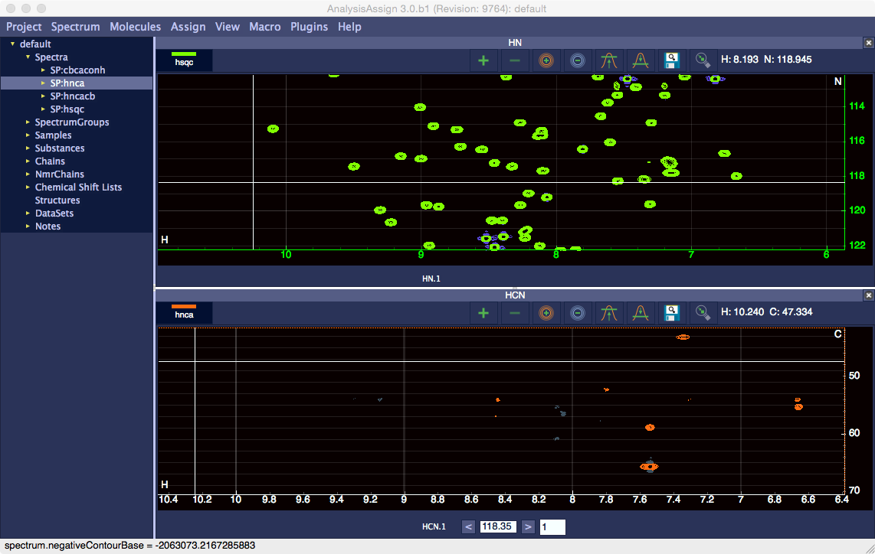

The modules are contained in a dock area and as such can be undocked to create floating modules by double clicking the module label. This will cause the module to pop out into its own dock area and it can be manipulated as a separate window. To demonstrate this, create a new blank display (shortcut nd) and drop the cbcaconh spectrum onto it. Pop the module out to make it a ‘free-floating’ module and then drag it onto the HN module, which is also free floating. If you drop it on the right hand side of the HN module, it will be added to the right.

To put a module back into the main window, you need to pop it out of a dock area if it is in one and then drag it back to the dock area of the main window. Hereby, you can create any number of dock areas you like with as many different modules as you desire.

Notes

Assign also provides a means to make free text notes and store them with the project. To create a note, go to the Sidebar, expand the Notes section and double click on <New>. This will create a new note called NO:1.Note and double clicking on that will open the Notes editor.

In the Notes Editor you can change the name of the note and add any amount of free text you want and clicking Save Note will store your text and set a new name if the note is renamed.

This completes the Introductory Tutorial.

