 | title | figure | results | pub | links
1 | Temporal Knowledge Propagation for Image-to-Video Person Re-identifification | 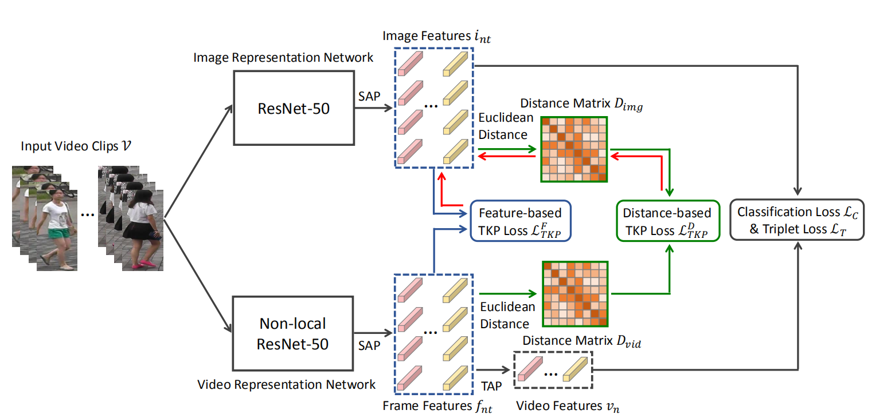 | Ilids-VID:  rank1(54.6%)  MARS:  rank1(75.6%), mAP(65.1%) | ICCV2019 | Paper:https://arxiv.org/pdf/1908.03885.pdf  Code:https://github.com/guxinqian/TKP

