Report: Continuous Control
Environment

For this project, you will work with the Reacher environment. In this environment, a double-jointed arm can move to target locations.
A reward of +0.1 is provided for each step that the agent's hand is in the goal location. Thus, the goal of your agent is to maintain its position at the target location for as many time steps as possible.
The observation space consists of 33 variables corresponding to position, rotation, velocity, and angular velocities of the arm. Each action is a vector with four numbers, corresponding to torque applicable to two joints. Every entry in the action vector should be a number between -1 and 1.

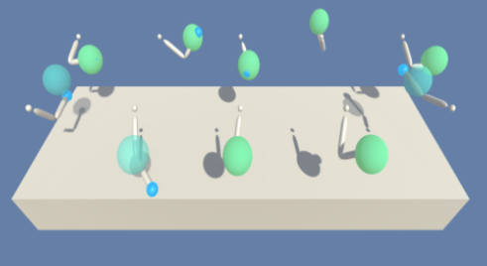

DDPG

Deep Deterministic Policy Gradient (DDPG) is an algorithm which concurrently learns a Q-function and a policy. It uses off-policy data and the Bellman equation to learn the Q-function, and uses the Q-function to learn the policy. Policy gradienst methods directly operates in the policy space. They can learn stochastic policies, can be applied to model continuous action spaces and usually show faster convergence than DQN. However they can have high variance in estimating the gradient of the estimated reward. Using a Q-function as a baseline can be used to redice variance. In this context, the Policy gradient network is called an ACTOR and the Q-funcion baseline is called a CRITIC.

Approach

For this project, I essentially used the same code as in the ddpg-pendulum example. The code can be found in Udacity’s deep-reinforcement-learning repository: https://github.com/udacity/deep-reinforcement-learning/tree/master/ddpg-pendulum
Only minor changes were made to solve the project. The main changes were:

- The ddpg method was adapter for the Reacher Unity environment. The environment is able to handle 20 agents, which improves training times. To account for this, the agent.step method must be able to save the experience for all agents. The “score” returned will be the mean score for all the agents. The Benchmark Implementation suggest to learn 10 times for every 20 time steps. In the code this can be controlled with the LEARN_EVERY parameter. If this param =0, the agent trains once every timestep. For the final implementation, I chose the following behavior: save the experiences of the 20 agents two times in the buffer and train once every time step. I saved the experiences two times because I noticed it trained a little faster, probably because the buffer fills-up faster.
- As suggested in the Benchmark Implementation for this project, we added gradient clipping when training the critic network. This helps us avoid an exploting gradient as it seemed to be causing sudden drops in score. This is managed by the parameter GRAD_CLIPPING.
- A normalization, using pytorch’s Batchnorm1d, was added between layers for the actor and critic networks. This helps with training giving a nicer distibution of data for the activation functions.
- From the pendulum example, we are returning a noisy value for our agents’ actions, As we get better with time, we would like to reduce the noise as we learn. For this reason, a noise decay rate factor EPSILON was added. For every pass of agent.learn the factor is reduced in EPSILON_DECAY.

Model
The model, again is exactly the same as the one in the ddpg-pendulum example, but with Batchnorm1d added. The Agent is a 3-layered network with Relu activation for the hidden dimensions and a Tanh ecativatior for the output.

Hyperparameters
The relevant hyperparameters are:

BUFFER_SIZE = int(1e6) | Replay buffer size
BATCH_SIZE = 256 | Minibatch size
GAMMA = 0.99 | Discount factor
TAU = 1e-3 | For soft update of target parameters
LR_ACTOR = 1e-3 | Learning rate of the actor
LR_CRITIC = 1e-3 | Learning rate of the critic
WEIGHT_DECAY = 0 | L2 weight decay
EPSILON = 1.0 | Noise decay start value
EPSILON_DECAY = 1e-6 | Noise decay factor
LEARN_EVERY = 0 | Learning timestep interval
LEARN_NUM = 10 | Number of learning passes
GRAD_CLIPPING = 1.0 | Gradient Clipping

From ddpg-pendulum example only few parametesr where modifed. The BUFFER_SIZE was increase from 1e5 to 1e6. BATCH_SIZE was increased from 128 to 256. All other parameters in the example were left the same.
The params EPSILON, EPSILON_DECAY, LEARN_EVERY, GRAD_CLIPPING were added. They are explained in the “Aproach” scetion.

Result

An average score > 30.0 over the last 100 episodes was achieved at 134 episodes.

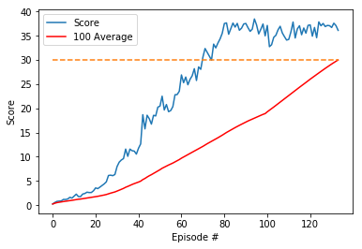

Ideas for Future Work

The first thing that comes to mind as improvements for this project is the algorithms suggested in
Lesson 2-8 (Deep Q-Learning Improvements), namely:
• Double DQN (DDQN)
• Prioritized Experience Replay
• Dueling DQN
Apart from that, playing a bit more with the hyper parameters might make a difference, specially in

References

[1] https://arxiv.org/abs/1509.02971
[2] https://github.com/Unity-Technologies/ml-agents/blob/master/docs/Learning-Environment-Examples.md
[3 ]https://flyyufelix.github.io/2017/10/12/dqn-vs-pg.html
[4] https://spinningup.openai.com/en/latest/algorithms/ddpg.html

