P3: Collaboration and Competition
Environment

In this environment, two agents control rackets to bounce a ball over a net. If an agent hits the ball over the net, it receives a reward of +0.1. If an agent lets a ball hit the ground or hits the ball out of bounds, it receives a reward of -0.01. Thus, the goal of each agent is to keep the ball in play.

The observation space consists of 8 variables corresponding to the position and velocity of the ball and racket. Each agent receives its own, local observation. Two continuous actions are available, corresponding to movement toward (or away from) the net, and jumping.

After each episode, we add up the rewards that each agent received (without discounting), to get a score for each agent. This yields 2 (potentially different) scores. We then take the maximum of these 2 scores. This yields a single score for each episode.

The environment is considered solved, when the average (over 100 episodes) of those scores is at least +0.5.

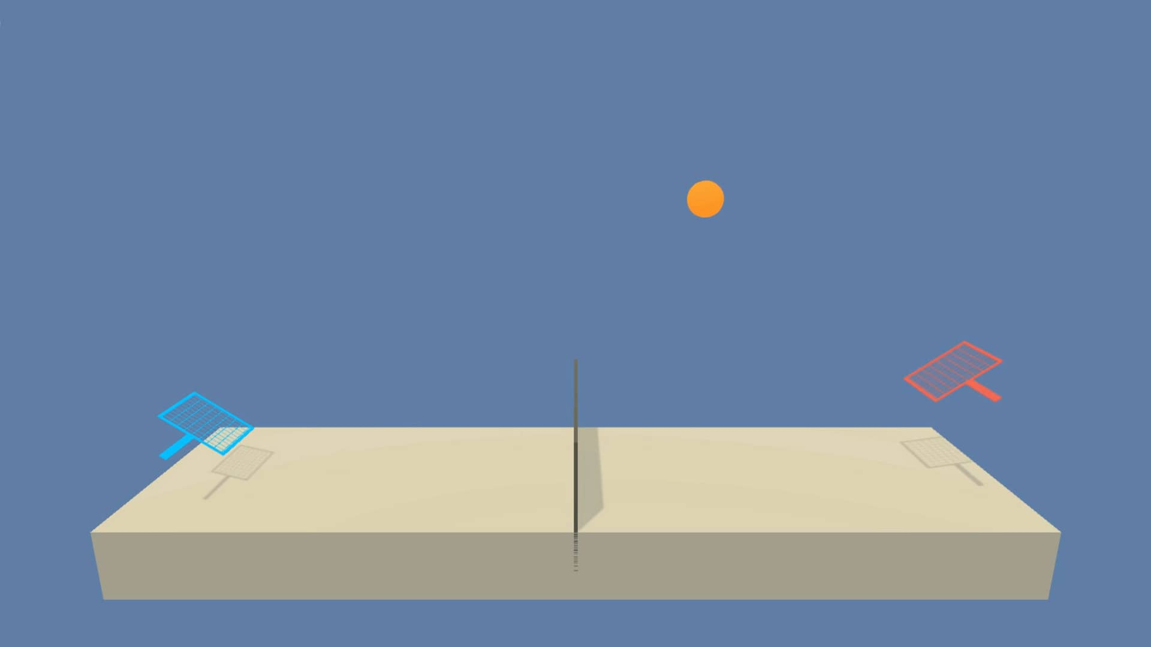

DDPG Algorithm

Deep Deterministic Policy Gradient (DDPG) is an algorithm which concurrently learns a Q-function and a policy. It uses off-policy data and the Bellman equation to learn the Q-function, and uses the Q-function to learn the policy. The DDP algorithm was proposed and is described in reference [1].

MADDPG Algorithm

Multi Agent Deterministic Policy Gradient (MADDPG) is an extention of DDPG for many agents. This algorithm is able to catc both compeeting agents anf collaboraitng agent. The MADDP algorithm was proposed and is described in reference [2].

Implementation

For this project I used both DDPG and MADDPG to solve the environment.

Model
In both approaches I used the same model. The model is essentially the same as the one in the ddpg-pendulum example. For DDPG I added Batchnorm1d. The Agent is a 3-layered network with Relu activation for the hidden dimensions and a Tanh activation for the output. The Agent receives a state as an input and returns the probabilities for each action. The critic has a similar architecture but actions are being concatenated after the first layer. It also receives a state but outputs a single number (with no activation), which represents the predicted Q-value for that action-state.

First Implementation: DDPG

Exactly the same code as for P2. For this project, I essentially used the same code as in the ddpg-pendulum example. The code can be found in Udacity’s deep-reinforcement-learning repository: https://github.com/udacity/deep-reinforcement-learning/tree/master/ddpg-pendulum

Hyperparameters
BUFFER_SIZE = int(1e6) | Replay buffer size
BATCH_SIZE = 256 | Minibatch size
GAMMA = 0.99 | Discount factor
TAU = 1e-3 | For soft update of target parameters
LR_ACTOR = 1e-3 | Learning rate of the actor
LR_CRITIC = 1e-3 | Learning rate of the critic
WEIGHT_DECAY = 0 | L2 weight decay
EPSILON = 1.0 | Noise decay start value
EPSILON_DECAY = 1e-6 | Noise decay factor
GRAD_CLIPPING = 1.0 | Gradient Clipping
FC1 = 400 | Size of first FC layer
FC2 = 300 | Size of second FC layer

Result
Solved in: 634 episodes
Running time (Udacity’s workspace): 13.2 minutes.
Average Score (last 100): 0.51
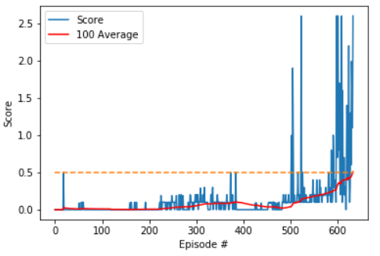

Second Implementation: MADDPG

Hyperparameters
BUFFER_SIZE = int(1e6) | Replay buffer size
BATCH_SIZE = 512 | Minibatch size
GAMMA = 0.95 | Discount factor
TAU = 1e-2 | For soft update of target parameters
LR_ACTOR = 1e-3 | Learning rate of the actor
LR_CRITIC = 1e-3 | Learning rate of the critic
WEIGHT_DECAY = 0 | L2 weight decay
EPSILON = 1.0 | Noise decay start value
EPSILON_DECAY = 1e-6 | Noise decay factor
GRAD_CLIPPING = 1.0 | Gradient Clipping
FC1 = 64 | Size of first fully connected layer
FC2 = 64 | Size of second connected layer

Result
Solved in: 1004 episodes
Running time (Udacity’s workspace): 27.6 minutes.
Average Score (last 100): 0.50

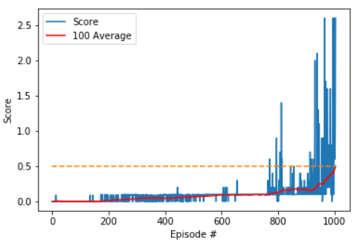

Ideas for Future Work

The first thing that should be interesting to try will be to implement different algorithms for this same environment. Particularly PPO Proximity Policy
Apart from that, playing a bit more with the hyper parameters might make a difference. For example, I didn't’ touch the noise parameters, which might result in something interesting. I also chose to learn once every time step, because it worked ok, but definitely other behaviors might make an important difference.

References

[1] https://arxiv.org/abs/1509.02971
[2] https://arxiv.org/abs/1706.02275

