**Hue (Game)**

**Team #2**

Carlos Crane

Jacob Willkins

Thomas Shipman

Sammy Hamwi

**Increment I: UML Diagrams**

**Table of Contents**

Page 2 …………………………………………………………..Sequence Diagram

Page 3 …………………………………...…………………Activity Class Diagram

Page 4 ………………...……………………………………….……..State Diagram

Page 5 …...……………………………………………………Game Class Diagram

**Sequence Diagram**

Hue has a fairly simple set of sequences. The player begins in the homescreen/pause menu, which lets the user start a game (“Play”). The player can also enter settings and resume a previous game from the Main Menu, and can quit the game into the Main Menu.

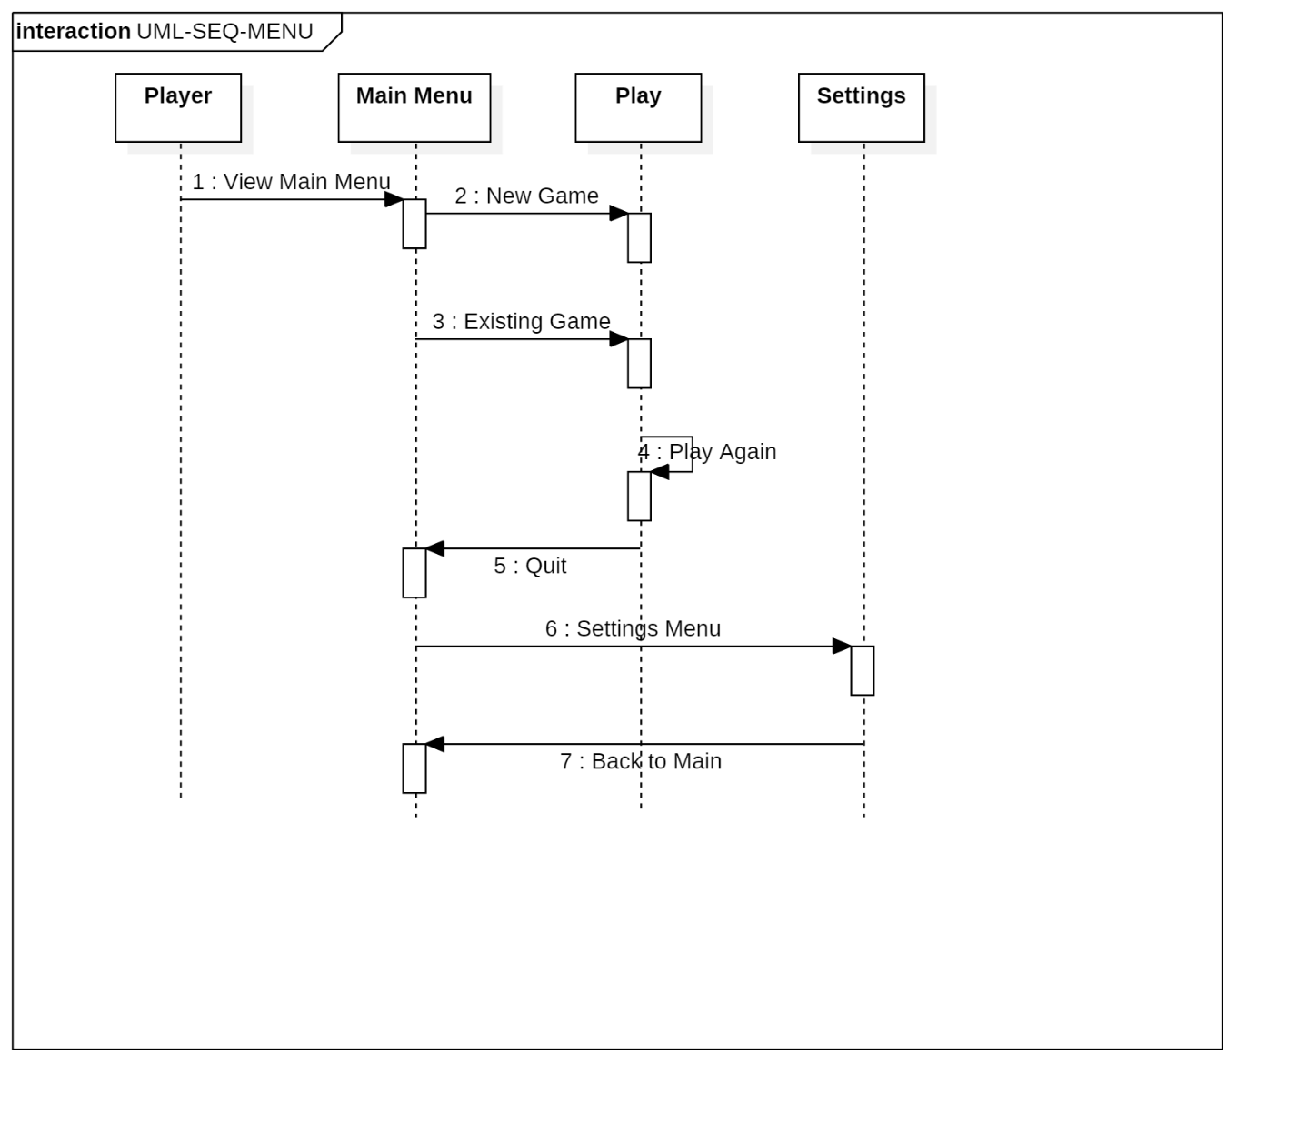

**Activity Class Diagram**

This class diagram lists the methods and variables stored in Hue’s three main Android Activities. Variables such as “GameGridView” are de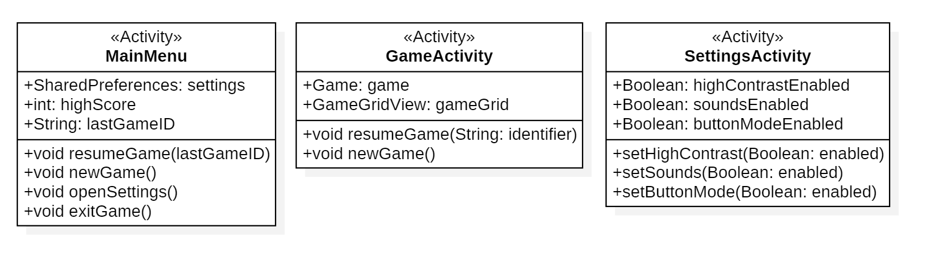scribed in more detail on Page 5.

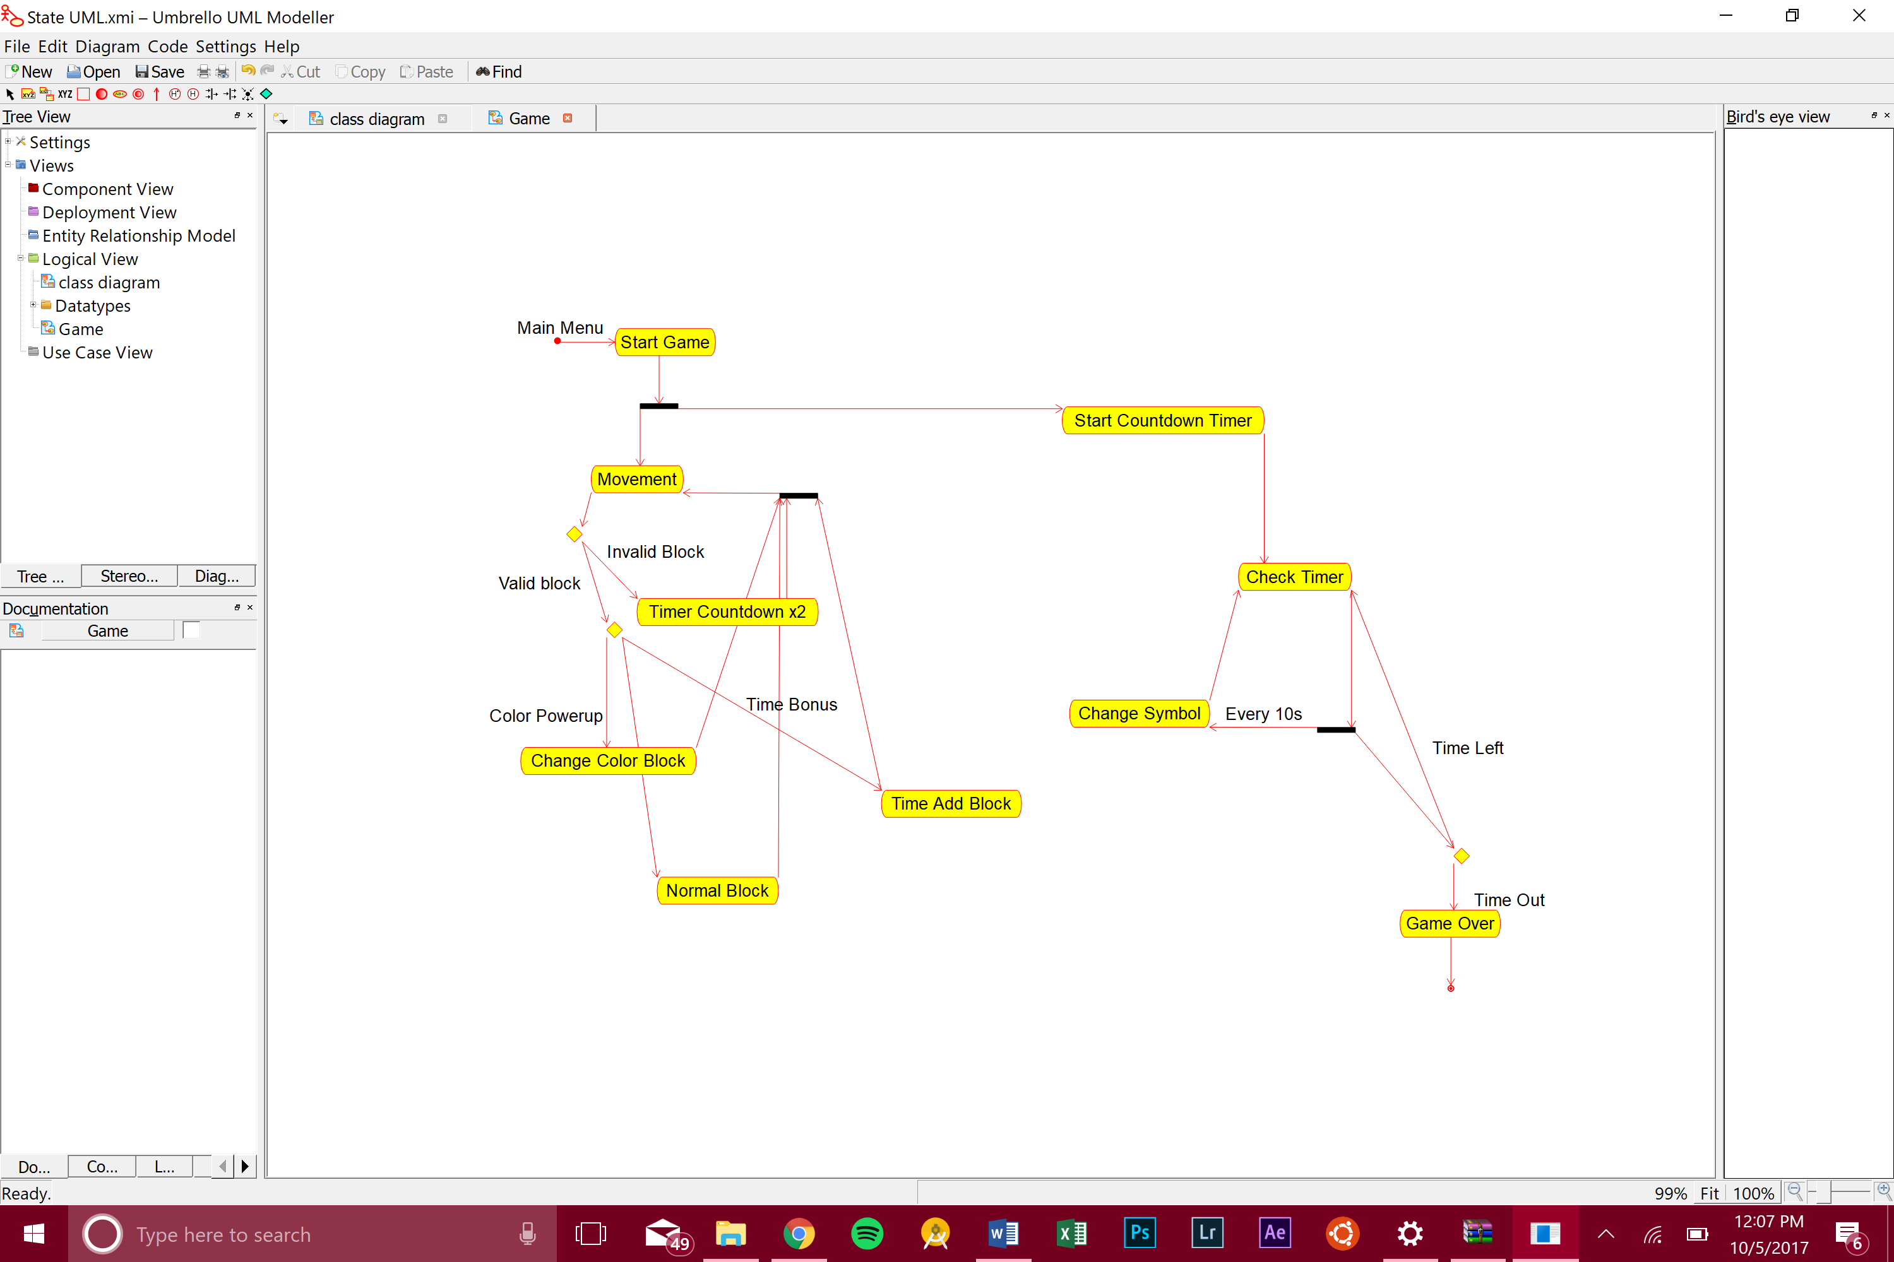**State Diagram**

This state diagram describes how Hue game mechanics works. When the game starts, it begins a touch listener labeled “Movement” and an Android timer called the “Countdown Timer”, which run the game. A User can land on a valid or invalid block through movement, which can change the time multiplier or give certain powerups (“Change Color Block”, “Time Add Block”). Meanwhile, the timer constantly counts down until there is no time left, which then ends the game.

**Game Class Diagram**

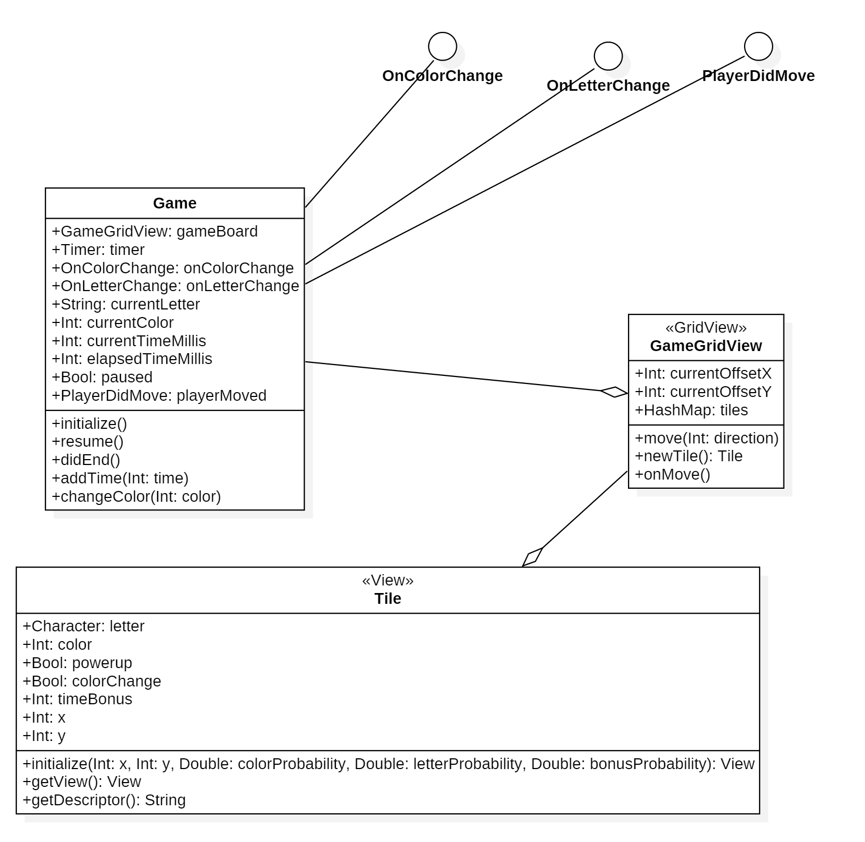There are three main classes in use in the Game Activity; the Game, GameGridView, and Tile. There are also three event callbacks that will be created, OnColorChange, OnLetterChange, and PlayerDidMove, which allow the classes to interact and receive events from the Game class. The callbacks are interfaces, because their implementation can change to fit the parent class’ needs. GameGridView is a subclass of GridView in Android, and Tile is a subclass of View.