Cory Cresswell

R10903006

ME3165-308

CFD Report

The purpose of this report is to determine how different variables affect a fluids velocity between two parallel plates. The major factors being changed is the magnitude and direction of a pressure gradient and the steps in-between the parallel plates. Also while determining the fluids velocity determine what these parameters do to the Reynolds number. Previous fluids knowledge tells one that an increase of magnitude on a pressure gradient will increase a fluids overall velocity. Any time the number of nodes being examined is increased the results found throughout the whole problem will be more precise. Due to the formula of the Reynolds number being directly proportional to the velocity of a fluid one can easily tell that the higher a fluids velocity gets the larger the number becomes. Throughout all these examples that will be shown below the velocity of the bottom plate is zero.

The first variable being examined is the pressure gradient. The first figure ( Figure#1) shows five different pressure gradients acting on a fluid while the top plate remains zero. While in the second figure (Figure #2) the velocity of the plate was changed to a magnitude of 100.

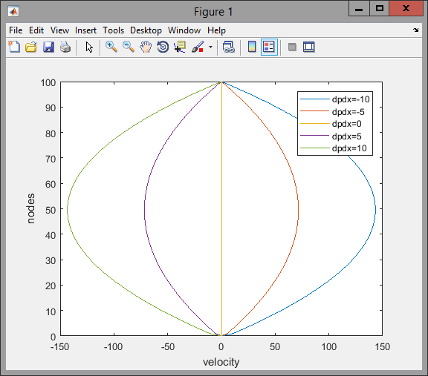

Figure #1

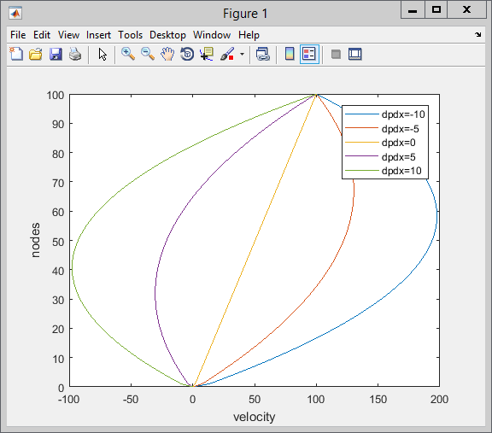  
 Figure #2

In the first figure we can see that the magnitude of the pressure gradient is in direct correlation with the magnitude of the velocity. The direction of the pressure gradient simply had the flow of the velocity flowing the other way. Maximum velocity occurs between the two plates where the velocity of the plates has the smallest influence. When the velocity of the top plate is non zero the flow of the velocity of the fluid either increases or decreases depending on the direction of the pressure gradient. If flow is moving left on the bottom of the plate but the top plate is moving right it would make sense that the negative flow will eventually come to equilibrium with the top flow. This would create a type of swirl motion in the fluid itself going from left to right.

As stated in the introduction common sense tells us that the more nodes between elements the more accurate and precise your numbers will become. Shown below are the changes in node numbers from 10, 50, 100, and 500. These will be shown by figures3-6 respectively.

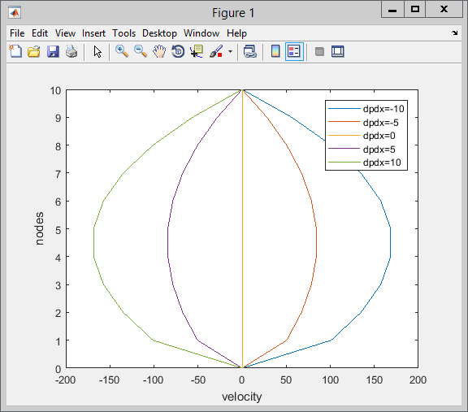

Figure#3

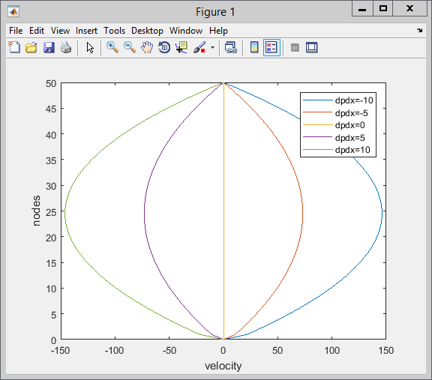

Figure#4

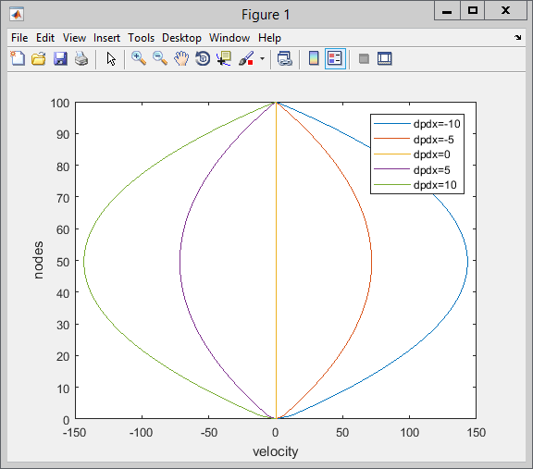

Figure #5

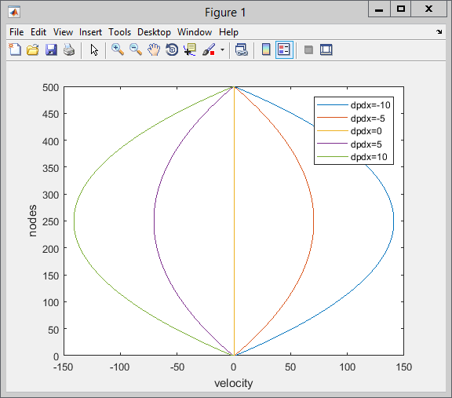

Figure #6

As seen above our original theory stands still. When less than 100 nodes was applied to the formula the lines of the graphs had jagged edges and data that was given was less than desired. However to many nodes could create a long computation time and the answer given by a smaller node count can be desired just as much as a higher node count. This idea can be seen demonstrated in figures 5 and 6 as there is no visual difference between the two.

Shown below is a table showing the Reynolds number at each of the 100 nodes. The desired number for laminar flow is between 1000 and 10000. Given the parameters of 1000 for density, a length of 0.001, and mu of 8.93E-3 the flow never gets turbulent for any of the pressure gradients. Clearly one can see the higher the velocity, middle of plates, the larger the Reynolds number becomes and the risk of turbulent flow increases. Parameters that can be easily changed to decrease the risk of turbulent flow are length of the system and the velocity of the fluid.

|  |  |  |  |  |
| --- | --- | --- | --- | --- |
| 0 | 0 | 0 | 0 | 0 |
| 1249.84219164246 | 624.921095821229 | 0 | -624.921095821229 | -1249.84219164246 |
| 1855.82628456001 | 927.913142280006 | 0 | -927.913142280006 | -1855.82628456001 |
| 2449.18570887512 | 1224.59285443756 | 0 | -1224.59285443756 | -2449.18570887512 |
| 3029.92046458777 | 1514.96023229389 | 0 | -1514.96023229389 | -3029.92046458777 |
| 3598.03055169798 | 1799.01527584899 | 0 | -1799.01527584899 | -3598.03055169798 |
| 4153.51597020574 | 2076.75798510287 | 0 | -2076.75798510287 | -4153.51597020574 |
| 4696.37672011105 | 2348.18836005552 | 0 | -2348.18836005552 | -4696.37672011105 |
| 5226.61280141391 | 2613.30640070695 | 0 | -2613.30640070695 | -5226.61280141391 |
| 5744.22421411432 | 2872.11210705716 | 0 | -2872.11210705716 | -5744.22421411432 |
| 6249.21095821228 | 3124.60547910614 | 0 | -3124.60547910614 | -6249.21095821228 |
| 6741.57303370779 | 3370.78651685389 | 0 | -3370.78651685389 | -6741.57303370779 |
| 7221.31044060085 | 3610.65522030043 | 0 | -3610.65522030043 | -7221.31044060085 |
| 7688.42317889146 | 3844.21158944573 | 0 | -3844.21158944573 | -7688.42317889146 |
| 8142.91124857963 | 4071.45562428981 | 0 | -4071.45562428981 | -8142.91124857963 |
| 8584.77464966534 | 4292.38732483267 | 0 | -4292.38732483267 | -8584.77464966534 |
| 9014.01338214861 | 4507.00669107430 | 0 | -4507.00669107430 | -9014.01338214861 |
| 9430.62744602942 | 4715.31372301471 | 0 | -4715.31372301471 | -9430.62744602942 |
| 9834.61684130779 | 4917.30842065390 | 0 | -4917.30842065390 | -9834.61684130779 |
| 10225.9815679837 | 5112.99078399186 | 0 | -5112.99078399186 | -10225.9815679837 |
| 10604.7216260572 | 5302.36081302859 | 0 | -5302.36081302859 | -10604.7216260572 |
| 10970.8370155282 | 5485.41850776410 | 0 | -5485.41850776410 | -10970.8370155282 |
| 11324.3277363968 | 5662.16386819839 | 0 | -5662.16386819839 | -11324.3277363968 |
| 11665.1937886629 | 5832.59689433146 | 0 | -5832.59689433146 | -11665.1937886629 |
| 11993.4351723266 | 5996.71758616330 | 0 | -5996.71758616330 | -11993.4351723266 |
| 12309.0518873878 | 6154.52594369391 | 0 | -6154.52594369391 | -12309.0518873878 |
| 12612.0439338466 | 6306.02196692330 | 0 | -6306.02196692330 | -12612.0439338466 |
| 12902.4113117029 | 6451.20565585146 | 0 | -6451.20565585146 | -12902.4113117029 |
| 13180.1540209568 | 6590.07701047840 | 0 | -6590.07701047840 | -13180.1540209568 |
| 13445.2720616082 | 6722.63603080412 | 0 | -6722.63603080412 | -13445.2720616082 |
| 13697.7654336572 | 6848.88271682861 | 0 | -6848.88271682861 | -13697.7654336572 |
| 13937.6341371038 | 6968.81706855188 | 0 | -6968.81706855188 | -13937.6341371038 |
| 14164.8781719478 | 7082.43908597392 | 0 | -7082.43908597392 | -14164.8781719478 |
| 14379.4975381895 | 7189.74876909474 | 0 | -7189.74876909474 | -14379.4975381895 |
| 14581.4922358287 | 7290.74611791434 | 0 | -7290.74611791434 | -14581.4922358287 |
| 14770.8622648654 | 7385.43113243271 | 0 | -7385.43113243271 | -14770.8622648654 |
| 14947.6076252997 | 7473.80381264985 | 0 | -7473.80381264985 | -14947.6076252997 |
| 15111.7283171315 | 7555.86415856577 | 0 | -7555.86415856577 | -15111.7283171315 |
| 15263.2243403609 | 7631.61217018047 | 0 | -7631.61217018047 | -15263.2243403609 |
| 15402.0956949879 | 7701.04784749394 | 0 | -7701.04784749394 | -15402.0956949879 |
| 15528.3423810124 | 7764.17119050619 | 0 | -7764.17119050619 | -15528.3423810124 |
| 15641.9643984344 | 7820.98219921721 | 0 | -7820.98219921721 | -15641.9643984344 |
| 15742.9617472540 | 7871.48087362701 | 0 | -7871.48087362701 | -15742.9617472540 |
| 15831.3344274712 | 7915.66721373559 | 0 | -7915.66721373559 | -15831.3344274712 |
| 15907.0824390859 | 7953.54121954294 | 0 | -7953.54121954294 | -15907.0824390859 |
| 15970.2057820981 | 7985.10289104906 | 0 | -7985.10289104906 | -15970.2057820981 |
| 16020.7044565079 | 8010.35222825396 | 0 | -8010.35222825396 | -16020.7044565079 |
| 16058.5784623153 | 8029.28923115764 | 0 | -8029.28923115764 | -16058.5784623153 |
| 16083.8277995202 | 8041.91389976009 | 0 | -8041.91389976009 | -16083.8277995202 |
| 16096.4524681226 | 8048.22623406131 | 0 | -8048.22623406131 | -16096.4524681226 |
| 16096.4524681226 | 8048.22623406131 | 0 | -8048.22623406131 | -16096.4524681226 |
| 16083.8277995202 | 8041.91389976009 | 0 | -8041.91389976009 | -16083.8277995202 |
| 16058.5784623153 | 8029.28923115765 | 0 | -8029.28923115765 | -16058.5784623153 |
| 16020.7044565080 | 8010.35222825398 | 0 | -8010.35222825398 | -16020.7044565080 |
| 15970.2057820982 | 7985.10289104908 | 0 | -7985.10289104908 | -15970.2057820982 |
| 15907.0824390859 | 7953.54121954296 | 0 | -7953.54121954296 | -15907.0824390859 |
| 15831.3344274712 | 7915.66721373561 | 0 | -7915.66721373561 | -15831.3344274712 |
| 15742.9617472541 | 7871.48087362704 | 0 | -7871.48087362704 | -15742.9617472541 |
| 15641.9643984345 | 7820.98219921724 | 0 | -7820.98219921724 | -15641.9643984345 |
| 15528.3423810124 | 7764.17119050622 | 0 | -7764.17119050622 | -15528.3423810124 |
| 15402.0956949879 | 7701.04784749397 | 0 | -7701.04784749397 | -15402.0956949879 |
| 15263.2243403610 | 7631.61217018050 | 0 | -7631.61217018050 | -15263.2243403610 |
| 15111.7283171316 | 7555.86415856581 | 0 | -7555.86415856581 | -15111.7283171316 |
| 14947.6076252998 | 7473.80381264988 | 0 | -7473.80381264988 | -14947.6076252998 |
| 14770.8622648655 | 7385.43113243274 | 0 | -7385.43113243274 | -14770.8622648655 |
| 14581.4922358287 | 7290.74611791437 | 0 | -7290.74611791437 | -14581.4922358287 |
| 14379.4975381896 | 7189.74876909478 | 0 | -7189.74876909478 | -14379.4975381896 |
| 14164.8781719479 | 7082.43908597396 | 0 | -7082.43908597396 | -14164.8781719479 |
| 13937.6341371038 | 6968.81706855192 | 0 | -6968.81706855192 | -13937.6341371038 |
| 13697.7654336573 | 6848.88271682865 | 0 | -6848.88271682865 | -13697.7654336573 |
| 13445.2720616083 | 6722.63603080416 | 0 | -6722.63603080416 | -13445.2720616083 |
| 13180.1540209569 | 6590.07701047844 | 0 | -6590.07701047844 | -13180.1540209569 |
| 12902.4113117030 | 6451.20565585150 | 0 | -6451.20565585150 | -12902.4113117030 |
| 12612.0439338467 | 6306.02196692334 | 0 | -6306.02196692334 | -12612.0439338467 |
| 12309.0518873879 | 6154.52594369395 | 0 | -6154.52594369395 | -12309.0518873879 |
| 11993.4351723267 | 5996.71758616333 | 0 | -5996.71758616333 | -11993.4351723267 |
| 11665.1937886630 | 5832.59689433149 | 0 | -5832.59689433149 | -11665.1937886630 |
| 11324.3277363969 | 5662.16386819843 | 0 | -5662.16386819843 | -11324.3277363969 |
| 10970.8370155283 | 5485.41850776414 | 0 | -5485.41850776414 | -10970.8370155283 |
| 10604.7216260573 | 5302.36081302863 | 0 | -5302.36081302863 | -10604.7216260573 |
| 10225.9815679838 | 5112.99078399189 | 0 | -5112.99078399189 | -10225.9815679838 |
| 9834.61684130786 | 4917.30842065393 | 0 | -4917.30842065393 | -9834.61684130786 |
| 9430.62744602948 | 4715.31372301474 | 0 | -4715.31372301474 | -9430.62744602948 |
| 9014.01338214866 | 4507.00669107433 | 0 | -4507.00669107433 | -9014.01338214866 |
| 8584.77464966539 | 4292.38732483270 | 0 | -4292.38732483270 | -8584.77464966539 |
| 8142.91124857967 | 4071.45562428984 | 0 | -4071.45562428984 | -8142.91124857967 |
| 7688.42317889150 | 3844.21158944575 | 0 | -3844.21158944575 | -7688.42317889150 |
| 7221.31044060088 | 3610.65522030044 | 0 | -3610.65522030044 | -7221.31044060088 |
| 6741.57303370782 | 3370.78651685391 | 0 | -3370.78651685391 | -6741.57303370782 |
| 6249.21095821230 | 3124.60547910615 | 0 | -3124.60547910615 | -6249.21095821230 |
| 5744.22421411434 | 2872.11210705717 | 0 | -2872.11210705717 | -5744.22421411434 |
| 5226.61280141393 | 2613.30640070696 | 0 | -2613.30640070696 | -5226.61280141393 |
| 4696.37672011107 | 2348.18836005553 | 0 | -2348.18836005553 | -4696.37672011107 |
| 4153.51597020575 | 2076.75798510288 | 0 | -2076.75798510288 | -4153.51597020575 |
| 3598.03055169799 | 1799.01527584900 | 0 | -1799.01527584900 | -3598.03055169799 |
| 3029.92046458779 | 1514.96023229389 | 0 | -1514.96023229389 | -3029.92046458779 |
| 2449.18570887513 | 1224.59285443756 | 0 | -1224.59285443756 | -2449.18570887513 |
| 1855.82628456002 | 927.913142280009 | 0 | -927.913142280009 | -1855.82628456002 |
| 1249.84219164246 | 624.921095821231 | 0 | -624.921095821231 | -1249.84219164246 |
| 631.233430122455 | 315.616715061228 | 0 | -315.616715061228 | -631.233430122455 |
| 0 | 0 | 0 | 0 | 0 |