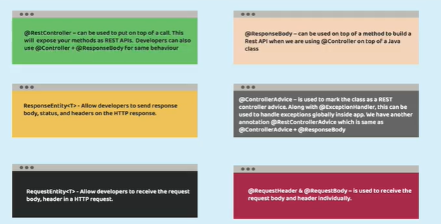

**Important Links**

* Spring Boot - <https://spring.io/projects/spring-boot>
* Create SpringBoot project - [https://start.spring.io](https://start.spring.io/)
* DTO pattern blog - <https://martinfowler.com/eaaCatalog/dataTransferObject.html>
* Model Mapper - <http://modelmapper.org/>
* Map Struct - <https://mapstruct.org/>
* Spring Doc - <https://springdoc.org/>
* Open API - <https://www.openapis.org/>
* Lucidchart Blog - <https://www.lucidchart.com/blog/ddd-event-storming>
* Docker website - [https://www.docker.com](https://www.docker.com/)
* Docker hub website - [https://hub.docker.com](https://hub.docker.com/)
* Buildpacks website - [https://buildpacks.io](https://buildpacks.io/)
* Google Jib website - <https://github.com/GoogleContainerTools/jib>
* Docker compose website - <https://docs.docker.com/compose/>
* Twelve-Factor methodology - [https://12factor.net](https://12factor.net/)
* Beyond the Twelve-Factor App book - <https://www.oreilly.com/library/view/beyond-the-twelve-factor/9781492042631/>
* Spring Cloud website - <https://spring.io/projects/spring-cloud>
* Spring Cloud Config website - <https://spring.io/projects/spring-cloud-config>
* Spring Cloud Bus website - <https://spring.io/projects/spring-cloud-bus>
* RabbitMQ website - [https://www.rabbitmq.com](https://www.rabbitmq.com/)
* Hookdeck website- [https://hookdeck.com](https://hookdeck.com/)
* Spring Cloud Netflix website - <https://spring.io/projects/spring-cloud-netflix>
* Spring Cloud OpenFeign - <https://spring.io/projects/spring-cloud-openfeign>
* Netflix Blog - <https://netflixtechblog.com/netflix-oss-and-spring-boot-coming-full-circle-4855947713a0>
* Resilience4j website - [https://resilience4j.readme.io](https://resilience4j.readme.io/)
* Spring Cloud Gateway website - <https://spring.io/projects/spring-cloud-gateway>
* Stripe RateLimitter pattern blog - <https://stripe.com/blog/rate-limiters>
* Apache Benchmark website - [https://httpd.apache.org](https://httpd.apache.org/)
* Grafana website - [https://grafana.com](https://grafana.com/)
* Grafana Loki setup - <https://grafana.com/docs/loki/latest/getting-started/>
* Micrometer website - [https://micrometer.io](https://micrometer.io/)
* Prometheus website - <https://prometheus.io/>
* Grafana Dashboards - <https://grafana.com/grafana/dashboards/>
* OpenTelemetry website - <https://opentelemetry.io/>
* OpenTelemetry automatic instrumentation - <https://opentelemetry.io/docs/instrumentation/java/automatic/>
* Keycloak website - <https://www.keycloak.org/>
* Apache Kafka website - [https://kafka.apache.org](https://kafka.apache.org/)
* Docker compose file for Kafka - <https://github.com/bitnami/containers/blob/main/bitnami/kafka/docker-compose.yml>
* Local Kubernetes Cluster with Docker Desktop - <https://docs.docker.com/desktop/kubernetes/>
* Kubernetes Dashboard - <https://kubernetes.io/docs/tasks/access-application-cluster/web-ui-dashboard/>
* Helm website - [https://helm.sh](https://helm.sh/)
* Chocolatey website - <https://chocolatey.org/>
* Bitnami Helm charts GitHub repo - <https://github.com/bitnami/charts>
* Spring Cloud Kubernetes website - <https://spring.io/projects/spring-cloud-kubernetes>
* Spring Cloud Kubernetes Blog - <https://spring.io/blog/2021/10/26/new-features-for-spring-cloud-kubernetes-in-spring-cloud-2021-0-0-m3>
* GCP website - [https://cloud.google.com](https://cloud.google.com/)
* GCP SDK installation - <https://cloud.google.com/sdk/docs/install>
* Kubernetes Ingress - <https://kubernetes.io/docs/concepts/services-networking/ingress/>
* Ingress Controllers - <https://kubernetes.io/docs/concepts/services-networking/ingress-controllers/>
* Istio (Service mesh) - [https://istio.io](https://istio.io/)

**Maven Commands used in the course**

| **Maven Command** | **Description** |
| --- | --- |
| "mvn clean install -Dmaven.test.skip=true" | To generate a jar inside target folder |
| "mvn spring-boot:run" | To start a springboot maven project |
| "mvn spring-boot:build-image" | To generate a docker image using Buildpacks. No need of Dockerfile |
| "mvn compile jib:dockerBuild" | To generate a docker image using Google Jib. No need of Dockerfile |