The Audicle: A Context-Sensitive, On-the-fly

Audio Programming Environ/mentality

Ge Wang and †Perry R. Cook

Computer Science Department, †(Also Music)
Princeton University
{gewang,prc}@cs.princeton.edu

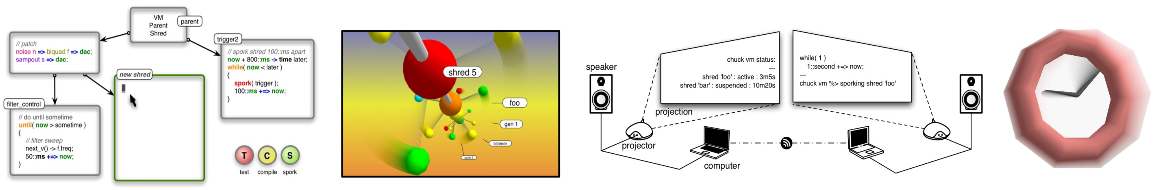
Figure 0. Some things associated with an Audicle.

Abstract
Many software environments have been developed for computer music. Programming environments typically provide constructs to implement synthesis or musical algorithms, whereas runtime environments allow performers to exert parametric control over their programs onstage, in real-time. We present a new type of audio programming environment that integrates the programmability of the development environment with elements of the runtime environment. The result, called the Audicle, is a novel integration of a concurrent “smart” editor, compiler, virtual machine, and debugger, all running in the same address space, sharing data, and working together at runtime. We believe this augmentation has the potential to fundamentally enhance the way we write and visualize audio programs both offline and on-the-fly.
In this paper, we examine existing programming and runtime environments, present the ideas behind the Audicle, and demonstrate its features and properties. Our model of the Audicle is integrated with the ChucK programming language and inherits many of its fundamental properties, including: decoupling of data-flow and time, concurrency, and modularity for on-the-fly programming. We discuss the main components of the Audicle, and show that it not only provides a useful class of programming tools for real-time composition and performances, but also motivates a new type of on-the-fly programming aesthetic – one of visualizing the audio programming process.

Introduction
Software environments play a pivotal role in the creation and performance of computer music. Programming environments provide the setting to design/implement synthesis and compositional algorithms. Runtime environments realize and render these algorithms into sound (and images), and allow performers to interact with the system, often in real-time. In this work, we present a new type of audio programming environment, called the Audicle, which combines the programmability of programming environments and the immediate feedback of runtime environments. The Audicle is an integration of "smart" concurrent editor, compiler, virtual machine, and visualizations – all operating in a single on-the-fly environment. This has the potential to fundamentally enhance the way we write, visualize, and interact with audio programs.
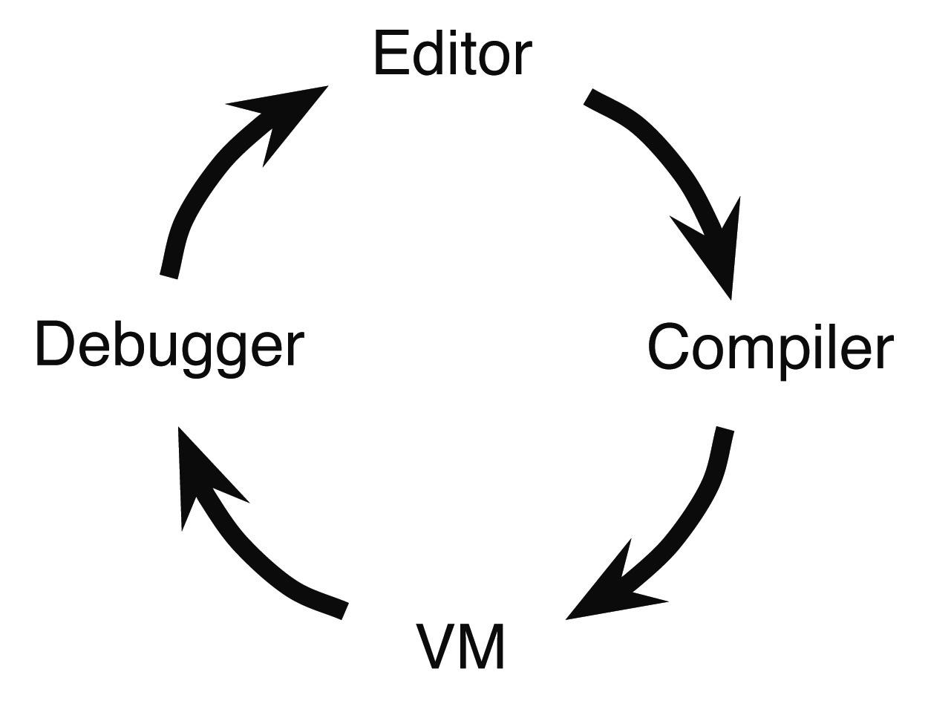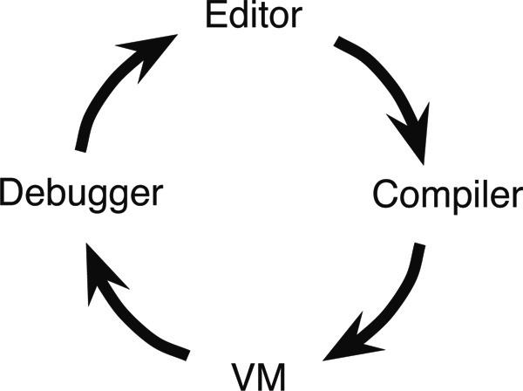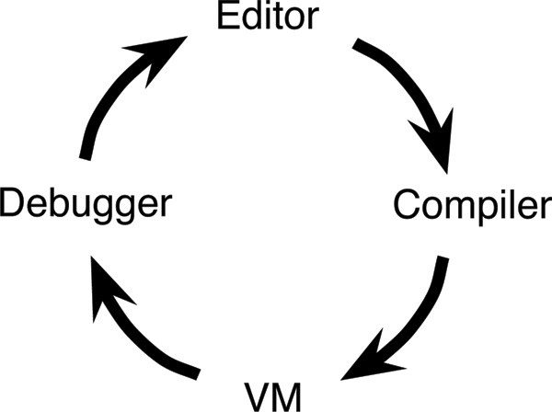
Figure 1. Completing the loop. The Audicle bridges runtime and development by integrating elements of both.
The Audicle differs from traditional environments in the following ways. Conceptually, it brings the editor and compiler into the runtime environment (Figure 1), which allows a fundamentally greater level of interactivity in the programming process. Secondly, it is tightly coupled with a programming language – in this case, ChucK, a concurrent and on-the-fly synthesis language (Wang and Cook, 2003). This coupling is advantageous because it leverages and enhances the desirable ChucK properties of precise timing and concurrency. This is different from systems like Max and Pure Data, where the environment essentially is the language. ChucK is fully functional by itself – the Audicle aims to complement the language and enhances the ability to rapidly develop and visualize programs both offline and on-the-fly. Thirdly, the Audicle embodies the aesthetic and mentality of visualizing the process of programming and the state of the runtime system.
This paper is organized as follows. In Section 2, we present the goals of the Audicle and also examine the background of existing programming and runtime environments (both audio and non-audio). The Audicle’s runtime compiler, virtual machine, and much of the concurrent editor semantics are based on our earlier work with ChucK and on-the-fly programming. In Section 3, we overview the key features and properties of ChucK, as well as the challenges of on-the-fly programming as they pertain to the Audicle. In Section 4, we present the design of the Audicle, introduce the Audicube, and discuss its properties and implementation. In Section 5, we address how these ideas motivate a new kind of on-the-fly programming aesthetic, and discuss future work.

Background

Goals of the Audicle
A simple but important question to answer is: why investigate the programming environment? We believe that the programming language and the environment it is used with fundamentally influence how we think about and write programs. ChucK provided a new way of reasoning about time, data-flow, and concurrency in a programming language. The Audicle is designed to enhance and complement these features, and make them more accessible, faster, and perhaps more enjoyable to use.
Context-sensitive. The goal of the editor is to allow concurrent code to be clearly entered and represented. Also, it should have knowledge of the deep structure of the program and runtime information (such as program state and profiling hints) – and use this information to aid the programmer to more easily write code. We call this a concurrent, “smart” editor.
On-the-fly. On-the-fly programming is the practice of coding at runtime – while the program is running. The Audicle aims to complete the development/runtime loop by bringing the editor and compiler to the virtual machine, and vice versa. By making them accessible to each other, new and faster interfaces and paradigms for runtime audio programming may emerge.
Different views. Having different views of the same program can be very useful to writing and fine-tuning code. The Audicle should allow a program to be viewed and manipulated in many ways: as concurrent code, syntactic/semantic representations, or timing and synchronizations. Additionally, the Audicle is an observation or visualization of the process of on-the-fly programming, giving it the potential to be a useful, general-purpose performance or educational tool.
Minimal. The Audicle provides a minimal interface, and rely on the underlying interactions of the language and the multiple viewing models to achieve a great deal of expressiveness and power, without imposing a particular programming style.

Existing Environments
An environment, in the context of this investigation, is defined as a comprehensive software setting in which programming and/or runtime control is carried out and/or facilitated. There have been many environments developed for programming, performance, and composition, as well as several environments not specifically intended for audio and music that are also useful to examine.
Programming environments provide a setting to write and edit programs at development time, and often include a compiler and debugger. Examples include graphical environments such as Max (Puckette, 1991) and Pure Data (Puckette, 1996), integrated development environments (IDE’s) for text-based languages such as Java, C/C++, Nyquist (Dannenberg, 1997), and SuperCollider (McCartney, 1996), and software frameworks such as Ptolemy (Lee et al. 2003). These environments allow code, flow graphs, and other programming constructs to be entered, compiled, and run (in separate phases).
Runtime environments, on the other hand, provide an engine and a related set of interface elements for manipulating parameters at runtime (and often in real-time). The graphical front-ends of Max, as well as Real-Time CSOUND (Vercoe, 1990), Aura (Dannenberg and Brandt, 1996), and more recently, Soundium 2 (Schubiger and Muller, 2003) are good examples of runtime environments. These environments compute audio in real-time, taking in data from input devices and UI elements, and may also display graphical or video feedback.
On-the-fly environments possess elements of both programming and runtime systems – and most importantly, the runtime capability to modify the structure and logic of the executing program itself. Several existing environments possess varying degrees of on-the-fly capabilities. Max and Pd give programmers limited ability to change their patches at runtime. The SuperCollider programming environment allows for synthesis patches to be sent and added to a server in real-time. Another interesting system for runtime graphical and virtual-reality programming is Alice (Pausch et. al. 1995), which allows users to create a virtual world, and to add and modify behaviors using a high-level scripting language (Python in this case) on-the-fly. This rapid-prototyping graphical environment is notable for having no hard distinction between development and runtime. Similarly, MATLAB (Mathworks), while not intended as a real-time programming tool, has a command line that directly uses statements from the language and embodies a similar immediate run aesthetic. However, many existing environments lack a unified timing framework.

ChucK + On-the-fly Programming
The Audicle is based on our previous work with the ChucK programming language and on-the-fly programming. ChucK’s timed-concurrency model and our operational semantics for on-the-fly programming help form the foundation for the Audicle. In this section, we overview the features of ChucK (we do not discuss detailed implementation here) and the semantics of on-the-fly programming that are pertinent to the Audicle.

ChucK
ChucK is a strongly-timed, concurrent, on-the-fly audio programming language (Wang and Cook, 2003). It is not based on a single existing language but is built from the ground up. ChucK code is type-checked, emitted over a special virtual instruction set, and run in a virtual machine with a native audio engine and a user-level scheduler. The following ChucK features and properties are pertinent to the Audicle:
- A straightforward way to connect data-flow / unit generators.
- A sample-synchronous timing mechanism that provides a consistent, unified view and control of time – embedded directly in the program flow. Time is decoupled from data-flow.
- A cooperative multi-tasking, concurrent programming model based on time that allows programmers to add concurrency easily and scalably. Synchronization is accurately and automatically derived from the timing mechanism.
- Multiple, simultaneous, arbitrary, and dynamically programmable control rates via timing and concurrency.
- A compiler and virtual machine that run in the same process, both accessible from within the language.
ChucK’s programming model addresses several problems in computer music programming: representation, level of control for data-flow and time, and concurrency. We summarize the features and properties of ChucK in the context of these areas. In doing so, we lay the foundation for describing the semantics of on-the-fly programming and the Audicle.
Representation. At the heart of the syntax is the ChucK operator: a group of related operators (=>, ->) that denote interconnection and direction of data-flow. A unit generator (ugen) patch can be quickly and clearly constructed by using => to connect ugen’s in a left-to-right manner (Figure 2). Unit generators logically compute one sample at a time. Parameters to the unit generators can also be modified using =>. By default, => deals only with data-flow (and control data), leaving time to the ChucK timing mechanism.
White
Noise
BiQuad
Filter

DAC

(a)
noise n => biquad f => dac;
(b)
Figure 2. (a) A noise-filter patch using three unit generators. (b) ChucK statement representing the patch. dac is the global sound output variable.
Levels of Control. In the context of audio programming, we are concerned not only with control over data but also over time. The latter deals with control and audio rates, and the manner in which time is reasoned about in the language. In ChucK, the key to having a flexible level of control lies in the timing mechanism, which consists of two parts. First, time (time) and duration (dur) are native types in the language. Time refers to a point in time, whereas duration is a finite amount of time. Basic duration variables are provided by default: samp (the duration between successive samples), ms (millisecond), second, minute, hour, day, and week. Additional durations (and times) can be inductively constructed by performing arithmetic on existing time and duration values.
Secondly, there is a special keyword now (of type time) that holds the current ChucK time, which starts from 0 (at the beginning of the program execution). now is the key to reasoning about and manipulating time in ChucK. Programs can read the globally consistent ChucK time by reading the value of now. Also, assigning time values or adding duration values to now causes time to advance. As an important side-effect, this operation causes the current process to block (allowing audio to compute) until now actually reaches the desired point in time. (Figure 3)
// construct a unit generator patch
noise n => biquad f => dac;

// loop: update biquad every 100 ms
while( true ) {
// sweep biquad center frequency
200 + 400 * math.sin(now*FC) => f.freq;

// advance time by 100 ms
100::ms +=> now;
}
Figure 3. A control loop. The => ChucK operator is used to change a filter’s center frequency. The last line in the loop causes time to advance by 100 milliseconds – this can be thought of as the control rate.
The mechanism provides a consistent, sample-synchronous view of time and embeds timing control directly in the code. This formal correspondence between timing and code makes programs easier to write and maintain, and fulfills several properties (i.e. deterministic order of computation) – therefore, ChucK is said to be strongly-timed. Furthermore, data-flow is decoupled from time, and control rates are fully throttled by the programmer. Audio rates, control rates, and high-level musical timing are unified under the same mechanism.
Concurrent Audio Programming. The intuitive goal of concurrent audio programming is straightforward: to write concurrent code that shares data as well as time (Figure 4).

impulse i => biquad f => dac;
while( true )
{
// impulse train
1.0 => i.value;
// advance time
50::samp +=>now;
}
while( true )
{
// sweep
next_f() =>
f.freq;
80:ms +=> now;
}
while( true )
{
// poll
sensor[8]
=> listener;
.5::second+=>now;
}

Figure 4. Unit generator patch with three concurrent paths of execution at different control rates (from left to right, control period = 50 samples, 80 millisecond, 1/2 second)
ChucK introduced the concepts of shreds and the shreduler. A shred is a concurrent entity like a thread. But unlike threads, a shred is a deterministic shred of computation, synchronized by time. Each of the concurrent paths of execution in Figure 4 can be realized by a shred. They can reside in separate source files or be dynamically spawned (sporked) from a parent shred.
The key insight to understanding concurrency in ChucK is that shreds are automatically synchronized by time. Two independent shreds can execute with precise timing relative to each other and to the virtual machine, without any knowledge of each other. This is a powerful mechanism for specifying and reasoning about time locally and globally.
This semantic resembles, and yet diverges from concurrency models found in languages such as Formula (Anderson and Kuivila, 1991), Nyquist, and SuperCollider. At the lowest level, Chuck’s timing/concurrency model is fully deterministic and data-driven (by samples or any other granularity), and is not tightly coupled with any a priori model (such as musical constructs in Formula). ChucK provides a fundamentally expressive programming model in the sense that timing control is embedded directly in the program flow (instead of only as parameters or events, as in the above languages), enabling precise timing control over the computational stream itself.

On-the-fly Programming
On-the-fly programming is the practice of adding or modifying code at runtime and presents several challenges that include modularity, timing, manageability, and flexibility (Wang and Cook, 2004). Our previous work described a formal on-the-fly programming model based on the timing and concurrency of ChucK and included both an external and an internal semantic, as well as an on-the-fly performance aesthetic (Figure 5). The external interface uses shreds to provide modularity. The internal semantic provides a means to precisely synchronize the shreds using the timing mechanism. The Audicle both leverages this model and facilitates its usage.
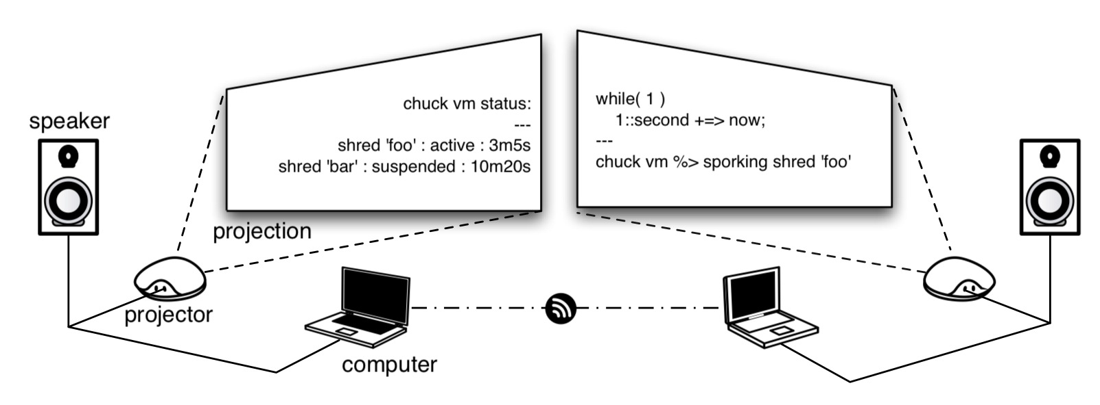
Figure 5. An instance of the on-the-fly performance aesthetic. Each computer is projected at runtime, allowing for the programming process to be visually communicated to the audience, constructing a live correspondence of the intentions to the outcome.
External Interface. The on-the-fly programming model, at the high-level, can be described in the following way. A ChucK virtual machine begins execution, generating samples (as necessary), keeping time, and waiting for incoming shreds. A new shred can be assimilated on-the-fly into the virtual machine, sharing the memory address space, the global timing mechanism, and is said to be active. Similarly, an active shred can be dissimilated (removed from the virtual machine), suspended, or replaced by another shred. This interface is designed to be simple, and delegates the actual timing and synchronization logic to the code within the shred.
The high level commands to the external interface are listed below. They can be invoked on the command-line, in ChucK programs (as functions calls to the machine and compiler objects), over the network, or – as we will see in Section 4 – using the Audicle.
- Execute – starts a new instance of a virtual machine in a new address space (in an infinite time-loop).
- Add – type-checks, compiles, and sporks a new shred (from ChucK source file, a string containing ChucK code, or a pre-compiled shred).
- Remove – removes a shred by ID from the virtual machine.
- Suspend – suspends and places a shred on the shredulers’s suspended list.
- Resume – resumes a suspended shred. The shred will begin execution at the suspended point in the code.
- Replace – invokes remove followed by an add.
- Status – queries the virtual machine for the following information: (1) a list of active shred ID's, source, and duration since assimilation (spork time), (2) VM state: current shreduler timeline, CPU usage, synthesis resources.
As an example, Figure 6 shows code that adds a new shred from file to the virtual machine using two different methods.
# add foo.ck (a VM should be listening already)
shell%> chuck --add foo.ck
(a)
// compile shred from file "foo.ck"
compiler.compile( “foo.ck” ) => code foo;
// advance time by 500 milliseconds
500::ms +=> now;
// spork "foo"
machine.spork( foo ) => shred s_foo;
(b)
Figure 6. Two examples of using the runtime shred management interface: (a) from a command-line shell, (b) from within a shred, which has precise timing control.
Internal Semantics. The internal semantics of our on-the-fly model deal with the issue of precise timing and synchronization between on-the-fly modules (shreds). In our model, the semantics are natural extensions of the ChucK timing mechanism. By querying and manipulating time using the special variable now, the programmer can determine the current time, and specify how the code should respond. By the properties of ChucK timing and concurrency: (1) now always holds the current ChucK time. (2) Changing the value of now advances time and has the side effect of blocking the current shred (allowing audio and other shreds to compute) until now “reaches” the desired time. (3) If t is of type time, t => now advances time until t equals now. (4) If d is a duration, d +=> now advances time by d. Examples of time-synchronization:
- Let time pass for some duration (in this case 10 seconds)
now + 10::second => now;
// or simply:
10::second +=> now;
- Synchronize to some absolute time t
t => now;
- Synchronize to some absolute time t (or after)
if( t < now ) t => now;
- Synchronize to the beginning of next period of duration T
120::ms => dur T; // period to synchronize to
T – (now % T) +=> now; // advance time by remainder
- Synchronize to the beginning of next period, plus offset D
T – (now % T) + D +=> now;
- Start as soon as possible
// no code necessary

The Audicle
The Audicle is a graphical, on-the-fly audio programming environment. It is based on the semantics of on-the-fly programming and ChucK’s strongly-timed concurrency model. This powerful feature of the language is extended in the Audicle in that concurrency is also visualized. Thus, the Audicle’s graphical aesthetic is given significant consideration in the design: it is to be visually bold, colorful, and open to customization. It aims to provide an orthogonal set of tools and visualizations that can be combined into more complex configurations and usages. Much of the information is conveyed by 3D shapes, which can be viewed from virtually any viewpoint or distance. The Audicle is rendered exclusively using 3D graphics (no external windowing system is involved), running in full-screen or windowed mode. We present its design and properties (Sections 4.1 and 4.2) and discuss its implementation (Section 4.3). We show that the Audicle is capable of achieving expressive, high-quality audio synthesis in combination with high-performance visualizations.

Design of the Audicle
In the Audicle, there is no distinction between development and runtime: all components are fully accessible at runtime. This integration is based on the ChucK compiler and virtual machine – augmented with a smart editor and interfaces for viewing/manipulating concurrency, timing, and system state. The design philosophy is one of runtime cohesion of phases and visualizations of system state.
As in ChucK, data-flow and time are fundamentally decoupled, leading to more expressive and clearer audio programs. Also, the Audicle’s architecture is based on a decoupled simulation model for virtual reality (Shaw et. al, 1992). In this model, the simulation can operate at an arbitrary rate independent of the graphics rendering-rate, leading to smoother graphics and more flexibility in the simulation algorithms. In the Audicle, audio synthesis, graphics, and simulation are loosely-coupled, with the highest priority given to audio computations and the virtual machine.
Out of the desire to provide a simple, “graspable” virtual environment and interface, we associate the Audicle with a simple geometric shape. The various parts of the Audicle are mapped and displayed on the faces of a virtual cube, called the Audicube (Figure 7a). At any time, the user can interact with one face, and have the ability to move to others faces by using hotkeys (USER_KEY+[up|down|left|right|face#]), graphical interface, Audicle shell commands (%> face 4 -or- %> face shredder), or even ChucK statements (audicle.face(4);).
There is a slim command-line console (Figure 7b) that can be invoked to appear over the currently active face. The console resembles that of MATLAB, where statements of the underlying language can be entered directly on the command-line. The key difference is that the Audicle console also has a strong notion of time. For example, it is possible to write a console command that loops and fires off N number of shreds, 100ms apart (see example in Figure 7b). Indeed, the Audicle console itself is a powerful on-the-fly programming tool.
On the Audicube, there are 5 primary faces plus one blank tabula rasa face for real-time graphics or for use as an audio/visual scratchpad. These faces are listed below and discussed in detail in Section 4.2.
- Concurrent Editor – “smart” editor interface
- Compiler-space – deep structure of the program
- VM-space – system resource and I/O management
- The Shredder – shred and concurrency management
- Time and Timing (TnT) – time management
- Tabula Rasa – blank slate (“anything goes here”)
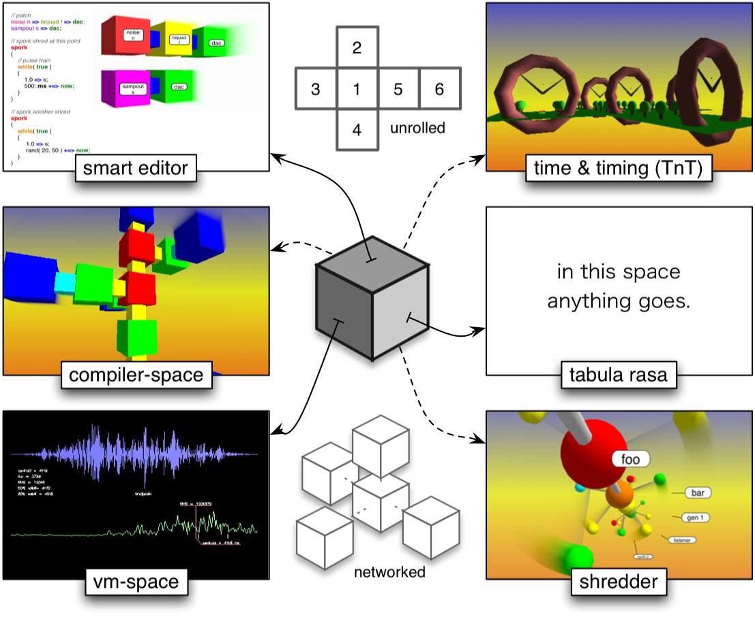
(a)
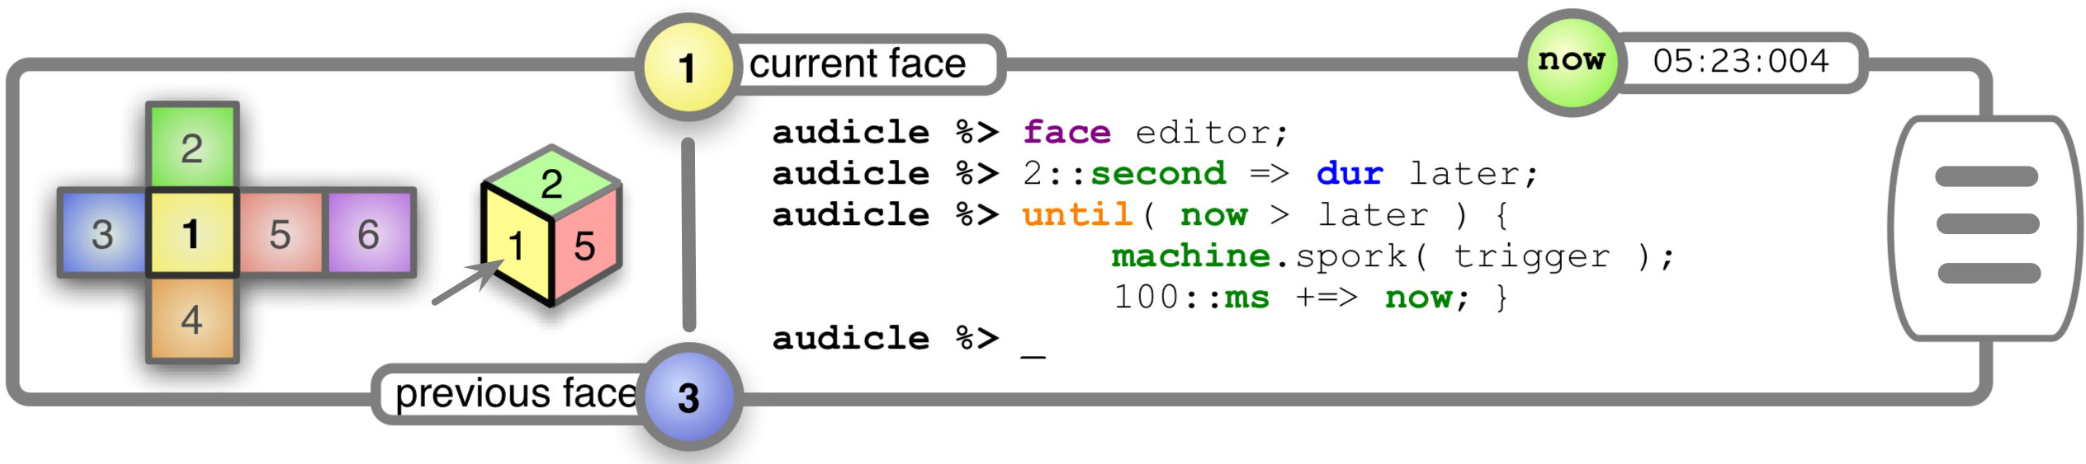
(b)
Figure 7. (a) Faces of the Audicube. The ‘cube can be “unrolled”, or “stacked” into a networked configuration. The six faces are shown on the two sides. (b) Audicle Console. The interface (left) can be used to graphically navigate the Audicube. The on-the-fly command prompt (right) accepts ChucK statements and Audicle commands (built using ChucK macros).
Additionally, the Audicle is designed to be a networked, collaborative development and performance environment. The simplest type of collaboration involves several Audiclae connected over a network sharing a central virtual machine for audio synthesis and computation. In this scheme, precise timing can be preserved. For example, each Audicle can send pieces of ChucK code over TCP/IP to be compiled and executed on a central Audicle, with precise timing embedded within the code. Concurrency provides modularity and organization, while the timing mechanism ensures that all modules can operate together with correct timing and other synchronizations (i.e. asynchronous events). As part of future work, we will investigate more complex Audiclae topologies.

Faces of the Audicube
Concurrent Editor. The editor is the primary interface to enter/edit code (an alternative is the console). It is on-the-fly – new code can be written and assimilated while existing code is running in the virtual machine. The editor is also concurrent, allowing programmers to create both serial and parallel code blocks by constructing a flow-graph of code (Figure 9a). A new concurrent shred can be introduced by adding a code block. Directed edges in the graph determine the parent/child relationship between concurrent code blocks. Furthermore, blocks can also be named and reused.
There is an one-to-one correspondence between concurrent ChucK code and the flow graph – the edges in the graph map to spork statements in ChucK, allowing for any ChucK program to be uniquely represented as code or as a graph. Also, the editor automatically visualizes ChucK statements using simple objects (Figure 9b). The result is a 3-dimensional, Max/Pd-like sub-environment with a very important underlying difference: this visualization only displays data-flow, leaving time to be dealt with separately in the code using ChucK’s timing mechanism, again separating data and time.
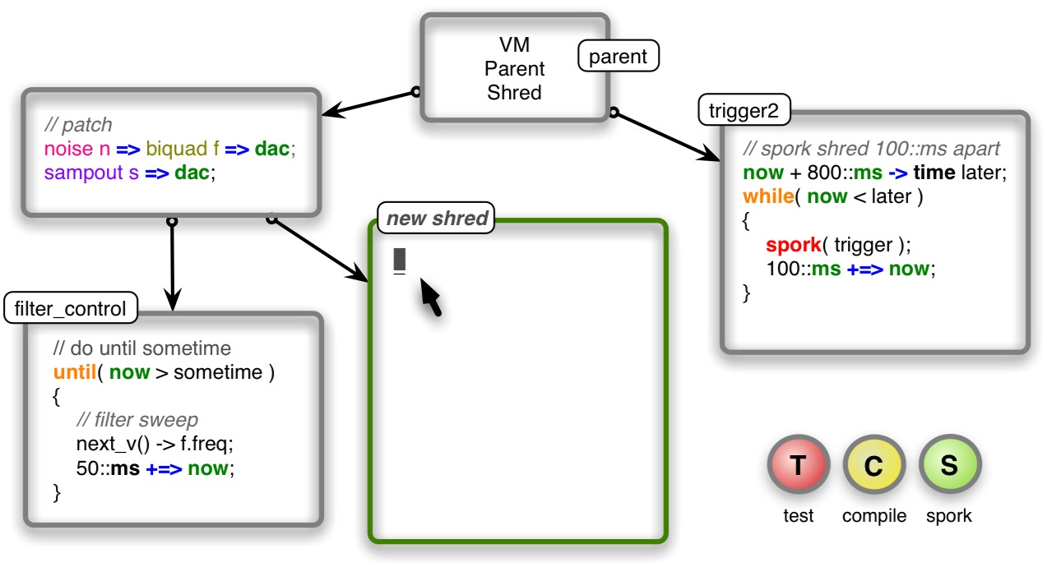
(a)
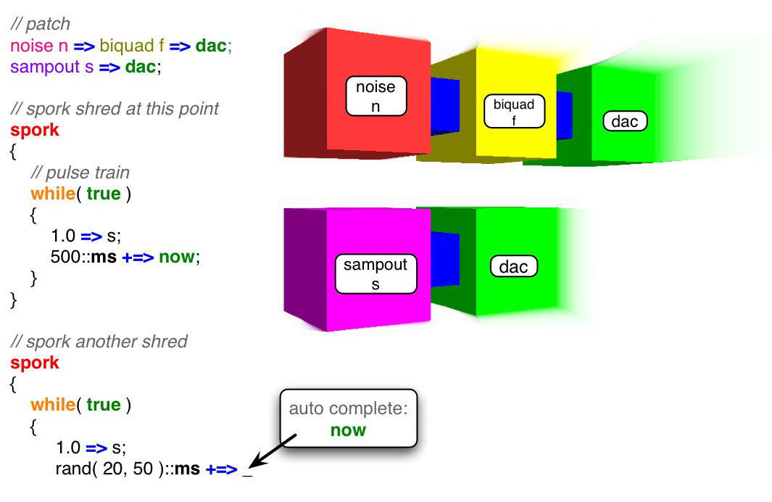
(b)
Figure 8. Concurrent Editor. (a) The editor allows the programmer to construct flow-graphs of concurrent code. Arrows represent sporking of new shreds. Code can be on-the-fly edited, tested, compiled, and sporked using the editor or the console. (b) ChucK code is entered (left). In the same space, parts of the program structure are visualized. In this example, the two simple patches (left top) are automatically represented by similarly-colored objects (right).
The editor is "smart" in several senses. First, it has access to the deep structure of the existing ChucK program, including type and timing information, in addition to results gathered from live background processing. The editor can use this information to suggest potential statement completions (class members, arguments, etc.). This is similar to features in existing commercial integrated development environments (IDE’s) such as Microsoft Visual Studio. Also, the editor serves an important ChucK-specific task – that of assisting resolutions of the massively-overloaded ChucK operator.
Second, since ChucK programs are type-checked and emitted into virtual ChucK instructions, the editor can serve as an “on-the-fly debugger”. It is possible to halt the program at any instruction and change the code before or after it.
Finally, there are various options for running and testing the code. (One useful option is to “test-run” the code in a protected “sandbox” environment) These can be accessed via the graphical interface buttons, keyboard shortcuts, or through the Audicle console.
Compiler-space. The compiler-space face of the Audicle allows viewing of the deep structure of the program gathered during compilation. Many aspects of the program structure can be visualized here. The syntax tree, with typing annotations is available for all code segments. One can see the ChucK virtual instructions emitted from a piece of code. Also, the user can examine global variables, or select a shred (from the console or the Shredder) and examine values of local variables during runtime. It is possible to traverse the compiler-space in 3D and to select code segments to be displayed in the editor.
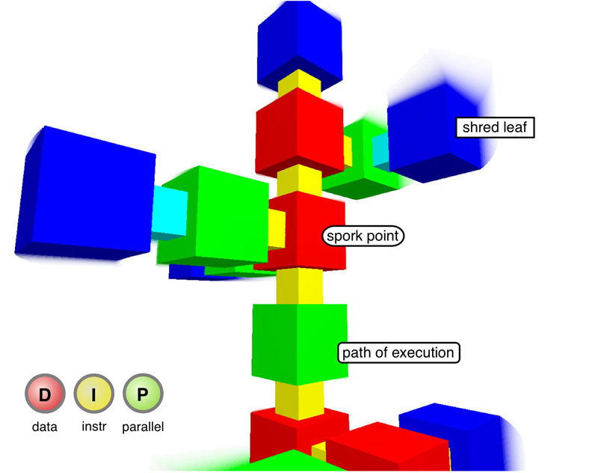
Figure 9. Compiler-space Explorer. In this example, the real-time shred-sporking pattern for a code segment is shown, with red objects representing points in the code where shreds were sporked, and blue and green representing paths of execution. The structure grows dynamically. Clicking on the objects invokes appropriate actions (viewing code or switching to another face).
The Shredder. The Shredder visualizes and manages shreds and concurrency. While it is possible to do this from within the language or via the console, the Shredder provides a more straightforward (and often more timely) interface to add/remove/modify shreds. The Shredder operations can also be mapped to input devices, allowing shreds to be managed with minimal typing and other user-introduced latency.
Programmers can view all the shreds in the virtual machine using a text-based list and/or a graphical tree-view (Figure 10). Because code can generate code or originate from other Audiclae, the shreds in the Shredder are identified as local, generated, or remote. Additionally, shred id/name, creation time, number of cycles computed, number of context switches, and state (active, suspended) are available for each shred.
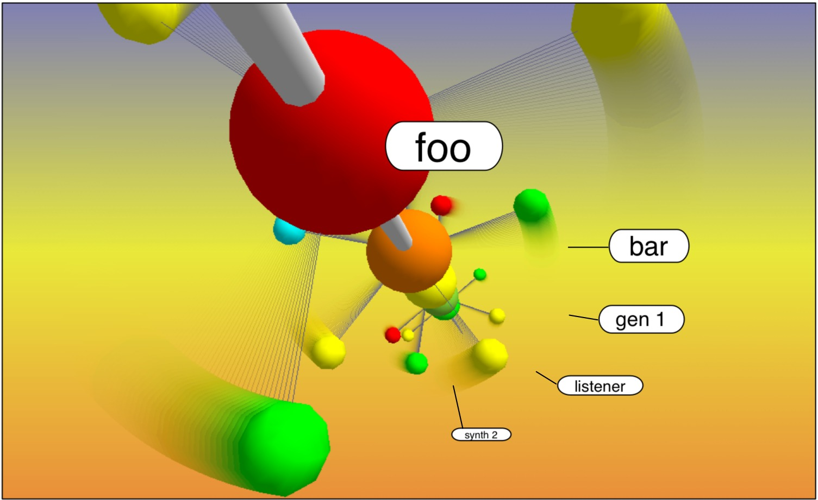
(a)
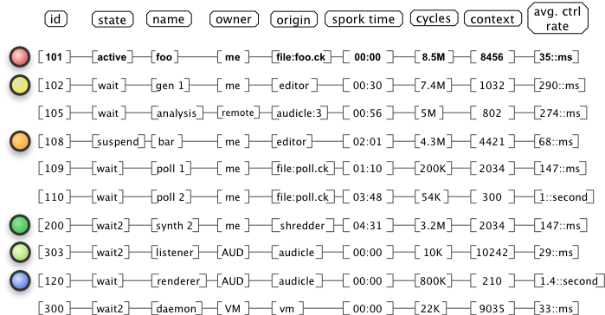
(b)
Figure 10. The Shredder. (a) Visualization of shred activity. Larger spheres are parent shreds. The smaller child shreds “orbit” the parents at a rate proportional to their current average control rate. The names refer to the parents. (b) On-the-fly timetable of shreds in the virtual machine.
An important use of this mechanism is to monitor and manage currently executing shreds, and to identify hanging or non-cooperative shreds. For example, if the system runs a shred containing an infinite loop, it will fail to yield and cause the virtual machine execution unit to hang indefinitely. This type of behavior can never be reliably detected at compile time (the Halting Problem). However, the on-the-fly programmer can identify and remove misbehaving shreds from the virtual machine manually by suspending them in the Shredder (and potentially debugging them immediately in the editor), resulting in minimal interruption to the session. While this recovery mechanism is far from perfect, it is far more advantageous over killing the system and restarting. Similarly, it can help the programmer optimize the system by identifying shreds that are consuming too much CPU time.
Time and Timing (TnT). This face is a visualization of shreduling at runtime. It is like an electrocardiogram (EKG). Parallel lines, representing active shreds, move along in ChucK system time. The nature of the time-based concurrency in ChucK implies that shreds only compute at discrete points in time, and must explicitly allow time to advance. When a shred computes, a spike is displayed on the corresponding line. The height of the spike is mapped to some measure of resources consumption (such as computation cycles). (Figure 11)
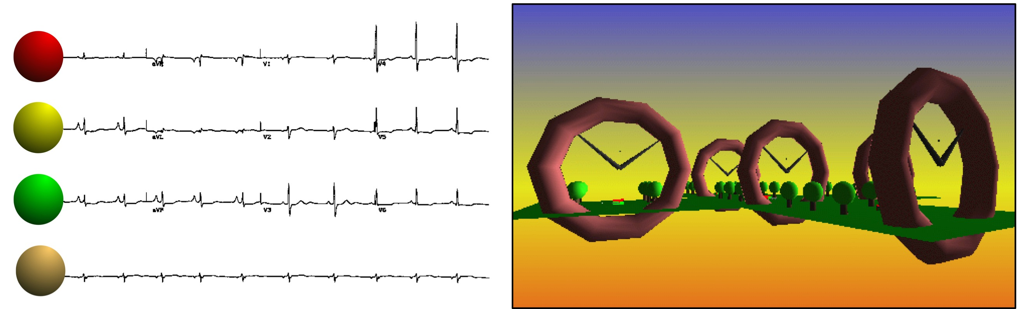
Figure 11. (left) EKG of the shreds. Spike height is a quick estimate of computations per execution in time. (right) Clock array visualization of average shred control rates.
This visualization presents a way to gain a high-level glance at the overall timing behavior. For example, it is easy to see how frequently each part of the system is computing (an effective view of relative control rates) and gain a rough idea of resources used as a function of time.
VM-space. The VM-space contains useful (or interesting) runtime information and statistics about the Audicle and the virtual machine. It is responsible for management of input devices, interface protocols (MIDI, OSC, SKINI), dynamic linking, and network connectivity (including establishing connections with remote Audiclae). Additionally, CPU load, unit generator resources, and analysis output (such as FFT and audio feature extraction), can be displayed here.
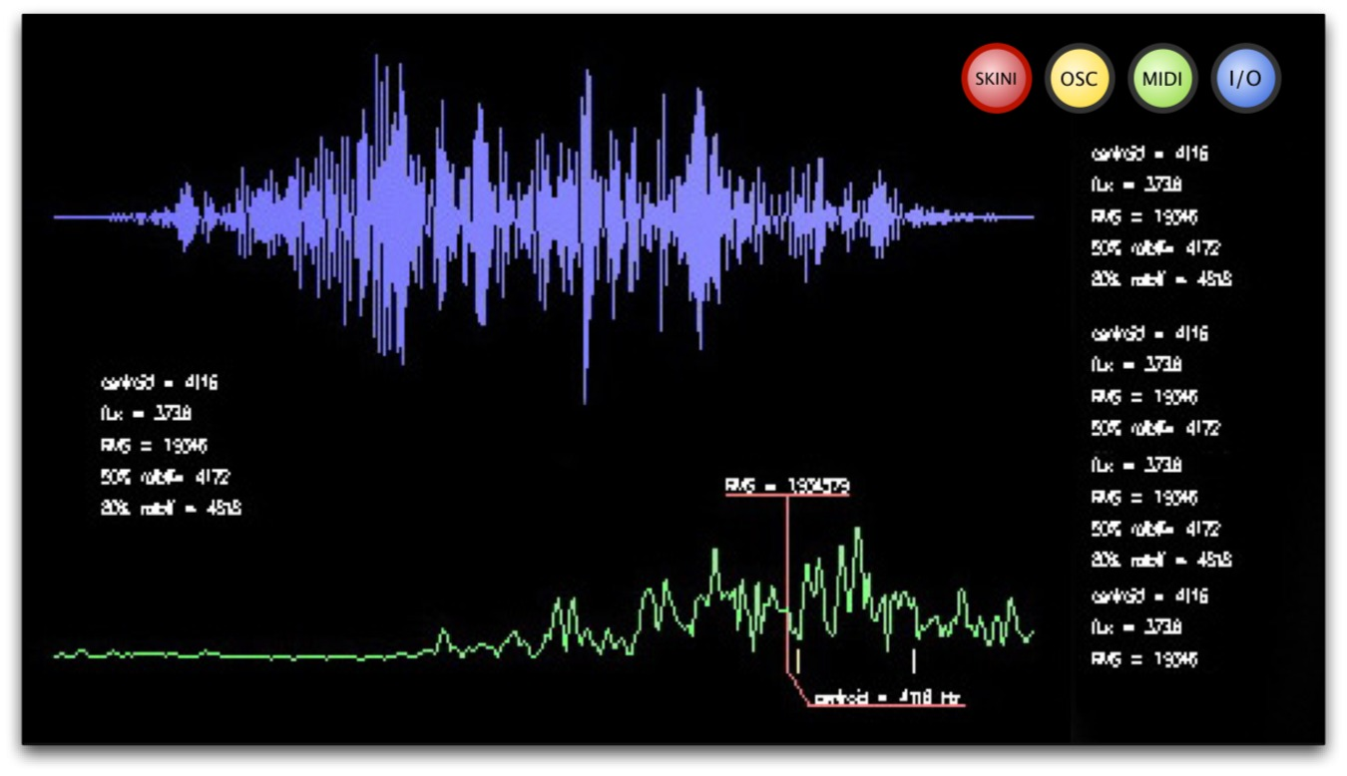
Figure 12. The VM-space Explorer. In this case, we see the input waveform (top-left) and its FFT magnitude spectrum (bottom-left), as well as resource usage (right).
Tabula Rasa. The "blank slate" face is actually not limited to one face, but any number of faces as requested by the programmer. Content is fully programmable using ChucK and the OpenGL API. In addition, the ChucK graphical programming interface includes access to the Audicle graphics and windowing engines, along with its set of minimal user interface widgets (used in the rest of the Audicle). This space makes the Audicle suitable for rapidly developing custom, high-performance graphical front-ends for synthesis, analysis, and performance.

Implementation Overview
The Audicle’s implementation consists of a graphical rendering engine, a low-latency I/O & networking framework, a minimal windowing system, and internal logic with interface into the ChucK virtual machine. The implementation (in C/C++, with some high-level components are written in ChucK) reuses many data structures from ChucK’s compiler and virtual machine. All components run in the same address space.
The graphics-rendering engine of the Audicle (implemented in the OpenGL API) runs on Mac OS X, Linux, and Windows. Using 3-D graphics exclusively with real-time audio synthesis can be highly feasible. With even modest graphics hardware support, the vast majority of the rendering can take place on the GPU (graphics processing unit), leaving CPU cycles (85-95%) for synthesis. Using custom-built, minimal user interface elements, we can handle user-interface events more efficiently than the windowing sub-system, and with potentially better responsiveness. Because the rendering-rate stays relatively constant (at 30+ frame/second), the CPU usage stays constant and is less subject to large bursts due to user interface processing. Also, 3D graphics is flexible. It can emulate 2D when needed, and also provides significant viewing freedom.

Conclusions and Future Work
On-the-fly programming opens the potential for interesting interactions and visualizations in the audio programming process. Through the different faces in the Audicube, the programmer, composer, and performer can develop code in a truly concurrent editor, and simultaneously visualize its behavior in terms of concurrency, timing, and its runtime interactions with the rest of the system. Concurrency, a natural and useful way to represent many concepts in sound and music, is captured by ChucK, and visualized by the Audicle.
The integrated, on-the-fly environment of the Audicle completes the development-to-runtime loop. The result is greater than the sum of its parts. The expressive power of coding is made available for runtime manipulation. In turn, on-the-fly information from runtime aids the development process, expanding the horizons of both. We gain the advantages of immediate feedback in an always-modifiable continuum.
Additionally, the Audicle motivates a new kind of audio programming mentality – one involving continuous exploration and experimentation. Recall our points on on-the-fly programming from Section 3.2. The Audicle further motivates this notion of runtime programmability as a new form of performance aesthetic, where code is used to expressively control the synthesis and the process is conveyed to the audience. It also provides a platform where a degree of virtuosity can evolve. Due to its visual nature and immediate feedback, the Audicle can also be a useful compositional environment, where the composer can incrementally work on concurrent parts of a program piece. Similarly, it could function as an educational tool, for teaching synthesis, audio programming, or multimedia.
Potentially, the Audicle is the beginning of a new class of environments for developing programs on-the-fly, as well as for visualizing the audio programming process. We look forward to experimenting with new interfaces for on-the-fly editing and code control, and new types of visualizations. Also, future work can investigate the technical and aesthetic aspects of collaborations between remotely connected Audiclae, as well as devise new on-the-fly programming systems and environments.
http://audicle.cs.princeton.edu/

Acknowledgements
We sincerely thank Ari Lazier, Nick Collins, Alex McLean, Adrian Ward, Julian Rohrhuber, and the Princeton Graphics Group for their encouragement, ideas, and support.

References

Anderson, D. P. and R. Kuivila. 1991. “Formula: A Programming Language for Expressive Computer Music.“ IEEE Computer 24(7):12-21.

Dannenberg, R. B. and E. Brandt. 1996. "A Flexible RealTime Software Synthesis System." In Proceedings of the International Computer Music Conference. International Computer Music Association, pp. 270-273.

Dannenberg, R. B. 1997. “Machine Tongues XIX: Nyquist, a Language for Composition and Sound Synthesis.” Computer Music Journal 21(3):50-60.

Lee, E. 2003. "Overview of the Ptolemy Project," Technical Memorandum UCB/ERL M03/25, U. C. Berkeley.

McCartney, J. 1996. "SuperCollider: A New Real-time Synthesis Language." In Proceedings of the International Computer Music Conference. International Computer Music Association.

Mathworks, Inc. MATLAB Documentation.

http://www.mathworks.com/

Pausch, R., T. Burnette, A. C. Capeheart, M. Conway, D. Cosgrove, R. DeLine, J. Durbin, R. Gossweiler, S. Koga, J. White. 1995. "Alice: Rapid Prototyping System for Virtual Reality." In IEEE Computer Graphics and Applications, May 1995.

Puckette, M. 1991. "Combining Event and Signal Processing in the MAX Graphical Programming Environment." Computer Music Journal 15(3):68-77.

Puckette, M. 1997. "Pure Data." In Proceedings of the International Computer Music Conference. International Computer Music Association, pp. 269-272.

Schubiger S. and S. Muller. 2003. "Soundium 2: An Interactive Multimedia Playground." In Proceedings of the International Computer Music Conference. International Computer Music Association, pp. 301-304.

Shaw, C., J. Liang, M. Green, and Y. Sun. 1992. "The Decoupled Simulation Model for Virtual Reality Systems." In Proceedings of the ACM SIGCHI Human Factors in Computer Systems Conference. pp. 321-328.

Vercoe, B. and D. Ellis. 1990. “Real-Time CSOUND: Software Synthesis with Sensing and Control.” In Proceedings of the International Computer Music Conference. International Computer Music Association, pp. 209-211.

Wang, G. and P. R. Cook. 2003. "ChucK: a Concurrent and On-the-fly Audio Programming Language." In Proceedings of the International Computer Music Conference. International Computer Music Association, pp. 219-226.

Wang, G. and P. R. Cook. 2004. “On-the-fly Programming: Using Code as an Expressive Musical Instrument.” In Proceedings of the International Conference on New Interfaces for Musical Expression. pp. 138-143.

