miniAudicle and ChucK Shell: New Interfaces for

ChucK Development and Performance

Spencer Salazar, Ge Wang, and Perry Cook†

Princeton University, Department of Computer Science †(also Music)

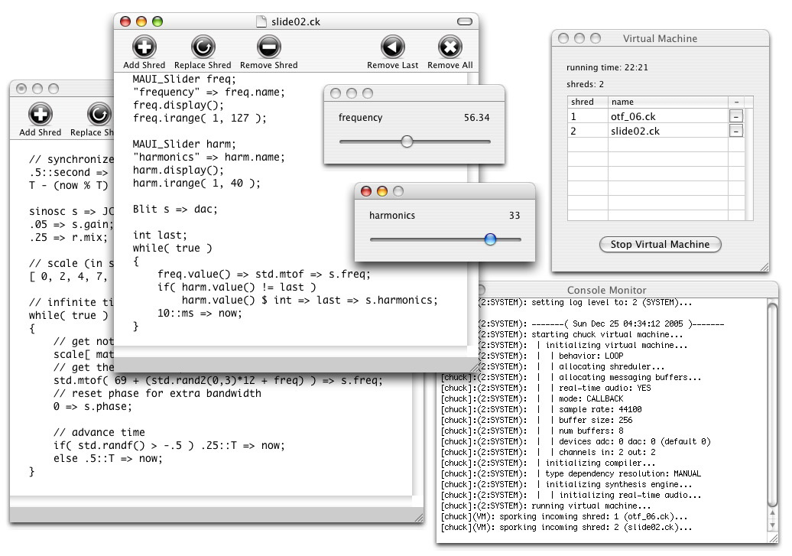
{ssalazar, gewang, prc}@cs.princeton.edu

Figure 1. The miniAudicle in action.

Abstract
ChucK, a powerful audio synthesis programming language, traditionally provides only a command line interface. Accompanying the ongoing development of the ChucK language is the production of two new interfaces for ChucK, the ChucK shell and the miniAudicle. The ChucK shell provides a lightweight method of access to ChucK in a shell-like console environment. The miniAudicle offers a powerful integrated solution to the ChucK development process and a framework for further enhancements to the ChucK programming environment. In this way, the miniAudicle streamlines and simplifies development, allowing programmers to focus on design and artistic issues while also facilitating ChucK to computer musicians who are unfamiliar with or averse to the command line.

1 Introduction
ChucK, a programming language for audio synthesis (Wang and Cook 2003), affords programmers a rich digital audio development environment for both traditional write-compile-run style programming and an on-the-fly programming model (Wang and Cook 2004a). On-the-fly programming is a concept in which programs can be modified and controlled at runtime both precisely and directly, affording greater and more immediate powers of expression to the programmer. On-the-fly programming typically requires some degree of runtime support in a given language. ChucK provides such capabilities in the form of a virtual machine, which compiles, executes, and coordinates different ChucK program components. However, ChucK itself lacks a convenient user interface; to execute ChucK programs, users must familiarize themselves with ChucK’s command line interface, accessible only through a shell environment such as bash. Additionally, ChucK offers no support for editing program sources, which instead must be done in an external editor. The Audicle, a graphical system for monitoring and modifying ChucK programs, presents one solution to this problem (Wang and Cook 2004b), but is still in the early stages of development. The purpose of the ChucK Shell and miniAudicle are to provide accessible, lightweight, and versatile interfaces to the ChucK language and on-the-fly programming.
In this aim, ChucK shell presents users with a native shell-like interface for interaction with the ChucK virtual machine. miniAudicle provides graphical user interfaces for editing, running, and managing ChucK programs. It also supplies a framework for extending the expressive capabilities of ChucK in potentially unforeseen ways, and makes ChucK more accessible to individuals with little or no experience with command lines or even software development in general.
In Section 2, we discuss related work. Section 3 presents the design and implementation of the ChucK shell and section 4 describes the design and implementation of miniAudicle. Lastly, we conclude and outline future work in Section 5.

2 Related Work
Existing language-specific shell environments include MATLAB (Mathworks, Inc.) and Python (Python Software Foundation). Existing software environments for audio synthesis include those for text-based languages such as CSound (Vercoe 1990), Nyquist (Danneberg 1996), and SuperCollider (McCartney 1996), graphical audio programming languages such as Max/MSP (Puckette 1991) and PureData (Puckette 1997), and modular synthesizer systems like Reaktor.
One existing extension of the traditional ChucK interface is the Audicle, an advanced 3-D graphical environment for interacting with the ChucK language (Wang and Cook 2004b). The Audicle is a cross-platform, OpenGL-based application that supports editing, execution, and modification of ChucK programs, as well as advanced monitoring of ChucK virtual machine state. While the Audicle offers a well-developed feature set and a visually impressive interface, it has several limitations. For instance, as the Audicle is implemented from the ground-up using OpenGL, the complexity and time required to develop new functionality in the Audicle is increased. Additionally, by implementing its own user interface primitives, the Audicle intentionally differentiates its look-and-feel from the native graphical user interface API of its host operating system. This can augment the barrier to accessibility, requiring users to learn a different interface structure to effectively use the Audicle.

3 ChucK Shell
The goals of the ChucK shell are to simplify and streamline basic runtime tasks in the ChucK environment, and potentially provide facilities for more advanced tasks as needed. The ChucK shell is accessed via the chuck command line application, by specifying the --shell command line option. This command alone will invoke the ChucK shell and also create a ChucK virtual machine, in separate threads; the shell is implicitly connected to this virtual machine. It is possible to suppress creation of the virtual machine by specifying the --empty command, spawning a shell process which must then be explicitly connected to a separate virtual machine. Multiple ChucK shell instances can remotely connect to a single VM.
The ChucK shell has been designed using fully reusable and modular components, allowing it to be easily embedded in both the miniAudicle and the Audicle.

3.1 Shell Commands
The basic ChucK shell commands are add(+), remove(-), replace(=), removeall, and removelast(--). These commands can be invoked by name, or by the associated symbolic name (see Figure 2). These commands map directly to the ChucK on-the-fly programming commands of the same name. Additionally, by using the vm @ command, users can specify a network address and port number to which these commands are sent (ChucK virtual machines typically bind to a port on the host machine to listen for commands over the network). ChucK shell also supports selected standard shell commands such as ls, cd, pwd, source, and alias.
Figure 2. Example ChucK shell commands.
chuck %> + sequencer.ck
chuck %> = 1 sequencer-new.ck
chuck %> - 1
chuck %> removeall

3.2 Inline Coding
The inline coding functionality of ChucK shell allows users to quickly execute small snippets of ChucK code from within the shell, without having to employ an external source file editor. Small snippets of code or even entire programs can be written without having to leave the shell, although the latter is not necessarily advisable. This functionality is primarily intended for the context of a performance, in which the small time to open a new file in an editor is significant, and it is only necessary to run some small snippet of code that does not already exist as a file on disk.
Inline code is preceded by an open bracket “{“ and terminated by a matching close bracket “}” (see Figure 3). ChucK shell tracks open and close brackets so that intermediate close brackets are not misinterpreted as the end of the code fragment. Code fragments can be saved to disk after they are sent to the virtual machine.
Figure 3. Example of inline coding. The lexical scope level is printed in the command prompt.

4 miniAudicle
chuck %> {
code 1> sinosc s => dac;
code 1> while( true ) {
code 2> 1::minute => now;
code 2> }
code 1> }
chuck %>
The miniAudicle offers an integrated, graphical environment for developing audio software using the ChucK programming language. miniAudicle features a text editor, an embedded virtual machine, a virtual machine monitor, a stdin/stderr monitor for displaying log and error messages from the virtual machine, an embedded ChucK shell, and support for on-the-fly programming commands like add, remove and replace. miniAudicle also supports creation and usage of typical graphical user interface widgets directly from ChucK code, chiefly for modifying program behavior and parameters at runtime in a well-defined and expressive manner. Currently, the miniAudicle uses the Cocoa API in the Mac OS X operating system to render its graphical user interface. Native Linux and Windows support is planned.
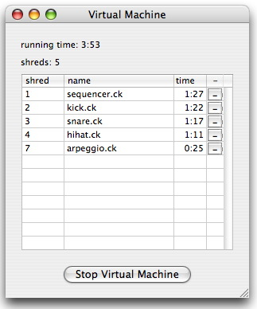
Figure 4. The miniAudicle virtual machine monitor. A “shred” refers to a running ChucK program.
The basic layout of the miniAudicle comprises five windows. The document window encapsulates ChucK source code files and presents them for editing. Several buttons in the document window correspond to on-the-fly programming commands, and as applicable will add, remove, or replace the file open in the editing window. Multiple document windows can be created, either with a new blank document or an existing document from disk, as is typical behavior with text editors.
The second window is the virtual machine monitor (see Figure 4). The virtual machine monitor can be used to start and stop the virtual machine. The virtual machine runs in the address space of the miniAudicle. This virtual machine accepts on-the-fly programming commands from both the command line ChucK client and the ChucK shell, by binding to port 8888 on the host machine. When the virtual machine is on, the virtual machine monitor also displays a table of all currently executing ChucK programs on the virtual machine, showing the unique program identification number, the filename of the program, and the running time of that program. Additionally, a small button in each entry of the table can be pressed to remove the ChucK program associated with that entry. The virtual machine monitor also prints the running time of the virtual machine and the number of programs currently running.
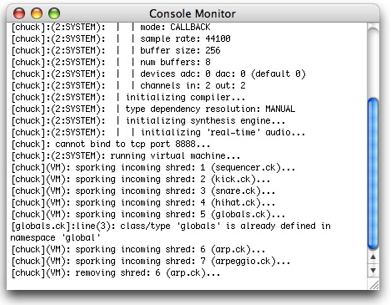
The third window is the console monitor (see Figure 5). The console monitor simply redirects console output to itself, and displays them on screen. In this way, log and error messages printed by the virtual machine to stdout and stderr can be displayed to the user without requiring an actual terminal window open.
Figure 5. The miniAudicle console monitor.
The fourth window is the ChucK shell window. This window is essentially a simple terminal emulator that directs its input to a ChucK shell instance, and prints any output from the ChucK shell.
The fifth window is the miniAudicle user interface elements panel. The miniAudicle user interface elements, or MAUI Elements, are a set of generic user interface widgets common to various graphical user interface APIs, which can be created, manipulated, and queried within a ChucK program in real-time. Currently, a new panel is created for each instance of a user interface element; in the future this behavior may be modified to support logical groupings of associated elements in the same window.
Figure 6. Example ChucK code for invoking the MAUI Slider element. This example generates a sine wave and displays a slider, with values between 100 and 10000. The frequency of the sine wave is bound to the value of the slider.
MAUI_Slider slider;
slider.range( 100, 10000 );
slider.value( 100 );
slider.name( "frequency" );
slider.display();

sinosc s => dac;

while( true )
{
slider.value() => s.freq;
slider => now; // wait on change
}
MAUI Elements exist in ChucK as built-in classes that can be instantiated and accessed as any other ChucK class. Types include sliders, buttons, text-fields, selection boxes, radio buttons, as well as more specialized widgets such as musical keyboards. Each element’s associated class has member functions for creation, accessing and setting properties, display, and destruction. Additionally, using ChucK’s built-in event notification support, ChucK programs can elect to block execution until a user has modified the external state of an element (see Figures 6, 7). Using the MAUI interface, developers can create sophisticated GUIs as front-ends for synthesis frameworks written in ChucK.
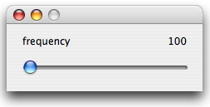
Figure 7. The slider resulting from executing the program in Figure 6.

5 Conclusions and Future Work
The ChucK shell improves upon ChucK’s traditional interface by reducing the keystrokes required for basic tasks and providing additional functionality like inline coding. The miniAudicle offers an integrated environment for ChucK development, using native GUI APIs of Mac OS X. Additionally, the miniAudicle supplies an extensible framework for accessing graphical user interface widgets from ChucK programs.
Future development plans for miniAudicle include porting to Microsoft Windows and Linux systems, syntax highlighting within editing windows, automatic completion of code during editing, and implementation of additional MAUI Elements. Additionally, plans exist to embed portions of the Audicle within the miniAudicle.
The ChucK shell is now part of the standard ChucK distribution; the miniAudicle is also open-source and freely available:
http://chuck.cs.princeton.edu/
http://audicle.cs.princeton.edu/mini/

6 Acknowledgements
Thanks to Adam Tindale for his help in documenting the ChucK shell and the ChucK users community for their ideas and support.

References
Mathworks, Inc. MATLAB Documentation. http://www.mathworks.com/
McCartney, J. 1996. "SuperCollider: A New Real-time Synthesis Language." In Proceedings of the International Computer Music Conference. International Computer Music Association.
Puckette, M. 1997. "Pure Data." In Proceedings of the International Computer Music Conference. International Computer Music Association, pp. 269-272.
Python Software Foundation. Python Documentation. http://www.python.org/
Vercoe, B. and D. Ellis. 1990. “Real-Time CSOUND: Software Synthesis with Sensing and Control.” In Proceedings of the International Computer Music Conference. International Computer Music Association, pp. 209-211.
Wang, G. and P. R. Cook. 2003. ChucK: a Concurrent and On-the-fly Audio Programming Language. In Proceedings of the International Computer Music Conference. International Computer Music Association, pp. 219-226.
Wang, G. and P. R. Cook. 2004. On-the-fly Programming: Using Code as an Expressive Musical Instrument. In Proceedings of the International Conference on New Interfaces for Musical Expression. pp. 138-143.
Wang, G. and P. R. Cook. 2004. The Audicle: A Context-Sensitive, On-the-fly Audio Programming Environ/mentality." In Proceedings of the International Computer Music Conference. International Computer Music Association.

