https://docs.google.com/spreadsheets/d/1o1mNk-I_-CnCJRZtUQgrDqa9OVf_qjQf69KSdcZNAcY/edit?usp=sharing

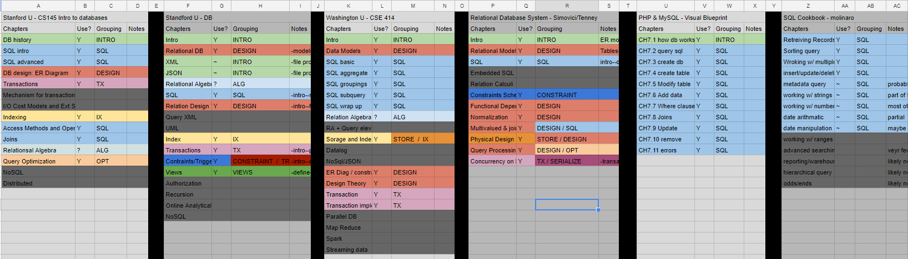

Consolidated index proposal

Intro
DB History

Relational DB concepts and design
DB design
Functional dependencies
Normalization
ER diagrams

Introduction to SQL
SQL queries
Create tables and databases
Add modify data
SQL aggregates
SQL groupings
SQL subqueries
SQL joins
Views

Storage
Indexing
Transactions

Constraints
Triggers

