The way in which Ethereum provides consensus leads to the possibility of two problems.

The first is the way in which nodes will eventually agree on what blockchain is the true chain. As blocks are added on competing nodes, these new chains are socialized out to neighboring nodes. What happens when neighboring nodes get differing versions of the same chain? Each blockchain has its own strategy, Ethereum uses an algorithm called Greedy Heaviest Observed Sub-tree (GHOST). A node, when presented with differing versions of the chain, will pick the version that has the the most nodes and sub-nodes.

This leads to the second problem. What happens when the network at large chooses one version of a block chain over another? The winning chain will have more blocks to the chain, but that does not mean it will contain all blocks that were ultimately mined. In fact, there is a guarantee that during this choosing process, there will be some blocks that have 'accepted' by the network but are not officially a part of the blockchain. These abandoned blocks are known as 'Uncles'

For example, if a consumer purchases an item for $5 using a crypto-currency built on top of Ethereum, the seller waits to verify the transaction gets included into a block, then gives the consumer their product. However, unknown to the buyer or consumer, the block isn't actually added to the canonical chain. This means the consumer hasn't had funds removed, the seller hasn't been paid, but the consumer now has their product and has moved on.

Ethereum has a built in resolution for this phenomenon. When a miners version of the blockchain is not chosen for promotion, blocks that are abandoned are marked as 'Uncles' and tracked. The network as a whole then offers incentives to miners to pick these Uncle blocks up and include them on future submissions of the blockchain. Thee incentives, in Proof of Work (PoW), are less than granted for normal transaction mining/block sealing, but are essentially free operation. The calculations for the block have already been completed, the block hashes just need to be verified and included in the new submission.

Let’s look an example of this. Any time two blocks are introduced at the same time to two different sets of nodes in the system, we call this a ‘fork’. Essentially the chain has forked and we have to contend with two different versions existing at the same time. Since this means Branch A could have our $5 purchase but Branch B doesn’t, we are left with the inevitable conclusion that we have two different account balances.

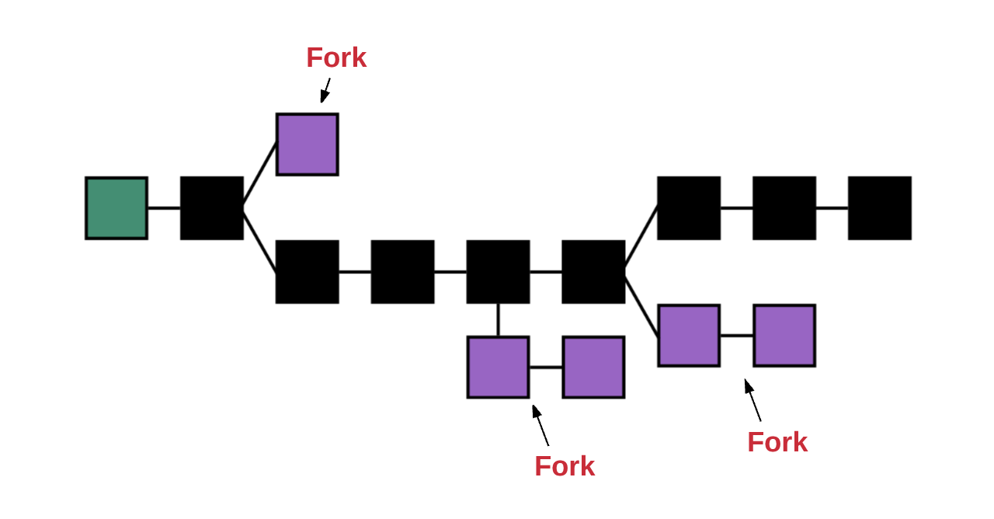

Recall from early on in our discussion, we know our blockchain begins from a Genesis block (green) and the final, accepted version of the chain is called the Canonical version. The figure below is updated to reflect this terminology.
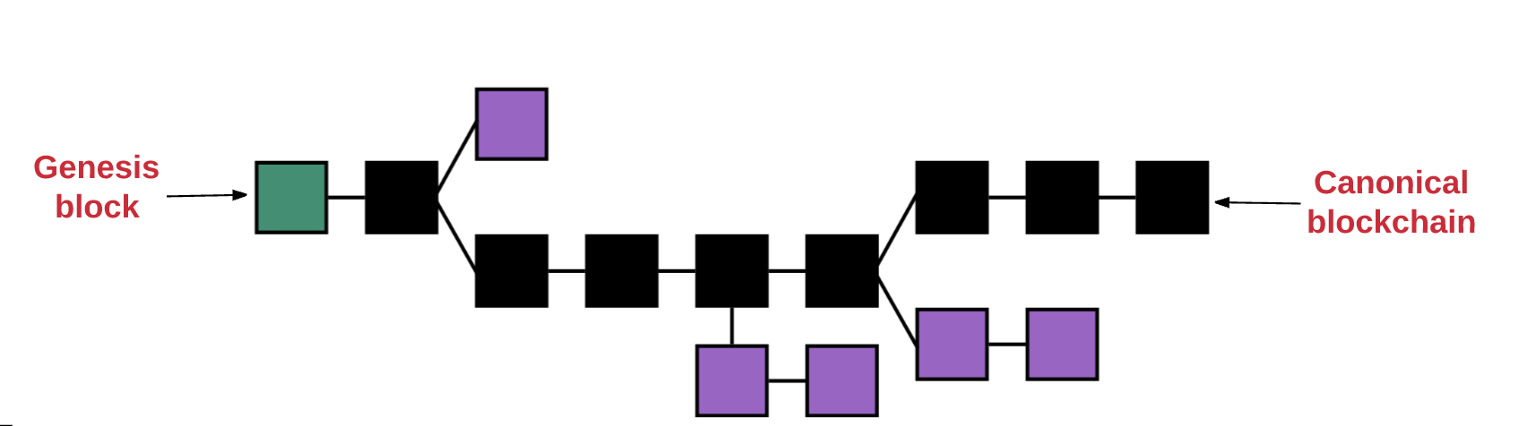

But how did we ultimately decide on which was the Canonical version? The GHOST protocol. Ethereum will continually choose the longest (heaviest) version of the chain and will mark it as the canonical version. This doesn’t mean that the other forked nodes are lost and, in fact, these forks could become the canonical version themselves in the future.
