Getting Deep Into Ethereum: How Data Is Stored In Ethereum

https://hackernoon.com/getting-deep-into-ethereum-how-data-is-stored-in-ethereum-e3f669d96033

dive into Ethereum’s data storage layer.

We will introduce the concept of blockchain “state”.

We will cover the theory behind the Patricia Trie data structure and demonstrate Ethereum’s concrete implementation of tries using Google’s leveldb database.

Ethereum world state is able to manage account balances, and more.
The state of Ethereum is not an abstract concept. It is part of Ethereum’s base layer protocol. As the yellow paper mentions, Ethereum is a transaction-based “state” machine; a technology on which all transaction-based state machine concepts may be built.

Chain starts with ‘Genesis block’ at block 0. Transactions are tracked from that state forward (stored in state trie)

Importantly, data such as account balances are not stored directly in the blocks of the Ethereum blockchain.
Only the root node hashes of the transaction trie, state trie and receipts trie are stored directly in the blockchain.
the root node hash of the storage trie (where all of the smart contract data is kept) actually points to the state trie, which in turn points to the blockchain. We will zoom in and cover all of this in more detail soon.

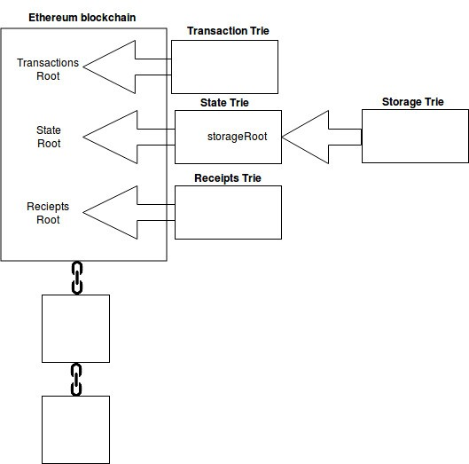

There are two vastly different types of data in Ethereum; permanent data and ephemeral data.
An example of permanent data would be a transaction. Once a transaction has been fully confirmed, it is recorded in the transaction trie; it is never altered.
An example of ephemeral data would be the balance of a particular Ethereum account address. The balance of an account address is stored in the state trie and is altered whenever transactions against that particular account occur.

State Trie

There is one, and one only, global state trie in Ethereum.

This global state trie is constantly updated.

The state trie contains a key and value pair for every account which exists on the Ethereum network.

The “key” is a single 160 bit identifier (the address of an Ethereum account).

The “value” in the global state trie is created by encoding the following account details of an Ethereum account (using the Recursive-Length Prefix encoding (RLP) method):
- nonce
- balance
- storageRoot
- codeHash

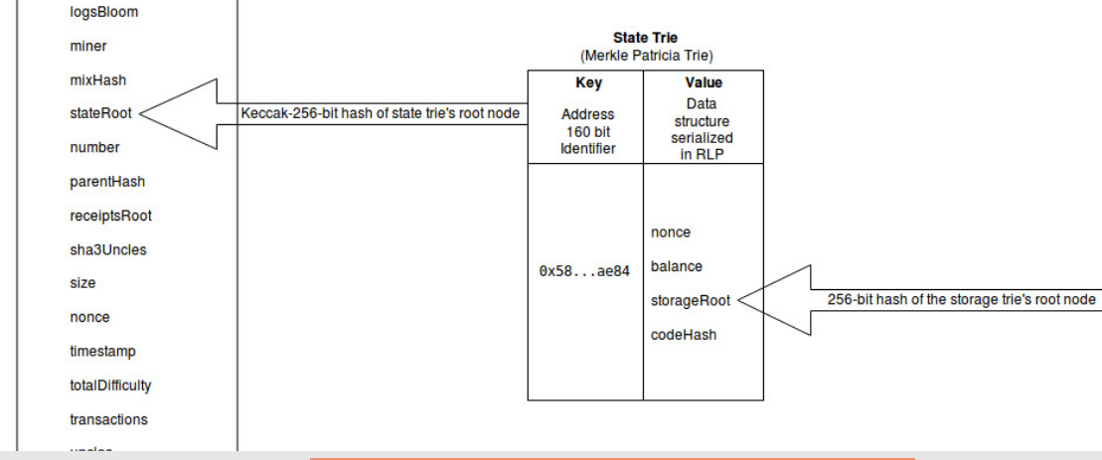

Storage Trie

A storage trie is where all of the contract data lives.

Each Ethereum account has its own storage trie.

A 256-bit hash of the storage trie’s root node is stored as the storageRoot value in the global state trie (which we just discussed).

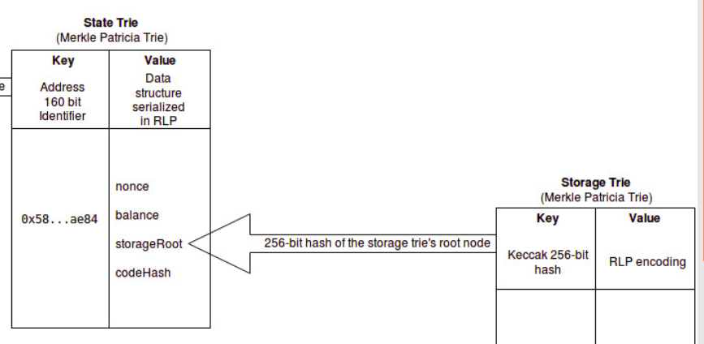

Transaction trie - one per block

Each Ethereum block has its own separate transaction trie.

A block contains many transactions. The order of the transactions in a block are of course decided by the miner who assembles the block. The path to a specific transaction in the transaction trie, is via (the RLP encoding of) the index of where the transaction sits in the block.

Mined blocks are never updated; the position of the transaction in a block is never changed. This means that once you locate a transaction in a block’s transaction trie, you can return to the same path over and over to retrieve the same result.

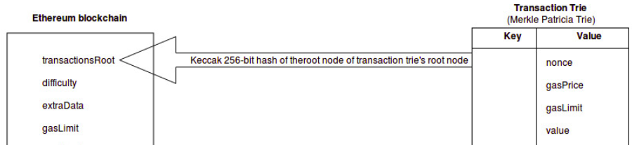

Concrete examples of tries in Ethereum

The main Ethereum clients use two different database software solutions to store their tries. Ethereum’s Rust client Parity uses rocksdb. Whereas Ethereum’s Go, C++ and Python clients all use leveldb.

Ethereum and leveldb

LevelDB is an open source Google key-value storage library which provides, amongst other things, forward and backward iterations over data, ordered mapping from string keys to string values, custom comparison functions and automatic compression. The data is automatically compressed using “Snappy” an open source Google compression/decompression library. Whilst Snappy does not aim for maximum compression, it aims for very high speeds. Leveldb is an important storage and retrieval mechanism which manages the state of the Ethereum network. As such, leveldb is a dependency for the most popular Ethereum clients (nodes) such as go-ethereum, cpp-ethereum and pyethereum.

Whilst the implementation of the trie data structure can be done on disk (using database software such as leveldb) it is important to note that there is a difference between traversing a trie and simply looking at the flat key/value database.

