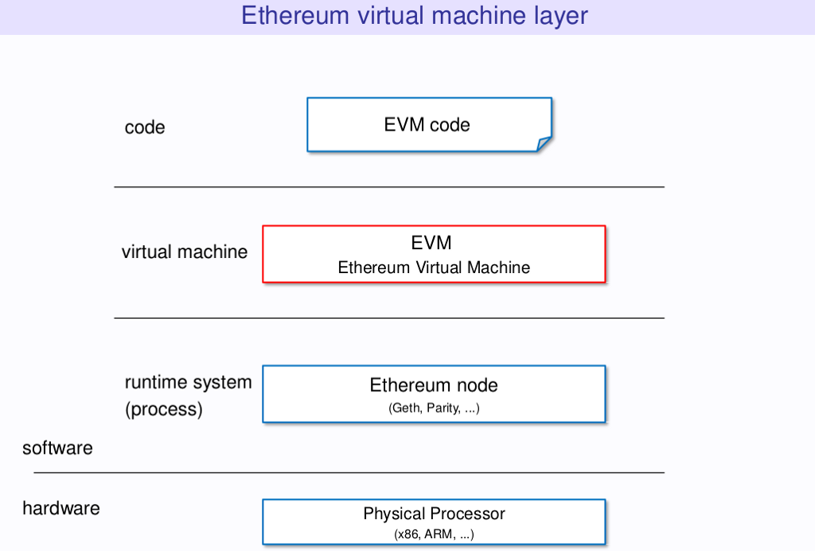
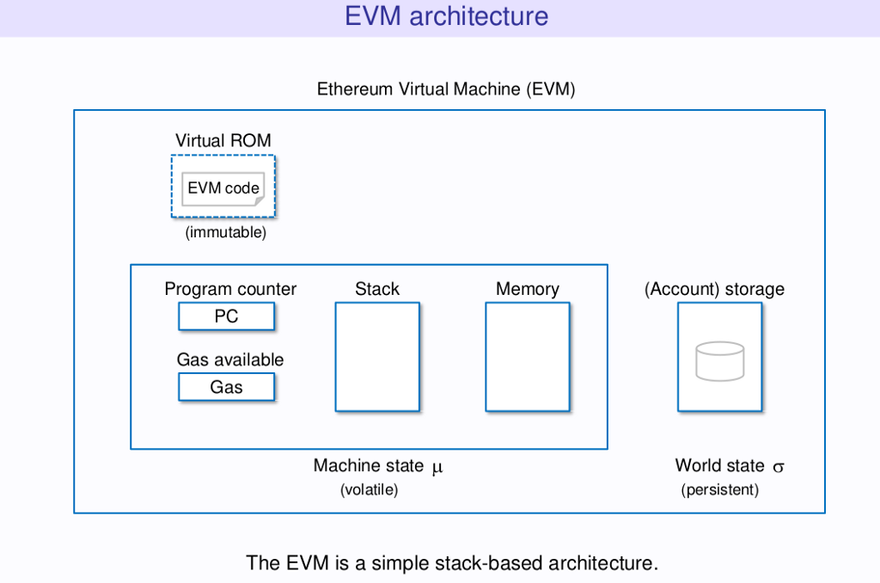

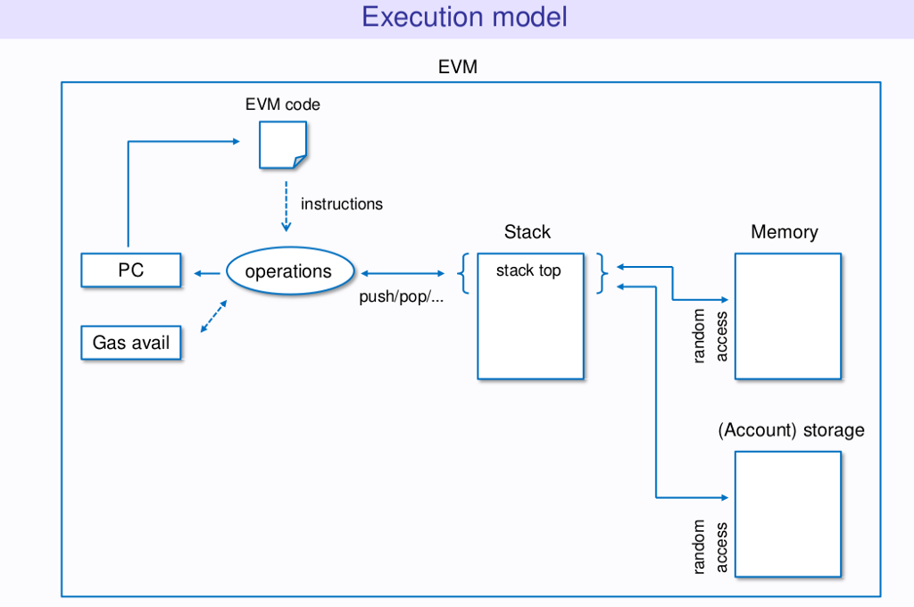

Ethereum Contracts

Basics

Smart contracts are just computer programs, and we can say that Ethereum contracts are smart contracts that run on the Ethereum Virtual Machine. The EVM is the sandboxed runtime and a completely isolated environment for smart contracts in Ethereum. This means that every smart contract running inside the EVM has no access to the network, file system, or other processes running on the computer hosting the VM.

As we already know, there are two kinds of accounts: contracts and external accounts. Every account is identified by an address, and all accounts share the same address space. The EVM handles addresses of 160-bit length.

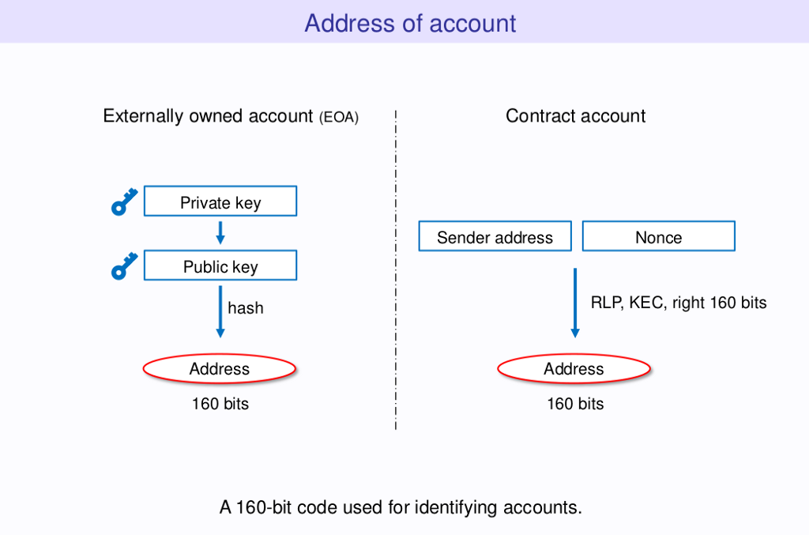

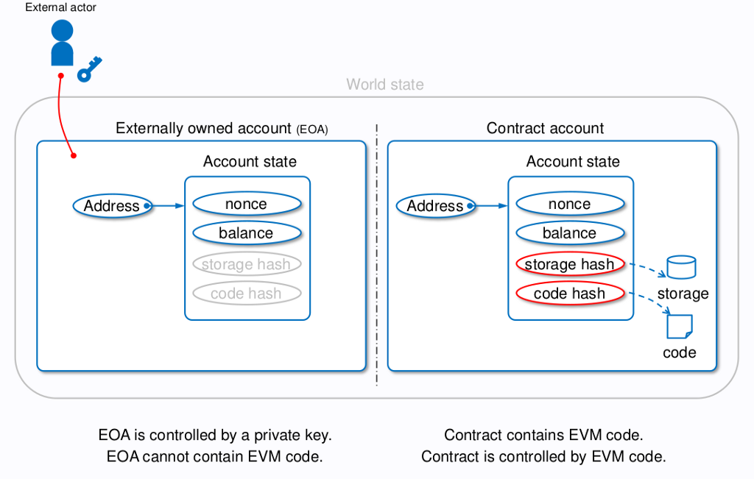

Every account consists of a balance, a nonce, bytecode, and stored data (storage). However, there are some differences between these two kinds of accounts. For instance, the code and storage of external accounts are empty, while contract accounts store their bytecode and the merkle root hash of the entire state tree. Moreover, while external addresses have a corresponding private key, contract accounts don’t. The actions of contract accounts are controlled by the code they host in addition to regular cryptographic signing of every Ethereum transaction.

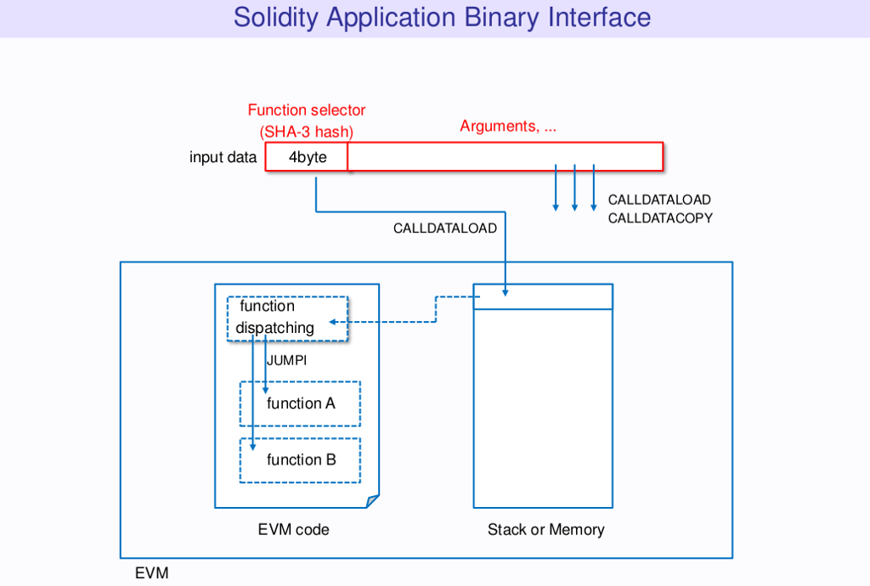

Message Calls
Contracts can call other contracts through message calls. Every time a Solidity contract calls a function of another contract, it does so by producing a message call. Every call has a sender, a recipient, a payload, a value, and an amount of gas. The depth of message call is limited to less than 1024 levels.

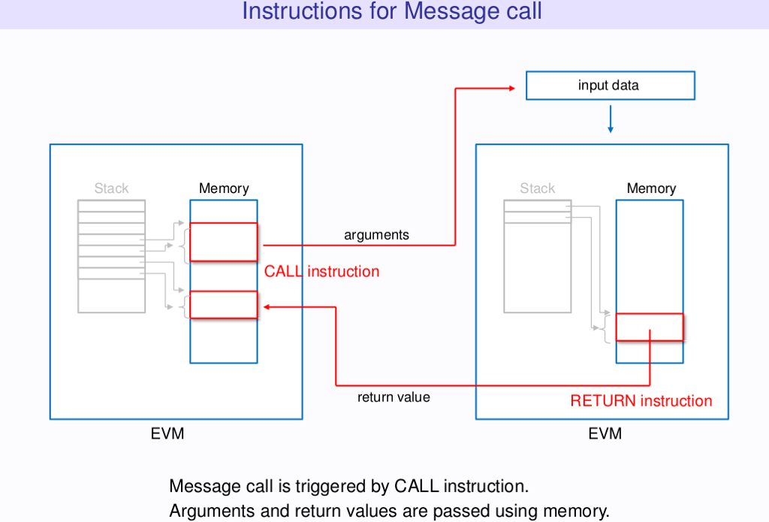

Data Management

The EVM manages different kinds of data depending on their context, and it does that in different ways. We can distinguish at least four main types of data: stack, calldata, memory, and storage, besides the contract code. Let’s analyze each of these:

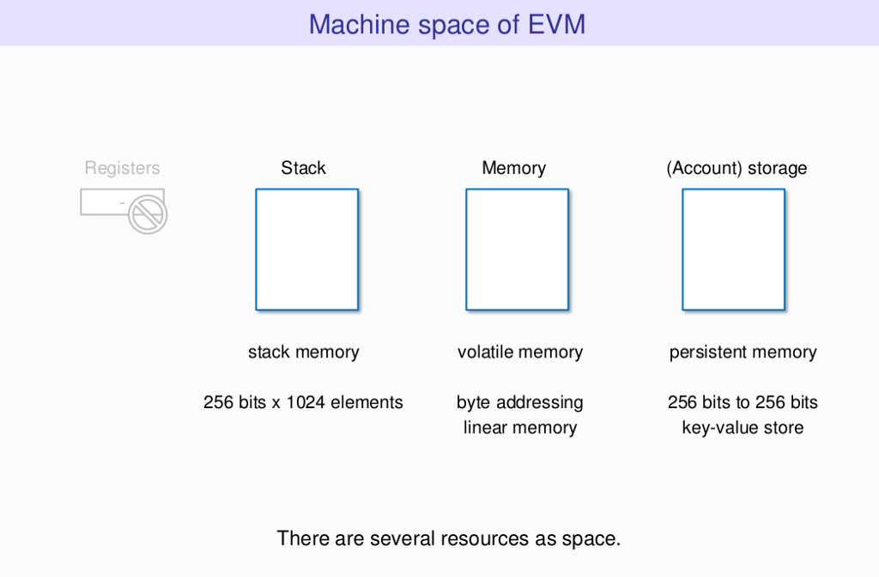

Stack
The EVM is a stack machine, meaning that it doesn’t operate on registers but on a virtual stack. The stack has a maximum size of 1024. Stack items have a size of 256 bits; in fact, the EVM is a 256-bit word machine (this facilitates Keccak256 hash scheme and elliptic-curve computations). Here is where most opcodes consume their parameters from.

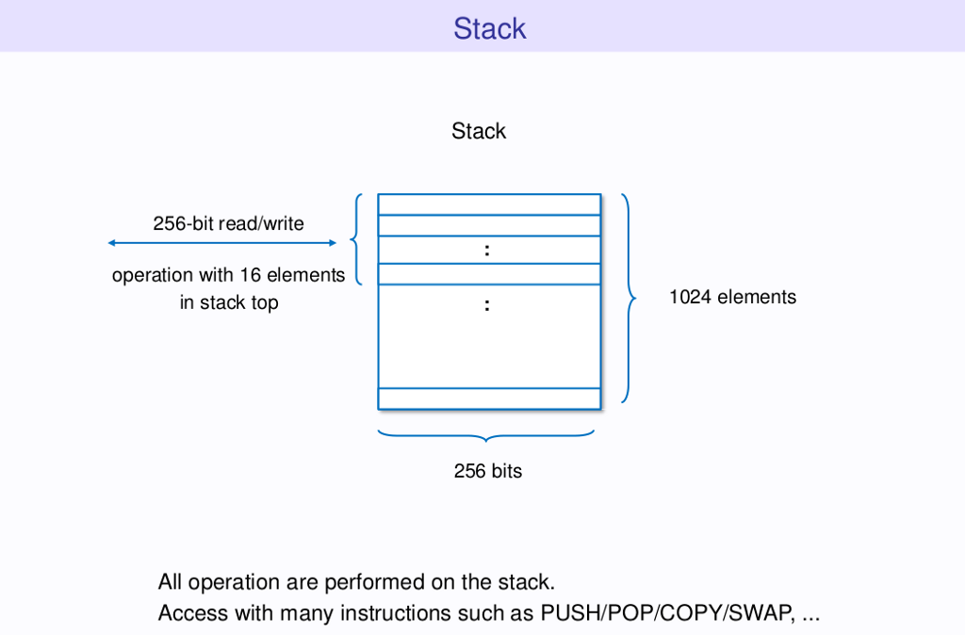

Calldata
The calldata is a read-only byte-addressable space where the data parameter of a transaction or call is held. Unlike the stack, to use this data you have to specify an exact byte offset and number of bytes you want to read.

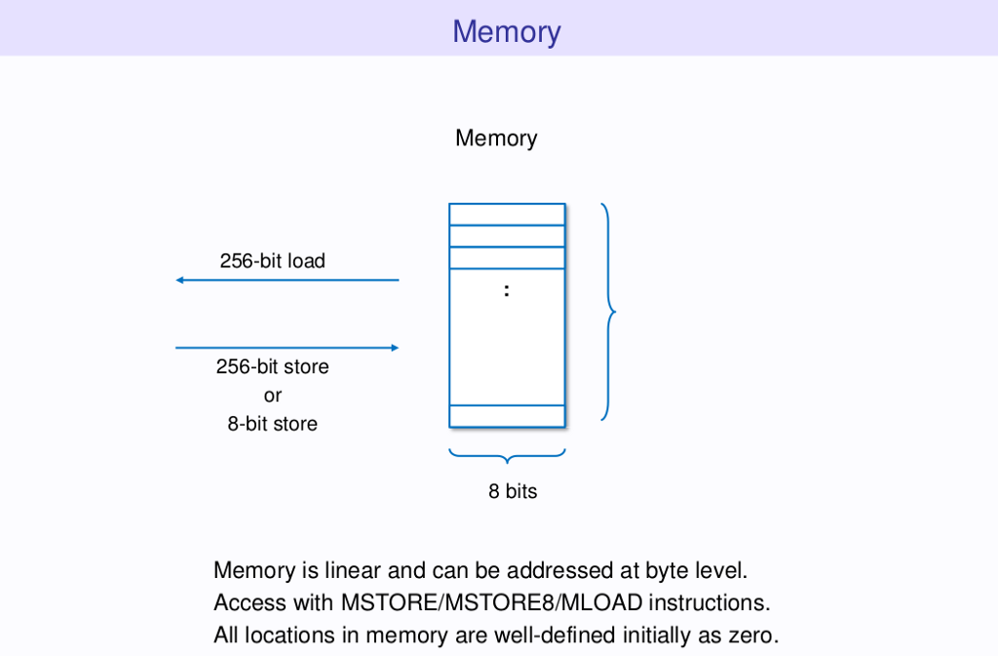

Memory
Memory is a volatile read-write byte-addressable space. It is mainly used to store data during execution, mostly for passing arguments to internal functions. Given this is volatile area, every message call starts with a cleared memory. All locations are initially defined as zero. As calldata, memory can be addressed at byte level, but can only read 32-byte words at a time.

Memory is said to “expand” when we write to a word in it that was not previously used. Additionally to the cost of the write itself, there is a cost to this expansion, which increases linearly for the first 724 bytes and quadratically after that.

Storage
Storage is a persistent read-write word-addressable space. This is where each contract stores its persistent information. Unlike memory, storage is a persistent area and can only be addressed by words. It is a key-value mapping of 2²⁵⁶ slots of 32 bytes each. A contract can neither read nor write to any storage apart from its own. All locations are initially defined as zero.

The amount of gas required to save data into storage is one of the highest among operations of the EVM. This cost is not always the same. Modifying a storage slot from a zero value to a non-zero one costs 20,000. While storing the same non-zero value or setting a non-zero value to zero costs 5,000. However, in the last scenario when a non-zero value is set to zero, a refund of 15,000 will be given.

Solidity will automatically map every defined state variable of your contract to a slot in storage. The strategy is fairly simple — statically sized variables (everything except mappings and dynamic arrays) are laid out contiguously in storage starting from position 0.

For dynamic arrays, this slot (p) stores the length of the array and its data will be located at the slot number that results from hashing p(keccak256(p)). For mappings, this slot is unused and the value corresponding to a key k will be located at keccak256(k,p). Bear in mind that the parameters of keccak256 (k and p) are always padded to 32 bytes.

