https://medium.com/@preethikasireddy/how-does-ethereum-work-anyway-22d1df506369

The Ethereum blockchain is essentially a transaction-based state machine. In computer science, a state machine refers to something that will read a series of inputs and, based on those inputs, will transition to a new state.

With Ethereum’s state machine, we begin with a “genesis state.” This is analogous to a blank slate, before any transactions have happened on the network. When transactions are executed, this genesis state transitions into some final state. At any point in time, this final state represents the current state of Ethereum.

The state of Ethereum has millions of transactions. These transactions are grouped into “blocks.” A block contains a series of transactions, and each block is chained together with its previous block.

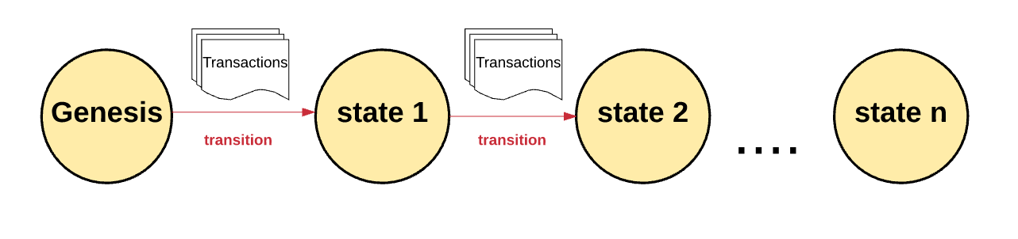
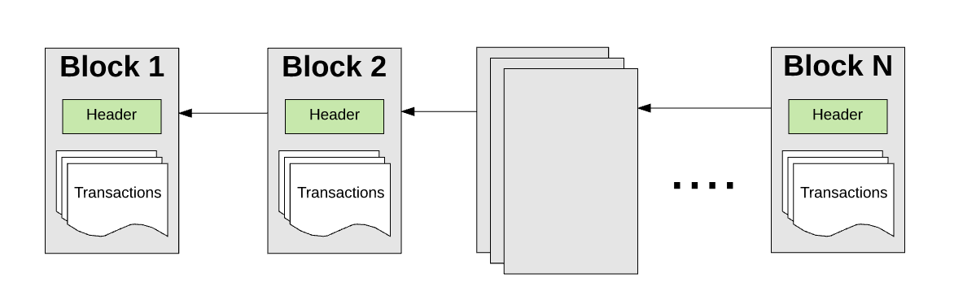

To cause state transition, must have a transaction and transaction must be valid.
To be valid, must be verified via mining by a miner.
A miner will collect transactions into a block and submit it to the network.
Miner submits ‘proof of work’ to show the block is valid.

The blockchain can be seen as a transactional singleton machine with shared state. There can never be multiple active states or chains. Any difference in the chain results in a ‘fork’, the network must agree on what branch of the fork is the valid state.

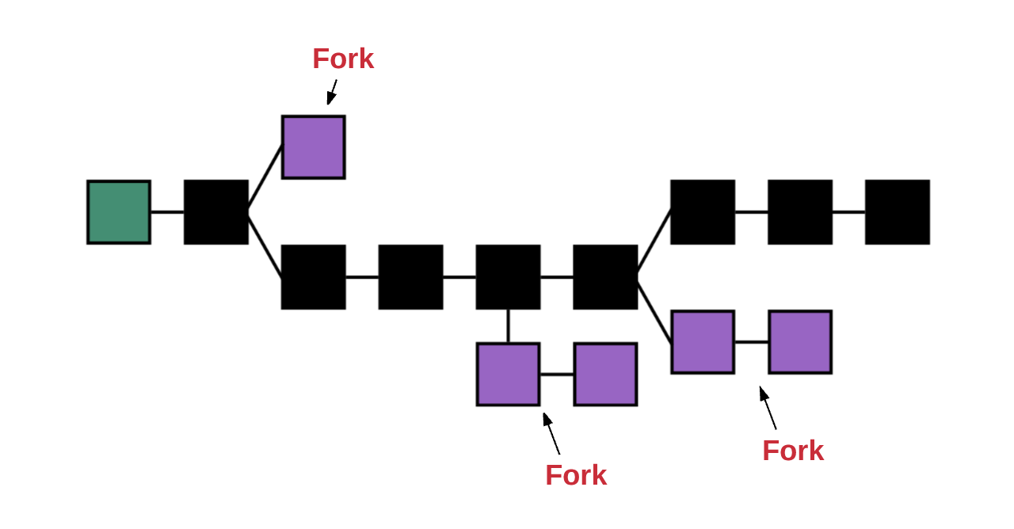
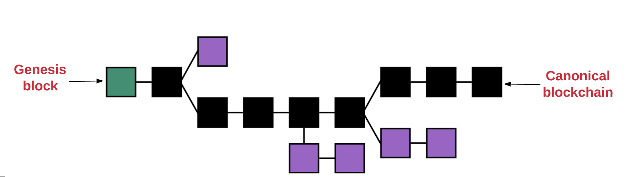

Ethereum uses GHOST protocol (greedy heaviest observed subtree)
GHOST says we must pick the path that has had the most computation done upon it.

The main components of Ethereum are
Accounts
State
Gas and fees
Transacions
Blocks
Transaction executions
Mining
Proof of work

Accounts

Global state of Ethereum is comprised of many accounts that interact by passing messages (transactions). Each account has a state with a 20byte address. An address is a 160 bit id used to identify account.

External accounts - controlled by private keys and have no code associated with them
Contract accounts - controlled by their contract code

External vs contract accounts
External can send messages directly to other external accounts or contracts by creating creating and signing transaction using private key.
External to external can only be a value transfer
Contract accounts can not initiate transactions but can call contracts on behalf of calling external account

Account State
Has 4 components
Nonce - for external accounts, this is the number of transactions sent from this account. If the account is a contract account, it is the number of contracts created by the account.
Balance - number of wei owned by this address
StorageRoot - hash of the root node. This tree encodes the hash of the storage contents of this account, empty by default
CoeHash - hash of the EVM code of this account for contract accounts. Empty for external accounts

World State
Global state consists of mapping between account addresses and account state - this mapping is stored in Merkle Patricia tree (Merkle tree, merkle trie). Tree is composed of:

a large number of leaf nodes at the bottom of the tree that contain the underlying data
a set of intermediate nodes, where each node is the hash of its two child nodes
a single root node, also formed from the hash of its two child node, representing the top of the tree

This tree structure is used for State, Transaction, Receipts, Storage

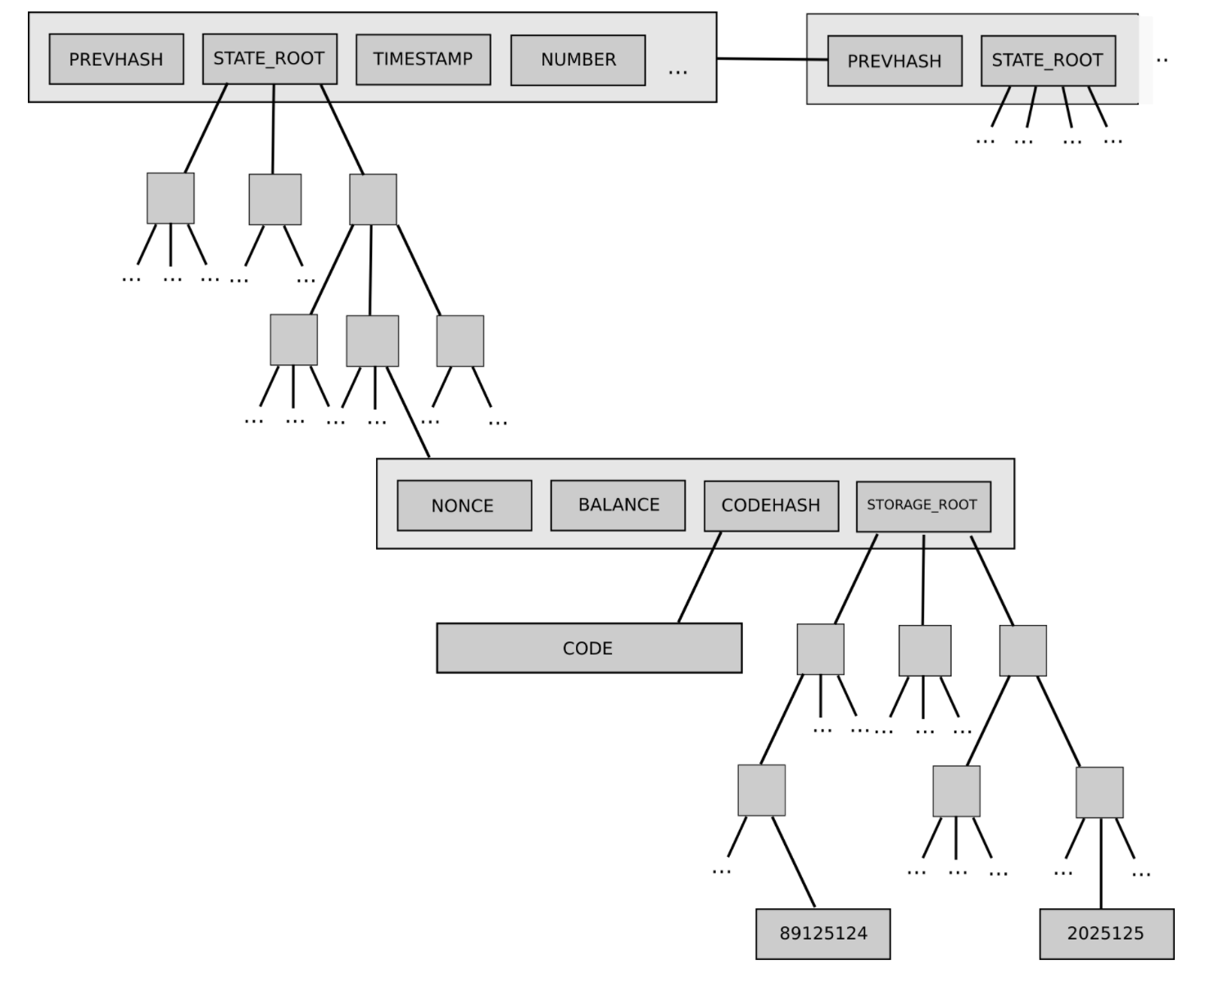
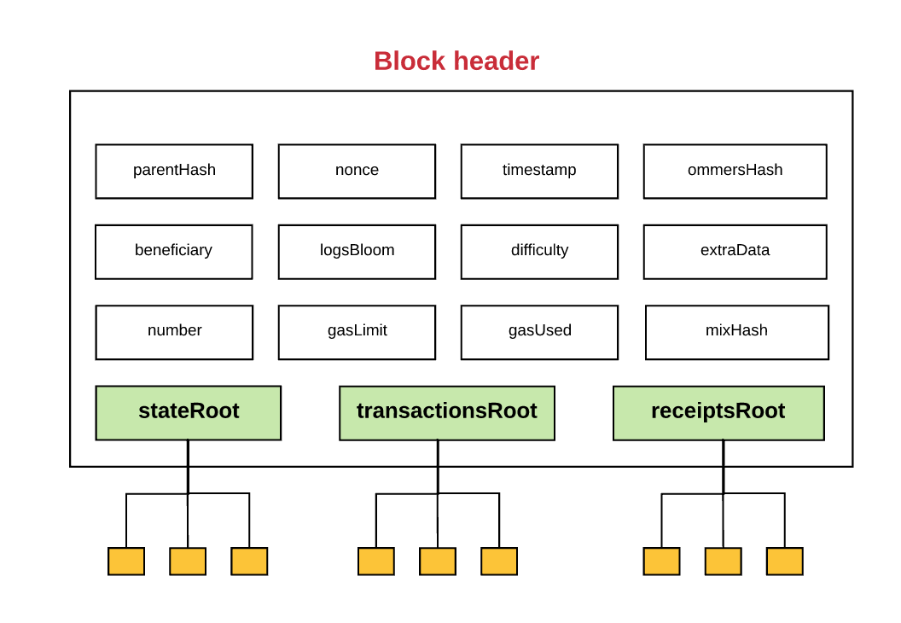

A result of using this tree structure is that either the hashes or the full contents of the tree can be sent to nodes in the network. If only hashes are sent, this is considered ‘light clients’ or ‘light nodes’ and allow for traversing the entire blockchain but does not contain the detailed transaction or state data that exists.
A full archive, full copy, or full node will require all the data and the hashes. Miners are required to keep a full history to mine new blocks. New miners that are added to the network must begin with the genesis block and replay all transactions to verify the next node. Full copies are required for miners and for querying historical data.
Nodes will often not need a full copy, instead it is possible to download just the chain of headers, without executing transactions or retreiving state data. These are called Light Nodes and have access to hashes of the three tries.

Gas and payment
Every computation that occurs as a result of a transaction on the Ethereum network incurs a fee, that fee is called ‘gas’

Gas is the unit used to measure fee required.

Every transaction has ‘Gas Price’ and ‘Gas Limit’
Gas price is in ‘gwei’ = 1.000.000.000 wei
Gas limit is the total number (max) of gas that the sender is willing to spend. This may not be completely used, and any remaining after all transactions have completed are refunded to the sender.
Any gas spent on the transaction goes to the miner.
Miners are more likely to pick higher yielding transactions to mine, are able to advertise min gas amount they are willing to mine.

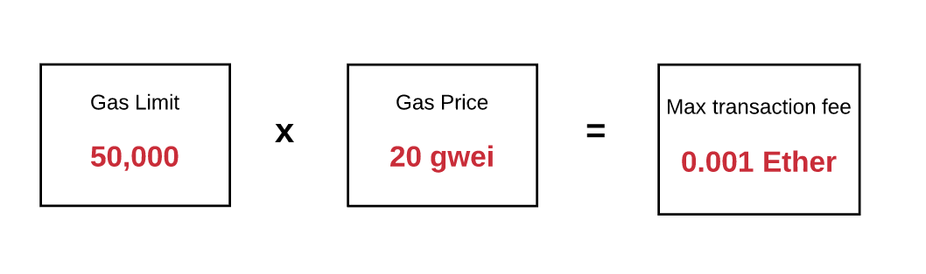
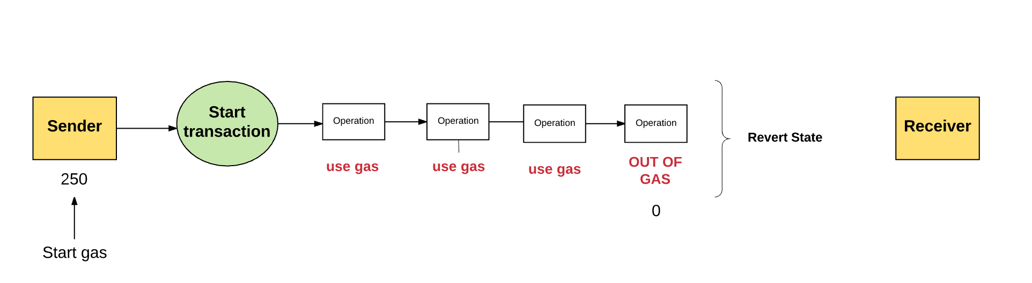
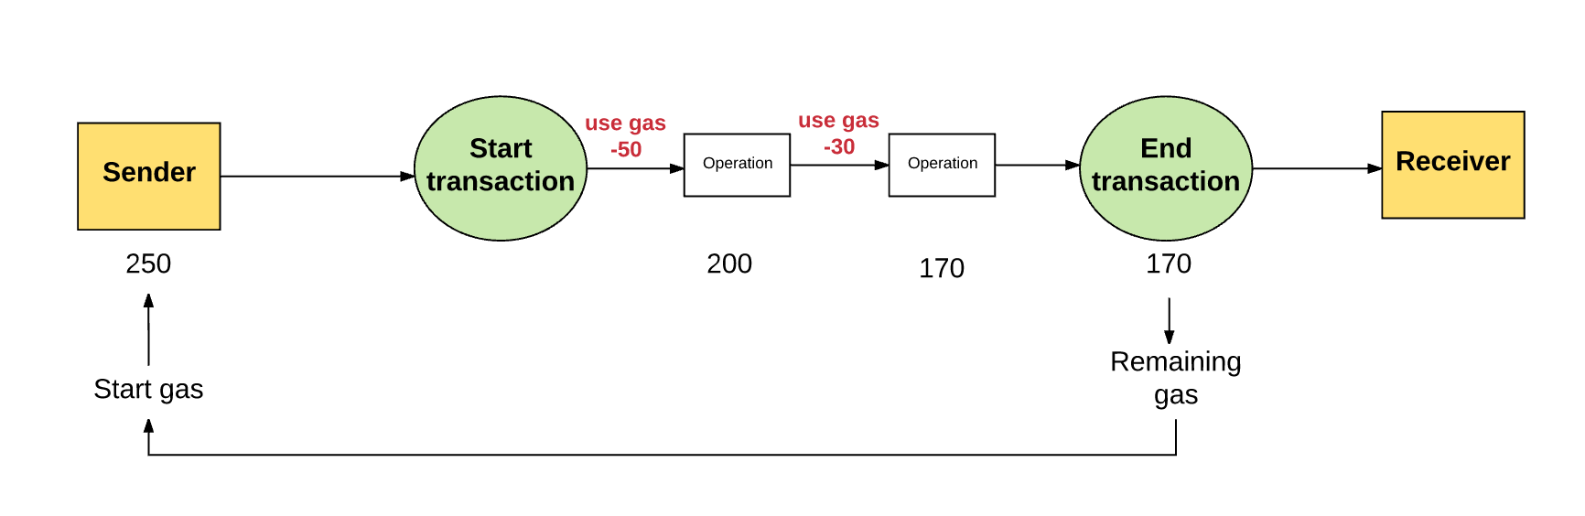

Storage fees
There is a fee for computation as well as storage
Total fee is proportional to the smallest multiple of 32 bytes used
If space is freed by a transaction, there may be a refund back to the sender

Fee purpose
Every operations affects every node on the network, so there has to be some cost on the submitter to prevent abuse.
Computation in the EVM is expensive, and given smart contracts can contain any logic and are susceptible to the halting problem (potentially infintely running) this allows a maximum amount of time to run on the EVM in the form of gas.

Transaction and Messages
Ethereum is a transaction based machine; transactions between different accounts are what move from one state to the next.

A transaction is cryptographically signed piece of instruction that is generated by an externally owned account, serialized, and submitted to the blockchain

2 types: message calls and contract creations

All transactions:
-nonce: a count of the number of transactions sent by the sender.
-gasPrice: the number of Wei that the sender is willing to pay per unit of gas required to execute the transaction.
-gasLimit: the maximum amount of gas that the sender is willing to pay for executing this transaction. This amount is set and paid upfront, before any computation is done.
-to: the address of the recipient. In a contract-creating transaction, the contract account address does not yet exist, and so an empty value is used.
-value: the amount of Wei to be transferred from the sender to the recipient. In a contract-creating transaction, this value serves as the starting balance within the newly created contract account.
-v, r, s: used to generate the signature that identifies the sender of the transaction.
-init (only exists for contract-creating transactions): An EVM code fragment that is used to initialize the new contract account. init is run only once, and then is discarded. When init is first run, it returns the body of the account code, which is the piece of code that is permanently associated with the contract account.
-data (optional field that only exists for message calls): the input data (i.e. parameters) of the message call. For example, if a smart contract serves as a domain registration service, a call to that contract might expect input fields such as the domain and IP address.

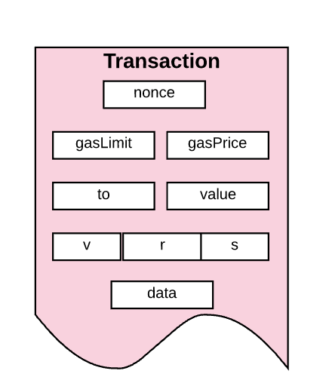

Blocks
All transactions are grouped together into blocks
A blockchain contains series of blocks chained together

Consists of:
-block header
-information about the transactions included in that block
-set of block headers for current blocks ommers

Ommers
Ommer is a block whose parent is equal to current blocks parents parent

Because of the way Ethereum is built, block times are much lower (~15 seconds) than those of other blockchains, like Bitcoin (~10 minutes). This enables faster transaction processing. However, one of the downsides of shorter block times is that more competing block solutions are found by miners. These competing blocks are also referred to as “orphaned blocks” (i.e. mined blocks do not make it into the main chain).
The purpose of ommers is to help reward miners for including these orphaned blocks. The ommers that miners include must be “valid,” meaning within the sixth generation or smaller of the present block. After six children, stale orphaned blocks can no longer be referenced (because including older transactions would complicate things a bit).

Ommer blocks receive a smaller reward than a full block. Nonetheless, there’s still some incentive for miners to include these orphaned blocks and reap a reward.

Block Header
Consists of:

-parentHash: a hash of the parent block’s header (this is what makes the block set a “chain”)
-ommersHash: a hash of the current block’s list of ommers
-beneficiary: the account address that receives the fees for mining this block
-stateRoot: the hash of the root node of the state trie (recall how we learned that the state trie is stored in the header and makes it easy for light clients to verify anything about the state)
-transactionsRoot: the hash of the root node of the trie that contains all transactions listed in this block
-receiptsRoot: the hash of the root node of the trie that contains the receipts of all transactions listed in this block
-logsBloom: a Bloom filter (data structure) that consists of log information
-difficulty: the difficulty level of this block
-number: the count of current block (the genesis block has a block number of zero; the block number increases by 1 for each each subsequent block)
-gasLimit: the current gas limit per block
-gasUsed: the sum of the total gas used by transactions in this block
-timestamp: the unix timestamp of this block’s inception
-extraData: extra data related to this block
-mixHash: a hash that, when combined with the nonce, proves that this block has carried out enough computation
-nonce: a hash that, when combined with the mixHash, proves that this block has carried out enough computation

Logs
Make it possible to track various transactions and messages
Contract can explicitly generate a log by defining “events”

Contains:
Loggers account address
Series of topics that represent events carried out by this transaction
Any data associated with events

Transaction recept
Logs stored in the header come from log info contained in the transaction receipt
Ethereum generates receipt for every transaction

Contains:
-block number
-block hash
-transaction hash
-gas used by current transaction
-cumulative gas used in block after current transaction executed
-logs created when executing current transaction

Transaction Execution
Most complex part of Etherum protocol, how to transition from state N to state N+1

All transaction to be included in state transition must:
-be a properly formatted RLP (”recursive length prefix”) and is a data format used to encode nested arrays of binary data.
-valid transaction signature
-valid transaction nonce (must be equal to the sender accounts nonce)
-gas limit must be >= than the intrinsic gas used by transaction
-senders accounts must have enough Ether to cover gas cost

Once transactions have met this, transition begins
1) deduct gas cost from sender, increase sender account nonce by 1
2) transaction executes
3) computations required by transaction are processed
4) if successful, unused gas + refund for freeing storage are calculated for sender - this finalizes the state
5) miner is rewarded
6) gas used by transaction are added to the block gas counter
7) any self-destruct accounts are deleted

Contract Creation
To create a new contract account:
1) declare the address of the account
2) initialize account
2.1)set nonce to 0
2.2)if sender sent ether - set account balance to this value
2.3)deduct any sent ether from sender account
2.4)set storage as emtpy
2.5)set codeHash as hash of an empty string

Once initialize, can create account using ‘init code’ (constructor from the contract)

If contract is successful, cost is paid, including storage

Any ether from the initial value is sent back to sender

If Contract fails, state is reverted back to what it was before attempting to create the account (no partial success concerns)

Message Calls
The execution of a message call is similar to that of contract creation, however:
-does not include init code
-can contain input data
-can contain output data, which is used if a subsequent execution needs this data

Execution Model
The thing that handles processing transaction is Ethereum Virtual Machine

EVM is a stack based architecture - uses LIFO stack to hold temp values. The size of each stack item is 256bit, stack has max size of 1024. EVM has memory, word-addressed byte arrays, is volatile.

EVM has storage, is non-volatile, (RAM) maintained as part of the system state. EVM stores program code seperately in read-only-memory (ROM).

EVM has its own language “EVM bytecode”. High level languages such as Solidity compile down to this.

Before execution starts, must validate:
-system state
-remaining gas for computation
-address of account that owns the code to execute
-address of the sender that originated execution
-address of account that caused code to execute (could be different from original sender, such as contract calling contract)
-gas price of transaction that originated execution
-input data for this execution
-value (wei) passed to this account as part of current transaction
-machine code to be executed
-block header of current block
-depth of the present message class or contract creation stack
-memory and stack are emptied
-program counter set to zero

EVM executes transaction recursively (computing system state and machine state for each loop). System state is Ethereum Global State.
Machine state consists:
-gas available
-program counter
-memory contents
-active number of words in memory
-stack contents

Each cycle of execution, gas is reduced and program counter increments

Continues looping until (reminds me of PLC code)
-Machine reach exceptional state (out of gas, invalid instruction, stack overflow, invalid flow, etc)
-Machine reaches controlled halt (end of execution process)

If execution doesnt reach exceptional state, but reaches “controlled” or normal halt, the machine generates anew sate.

How block gets finalized
How block of many transactions gets finalized

“Finalized” can be two things
-New block - referring to process required for mining the block
-Existing block - referring to the process of validating the block

Requirements to be finalized (for both types)
1-validate ommers (determine ommers if mining new block)
Each ommer block within the block header must be a valid header and be within the 6th generation of the present block

2-validate transaction (determine transaction if mining new block)
GasUsed number on block must be equal to cumulative gas used by all transactions listed in block

3-apply rewards (if mining new block)
Mining address is given 5 Ether for mining the block. For each ommer, awarded 1/32 of current block reward. Miner of ommers are award small amount

4-verify state and nonce (compute state and nonce if mining new block)
Ensure all transactions and resulting state changes are applied

Mining Proof of Work
Skipped

