https://medium.com/blockchannel/life-cycle-of-an-ethereum-transaction-e5c66bae0f6e

Uses voting contract as a running example

{\Scrv_ps=Voting.deployed().then(function(instance) {\end_Scrv_ps}
{\Scrv_ps= instance.voteForCandidate('Nick', {gas: 140000, from: web3.eth.accounts[0]}).then(function(r) {\end_Scrv_ps}
{\Scrv_ps= console.log("Voted successfully!")\end_Scrv_ps}
{\Scrv_ps= })\end_Scrv_ps}
{\Scrv_ps=})\end_Scrv_ps}

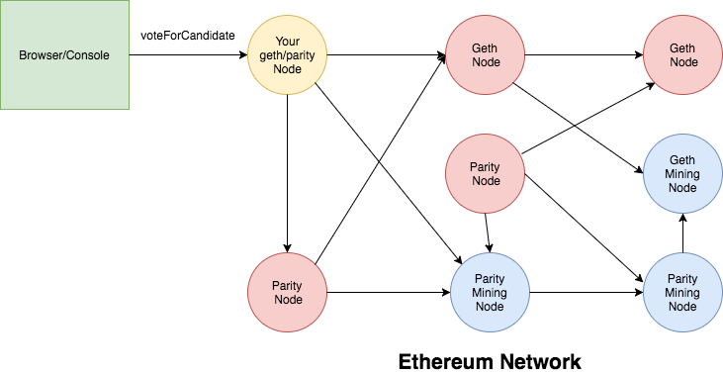

1 construct raw transaction object
VoteForCandidate() is a function containing

{\Scrv_ps=txnCount = web3.eth.getTransactionCount(web3.eth.accounts[0])\end_Scrv_ps}
{\Scrv_ps=var rawTxn = {\end_Scrv_ps}
{\Scrv_ps= nonce: web3.toHex(txnCount),\end_Scrv_ps}
{\Scrv_ps= gasPrice: web3.toHex(100000000000),\end_Scrv_ps}
{\Scrv_ps= gasLimit: web3.toHex(140000),\end_Scrv_ps}
{\Scrv_ps= to: '0x633296baebc20f33ac2e1c1b105d7cd1f6a0718b',\end_Scrv_ps}
{\Scrv_ps= value: web3.toHex(0),\end_Scrv_ps}
{\Scrv_ps= data: '0xcc9ab24952616d6100000000000000000000000000000000000000000000000000000000'\end_Scrv_ps}
{\Scrv_ps=};\end_Scrv_ps}

-nonce: Each Ethereum account has a field called nonce to keep track of the total number of transactions that account has executed. Nonce is incremented for every new transaction and this allows the network to know the order in which the transactions need to be executed. Nonce is also used for the replay protection.

-gasPrice: Price per unit of gas you are willing to pay for this transaction. If you are executing your transaction on the Mainnet, here is a handy website from ETH Gas Station that recommends what you should set the gas price for your transaction to succeed in a reasonable amount of time. Gas prices are current measured in GWei and range from 0.1->100+Gwei. You will learn more about gas price and it’s impact later in this article.

-gasLimit: Maximum gas you are willing to pay for this transaction. This value insures that in case of an issue executing your transaction (like infinite loop), you account is not drained of all the funds. Once the transaction is executed, any remaining gas is sent back to your account.
to: The address to which you are directing this function call. This is the contract address (0x633296baebc20f33ac2e1c1b105d7cd1f6a0718b) of the Voting contract in our case.

-value: Total Ether you want to send. When we executevoteForCandidate, we are not sending any Ether and so the value is 0. If you were executing a transaction to send Ether to another person or a contract, you would set this value.

-data:

Let’s see how this data field is calculated.

{\Scrv_ps=> web3.sha3('voteForCandidate(bytes32)')\end_Scrv_ps}
{\Scrv_ps='0xcc9ab267dda32b80892b2ae9e21b782dbf5562ef3e8919fc17cab72aa7db9d59'\end_Scrv_ps}

Take the first 4 bytes of this hash -> ‘0xcc9ab267’
You then take the argument ‘Nick’ and convert to bytes32 and you get 52616d6100000000000000000000000000000000000000000000000000000000

2 Sign the transaction
Transactions have to be started by an externally owned account, to begin the transaction there must be a way of proving the account owner is the one initiating - this is done by signing the transaction

{\Scrv_ps=const privateKey = Buffer.from('e331b6d69882b4ab4ea581s88e0b6s4039a3de5967d88dfdcffdd2270c0fd109', 'hex')\end_Scrv_ps}
{\Scrv_ps=const txn = new EthereumTx(rawTxn)\end_Scrv_ps}
{\Scrv_ps=txn.sign(privateKey)\end_Scrv_ps}
{\Scrv_ps=const serializedTxn = txn.serialize()\end_Scrv_ps}

3 transaction is validated
Submission will validate the transaction

4 transaction broadcast to the address
The signed transaction is broadcast to the larger network. Once transaction is broadcast, original node will output the transaction id, this can be used to track the transaction. This id is a hash of the signed transaction object.

Not all nodes will accept your transaction, some have a minimum gas price

{\Scrv_ps=transactionId = sha3(serializedTxn)\end_Scrv_ps}

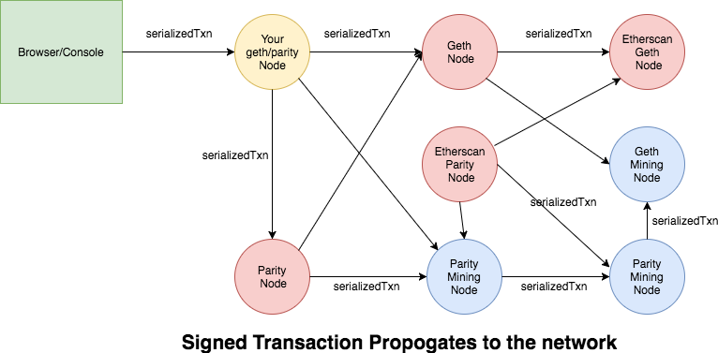

5 miner node accepts the transaction
Ethereum network has a mix of miner and non-miner nodes (nodes and miners). Miners are the ones that include transactions into blocks, these miners also maintain a transaction pool where transactions will be stored before a miner starts to evaluate them.

Miners will store transactions, sorted by gas price, the more expensive the gas price, the more likely it is to be picked up and included in the next block. This is configurable, and a miner is free to sort transactions in any manner they choose. This allows for a miner to even mine the lowest cost transaction first.

Miners can only hold a finite number of transactions. Therefore, if the network becomes flooded by a large number of high priced transactions they can fill up the transaction pools, meaning lower priced transactions may not be included and may need to be rebroadcast to the network.

To help with this, resubmitting a transaction with a higher gas price and re-using the nonce. This will help improve the transactions chance of being picked up, while assuring it will only be mined one time. If a transaction is resubmitted with a new nonce, there is the danger that both will eventually be mined.

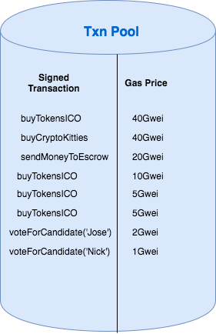

6 miner node finds a valid block and broadcasts to the network
Miners are able to pick up transactions to include in the block, but the total amount of gas to be used must be under a network wide, global limit.

Once the transactions have been chosen, they must be validated and included in a pending block and PoW or PoA begins. Once the block has been validated, it will be added to the local copy of the blockchain. Now, just like the raw transactions were broadcast to the network, this new version of the blockchain is broadcast.

7 local node receives/syncs new block
When a new node receives the new block, it must execute all transactions on that block and verify the new state.

