Accounts are the way that anything interacts with the blockchain. Unique to Ethereum, there are two types of accounts that be created.
- Externally owned accounts
- Contract accounts.

External accounts are owned by end users. These are the normal accounts that most people will be familiar with, you sign up for one with a tool such as MIST and you are then able to transfer ether on the network. These external accounts are defined by the fact that they will be controlled by a private key that is created with the account and that the account will not have any EVM code associated with them (we will discuss what the EVM and code is a bit later). Externally owned accounts are also the only accounts that are allowed to kick off transactions within the system. We will cover transactions in detail below, but for now transactions can be viewed simply as any modification or interaction with the block chain. Therefore, contracts can not trigger themselves based on timers or events from external systems, the must always be called by a valid external account.

Contract accounts do not have an associated private key but does have EVM code stored in the account. While we know that contracts can initiate transactions themselves, it is worth noting here that once called, a contract may be able to call contracts on the callers behalf. Contract-to-contract calls will be covered more in a subsequent section, but it is an important caveat to be aware of.
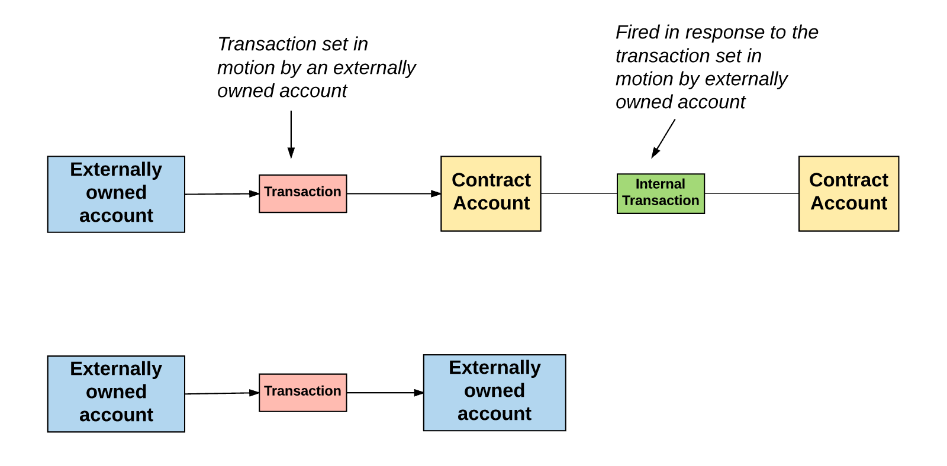

Accounts are tracked by the blockchain through something called the 'Account State' (we won't dive too deeply into this now, but want to point out at a high level what is tracked).

There are only 4 properties that are tracked at an account level
- Nonce
- Balance
- CodeHash
- StorageRoot
