Choose a Good Title!

Put your name here!

put the date here

# Introduction

We start by loading the data into 2 data frames

library(readr)  
Sec02 <- read_csv("Class_Survey_Sec02.csv")

## Parsed with column specification:  
## cols(  
## .default = col_character(),  
## Birthday = col_integer(),  
## Breathold = col_integer(),  
## Breathold2 = col_integer(),  
## pulse_start = col_integer(),  
## time_down_up = col_integer(),  
## pulse_after_down_up = col_integer(),  
## height_in = col_integer(),  
## Age_yrs = col_integer(),  
## arm_shoulder_fingertip_inches = col_integer(),  
## `right hand_thumb_pinkty_ inch` = col_double()  
## )

## See spec(...) for full column specifications.

Sec23 <- read_csv("Class_Survey_Sec23.csv")

## Parsed with column specification:  
## cols(  
## .default = col_character(),  
## Birthday = col_integer(),  
## Breathold = col_integer(),  
## Breathold2 = col_integer(),  
## pulse_start = col_integer(),  
## time_down_up = col_integer(),  
## pulse_after_down_up = col_integer(),  
## height_in = col_double(),  
## Age_yrs = col_integer(),  
## arm_shoulder_fingertip_inches = col_double(),  
## `right hand_thumb_pinkty_ inch` = col_double()  
## )  
## See spec(...) for full column specifications.

Sec02 <- mutate(Sec02,sect="PM")  
Sec23 <- mutate(Sec23,sect="Eve")  
alldat <- bind_rows(Sec02,Sec23)

write.csv(x=alldat,file="alldat.csv")

# Methods

# Results

## Descriptive Results

### Graphical Descriptive Results

Boxplot(Age_yrs~sect, data=alldat, id=list(method="y"))

## Warning in Boxplot.default(mf[[response]], x, id = list(method =  
## id.method, : NAs introduced by coercion

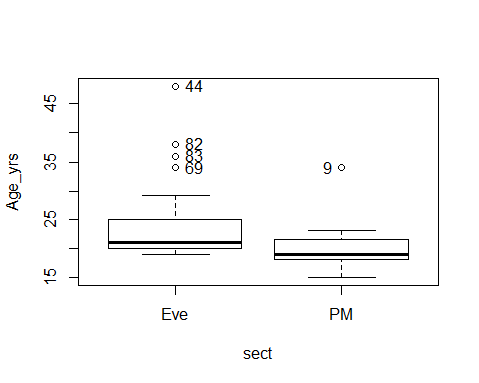

## [1] "44" "69" "82" "83" "9"

### Numerical Descriptive Results

## Inferential Results

# Discussion and Conclusion