Uncertainty Quantification and Optimal Design for Complex Systems
Bearcat Bing¹ and Baxter Vestal²
¹ Binghamton Center of Complex Systems, Binghamton University, Binghamton, NY, USA
² School of Nonlinear Dynamics and Chaos, Vestal University, Vestal, NY, USA
bearcat@binghamton.edu
The page size for this abstract should be set to US Letter, measuring 8.5 by 11 inches. All margins (left, right, top, and bottom) should be exactly 1 inch (2.54 cm). The entire abstract should be written in English. Page numbers, headers, footers, and footnotes should not be included in the document. The text should be formatted in a single column layout and justified to align with both the left and right margins. The entire abstract should be single-spaced. The page limit is one page for the complete abstract, which includes one mandatory figure. Submissions will be considered for both oral and poster presentations. The work presented in the abstract can be either new, unpublished work or based on the authors' recently published work. At the top of the page, the title, a list of authors, and their respective affiliations should be included. The title should be the only element set in bold face. The title, author list, and affiliations should all be centered on the page. All text in the manuscript should use 12-point Times font, or the closest comparable font available. This applies to the entire document, including the title, authors, affiliations, abstract body, figure captions, and any references. All abstracts are required to include one mandatory figure. This figure should clearly illustrate the key results of the present work. The use of color figures is permitted. Including references is optional for this abstract. If references are included, they should be cited within the text using numerical labels placed in brackets (for example, "[1]"). The list of references at the end of the document should be sorted in the order they first appear in the text. The complete manuscript, including all text, tables, and figures, should be submitted as a single PDF file via the EasyChair submission system. Any questions about the submission process or the abstract requirements can be addressed to: ccs2026binghamton@gmail.com. See Figure 1 for the Binghamton University campus map.
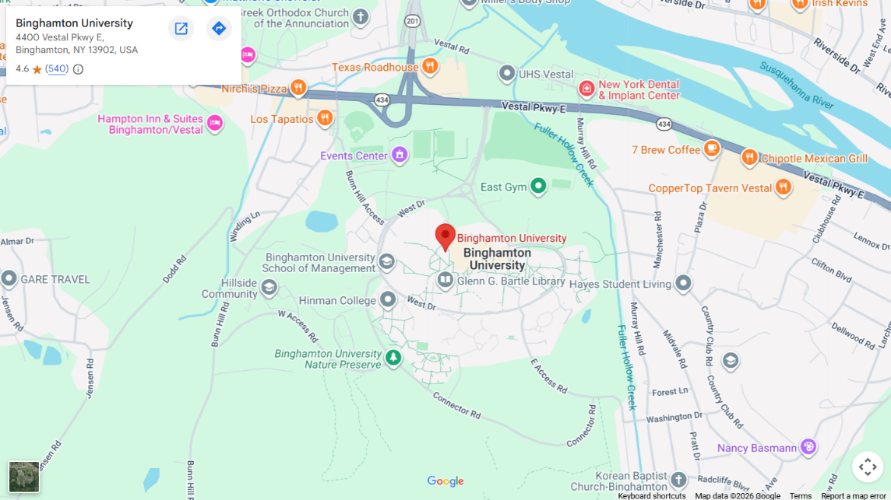
Figure 1. This is the caption for the mandatory figure.
[1] CCS 2026 website. CCS 2026: The 2026 Conference on Complex Systems @ Binghamton, NY, USA. Accessed on March 19th, 2026.

