atlas_mg

Autogenerated data summary from dataMaid

2023-10-09 22:58:13

# Data report overview

The dataset examined has the following dimensions:

| Feature | Result |
| --- | --- |
| Number of observations | 853 |
| Number of variables | 15 |

### Checks performed

The following variable checks were performed, depending on the data type of each variable:

|  | character | factor | labelled | haven labelled | numeric | integer | logical | Date |
| --- | --- | --- | --- | --- | --- | --- | --- | --- |
| Identify miscoded missing values | × | × | × | × | × | × |  | × |
| Identify prefixed and suffixed whitespace | × | × | × | × |  |  |  |  |
| Identify levels with < 6 obs. | × | × | × | × |  |  |  |  |
| Identify case issues | × | × | × | × |  |  |  |  |
| Identify misclassified numeric or integer variables | × | × | × | × |  |  |  |  |
| Identify outliers |  |  |  |  | × | × |  | × |

Please note that all numerical values in the following have been rounded to 2 decimals.

# Summary table

|  | Variable class | # unique values | Missing observations | Any problems? |
| --- | --- | --- | --- | --- |
| code_muni | numeric | 853 | 0.00 % |  |
| Nome do Município | character | 853 | 0.00 % | × |
| IDHM 2010 | numeric | 223 | 0.00 % | × |
| IDHM Renda 2010 | numeric | 232 | 0.00 % | × |
| IDHM Longevidade 2010 | numeric | 130 | 0.00 % | × |
| IDHM Educação 2010 | numeric | 288 | 0.00 % | × |
| Subíndice de frequência escolar - IDHM Educação 2010 | numeric | 260 | 0.00 % | × |
| Subíndice de escolaridade - IDHM Educação 2010 | numeric | 330 | 0.00 % | × |
| Esperança de vida ao nascer 2010 | numeric | 400 | 0.00 % | × |
| % de 5 a 6 anos de idade na escola 2010 | numeric | 638 | 0.00 % | × |
| % de 11 a 13 anos de idade nos anos finais do ensino fundamental ou com ensino fundamental completo 2010 | numeric | 685 | 0.00 % | × |
| % de 15 a 17 anos de idade com ensino fundamental completo 2010 | numeric | 754 | 0.00 % | × |
| % de 18 a 20 anos de idade com ensino médio completo 2010 | numeric | 756 | 0.00 % | × |
| % de 18 anos ou mais de idade com ensino fundamental completo 2010 | numeric | 732 | 0.00 % | × |
| Renda per capita 2010 | numeric | 844 | 0.00 % | × |

# Variable list

## code_muni

| Feature | Result |
| --- | --- |
| Variable type | numeric |
| Number of missing obs. | 0 (0 %) |
| Number of unique values | 853 |
| Median | 3137304 |
| 1st and 3rd quartiles | 3119500; 3154903 |
| Min. and max. | 3100104; 3172202 |

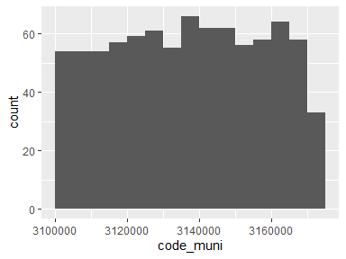

## Nome do Município

* The variable is a key (distinct values for each observation).

## IDHM 2010

| Feature | Result |
| --- | --- |
| Variable type | numeric |
| Number of missing obs. | 0 (0 %) |
| Number of unique values | 223 |
| Median | 0.67 |
| 1st and 3rd quartiles | 0.63; 0.7 |
| Min. and max. | 0.53; 0.81 |

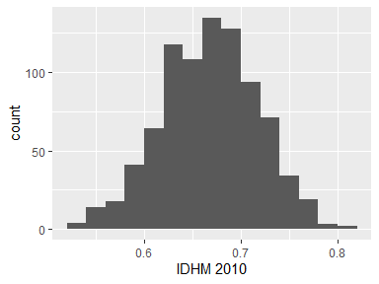

* Note that the following possible outlier values were detected: "0.79", "0.79", "0.81", "0.81".

## IDHM Renda 2010

| Feature | Result |
| --- | --- |
| Variable type | numeric |
| Number of missing obs. | 0 (0 %) |
| Number of unique values | 232 |
| Median | 0.66 |
| 1st and 3rd quartiles | 0.61; 0.69 |
| Min. and max. | 0.5; 0.86 |

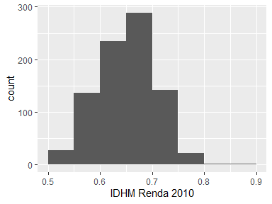

* Note that the following possible outlier values were detected: "0.77", "0.77", "0.78", "0.78", "0.78", "0.79", "0.79", "0.84", "0.86".

## IDHM Longevidade 2010

| Feature | Result |
| --- | --- |
| Variable type | numeric |
| Number of missing obs. | 0 (0 %) |
| Number of unique values | 130 |
| Median | 0.82 |
| 1st and 3rd quartiles | 0.8; 0.85 |
| Min. and max. | 0.72; 0.89 |

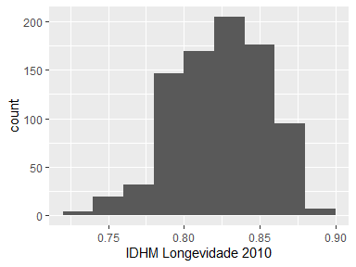

* Note that the following possible outlier values were detected: "0.72", "0.74", "0.74".

## IDHM Educação 2010

| Feature | Result |
| --- | --- |
| Variable type | numeric |
| Number of missing obs. | 0 (0 %) |
| Number of unique values | 288 |
| Median | 0.56 |
| 1st and 3rd quartiles | 0.51; 0.6 |
| Min. and max. | 0.34; 0.74 |

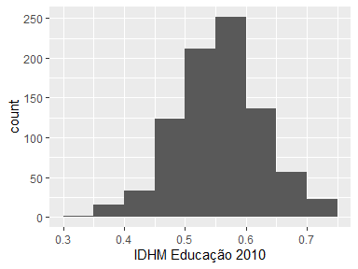

* Note that the following possible outlier values were detected: "0.34", "0.72", "0.74", "0.74", "0.74".

## Subíndice de frequência escolar - IDHM Educação 2010

| Feature | Result |
| --- | --- |
| Variable type | numeric |
| Number of missing obs. | 0 (0 %) |
| Number of unique values | 260 |
| Median | 0.68 |
| 1st and 3rd quartiles | 0.64; 0.72 |
| Min. and max. | 0.45; 0.92 |

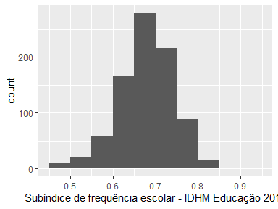

* Note that the following possible outlier values were detected: "0.45", "0.47", "0.47", "0.48", "0.48", …, "0.83", "0.84", "0.85", "0.85", "0.92" (6 values omitted).

## Subíndice de escolaridade - IDHM Educação 2010

| Feature | Result |
| --- | --- |
| Variable type | numeric |
| Number of missing obs. | 0 (0 %) |
| Number of unique values | 330 |
| Median | 0.37 |
| 1st and 3rd quartiles | 0.32; 0.43 |
| Min. and max. | 0.16; 0.7 |

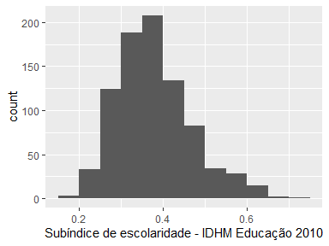

* Note that the following possible outlier values were detected: "0.16", "0.17", "0.18", "0.21", "0.21", "0.21", "0.7".

## Esperança de vida ao nascer 2010

| Feature | Result |
| --- | --- |
| Variable type | numeric |
| Number of missing obs. | 0 (0 %) |
| Number of unique values | 400 |
| Median | 74.41 |
| 1st and 3rd quartiles | 73.1; 75.78 |
| Min. and max. | 68.37; 78.15 |

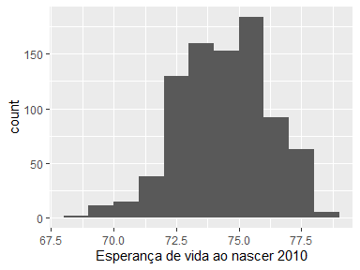

* Note that the following possible outlier values were detected: "68.37", "68.39", "69.29", "69.41", "69.6".

## % de 5 a 6 anos de idade na escola 2010

| Feature | Result |
| --- | --- |
| Variable type | numeric |
| Number of missing obs. | 0 (0 %) |
| Number of unique values | 638 |
| Median | 93.38 |
| 1st and 3rd quartiles | 88.38; 96.95 |
| Min. and max. | 57.66; 100 |

* Note that the following possible outlier values were detected: "57.66", "57.92", "58.01", "58.92", "59.04", "59.78", "60.87", "61.22", "61.89", "62.51".

## % de 11 a 13 anos de idade nos anos finais do ensino fundamental ou com ensino fundamental completo 2010

| Feature | Result |
| --- | --- |
| Variable type | numeric |
| Number of missing obs. | 0 (0 %) |
| Number of unique values | 685 |
| Median | 87.48 |
| 1st and 3rd quartiles | 83.54; 90.64 |
| Min. and max. | 59.38; 100 |

* Note that the following possible outlier values were detected: "59.38", "62.82", "64.3", "65.07", "66.4", …, "98.04", "98.42", "98.63", "98.71", "100" (8 values omitted).

## % de 15 a 17 anos de idade com ensino fundamental completo 2010

| Feature | Result |
| --- | --- |
| Variable type | numeric |
| Number of missing obs. | 0 (0 %) |
| Number of unique values | 754 |
| Median | 57.77 |
| 1st and 3rd quartiles | 50.5; 64.52 |
| Min. and max. | 26.29; 88.93 |

* Note that the following possible outlier values were detected: "81.17", "81.85", "82.01", "82.48", "82.95", "83.57", "84.08", "85.04", "88.88", "88.93".

## % de 18 a 20 anos de idade com ensino médio completo 2010

| Feature | Result |
| --- | --- |
| Variable type | numeric |
| Number of missing obs. | 0 (0 %) |
| Number of unique values | 756 |
| Median | 35.86 |
| 1st and 3rd quartiles | 29.57; 42.96 |
| Min. and max. | 9.45; 81.64 |

* Note that the following possible outlier values were detected: "9.45", "12.3", "12.99", "13.84", "67.92", "69.42", "81.64".

## % de 18 anos ou mais de idade com ensino fundamental completo 2010

| Feature | Result |
| --- | --- |
| Variable type | numeric |
| Number of missing obs. | 0 (0 %) |
| Number of unique values | 732 |
| Median | 36.62 |
| 1st and 3rd quartiles | 31.53; 42.9 |
| Min. and max. | 16; 70.15 |

* Note that the following possible outlier values were detected: "16", "17.18", "18.5", "20.62", "20.87", "21.37", "21.56", "70.15".

## Renda per capita 2010

| Feature | Result |
| --- | --- |
| Variable type | numeric |
| Number of missing obs. | 0 (0 %) |
| Number of unique values | 844 |
| Median | 475.23 |
| 1st and 3rd quartiles | 359.93; 592.95 |
| Min. and max. | 181.77; 1731.84 |

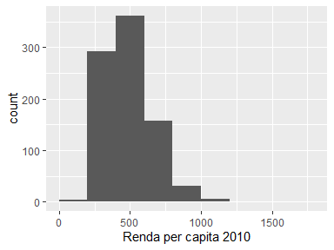

* Note that the following possible outlier values were detected: "1001.45", "1007.03", "1050.88", "1089.96", "1122.1", "1497.29", "1731.84".

Report generation information:

* Created by: Could not determine from system (username: Unknown)
* Report creation time: seg out 09 2023 22:58:14
* Report was run from directory: C:/Users/caios/OneDrive/Documentos/GitHub/mqagp
* dataMaid v1.4.1 [Pkg: 2021-10-08 from CRAN (R 4.2.3)]
* R version 4.2.2 (2022-10-31 ucrt).
* Platform: x86_64-w64-mingw32/x64 (64-bit)(Windows 10 x64 (build 22621)).
* Function call: makeDataReport(data = atlas_mg, replace = TRUE)