df

Autogenerated data summary from dataMaid

2023-08-21 15:44:50.292408

# Data report overview

The dataset examined has the following dimensions:

| Feature | Result |
| --- | --- |
| Number of observations | 32564 |
| Number of variables | 88 |

### Checks performed

The following variable checks were performed, depending on the data type of each variable:

|  | character | factor | labelled | haven labelled | numeric | integer | logical | Date |
| --- | --- | --- | --- | --- | --- | --- | --- | --- |
| Identify miscoded missing values | × | × | × | × | × | × |  | × |
| Identify prefixed and suffixed whitespace | × | × | × | × |  |  |  |  |
| Identify levels with < 6 obs. | × | × | × | × |  |  |  |  |
| Identify case issues | × | × | × | × |  |  |  |  |
| Identify misclassified numeric or integer variables | × | × | × | × |  |  |  |  |
| Identify outliers |  |  |  |  | × | × |  | × |

Please note that all numerical values in the following have been rounded to 2 decimals.

# Summary table

|  | Variable class | # unique values | Missing observations | Any problems? |
| --- | --- | --- | --- | --- |
| Cod_setor | numeric | 32564 | 0.00 % |  |
| Situacao_setor | numeric | 8 | 0.00 % |  |
| V001 | numeric | 1399 | 0.00 % | × |
| V002 | character | 37 | 0.00 % | × |
| V003 | character | 42 | 0.00 % | × |
| V004 | character | 48 | 0.00 % | × |
| V005 | character | 51 | 0.00 % | × |
| V006 | character | 59 | 0.00 % | × |
| V007 | character | 62 | 0.00 % | × |
| V008 | character | 61 | 0.00 % | × |
| V009 | character | 57 | 0.00 % | × |
| V010 | character | 58 | 0.00 % | × |
| V011 | character | 58 | 0.00 % | × |
| V012 | character | 60 | 0.00 % | × |
| V013 | character | 56 | 0.00 % | × |
| V014 | character | 58 | 0.00 % | × |
| V015 | character | 55 | 0.00 % | × |
| V016 | character | 57 | 0.00 % | × |
| V017 | character | 60 | 0.00 % | × |
| V018 | character | 61 | 0.00 % | × |
| V019 | character | 59 | 0.00 % | × |
| V020 | character | 62 | 0.00 % | × |
| V021 | character | 60 | 0.00 % | × |
| V022 | character | 59 | 0.00 % | × |
| V023 | character | 65 | 0.00 % | × |
| V024 | character | 61 | 0.00 % | × |
| V025 | character | 66 | 0.00 % | × |
| V026 | character | 67 | 0.00 % | × |
| V027 | character | 69 | 0.00 % | × |
| V028 | character | 66 | 0.00 % | × |
| V029 | character | 65 | 0.00 % | × |
| V030 | character | 56 | 0.00 % | × |
| V031 | character | 62 | 0.00 % | × |
| V032 | character | 59 | 0.00 % | × |
| V033 | character | 52 | 0.00 % | × |
| V034 | character | 53 | 0.00 % | × |
| V035 | character | 49 | 0.00 % | × |
| V036 | character | 49 | 0.00 % | × |
| V037 | character | 48 | 0.00 % | × |
| V038 | character | 47 | 0.00 % | × |
| V039 | character | 48 | 0.00 % | × |
| V040 | character | 43 | 0.00 % | × |
| V041 | character | 43 | 0.00 % | × |
| V042 | character | 45 | 0.00 % | × |
| V043 | character | 43 | 0.00 % | × |
| V044 | character | 42 | 0.00 % | × |
| V045 | character | 40 | 0.00 % | × |
| V046 | character | 39 | 0.00 % | × |
| V047 | character | 38 | 0.00 % | × |
| V048 | character | 38 | 0.00 % | × |
| V049 | character | 37 | 0.00 % | × |
| V050 | character | 35 | 0.00 % | × |
| V051 | character | 36 | 0.00 % | × |
| V052 | character | 36 | 0.00 % | × |
| V053 | character | 34 | 0.00 % | × |
| V054 | character | 30 | 0.00 % | × |
| V055 | character | 31 | 0.00 % | × |
| V056 | character | 26 | 0.00 % | × |
| V057 | character | 28 | 0.00 % | × |
| V058 | character | 27 | 0.00 % | × |
| V059 | character | 28 | 0.00 % | × |
| V060 | character | 24 | 0.00 % | × |
| V061 | character | 26 | 0.00 % | × |
| V062 | character | 24 | 0.00 % | × |
| V063 | character | 21 | 0.00 % | × |
| V064 | character | 19 | 0.00 % | × |
| V065 | character | 20 | 0.00 % | × |
| V066 | character | 18 | 0.00 % | × |
| V067 | character | 20 | 0.00 % | × |
| V068 | character | 21 | 0.00 % | × |
| V069 | character | 20 | 0.00 % | × |
| V070 | character | 18 | 0.00 % | × |
| V071 | character | 19 | 0.00 % | × |
| V072 | character | 18 | 0.00 % | × |
| V073 | character | 16 | 0.00 % | × |
| V074 | character | 16 | 0.00 % | × |
| V075 | character | 17 | 0.00 % | × |
| V076 | character | 16 | 0.00 % | × |
| V077 | character | 74 | 0.00 % | × |
| V078 | character | 537 | 0.00 % | × |
| V079 | character | 390 | 0.00 % | × |
| V080 | character | 507 | 0.00 % | × |
| V081 | character | 104 | 0.00 % | × |
| V082 | character | 71 | 0.00 % | × |
| V083 | character | 96 | 0.00 % | × |
| V084 | character | 77 | 0.00 % | × |
| V085 | character | 88 | 0.00 % | × |
| …88 | logical | 1 | 100.00 % | × |

# Variable list

## Cod_setor

| Feature | Result |
| --- | --- |
| Variable type | numeric |
| Number of missing obs. | 0 (0 %) |
| Number of unique values | 32564 |
| Median | 313380805000046 |
| 1st and 3rd quartiles | 311200005000030; 315210505062544 |
| Min. and max. | 310010405000001; 317220210000002 |

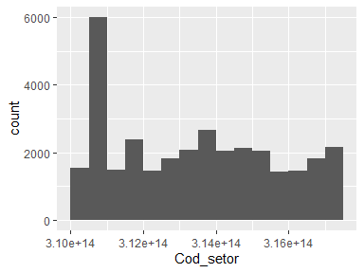

## Situacao_setor

| Feature | Result |
| --- | --- |
| Variable type | numeric |
| Number of missing obs. | 0 (0 %) |
| Number of unique values | 8 |
| Median | 1 |
| 1st and 3rd quartiles | 1; 3 |
| Min. and max. | 1; 8 |

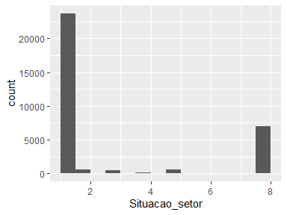

## V001

| Feature | Result |
| --- | --- |
| Variable type | numeric |
| Number of missing obs. | 0 (0 %) |
| Number of unique values | 1399 |
| Median | 510 |
| 1st and 3rd quartiles | 310; 695 |
| Min. and max. | 0; 2499 |

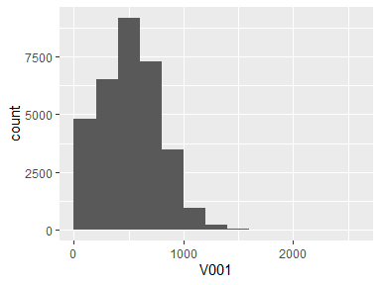

* Note that the following possible outlier values were detected: "1234", "1235", "1237", "1238", "1239", …, "2111", "2116", "2135", "2245", "2499" (167 values omitted).

## V002

| Feature | Result |
| --- | --- |
| Variable type | character |
| Number of missing obs. | 0 (0 %) |
| Number of unique values | 37 |
| Mode | “0” |

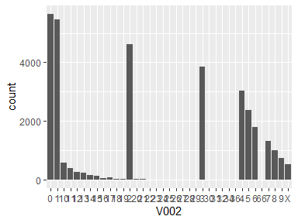

* The following suspected missing value codes enter as regular values: "8", "9".
* Note that the following levels have at most five observations: "24", "26", "27", "28", "29", …, "31", "32", "34", "36", "66" (1 values omitted).

## V003

| Feature | Result |
| --- | --- |
| Variable type | character |
| Number of missing obs. | 0 (0 %) |
| Number of unique values | 42 |
| Mode | “3” |

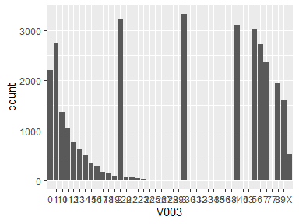

* The following suspected missing value codes enter as regular values: "8", "9".
* Note that the following levels have at most five observations: "31", "32", "33", "34", "35", "36", "38", "40", "43", "77".

## V004

| Feature | Result |
| --- | --- |
| Variable type | character |
| Number of missing obs. | 0 (0 %) |
| Number of unique values | 48 |
| Mode | “5” |

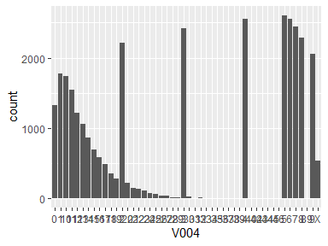

* The following suspected missing value codes enter as regular values: "8", "9".
* Note that the following levels have at most five observations: "34", "35", "36", "39", "40", …, "43", "44", "45", "46", "89" (1 values omitted).

## V005

| Feature | Result |
| --- | --- |
| Variable type | character |
| Number of missing obs. | 0 (0 %) |
| Number of unique values | 51 |
| Mode | “5” |

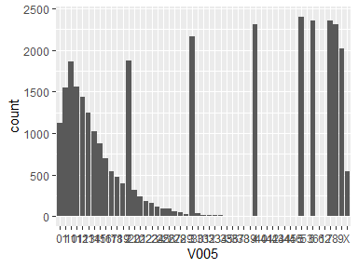

* The following suspected missing value codes enter as regular values: "8", "9".
* Note that the following levels have at most five observations: "35", "36", "39", "40", "41", …, "45", "46", "53", "61", "62" (3 values omitted).

## V006

| Feature | Result |
| --- | --- |
| Variable type | character |
| Number of missing obs. | 0 (0 %) |
| Number of unique values | 59 |
| Mode | “8” |

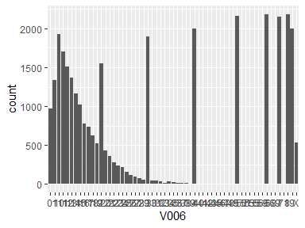

* The following suspected missing value codes enter as regular values: "8", "9".
* Note that the following levels have at most five observations: "39", "40", "41", "42", "43", …, "56", "59", "68", "69", "71" (9 values omitted).

## V007

| Feature | Result |
| --- | --- |
| Variable type | character |
| Number of missing obs. | 0 (0 %) |
| Number of unique values | 62 |
| Mode | “9” |

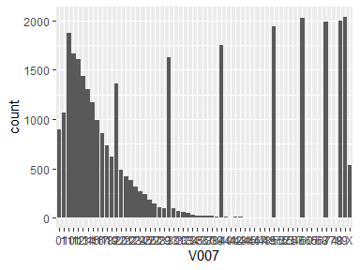

* The following suspected missing value codes enter as regular values: "8", "9".
* Note that the following levels have at most five observations: "44", "45", "46", "47", "48", …, "65", "66", "68", "74", "79" (7 values omitted).

## V008

| Feature | Result |
| --- | --- |
| Variable type | character |
| Number of missing obs. | 0 (0 %) |
| Number of unique values | 61 |
| Mode | “8” |

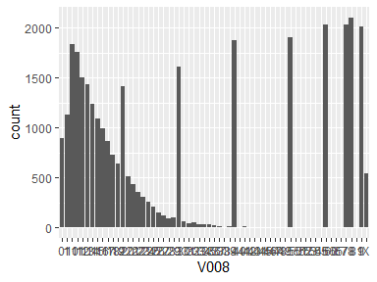

* The following suspected missing value codes enter as regular values: "8", "9".
* Note that the following levels have at most five observations: "42", "43", "44", "45", "46", …, "55", "60", "65", "67", "81" (8 values omitted).

## V009

| Feature | Result |
| --- | --- |
| Variable type | character |
| Number of missing obs. | 0 (0 %) |
| Number of unique values | 57 |
| Mode | “8” |

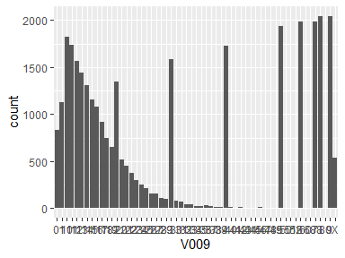

* The following suspected missing value codes enter as regular values: "8", "9".
* Note that the following levels have at most five observations: "41", "43", "44", "45", "47", …, "51", "52", "60", "68", "80" (3 values omitted).

## V010

| Feature | Result |
| --- | --- |
| Variable type | character |
| Number of missing obs. | 0 (0 %) |
| Number of unique values | 58 |
| Mode | “8” |

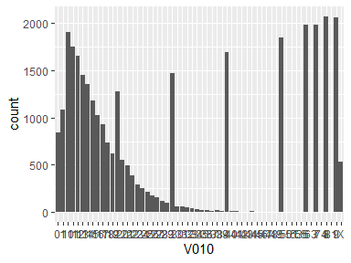

* The following suspected missing value codes enter as regular values: "8", "9".
* Note that the following levels have at most five observations: "42", "43", "45", "46", "47", …, "53", "55", "63", "74", "81" (4 values omitted).

## V011

| Feature | Result |
| --- | --- |
| Variable type | character |
| Number of missing obs. | 0 (0 %) |
| Number of unique values | 58 |
| Mode | “8” |

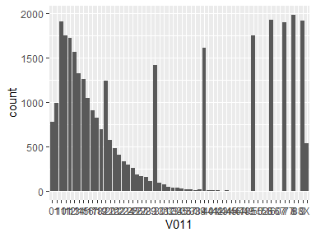

* The following suspected missing value codes enter as regular values: "8", "88", "9".
* Note that the following levels have at most five observations: "43", "45", "46", "47", "48", …, "58", "60", "67", "77", "88" (3 values omitted).

## V012

| Feature | Result |
| --- | --- |
| Variable type | character |
| Number of missing obs. | 0 (0 %) |
| Number of unique values | 60 |
| Mode | “9” |

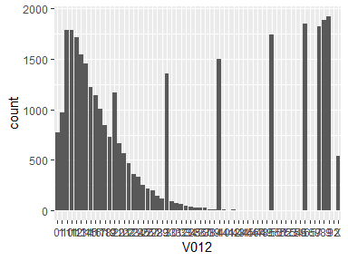

* The following suspected missing value codes enter as regular values: "8", "9".
* Note that the following levels have at most five observations: "43", "45", "46", "47", "48", …, "54", "59", "65", "69", "92" (5 values omitted).

## V013

| Feature | Result |
| --- | --- |
| Variable type | character |
| Number of missing obs. | 0 (0 %) |
| Number of unique values | 56 |
| Mode | “8” |

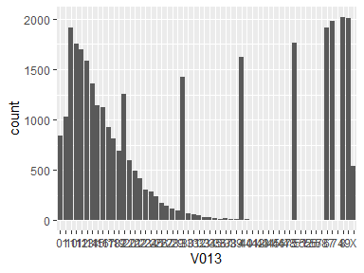

* The following suspected missing value codes enter as regular values: "8", "9".
* Note that the following levels have at most five observations: "41", "42", "43", "44", "45", …, "52", "56", "57", "58", "74" (4 values omitted).

## V014

| Feature | Result |
| --- | --- |
| Variable type | character |
| Number of missing obs. | 0 (0 %) |
| Number of unique values | 58 |
| Mode | “7” |

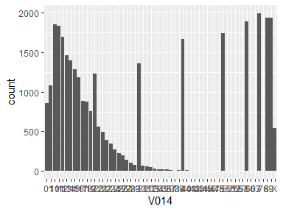

* The following suspected missing value codes enter as regular values: "8", "9".
* Note that the following levels have at most five observations: "38", "41", "42", "43", "44", …, "56", "57", "60", "63", "76" (7 values omitted).

## V015

| Feature | Result |
| --- | --- |
| Variable type | character |
| Number of missing obs. | 0 (0 %) |
| Number of unique values | 55 |
| Mode | “8” |

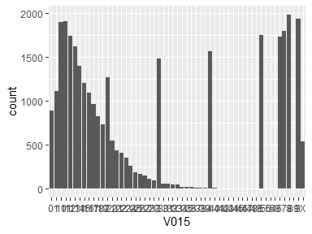

* The following suspected missing value codes enter as regular values: "8", "9".
* Note that the following levels have at most five observations: "41", "42", "43", "44", "45", …, "49", "50", "54", "59", "89" (3 values omitted).

## V016

| Feature | Result |
| --- | --- |
| Variable type | character |
| Number of missing obs. | 0 (0 %) |
| Number of unique values | 57 |
| Mode | “9” |

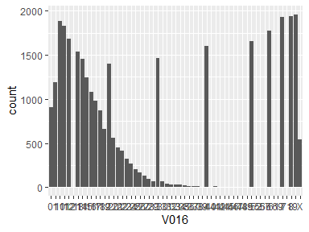

* The following suspected missing value codes enter as regular values: "8", "9".
* Note that the following levels have at most five observations: "121", "40", "42", "44", "45", …, "56", "57", "61", "69", "71" (5 values omitted).

## V017

| Feature | Result |
| --- | --- |
| Variable type | character |
| Number of missing obs. | 0 (0 %) |
| Number of unique values | 60 |
| Mode | “10” |

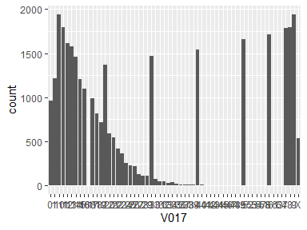

* The following suspected missing value codes enter as regular values: "8", "9".
* Note that the following levels have at most five observations: "168", "41", "42", "43", "44", …, "57", "58", "61", "63", "64" (8 values omitted).

## V018

| Feature | Result |
| --- | --- |
| Variable type | character |
| Number of missing obs. | 0 (0 %) |
| Number of unique values | 61 |
| Mode | “8” |

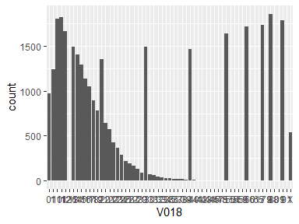

* The following suspected missing value codes enter as regular values: "8", "9".
* Note that the following levels have at most five observations: "126", "42", "43", "44", "45", …, "65", "79", "80", "81", "91" (8 values omitted).

## V019

| Feature | Result |
| --- | --- |
| Variable type | character |
| Number of missing obs. | 0 (0 %) |
| Number of unique values | 59 |
| Mode | “9” |

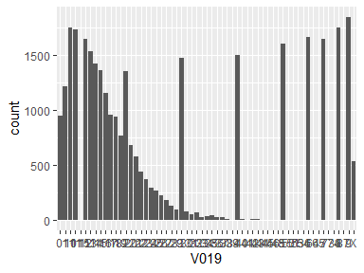

* The following suspected missing value codes enter as regular values: "8", "9".
* Note that the following levels have at most five observations: "115", "39", "44", "45", "46", …, "64", "65", "73", "74", "87" (5 values omitted).

## V020

| Feature | Result |
| --- | --- |
| Variable type | character |
| Number of missing obs. | 0 (0 %) |
| Number of unique values | 62 |
| Mode | “8” |

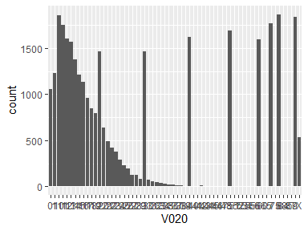

* The following suspected missing value codes enter as regular values: "8", "9".
* Note that the following levels have at most five observations: "41", "44", "45", "46", "47", …, "65", "75", "84", "85", "87" (8 values omitted).

## V021

| Feature | Result |
| --- | --- |
| Variable type | character |
| Number of missing obs. | 0 (0 %) |
| Number of unique values | 60 |
| Mode | “9” |

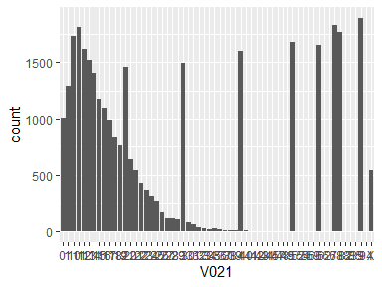

* The following suspected missing value codes enter as regular values: "8", "9".
* Note that the following levels have at most five observations: "41", "42", "44", "45", "47", …, "66", "82", "83", "85", "94" (7 values omitted).

## V022

| Feature | Result |
| --- | --- |
| Variable type | character |
| Number of missing obs. | 0 (0 %) |
| Number of unique values | 59 |
| Mode | “10” |

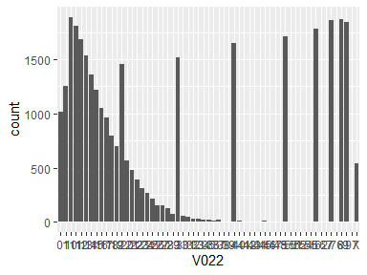

* The following suspected missing value codes enter as regular values: "8", "9".
* Note that the following levels have at most five observations: "41", "42", "44", "46", "47", …, "55", "62", "67", "76", "97" (5 values omitted).

## V023

| Feature | Result |
| --- | --- |
| Variable type | character |
| Number of missing obs. | 0 (0 %) |
| Number of unique values | 65 |
| Mode | “7” |

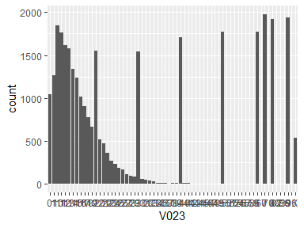

* The following suspected missing value codes enter as regular values: "8", "9".
* Note that the following levels have at most five observations: "42", "43", "44", "45", "46", …, "70", "82", "83", "86", "96" (12 values omitted).

## V024

| Feature | Result |
| --- | --- |
| Variable type | character |
| Number of missing obs. | 0 (0 %) |
| Number of unique values | 61 |
| Mode | “9” |

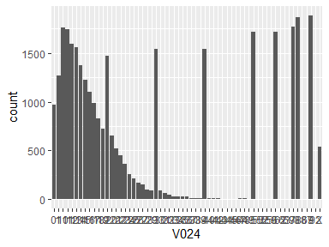

* The following suspected missing value codes enter as regular values: "8", "9".
* Note that the following levels have at most five observations: "44", "45", "46", "49", "50", …, "63", "69", "86", "87", "92" (4 values omitted).

## V025

| Feature | Result |
| --- | --- |
| Variable type | character |
| Number of missing obs. | 0 (0 %) |
| Number of unique values | 66 |
| Mode | “8” |

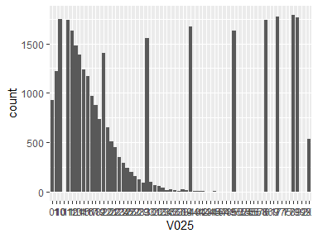

* The following suspected missing value codes enter as regular values: "8", "9", "99".
* Note that the following levels have at most five observations: "101", "43", "46", "47", "48", …, "71", "75", "77", "92", "99" (10 values omitted).

## V026

| Feature | Result |
| --- | --- |
| Variable type | character |
| Number of missing obs. | 0 (0 %) |
| Number of unique values | 67 |
| Mode | “9” |

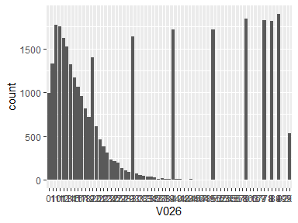

* The following suspected missing value codes enter as regular values: "8", "9", "99".
* Note that the following levels have at most five observations: "42", "45", "46", "47", "48", …, "69", "78", "84", "92", "99" (12 values omitted).

## V027

| Feature | Result |
| --- | --- |
| Variable type | character |
| Number of missing obs. | 0 (0 %) |
| Number of unique values | 69 |
| Mode | “9” |

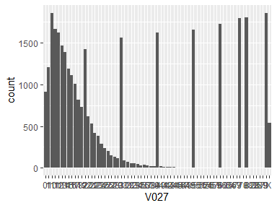

* The following suspected missing value codes enter as regular values: "8", "9".
* Note that the following levels have at most five observations: "46", "47", "48", "49", "50", …, "82", "83", "85", "87", "89" (12 values omitted).

## V028

| Feature | Result |
| --- | --- |
| Variable type | character |
| Number of missing obs. | 0 (0 %) |
| Number of unique values | 66 |
| Mode | “6” |

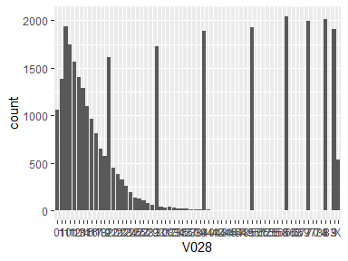

* The following suspected missing value codes enter as regular values: "8", "9".
* Note that the following levels have at most five observations: "41", "42", "43", "44", "45", …, "69", "70", "73", "74", "83" (14 values omitted).

## V029

| Feature | Result |
| --- | --- |
| Variable type | character |
| Number of missing obs. | 0 (0 %) |
| Number of unique values | 65 |
| Mode | “7” |

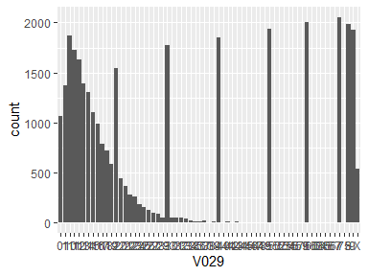

* The following suspected missing value codes enter as regular values: "8", "9".
* Note that the following levels have at most five observations: "38", "42", "44", "45", "46", …, "64", "65", "66", "67", "75" (12 values omitted).

## V030

| Feature | Result |
| --- | --- |
| Variable type | character |
| Number of missing obs. | 0 (0 %) |
| Number of unique values | 56 |
| Mode | “7” |

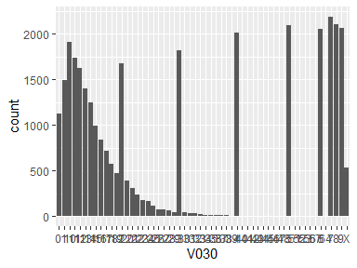

* The following suspected missing value codes enter as regular values: "8", "9".
* Note that the following levels have at most five observations: "41", "43", "44", "45", "46", …, "52", "53", "56", "57", "64" (3 values omitted).

## V031

| Feature | Result |
| --- | --- |
| Variable type | character |
| Number of missing obs. | 0 (0 %) |
| Number of unique values | 62 |
| Mode | “6” |

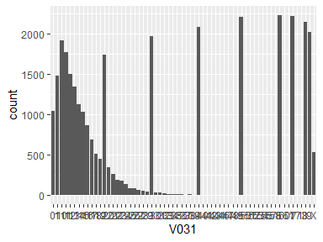

* The following suspected missing value codes enter as regular values: "8", "9".
* Note that the following levels have at most five observations: "37", "41", "42", "43", "44", …, "58", "60", "61", "71", "73" (11 values omitted).

## V032

| Feature | Result |
| --- | --- |
| Variable type | character |
| Number of missing obs. | 0 (0 %) |
| Number of unique values | 59 |
| Mode | “5” |

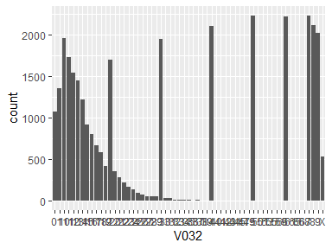

* The following suspected missing value codes enter as regular values: "8", "9".
* Note that the following levels have at most five observations: "36", "40", "42", "44", "45", …, "59", "61", "65", "66", "68" (7 values omitted).

## V033

| Feature | Result |
| --- | --- |
| Variable type | character |
| Number of missing obs. | 0 (0 %) |
| Number of unique values | 52 |
| Mode | “6” |

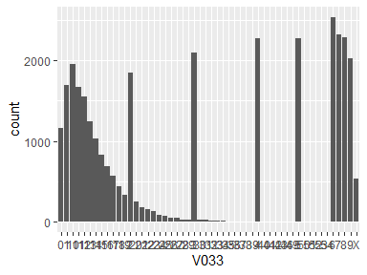

* The following suspected missing value codes enter as regular values: "8", "9".
* Note that the following levels have at most five observations: "37", "38", "39", "40", "41", …, "50", "51", "52", "53", "54" (4 values omitted).

## V034

| Feature | Result |
| --- | --- |
| Variable type | character |
| Number of missing obs. | 0 (0 %) |
| Number of unique values | 53 |
| Mode | “6” |

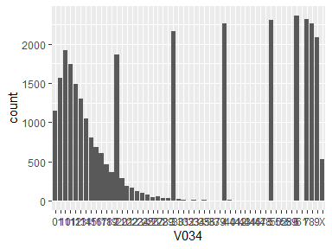

* The following suspected missing value codes enter as regular values: "8", "9".
* Note that the following levels have at most five observations: "37", "39", "41", "42", "43", …, "50", "52", "58", "59", "61" (4 values omitted).

## V035

| Feature | Result |
| --- | --- |
| Variable type | character |
| Number of missing obs. | 0 (0 %) |
| Number of unique values | 49 |
| Mode | “5” |

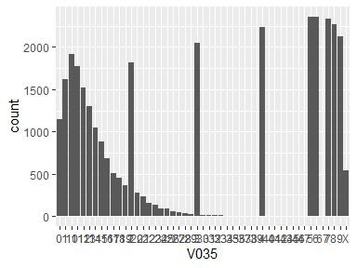

* The following suspected missing value codes enter as regular values: "8", "9".
* Note that the following levels have at most five observations: "39", "40", "41", "42", "43", "45", "46", "47", "67".

## V036

| Feature | Result |
| --- | --- |
| Variable type | character |
| Number of missing obs. | 0 (0 %) |
| Number of unique values | 49 |
| Mode | “6” |

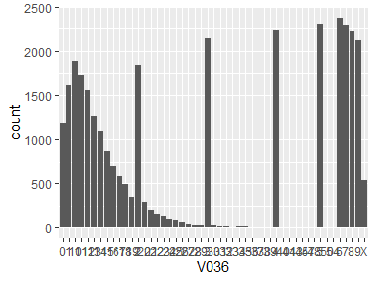

* The following suspected missing value codes enter as regular values: "8", "9".
* Note that the following levels have at most five observations: "36", "37", "38", "39", "40", …, "45", "47", "48", "50", "54" (2 values omitted).

## V037

| Feature | Result |
| --- | --- |
| Variable type | character |
| Number of missing obs. | 0 (0 %) |
| Number of unique values | 48 |
| Mode | “6” |

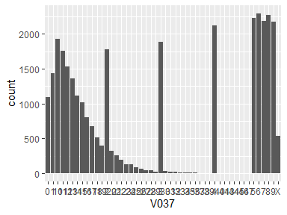

* The following suspected missing value codes enter as regular values: "8", "9".
* Note that the following levels have at most five observations: "37", "38", "39", "40", "41", "43", "44", "45", "46", "47".

## V038

| Feature | Result |
| --- | --- |
| Variable type | character |
| Number of missing obs. | 0 (0 %) |
| Number of unique values | 47 |
| Mode | “6” |

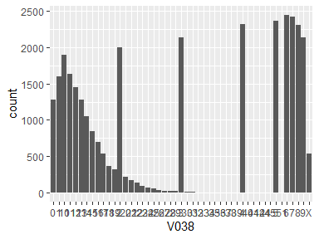

* The following suspected missing value codes enter as regular values: "8", "9".
* Note that the following levels have at most five observations: "32", "35", "36", "37", "38", …, "41", "42", "44", "45", "51" (2 values omitted).

## V039

| Feature | Result |
| --- | --- |
| Variable type | character |
| Number of missing obs. | 0 (0 %) |
| Number of unique values | 48 |
| Mode | “6” |

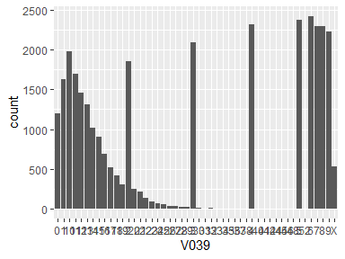

* The following suspected missing value codes enter as regular values: "8", "9".
* Note that the following levels have at most five observations: "31", "33", "35", "36", "37", …, "44", "45", "46", "48", "52" (4 values omitted).

## V040

| Feature | Result |
| --- | --- |
| Variable type | character |
| Number of missing obs. | 0 (0 %) |
| Number of unique values | 43 |
| Mode | “6” |

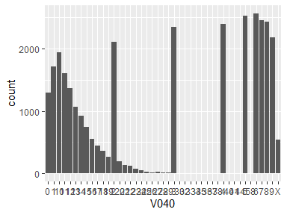

* The following suspected missing value codes enter as regular values: "8", "9".
* Note that the following levels have at most five observations: "33", "35", "36", "37", "38", "40", "41", "44", "58".

## V041

| Feature | Result |
| --- | --- |
| Variable type | character |
| Number of missing obs. | 0 (0 %) |
| Number of unique values | 43 |
| Mode | “5” |

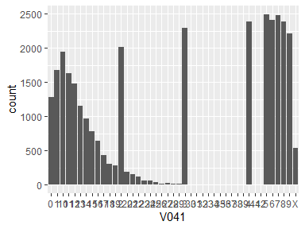

* The following suspected missing value codes enter as regular values: "8", "9".
* Note that the following levels have at most five observations: "30", "31", "33", "34", "35", …, "37", "38", "39", "41", "42" (1 values omitted).

## V042

| Feature | Result |
| --- | --- |
| Variable type | character |
| Number of missing obs. | 0 (0 %) |
| Number of unique values | 45 |
| Mode | “6” |

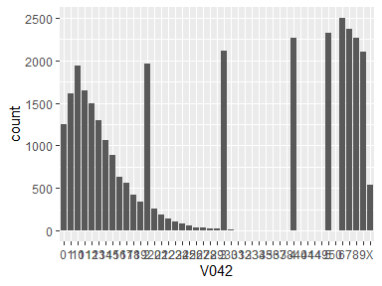

* The following suspected missing value codes enter as regular values: "8", "9".
* Note that the following levels have at most five observations: "32", "33", "34", "35", "36", …, "40", "41", "44", "49", "50" (2 values omitted).

## V043

| Feature | Result |
| --- | --- |
| Variable type | character |
| Number of missing obs. | 0 (0 %) |
| Number of unique values | 43 |
| Mode | “6” |

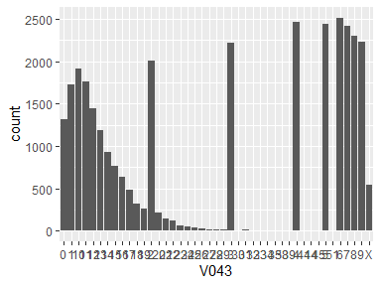

* The following suspected missing value codes enter as regular values: "8", "9".
* Note that the following levels have at most five observations: "33", "34", "35", "38", "39", "41", "44", "45", "51".

## V044

| Feature | Result |
| --- | --- |
| Variable type | character |
| Number of missing obs. | 0 (0 %) |
| Number of unique values | 42 |
| Mode | “5” |

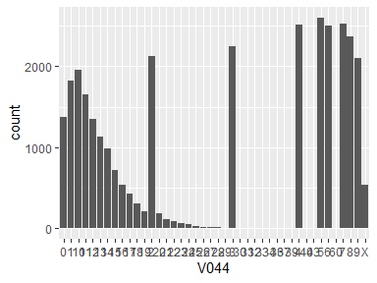

* The following suspected missing value codes enter as regular values: "8", "9".
* Note that the following levels have at most five observations: "31", "32", "33", "34", "36", "37", "39", "40", "43", "60".

## V045

| Feature | Result |
| --- | --- |
| Variable type | character |
| Number of missing obs. | 0 (0 %) |
| Number of unique values | 40 |
| Mode | “5” |

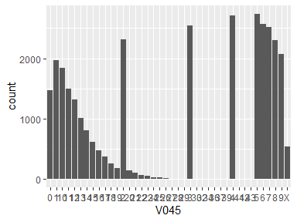

* The following suspected missing value codes enter as regular values: "8", "9".
* Note that the following levels have at most five observations: "30", "32", "34", "36", "37", "39", "41", "42", "43".

## V046

| Feature | Result |
| --- | --- |
| Variable type | character |
| Number of missing obs. | 0 (0 %) |
| Number of unique values | 39 |
| Mode | “6” |

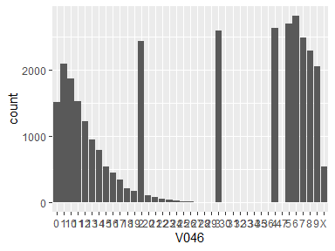

* The following suspected missing value codes enter as regular values: "8", "9".
* Note that the following levels have at most five observations: "29", "30", "31", "32", "33", "34", "35", "36", "47".

## V047

| Feature | Result |
| --- | --- |
| Variable type | character |
| Number of missing obs. | 0 (0 %) |
| Number of unique values | 38 |
| Mode | “5” |

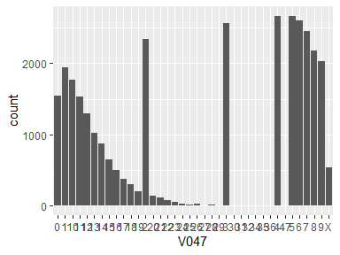

* The following suspected missing value codes enter as regular values: "8", "9".
* Note that the following levels have at most five observations: "30", "31", "32", "34", "35", "36", "47".

## V048

| Feature | Result |
| --- | --- |
| Variable type | character |
| Number of missing obs. | 0 (0 %) |
| Number of unique values | 38 |
| Mode | “5” |

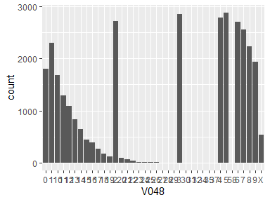

* The following suspected missing value codes enter as regular values: "8", "9".
* Note that the following levels have at most five observations: "27", "28", "29", "30", "31", "32", "34", "35", "37", "58".

## V049

| Feature | Result |
| --- | --- |
| Variable type | character |
| Number of missing obs. | 0 (0 %) |
| Number of unique values | 37 |
| Mode | “3” |

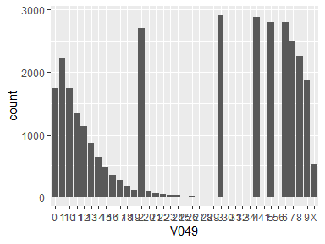

* The following suspected missing value codes enter as regular values: "8", "9".
* Note that the following levels have at most five observations: "27", "28", "29", "30", "31", "32", "34", "41", "56".

## V050

| Feature | Result |
| --- | --- |
| Variable type | character |
| Number of missing obs. | 0 (0 %) |
| Number of unique values | 35 |
| Mode | “3” |

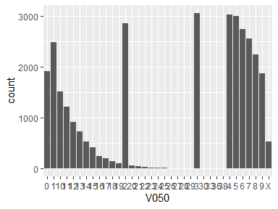

* The following suspected missing value codes enter as regular values: "8", "9".
* Note that the following levels have at most five observations: "26", "27", "28", "29", "30", "33", "36", "38".

## V051

| Feature | Result |
| --- | --- |
| Variable type | character |
| Number of missing obs. | 0 (0 %) |
| Number of unique values | 36 |
| Mode | “4” |

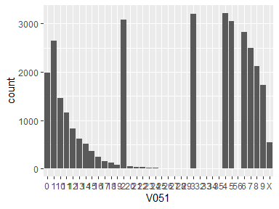

* The following suspected missing value codes enter as regular values: "8", "9".
* Note that the following levels have at most five observations: "25", "26", "27", "28", "29", "32", "33", "34", "35", "56".

## V052

| Feature | Result |
| --- | --- |
| Variable type | character |
| Number of missing obs. | 0 (0 %) |
| Number of unique values | 36 |
| Mode | “3” |

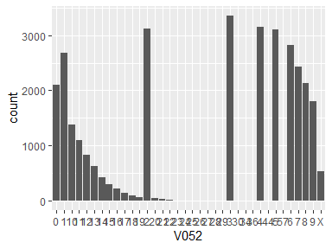

* The following suspected missing value codes enter as regular values: "8", "9".
* Note that the following levels have at most five observations: "25", "26", "27", "28", "29", "30", "34", "36", "44", "57".

## V053

| Feature | Result |
| --- | --- |
| Variable type | character |
| Number of missing obs. | 0 (0 %) |
| Number of unique values | 34 |
| Mode | “3” |

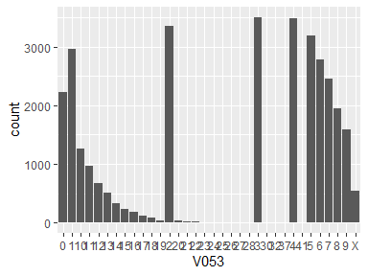

* The following suspected missing value codes enter as regular values: "8", "9".
* Note that the following levels have at most five observations: "23", "25", "26", "27", "28", "30", "32", "37", "41".

## V054

| Feature | Result |
| --- | --- |
| Variable type | character |
| Number of missing obs. | 0 (0 %) |
| Number of unique values | 30 |
| Mode | “2” |

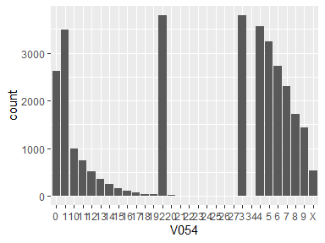

* The following suspected missing value codes enter as regular values: "8", "9".
* Note that the following levels have at most five observations: "23", "24", "25", "26", "27", "34".

## V055

| Feature | Result |
| --- | --- |
| Variable type | character |
| Number of missing obs. | 0 (0 %) |
| Number of unique values | 31 |
| Mode | “2” |

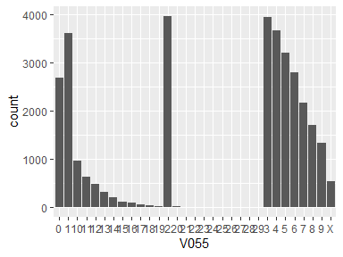

* The following suspected missing value codes enter as regular values: "8", "9".
* Note that the following levels have at most five observations: "23", "24", "25", "26", "27", "28", "29".

## V056

| Feature | Result |
| --- | --- |
| Variable type | character |
| Number of missing obs. | 0 (0 %) |
| Number of unique values | 26 |
| Mode | “2” |

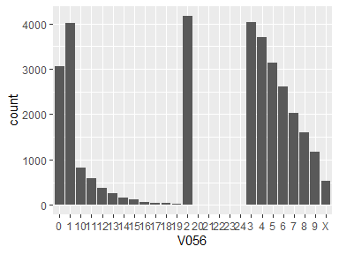

* The following suspected missing value codes enter as regular values: "8", "9".
* Note that the following levels have at most five observations: "21", "23", "24".

## V057

| Feature | Result |
| --- | --- |
| Variable type | character |
| Number of missing obs. | 0 (0 %) |
| Number of unique values | 28 |
| Mode | “2” |

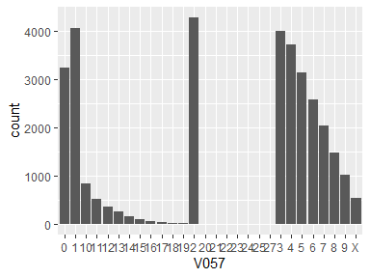

* The following suspected missing value codes enter as regular values: "8", "9".
* Note that the following levels have at most five observations: "21", "23", "24", "25", "27".

## V058

| Feature | Result |
| --- | --- |
| Variable type | character |
| Number of missing obs. | 0 (0 %) |
| Number of unique values | 27 |
| Mode | “1” |

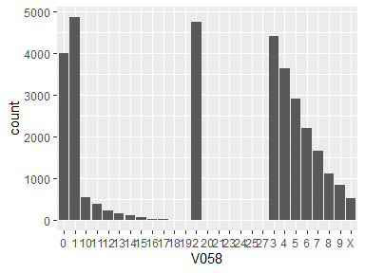

* The following suspected missing value codes enter as regular values: "8", "9".
* Note that the following levels have at most five observations: "21", "23", "24", "25", "27".

## V059

| Feature | Result |
| --- | --- |
| Variable type | character |
| Number of missing obs. | 0 (0 %) |
| Number of unique values | 28 |
| Mode | “2” |

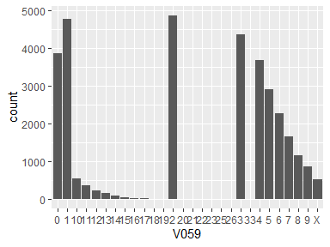

* The following suspected missing value codes enter as regular values: "8", "9".
* Note that the following levels have at most five observations: "20", "21", "22", "23", "25", "26", "33".

## V060

| Feature | Result |
| --- | --- |
| Variable type | character |
| Number of missing obs. | 0 (0 %) |
| Number of unique values | 24 |
| Mode | “1” |

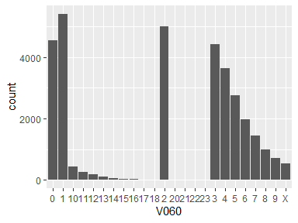

* The following suspected missing value codes enter as regular values: "8", "9".
* Note that the following levels have at most five observations: "20", "21", "22", "23".

## V061

| Feature | Result |
| --- | --- |
| Variable type | character |
| Number of missing obs. | 0 (0 %) |
| Number of unique values | 26 |
| Mode | “1” |

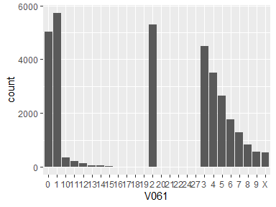

* The following suspected missing value codes enter as regular values: "8", "9".
* Note that the following levels have at most five observations: "19", "20", "21", "22", "24", "27".

## V062

| Feature | Result |
| --- | --- |
| Variable type | character |
| Number of missing obs. | 0 (0 %) |
| Number of unique values | 24 |
| Mode | “1” |

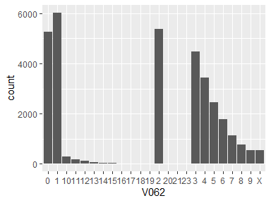

* The following suspected missing value codes enter as regular values: "8", "9".
* Note that the following levels have at most five observations: "18", "19", "20", "21", "23".

## V063

| Feature | Result |
| --- | --- |
| Variable type | character |
| Number of missing obs. | 0 (0 %) |
| Number of unique values | 21 |
| Mode | “1” |

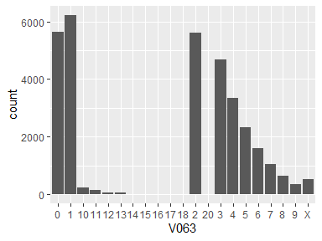

* The following suspected missing value codes enter as regular values: "8", "9".
* Note that the following levels have at most five observations: "17", "18", "20".

## V064

| Feature | Result |
| --- | --- |
| Variable type | character |
| Number of missing obs. | 0 (0 %) |
| Number of unique values | 19 |
| Mode | “1” |

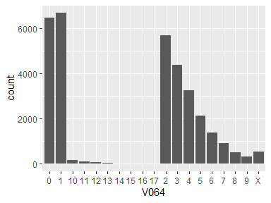

* The following suspected missing value codes enter as regular values: "8", "9".
* Note that the following levels have at most five observations: "16", "17".

## V065

| Feature | Result |
| --- | --- |
| Variable type | character |
| Number of missing obs. | 0 (0 %) |
| Number of unique values | 20 |
| Mode | “1” |

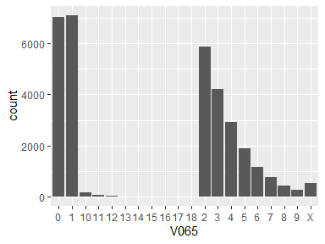

* The following suspected missing value codes enter as regular values: "8", "9".
* Note that the following levels have at most five observations: "17", "18".

## V066

| Feature | Result |
| --- | --- |
| Variable type | character |
| Number of missing obs. | 0 (0 %) |
| Number of unique values | 18 |
| Mode | “0” |

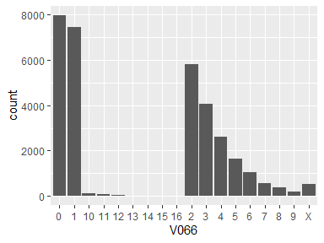

* The following suspected missing value codes enter as regular values: "8", "9".
* Note that the following levels have at most five observations: "15", "16".

## V067

| Feature | Result |
| --- | --- |
| Variable type | character |
| Number of missing obs. | 0 (0 %) |
| Number of unique values | 20 |
| Mode | “1” |

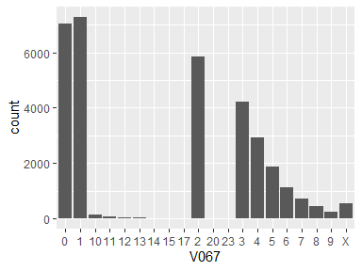

* The following suspected missing value codes enter as regular values: "8", "9".
* Note that the following levels have at most five observations: "15", "17", "20", "23".

## V068

| Feature | Result |
| --- | --- |
| Variable type | character |
| Number of missing obs. | 0 (0 %) |
| Number of unique values | 21 |
| Mode | “0” |

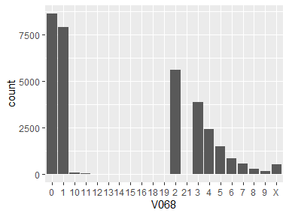

* The following suspected missing value codes enter as regular values: "8", "9".
* Note that the following levels have at most five observations: "15", "16", "18", "19", "21".

## V069

| Feature | Result |
| --- | --- |
| Variable type | character |
| Number of missing obs. | 0 (0 %) |
| Number of unique values | 20 |
| Mode | “0” |

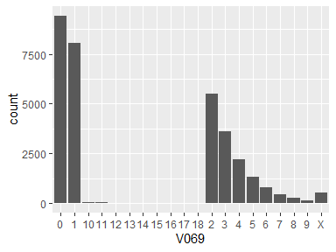

* The following suspected missing value codes enter as regular values: "8", "9".
* Note that the following levels have at most five observations: "15", "16", "17", "18".

## V070

| Feature | Result |
| --- | --- |
| Variable type | character |
| Number of missing obs. | 0 (0 %) |
| Number of unique values | 18 |
| Mode | “0” |

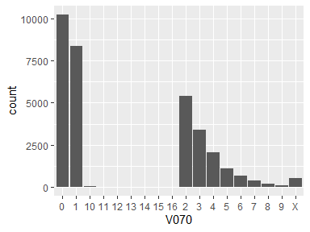

* The following suspected missing value codes enter as regular values: "8", "9".
* Note that the following levels have at most five observations: "14", "15", "16".

## V071

| Feature | Result |
| --- | --- |
| Variable type | character |
| Number of missing obs. | 0 (0 %) |
| Number of unique values | 19 |
| Mode | “0” |

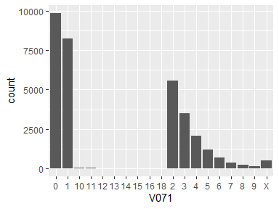

* The following suspected missing value codes enter as regular values: "8", "9".
* Note that the following levels have at most five observations: "14", "15", "16", "18".

## V072

| Feature | Result |
| --- | --- |
| Variable type | character |
| Number of missing obs. | 0 (0 %) |
| Number of unique values | 18 |
| Mode | “0” |

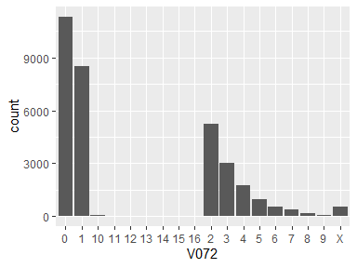

* The following suspected missing value codes enter as regular values: "8", "9".
* Note that the following levels have at most five observations: "14", "15", "16".

## V073

| Feature | Result |
| --- | --- |
| Variable type | character |
| Number of missing obs. | 0 (0 %) |
| Number of unique values | 16 |
| Mode | “0” |

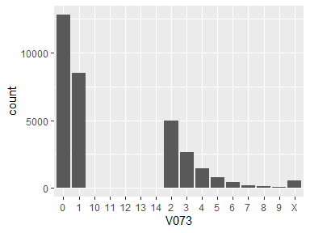

* The following suspected missing value codes enter as regular values: "8", "9".
* Note that the following levels have at most five observations: "13", "14".

## V074

| Feature | Result |
| --- | --- |
| Variable type | character |
| Number of missing obs. | 0 (0 %) |
| Number of unique values | 16 |
| Mode | “0” |

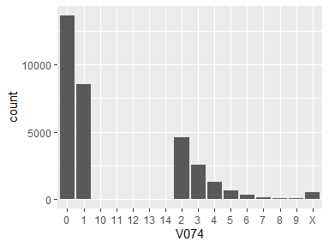

* The following suspected missing value codes enter as regular values: "8", "9".
* Note that the following levels have at most five observations: "12", "13", "14".

## V075

| Feature | Result |
| --- | --- |
| Variable type | character |
| Number of missing obs. | 0 (0 %) |
| Number of unique values | 17 |
| Mode | “0” |

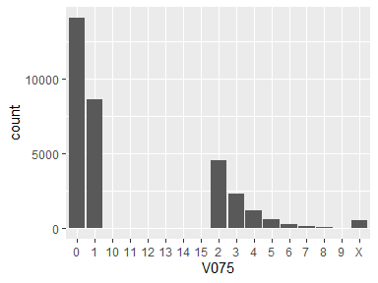

* The following suspected missing value codes enter as regular values: "8", "9".
* Note that the following levels have at most five observations: "11", "12", "13", "14", "15".

## V076

| Feature | Result |
| --- | --- |
| Variable type | character |
| Number of missing obs. | 0 (0 %) |
| Number of unique values | 16 |
| Mode | “0” |

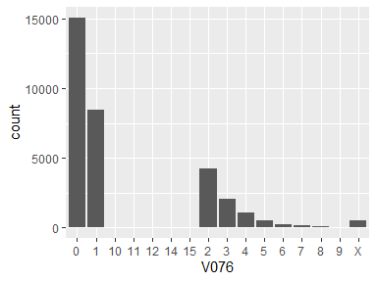

* The following suspected missing value codes enter as regular values: "8", "9".
* Note that the following levels have at most five observations: "12", "14", "15".

## V077

| Feature | Result |
| --- | --- |
| Variable type | character |
| Number of missing obs. | 0 (0 %) |
| Number of unique values | 74 |
| Mode | “1” |

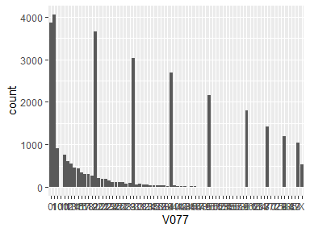

* The following suspected missing value codes enter as regular values: "8", "9".
* Note that the following levels have at most five observations: "100", "52", "54", "55", "57", …, "75", "79", "84", "85", "87" (9 values omitted).

## V078

| Feature | Result |
| --- | --- |
| Variable type | character |
| Number of missing obs. | 0 (0 %) |
| Number of unique values | 537 |
| Mode | “X” |

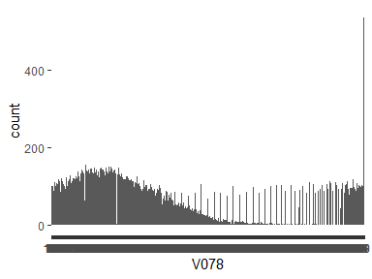

* The following suspected missing value codes enter as regular values: "8", "88", "9", "99".
* Note that the following levels have at most five observations: "2", "376", "380", "381", "384", …, "732", "746", "762", "764", "789" (130 values omitted).

## V079

| Feature | Result |
| --- | --- |
| Variable type | character |
| Number of missing obs. | 0 (0 %) |
| Number of unique values | 390 |
| Mode | “X” |

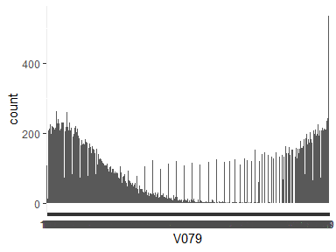

* The following suspected missing value codes enter as regular values: "8", "88", "9", "99".
* Note that the following levels have at most five observations: "267", "268", "275", "277", "283", …, "543", "550", "563", "577", "578" (93 values omitted).

## V080

| Feature | Result |
| --- | --- |
| Variable type | character |
| Number of missing obs. | 0 (0 %) |
| Number of unique values | 507 |
| Mode | “X” |

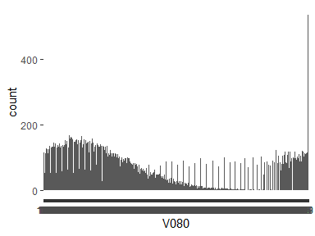

* The following suspected missing value codes enter as regular values: "8", "88", "9", "99".
* Note that the following levels have at most five observations: "361", "375", "381", "384", "388", …, "641", "694", "724", "738", "900" (101 values omitted).

## V081

| Feature | Result |
| --- | --- |
| Variable type | character |
| Number of missing obs. | 0 (0 %) |
| Number of unique values | 104 |
| Mode | “0” |

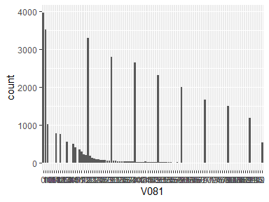

* The following suspected missing value codes enter as regular values: "8", "88", "9", "99".
* Note that the following levels have at most five observations: "105", "107", "108", "116", "123", …, "91", "93", "94", "95", "99" (16 values omitted).

## V082

| Feature | Result |
| --- | --- |
| Variable type | character |
| Number of missing obs. | 0 (0 %) |
| Number of unique values | 71 |
| Mode | “0” |

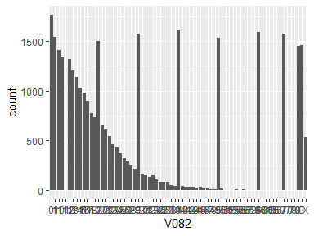

* The following suspected missing value codes enter as regular values: "8", "9".
* Note that the following levels have at most five observations: "112", "51", "52", "55", "57", …, "66", "69", "70", "78", "79" (6 values omitted).

## V083

| Feature | Result |
| --- | --- |
| Variable type | character |
| Number of missing obs. | 0 (0 %) |
| Number of unique values | 96 |
| Mode | “0” |

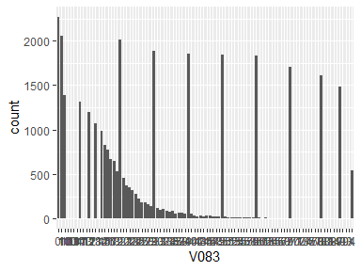

* The following suspected missing value codes enter as regular values: "8", "9".
* Note that the following levels have at most five observations: "100", "103", "104", "107", "113", …, "84", "87", "90", "93", "94" (19 values omitted).

## V084

| Feature | Result |
| --- | --- |
| Variable type | character |
| Number of missing obs. | 0 (0 %) |
| Number of unique values | 77 |
| Mode | “8” |

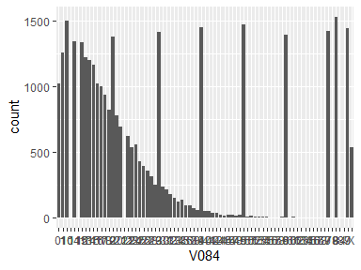

* The following suspected missing value codes enter as regular values: "8", "9".
* Note that the following levels have at most five observations: "104", "115", "211", "56", "57", …, "68", "69", "79", "84", "87" (8 values omitted).

## V085

| Feature | Result |
| --- | --- |
| Variable type | character |
| Number of missing obs. | 0 (0 %) |
| Number of unique values | 88 |
| Mode | “0” |

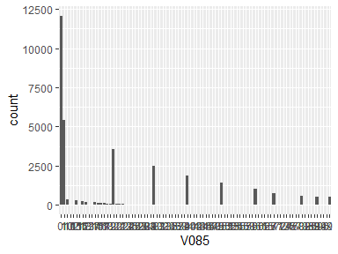

* The following suspected missing value codes enter as regular values: "8", "88", "9", "99".
* Note that the following levels have at most five observations: "102", "105", "116", "131", "137", …, "86", "88", "94", "96", "99" (36 values omitted).

## …88

* The variable only takes one value: "NA".

Report generation information:

* Created by: Caio Gonçalves (username: x15767253).
* Report creation time: seg ago 21 2023 15:47:05
* Report was run from directory: C:/Users/x15767253/Documents/GitHub/mqagp
* dataMaid v1.4.1 [Pkg: 2021-10-08 from CRAN (R 4.3.1)]
* R version 4.3.1 (2023-06-16 ucrt).
* Platform: x86_64-w64-mingw32/x64 (64-bit)(America/Sao_Paulo).
* Function call: makeDataReport(data = df, replace = TRUE)