pib_mun

Autogenerated data summary from dataMaid

2023-09-19 07:58:39.501137

# Data report overview

The dataset examined has the following dimensions:

| Feature | Result |
| --- | --- |
| Number of observations | 61255 |
| Number of variables | 43 |

### Checks performed

The following variable checks were performed, depending on the data type of each variable:

|  | character | factor | labelled | haven labelled | numeric | integer | logical | Date |
| --- | --- | --- | --- | --- | --- | --- | --- | --- |
| Identify miscoded missing values | × | × | × | × | × | × |  | × |
| Identify prefixed and suffixed whitespace | × | × | × | × |  |  |  |  |
| Identify levels with < 6 obs. | × | × | × | × |  |  |  |  |
| Identify case issues | × | × | × | × |  |  |  |  |
| Identify misclassified numeric or integer variables | × | × | × | × |  |  |  |  |
| Identify outliers |  |  |  |  | × | × |  | × |

Please note that all numerical values in the following have been rounded to 2 decimals.

# Summary table

|  | Variable class | # unique values | Missing observations | Any problems? |
| --- | --- | --- | --- | --- |
| ano | numeric | 11 | 0.00 % |  |
| cod_gr | numeric | 5 | 0.00 % |  |
| nome_gr | character | 5 | 0.00 % |  |
| cod_uf | numeric | 27 | 0.00 % | × |
| sigla_uf | character | 27 | 0.00 % |  |
| nome_uf | character | 27 | 0.00 % |  |
| cod_mun | numeric | 5570 | 0.00 % | × |
| nome_mun | character | 5297 | 0.00 % |  |
| rm | character | 83 | 74.30 % |  |
| cod_meso | numeric | 137 | 0.00 % | × |
| nome_meso | character | 137 | 0.00 % |  |
| cod_micro | numeric | 558 | 0.00 % | × |
| nome_micro | character | 554 | 0.00 % |  |
| cod_regim | numeric | 510 | 0.00 % | × |
| nome_regim | character | 508 | 0.00 % |  |
| mun_regim | character | 2 | 0.00 % |  |
| cod_regint | numeric | 133 | 0.00 % | × |
| nome_regint | character | 133 | 0.00 % |  |
| mun_regit | character | 2 | 0.00 % |  |
| cod_conc | numeric | 186 | 88.16 % | × |
| nome_conc | character | 186 | 88.16 % |  |
| tipo_conc | character | 3 | 88.16 % |  |
| cod_arranjo | numeric | 295 | 82.85 % | × |
| nome_arranjo | character | 295 | 82.85 % |  |
| hier_urb | character | 17 | 0.00 % |  |
| hier_urb_prin | character | 5 | 0.00 % |  |
| cod_regiao_rural | numeric | 104 | 0.00 % | × |
| nome_regiao_rural | character | 104 | 0.00 % |  |
| regiao_rural_nucleo | character | 6 | 0.00 % |  |
| amaz_legal | character | 2 | 0.00 % |  |
| semiarido | character | 2 | 0.00 % |  |
| cidade_regiao_sp | character | 2 | 0.00 % |  |
| va_agro | numeric | 61202 | 0.00 % | × |
| va_ind | numeric | 61177 | 0.00 % | × |
| va_serv | numeric | 61241 | 0.00 % | × |
| va_admin | numeric | 61238 | 0.00 % | × |
| va | numeric | 61251 | 0.00 % | × |
| imp | numeric | 61169 | 0.00 % | × |
| pib | numeric | 61251 | 0.00 % | × |
| pib_pc | numeric | 60652 | 0.00 % | × |
| ativ_1 | character | 10 | 0.00 % |  |
| ativ_2 | character | 10 | 0.00 % |  |
| ativ_3 | character | 10 | 0.00 % |  |

# Variable list

## ano

| Feature | Result |
| --- | --- |
| Variable type | numeric |
| Number of missing obs. | 0 (0 %) |
| Number of unique values | 11 |
| Median | 2015 |
| 1st and 3rd quartiles | 2012; 2018 |
| Min. and max. | 2010; 2020 |

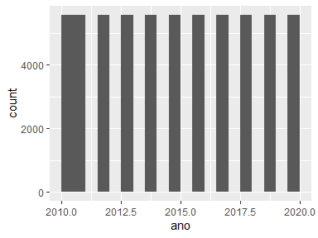

## cod_gr

* Note that this variable is treated as a factor variable below, as it only takes a few unique values.

| Feature | Result |
| --- | --- |
| Variable type | numeric |
| Number of missing obs. | 0 (0 %) |
| Number of unique values | 5 |
| Mode | “2” |
| Reference category | 1 |

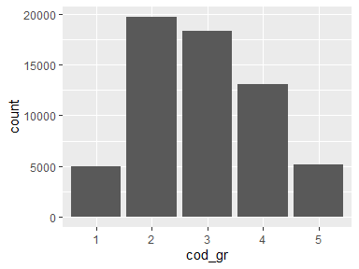

## nome_gr

| Feature | Result |
| --- | --- |
| Variable type | character |
| Number of missing obs. | 0 (0 %) |
| Number of unique values | 5 |
| Mode | “Nordeste” |

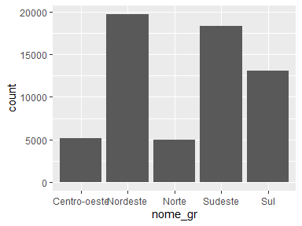

## cod_uf

| Feature | Result |
| --- | --- |
| Variable type | numeric |
| Number of missing obs. | 0 (0 %) |
| Number of unique values | 27 |
| Median | 31 |
| 1st and 3rd quartiles | 25; 41 |
| Min. and max. | 11; 53 |

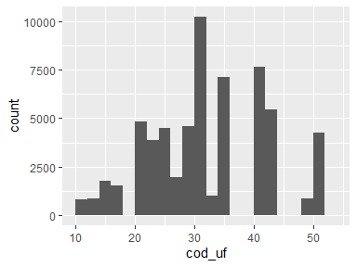

* Note that the following possible outlier values were detected: "11", "12".

## sigla_uf

| Feature | Result |
| --- | --- |
| Variable type | character |
| Number of missing obs. | 0 (0 %) |
| Number of unique values | 27 |
| Mode | “MG” |

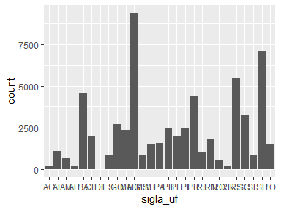

## nome_uf

| Feature | Result |
| --- | --- |
| Variable type | character |
| Number of missing obs. | 0 (0 %) |
| Number of unique values | 27 |
| Mode | “Minas Gerais” |

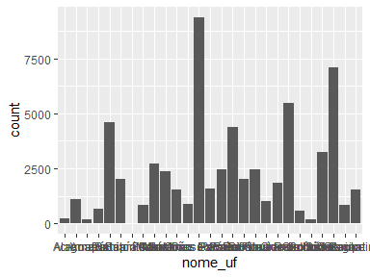

## cod_mun

| Feature | Result |
| --- | --- |
| Variable type | numeric |
| Number of missing obs. | 0 (0 %) |
| Number of unique values | 5570 |
| Median | 3146255 |
| 1st and 3rd quartiles | 2512101; 4119152 |
| Min. and max. | 1100015; 5300108 |

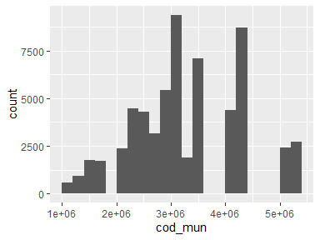

* Note that the following possible outlier values were detected: "1100015", "1100023", "1100031", "1100049", "1100056", …, "1200450", "1200500", "1200609", "1200708", "1200807" (64 values omitted).

## nome_mun

| Feature | Result |
| --- | --- |
| Variable type | character |
| Number of missing obs. | 0 (0 %) |
| Number of unique values | 5297 |
| Mode | “Bom Jesus” |

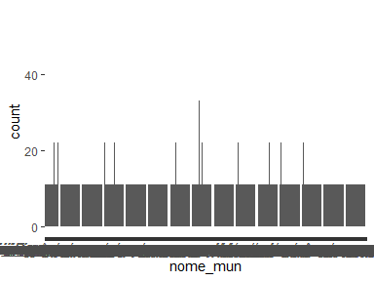

## rm

| Feature | Result |
| --- | --- |
| Variable type | character |
| Number of missing obs. | 45515 (74.3 %) |
| Number of unique values | 82 |
| Mode | “Região Metropolitana de Belo Horizonte” |

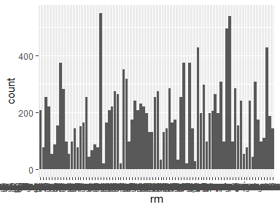

## cod_meso

| Feature | Result |
| --- | --- |
| Variable type | numeric |
| Number of missing obs. | 0 (0 %) |
| Number of unique values | 137 |
| Median | 3110 |
| 1st and 3rd quartiles | 2503; 4106 |
| Min. and max. | 1101; 5301 |

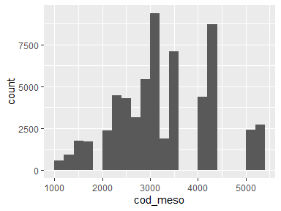

* Note that the following possible outlier values were detected: "1101", "1102", "1201", "1202", "1301", …, "1502", "1503", "1504", "1505", "1506" (6 values omitted).

## nome_meso

| Feature | Result |
| --- | --- |
| Variable type | character |
| Number of missing obs. | 0 (0 %) |
| Number of unique values | 137 |
| Mode | “Noroeste Rio-grandense” |

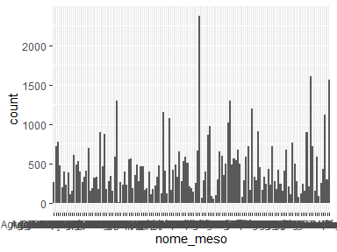

## cod_micro

| Feature | Result |
| --- | --- |
| Variable type | numeric |
| Number of missing obs. | 0 (0 %) |
| Number of unique values | 558 |
| Median | 31047 |
| 1st and 3rd quartiles | 25015; 41024 |
| Min. and max. | 11001; 53001 |

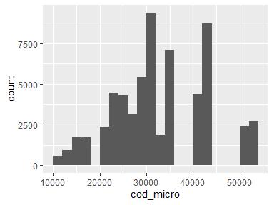

* Note that the following possible outlier values were detected: "11001", "11002", "11003", "11004", "11005", …, "13013", "14001", "14002", "14003", "14004" (20 values omitted).

## nome_micro

| Feature | Result |
| --- | --- |
| Variable type | character |
| Number of missing obs. | 0 (0 %) |
| Number of unique values | 554 |
| Mode | “Ilhéus-Itabuna” |

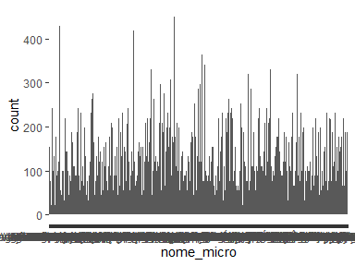

## cod_regim

| Feature | Result |
| --- | --- |
| Variable type | numeric |
| Number of missing obs. | 0 (0 %) |
| Number of unique values | 510 |
| Median | 310039 |
| 1st and 3rd quartiles | 250009; 410019 |
| Min. and max. | 110001; 530001 |

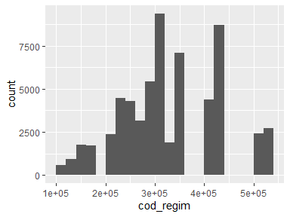

* Note that the following possible outlier values were detected: "110001", "110002", "110003", "110004", "110005", …, "130011", "140001", "140002", "140003", "140004" (16 values omitted).

## nome_regim

| Feature | Result |
| --- | --- |
| Variable type | character |
| Number of missing obs. | 0 (0 %) |
| Number of unique values | 508 |
| Mode | “Campina Grande” |

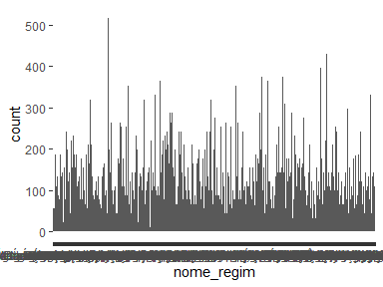

## mun_regim

| Feature | Result |
| --- | --- |
| Variable type | character |
| Number of missing obs. | 0 (0 %) |
| Number of unique values | 2 |
| Mode | “do Entorno” |

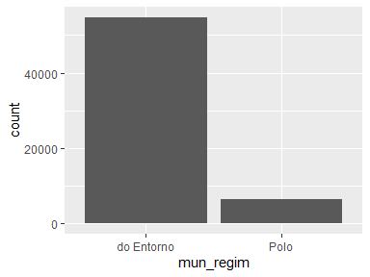

## cod_regint

| Feature | Result |
| --- | --- |
| Variable type | numeric |
| Number of missing obs. | 0 (0 %) |
| Number of unique values | 133 |
| Median | 3107 |
| 1st and 3rd quartiles | 2503; 4104 |
| Min. and max. | 1101; 5301 |

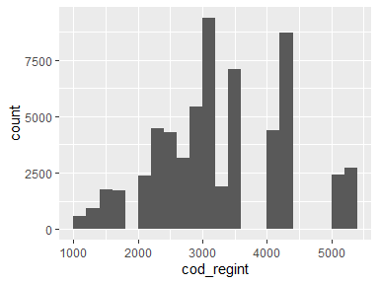

* Note that the following possible outlier values were detected: "1101", "1102", "1201", "1202", "1301", "1302", "1303", "1304", "1401", "1402".

## nome_regint

| Feature | Result |
| --- | --- |
| Variable type | character |
| Number of missing obs. | 0 (0 %) |
| Number of unique values | 133 |
| Mode | “Juíz de Fora” |

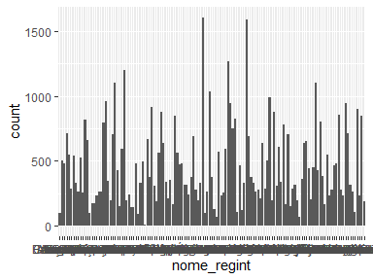

## mun_regit

| Feature | Result |
| --- | --- |
| Variable type | character |
| Number of missing obs. | 0 (0 %) |
| Number of unique values | 2 |
| Mode | “do Entorno” |

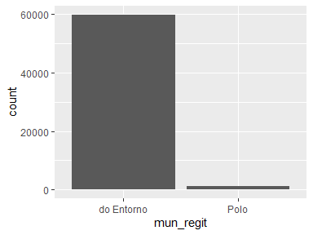

## cod_conc

| Feature | Result |
| --- | --- |
| Variable type | numeric |
| Number of missing obs. | 54004 (88.16 %) |
| Number of unique values | 185 |
| Median | 3523909 |
| 1st and 3rd quartiles | 3122306; 4119905 |
| Min. and max. | 1100122; 5300108 |

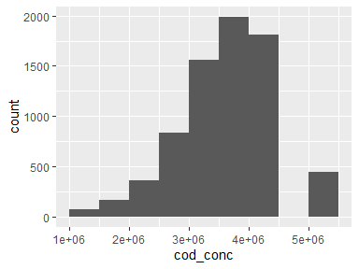

* Note that the following possible outlier values were detected: "1100122", "1100205", "1200401", "1302603", "1303403", …, "1502103", "1502400", "1504208", "1505536", "1506807" (4 values omitted).

## nome_conc

| Feature | Result |
| --- | --- |
| Variable type | character |
| Number of missing obs. | 54004 (88.16 %) |
| Number of unique values | 185 |
| Mode | “São Paulo/SP” |

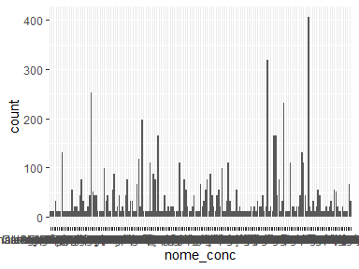

## tipo_conc

| Feature | Result |
| --- | --- |
| Variable type | character |
| Number of missing obs. | 54004 (88.16 %) |
| Number of unique values | 2 |
| Mode | “Média concentração urbana” |

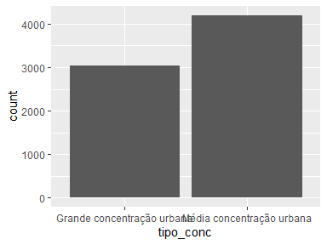

## cod_arranjo

| Feature | Result |
| --- | --- |
| Variable type | numeric |
| Number of missing obs. | 50748 (82.85 %) |
| Number of unique values | 294 |
| Median | 3529005 |
| 1st and 3rd quartiles | 3120904; 4204608 |
| Min. and max. | 1100106; 5300108 |

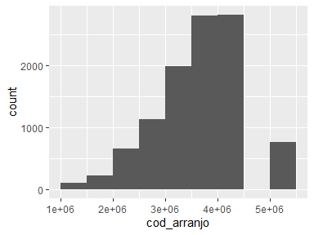

* Note that the following possible outlier values were detected: "1100106", "1100205", "1200054", "1200104", "1303007", …, "1600303", "1600501", "1713205", "1716505", "1721208" (6 values omitted).

## nome_arranjo

| Feature | Result |
| --- | --- |
| Variable type | character |
| Number of missing obs. | 50748 (82.85 %) |
| Number of unique values | 294 |
| Mode | “São Paulo/SP” |

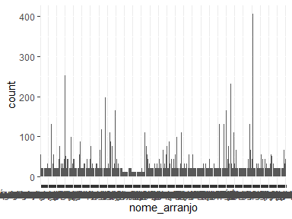

## hier_urb

| Feature | Result |
| --- | --- |
| Variable type | character |
| Number of missing obs. | 0 (0 %) |
| Number of unique values | 17 |
| Mode | “Centro Local” |

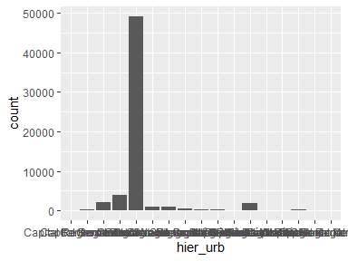

## hier_urb_prin

| Feature | Result |
| --- | --- |
| Variable type | character |
| Number of missing obs. | 0 (0 %) |
| Number of unique values | 5 |
| Mode | “Centro Local” |

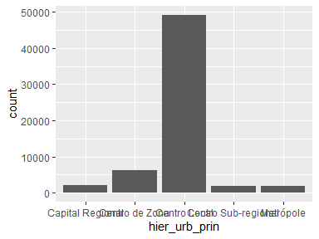

## cod_regiao_rural

| Feature | Result |
| --- | --- |
| Variable type | numeric |
| Number of missing obs. | 0 (0 %) |
| Number of unique values | 104 |
| Median | 3105 |
| 1st and 3rd quartiles | 2503; 4103 |
| Min. and max. | 1101; 5207 |

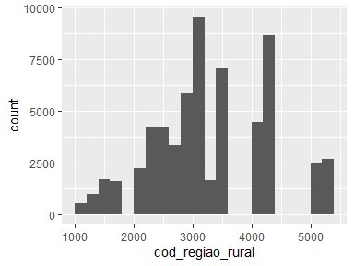

* Note that the following possible outlier values were detected: "1101", "1201", "1202", "1301", "1302", "1303", "1401", "1501", "1502", "1503".

## nome_regiao_rural

| Feature | Result |
| --- | --- |
| Variable type | character |
| Number of missing obs. | 0 (0 %) |
| Number of unique values | 104 |
| Mode | “Região Rural da Capital Regional de Passo Fundo” |

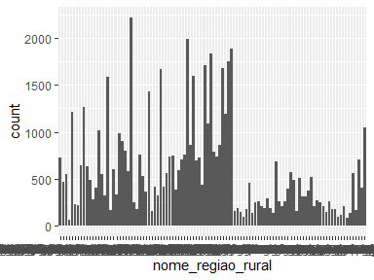

## regiao_rural_nucleo

| Feature | Result |
| --- | --- |
| Variable type | character |
| Number of missing obs. | 0 (0 %) |
| Number of unique values | 6 |
| Mode | “Região Rural de Capital Regional” |

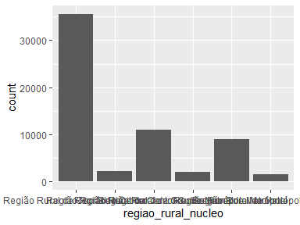

## amaz_legal

| Feature | Result |
| --- | --- |
| Variable type | character |
| Number of missing obs. | 0 (0 %) |
| Number of unique values | 2 |
| Mode | “Não” |

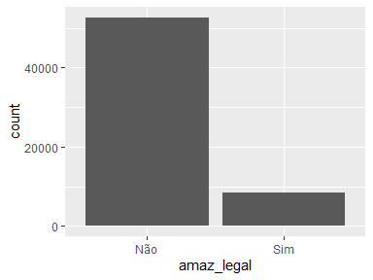

## semiarido

| Feature | Result |
| --- | --- |
| Variable type | character |
| Number of missing obs. | 0 (0 %) |
| Number of unique values | 2 |
| Mode | “Não” |

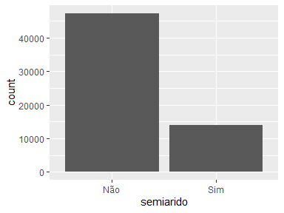

## cidade_regiao_sp

| Feature | Result |
| --- | --- |
| Variable type | character |
| Number of missing obs. | 0 (0 %) |
| Number of unique values | 2 |
| Mode | “Não” |

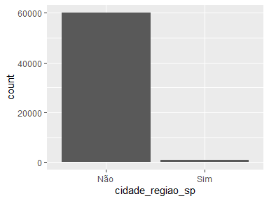

## va_agro

| Feature | Result |
| --- | --- |
| Variable type | numeric |
| Number of missing obs. | 0 (0 %) |
| Number of unique values | 61202 |
| Median | 22641.03 |
| 1st and 3rd quartiles | 9084.25; 51789.03 |
| Min. and max. | -2298.91; 3533041.01 |

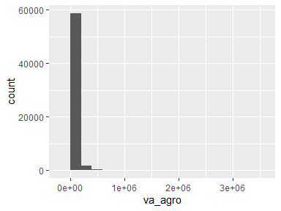

* Note that the following possible outlier values were detected: "-2298.91", "297570.64", "297787.94", "298178.86", "298456.76", …, "2161715.76", "2482541.82", "2538456.49", "2852056.69", "3533041.01" (1190 values omitted).

## va_ind

| Feature | Result |
| --- | --- |
| Variable type | numeric |
| Number of missing obs. | 0 (0 %) |
| Number of unique values | 61177 |
| Median | 10540.95 |
| 1st and 3rd quartiles | 3319; 58987.07 |
| Min. and max. | -2897193.29; 66893050.1 |

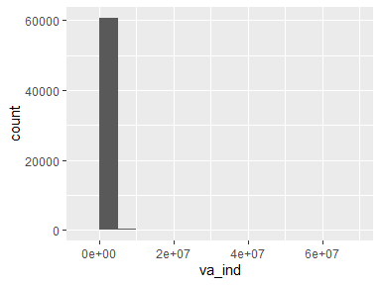

* Note that the following possible outlier values were detected: "-2897193.29", "-2498387.59", "-1734931.28", "-1664761.32", "-1248110.91", …, "62577555.05", "63105175.75", "66082751.68", "66882689.99", "66893050.1" (2602 values omitted).

## va_serv

| Feature | Result |
| --- | --- |
| Variable type | numeric |
| Number of missing obs. | 0 (0 %) |
| Number of unique values | 61241 |
| Median | 40383.04 |
| 1st and 3rd quartiles | 15471.59; 129841.99 |
| Min. and max. | 1206.55; 528404124.84 |

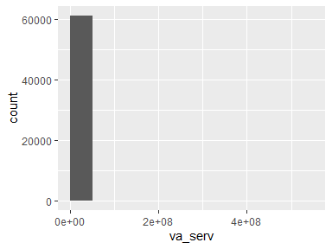

* Note that the following possible outlier values were detected: "1206.55", "1226.51", "1240.09", "1271.14", "1289.31", …, "463376974.42", "474787043.04", "485395448.6", "520357968.89", "528404124.84" (3200 values omitted).

## va_admin

| Feature | Result |
| --- | --- |
| Variable type | numeric |
| Number of missing obs. | 0 (0 %) |
| Number of unique values | 61238 |
| Median | 41803.02 |
| 1st and 3rd quartiles | 21928.1; 90998.81 |
| Min. and max. | 4226.54; 111267001.38 |

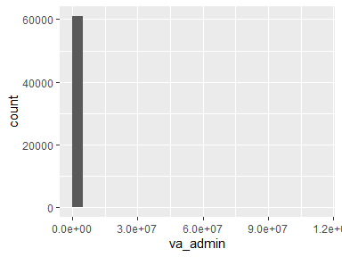

* Note that the following possible outlier values were detected: "4226.54", "4463.88", "4483.02", "4606.27", "4794.54", …, "92051447.72", "98002586.38", "101792841.45", "107219248.73", "111267001.38" (2743 values omitted).

## va

| Feature | Result |
| --- | --- |
| Variable type | numeric |
| Number of missing obs. | 0 (0 %) |
| Number of unique values | 61251 |
| Median | 138700.67 |
| 1st and 3rd quartiles | 62766.66; 367734.81 |
| Min. and max. | -510593.06; 631122747.12 |

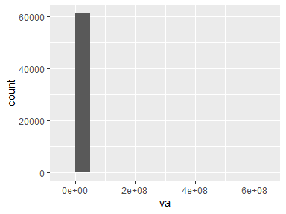

* Note that the following possible outlier values were detected: "-510593.06", "-358826.56", "-92078.04", "-67393.88", "7022.4", …, "565960106.82", "576426128.36", "587506566.89", "624409861.15", "631122747.12" (3530 values omitted).

## imp

| Feature | Result |
| --- | --- |
| Variable type | numeric |
| Number of missing obs. | 0 (0 %) |
| Number of unique values | 61169 |
| Median | 7702.33 |
| 1st and 3rd quartiles | 2551.79; 29617.05 |
| Min. and max. | -15088.4; 132475060.8 |

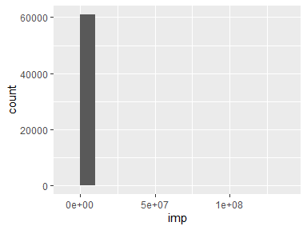

* Note that the following possible outlier values were detected: "-15088.4", "-14174.84", "-12914.52", "-9878.64", "-7761.35", …, "117106590.02", "122526061.02", "124349145.81", "127157037.15", "132475060.8" (3101 values omitted).

## pib

| Feature | Result |
| --- | --- |
| Variable type | numeric |
| Number of missing obs. | 0 (0 %) |
| Number of unique values | 61251 |
| Median | 147096.58 |
| 1st and 3rd quartiles | 65811.87; 399436.91 |
| Min. and max. | -19046.43; 763597807.91 |

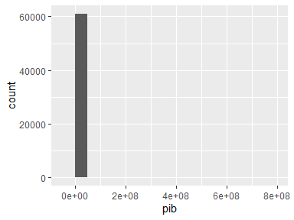

* Note that the following possible outlier values were detected: "-19046.43", "4198.94", "7217.76", "7371.41", "8086.92", …, "683066696.84", "698952189.37", "714663604.04", "748759006.96", "763597807.91" (3557 values omitted).

## pib_pc

| Feature | Result |
| --- | --- |
| Variable type | numeric |
| Number of missing obs. | 0 (0 %) |
| Number of unique values | 60652 |
| Median | 14056.3 |
| 1st and 3rd quartiles | 8298.41; 24104.54 |
| Min. and max. | -1459.83; 815697.76 |

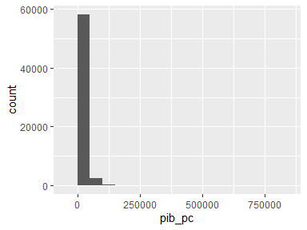

* Note that the following possible outlier values were detected: "-1459.83", "301.6", "89401.02", "89460.24", "89496.57", …, "591101.11", "622975.94", "717343.67", "777099.83", "815697.76" (732 values omitted).

## ativ_1

| Feature | Result |
| --- | --- |
| Variable type | character |
| Number of missing obs. | 0 (0 %) |
| Number of unique values | 10 |
| Mode | “Administração, defesa, educação e saúde públicas e seguridade social” |

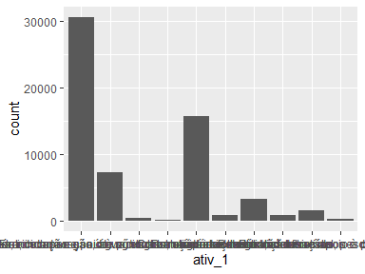

## ativ_2

| Feature | Result |
| --- | --- |
| Variable type | character |
| Number of missing obs. | 0 (0 %) |
| Number of unique values | 10 |
| Mode | “Demais serviços” |

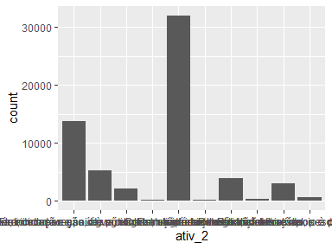

## ativ_3

| Feature | Result |
| --- | --- |
| Variable type | character |
| Number of missing obs. | 0 (0 %) |
| Number of unique values | 10 |
| Mode | “Comércio e reparação de veículos automotores e motocicletas” |

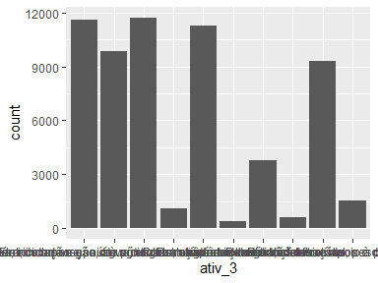

Report generation information:

* Created by: Caio Gonçalves (username: x15767253).
* Report creation time: ter set 19 2023 07:59:00
* Report was run from directory: C:/Users/x15767253/Documents/GitHub/mqagp
* dataMaid v1.4.1 [Pkg: 2021-10-08 from CRAN (R 4.3.1)]
* R version 4.3.1 (2023-06-16 ucrt).
* Platform: x86_64-w64-mingw32/x64 (64-bit)(America/Sao_Paulo).
* Function call: makeDataReport(data = pib_mun, replace = TRUE)