Bit16 Manual
Contents
Bit16 CPU Layout 3
Bit16 Specifications 4
Instructions and Cycle Times 4
Registers 4
RAM Module 5
Format Summary 5
Microcode Summary 6
ALU Opcode Summary 6
Load Operation Summary 6
Jump Instructions Summary 7
Macrocode Summary 7
Micro Instructions Formats 8
Format 0: Jump 8
Operation 8
Examples 8
Format 1: Binary ALU Operation 9
Operation 9
Examples 9
Format 1: Unary ALU Operation 9
Operation 9
Examples 9
Format 1: Binary Operation with Immediate 10
Operation 10
Examples 10
Format 2: Byte Operation 11
Operation 11
Examples 11
Format 3: Register Offset 12
Operation 12
Examples 12
Format 3: Frame Pointer Offset 12
Operation 12
Examples 12
Format 4: Load/Store 13
Operation 13
Examples 13
Format 4: Load/Store from Frame Pointer 14
Operation 14
Examples 14
Format 5: Load/Store with Register Offset 15
Operation 15
Examples 15
Format 6: Stack Operation (Push/Pop) 16
Operation 16
Examples 16
Format 7: Load Word 17
Operation 17
Examples 17

Bit16 CPU Layout
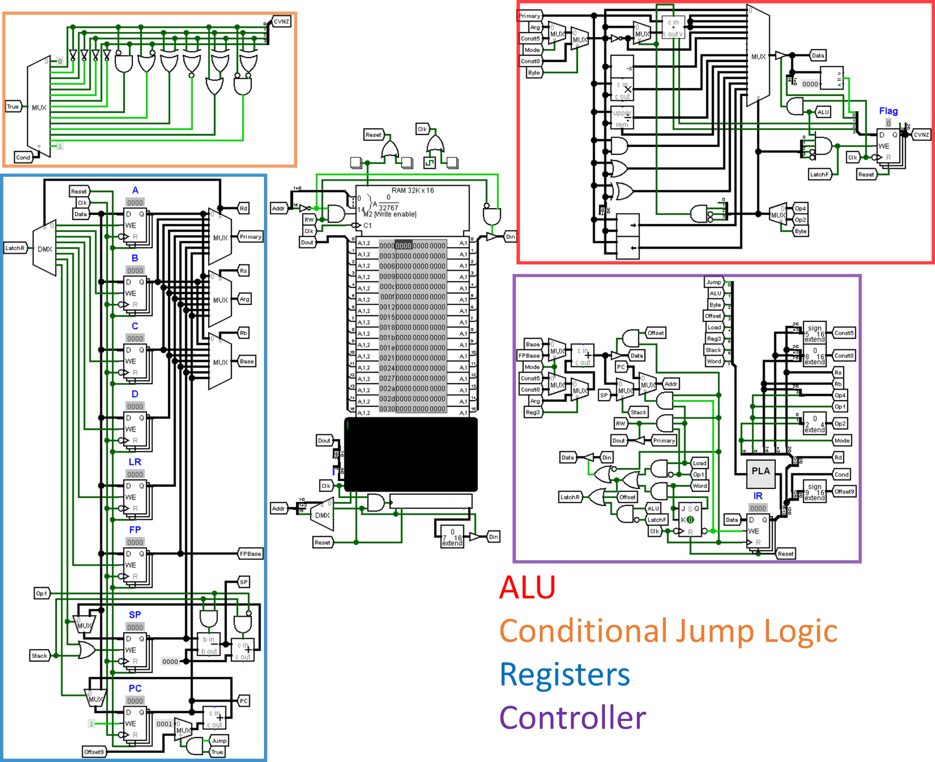
Figure 1: Layout of the bit CPU

Bit16 Specifications

Instructions and Cycle Times
Each instruction is 16 bits long. More information on the formats of each type of 16-bit instruction can be found later in this document. Every microcode instruction has a clock cycle of 1 except for the load word instruction which takes 2 clock cycles.

Registers
The bit16 CPU contains 8 addressable 16-bit registers: 4 general-purpose registers and 4 special purpose registers. The general-purpose registers can be used for anything including arithmetic and address calculations. There is also a 16-bit instruction register that stores the executing instruction and a 4-bit flag register which stores the different flags from the ALU’s operations.
The stack pointer (SP) register is used to keep track of the top of the stack. The stack starts at the last address in RAM and grows downward.
The frame pointer (FP) points to the beginning of the current stack frame and is used to load and store local variables on the stack.
The link register (LR) is used for calling and returning from procedures. LR is 16 bits and should only be used to calculate addresses for the RAM module.
The program counter (PC) register keeps track of the current instruction being executed. The program counter starts at 0 and is incremented after every instruction unless the instruction is a jump instruction in which case, the value in the PC becomes the target for the jump.
Code | Mnemonic | Purpose | Bits | Addressable
0 | A | General purpose | 16 | a
1 | B | General purpose | 16 | a
2 | C | General purpose | 16 | a
3 | D | General purpose | 16 | a
4 | FP | Frame pointer | 16 | a
5 | SP | Stack pointer | 16 | a
6 | LR | Link register | 16 | a
7 | PC | Program counter | 16 | a
 | Flag | Flag register | 4
 | IR | Instruction register | 16
Table 1: bit16 CPU registers

RAM Module
The Random-Access-Memory (RAM) module is addressable in the first half of the address space. This allows for 32,768 16-bit data/instruction locations. This makes the RAM module roughly 64 kilobytes in size.
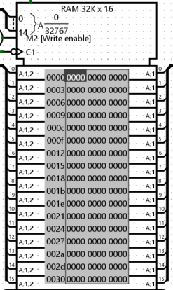
Figure 2: Random-access-memory module

Format Summary
The bit16 instruction set formats are shown in the following figure.
Figure 3: bit16 instruction set formats

Microcode Summary
The following section summarizes the bit16 instruction set microcode.

ALU Opcode Summary
The following table summarizes the bit16 instruction set operations.
Op code | Mnemonic | Instruction | Condition codes set
0 | MOV | Move to register
1 | ADD | Add
2 | SUB | Subtract
3 | CMP | Compare | a
0 (4) | NOT | Bitwise not
1 (5) | NEG | Negative
6
7
8 | MUL | Multiply
9 | DIV | Divide
10 | MOD | Modulo
11 | AND | Bitwise and
12 | OR | Bitwise or
13 | XOR | Bitwise exclusive or
14 | SHR | Shift right
15 | SHL | Shift left
Table 2: bit16 instruction set opcodes

Load Operation Summary
The following table summarizes the Load operation for the bit16 instruction set.
Mnemonic | Instruction
LD | Load
ST | Store
LDW | Load word
Table 3: bit16 load instruction

Jump Instructions Summary
The following table summarizes the jump codes for the bit16 instruction set.
Code | Mnemonic | Instruction
0 | JNV | Jump never
1 | JEQ | Jump if equal
2 | JNE | Jump if not equal
3 | JMI | Jump if minus
4 | JPL | Jump if plus
5 | JVS | Jump if overflow set
6 | JVC | Jump if overflow clear
7 | JCS/JHS | Jump if carry set/higher or same
8 | JCC/JLO | Jump if carry clear/lower
9 | JHI | Jump if higher
10 | JLS | Jump if lower or same
11 | JLT | Jump if greater than
12 | JGE | Jump if less than
13 | JLE | Jump if greater than or equal to
14 | JGT | Jump if less than or equal to
15 | JR/JMP | Jump relative
Table 4: bit16 jump instructions

Macrocode Summary
The following section summarizes the bit16 instruction set macrocode. Macrocode instructions are instructions that are not supported by the hardware and are made up of one or more microcode instructions.
Mnemonic | Instruction | Microcode
PUSH | Push register(s) to stack | PUSH A, B =  PUSH A  PUSH B
POP | Pop register(s) from stack | POP A, B =  POP B  POP A
JUMP | Jump to immediate address | JUMP L =  LDW PC, L
CALL | Call procedure | CALL L =  ADD LR, PC, 3  JUMP L
RET | Return from procedure | RET =  MOV PC, LR
HALT | Halt execution | HALT =  MOV PC, PC
Table 5: bit16 macro code instructions

Micro Instructions Formats
The following section covers the 8 different instruction formats of the bit16 CPU instruction set.

Format 0: Jump
Cond: Condition code
Offset9: Immediate signed 9-bit offset value
Figure 4: Format 0

Operation
Instructions of this format perform a conditional relative jump. This means that the given immediate value is added to the program counter depending on the state of the flag register.

Examples
JR loop ; Unconditionally jumps to the label “loop”
JNE .L0 ; Jumps to the label “.L0” if the Z bit is clear
JGE end ; Jumps to label “end” if greater than or equal to

Format 1: Binary ALU Operation
Rd: Source/destination register
Rs: Source register
Op4: 4-bit opcode
Figure 5: Format 1

Operation
Instructions of this format perform a binary ALU operation on the given registers and place the result in the destination register (Rd) unless it’s a comparison operation (CMP, CMN, TST, TEQ).

Examples
ADD A, B ; A = A + B
CMP A, B ; Subtract B from A and set the condition codes
OR A, B ; A = A | B
AND A, B ; A = A & B
MOV A, B ; Move the value in B to A

Format 1: Unary ALU Operation
Rd: Source/destination register
Op1: 1-bit opcode. (0 = NOT, 1 = NEG)
Figure 6: Format 1 (Unary)

Operation
Instructions of this format perform a unary ALU operation on the given source register and place the result in the destination register.

Examples
NOT A ; A = ~A
NEG A ; A = -A

Format 1: Binary Operation with Immediate
Rd: Source/destination register
Const5: Immediate signed 5-bit value
Op4: 4-bit opcode
Figure 7: Format 1 w/ immediate

Operation
Instructions of this format perform a binary ALU operation on the given register and the given immediate value and place the result in the destination register (Rd) unless it’s a the comparison operation

Examples
ADD SP, 1 ; SP = SP + 1
CMP B, 0 ; Subtract 0 from B and set the condition codes
AND A, 0b111 ; A = A & 0b111
MOV A, -1 ; Move the value -1 to A

Format 2: Byte Operation
Rd: Destination register
Const8: Immediate 8-bit value
Op2: 2-bit opcode (0 = MOV, 1 = ADD,
2 = SUB, 3 = CMP)
Figure 8: Format 2

Operation
Instructions of this format load one 8-bit value into one of the addressable registers.

Examples
CMP A, ‘\0’ ; Compares the ascii value in A to ‘\0’ (0)
MOV B, ‘\n’ ; Loads the ascii value for ‘\n’ (10) into register B
ADD B, ‘A’ ; Adds the ascii value for ‘A’ (65) to register B

Format 3: Register Offset
Rd: Source/destination register
Rb: Base Register
Const5: Immediate signed 5-bit value
Figure 9: Format 3

Operation
Instructions of this format add or subtract a 5-bit signed immediate value to or from the given base register and place the result in the destination register.

Examples
ADD A, B, 0x1 ; A = B + 0x1
SUB A, B, 3 ; A = B - 3
ADD A, A, 1 ; A = A – 1. Equivalent to ADD A, 1

Format 3: Frame Pointer Offset
Rd: Source/destination register
Const8: Immediate unsigned 8-bit value
Figure 10: Format 3

Operation
Instructions of this format add or subtract an 8-bit unsigned immediate value to or from the frame pointer register and place the result in the destination register.

Examples
ADD A, FP, 1 ; A = FP + 1
ADD B, FP, 0xFF ; B = FP + 0xFF

Format 4: Load/Store
Rd: Source/destination register
Rb: Base register
Offset5: Immediate signed 5-bit offset
S: Store flag (0 = Load, 1 = Store)
Figure 11: Format 4 with immediate offset

Operation
Instructions of this format transfer 16-bit values to and from registers and the RAM module. The load or store operation depends on the S flag. The offset value is added to the value in the base register and sent to the RAM module’s address BUS.

Examples
ST [SP, 2], C ; Stores the value in C to the address SP + 2
LD C, [SP, 2] ; Loads the value at address SP + 2 into C
LD A, [A] ; Loads the value at the address in A into A
ST [B], A ; Stores the value in A to the address in B

Format 4: Load/Store from Frame Pointer
Rd: Source/destination register
Const8: Immediate unsigned 8-bit value
S: Store flag (0 = Load, 1 = Store)
Figure 12: Format 4

Operation
Instructions of this format transfer 16-bit word values to and from registers and the RAM module. The load or store operation depends on the S flag. The offset value is added to the value in the frame pointer register and sent to the RAM module’s address BUS.

Examples
ST [FP, 0], A ; Stores the value in A to the address FP + 0
LD A, [FP, 4] ; Loads the value at address FP + 4 into A
LD A, [FP, 0xFF] ; Loads the value at address FP + 0xFF into A

Format 5: Load/Store with Register Offset
Rd: Source/destination register
Rb: Base register
Ro: Offset register
S: Store flag (0 = Load, 1 = Store)
Figure 13: Format 5

Operation
Instructions of this format transfer 16-bit values to and from registers and the RAM module. The load or store operation depends on the S flag. The value in the offset register is added to the value in the base register and sent to the RAM module’s address BUS.

Examples
ST [B, C], A ; Stores the value in A to the address B + C
LD A, [B, C] ; Loads the value at address B + C into A

Format 6: Stack Operation (Push/Pop)
Rd: Source/destination register
P: Push/pop flag (0 = Pop, 1 = Push)
Figure 14: Format 6

Operation
Instructions of this format transfer 16-bit values to and from registers and the stack in the RAM module. The push or pop operation depends on the P flag. The SP register is also altered depending the operation.

Examples
PUSH A ; Pushes A to the stack and decrements SP
POP A ; Pops the top of the stack into A and increments SP

Format 7: Load Word
Rd: Source/destination register
Figure 15: Format 7

Operation
Instructions of this format load a full 16-bit immediate value into one of the addressable registers. The 16-bit value is stored in the next location in memory.

Examples
LDW A, 3000 ; Loads the value 3000 from memory into register A
LDW B, =msg ; Loads the label address into register B
LDW C, 0x7fff ; Loads the hex value 7fff into register C

