2.2.3

number of horses: 2155

number of jockeys: 105

number of trainers: 93

3.1.1

Prediction evaluation:

|  |  |  |  |
| --- | --- | --- | --- |
|  | f1 | precision | recall |
| HorseWin | 0.284875 | 0.172752 | 0.811715 |
| HorseRankTop3 | 0.518893 | 0.378283 | 0.825874 |
| HorseRankTop50Percent | 0.71189 | 0.622695 | 0.830908 |

Running Time:

Fit (10-fold cross validation): 74.744310 s

Predict: 1.498674 s

3.1.2

GaussianNB, it is because some of the features like those avg_rank are in float number, and it is likely to have a normally distributed dataset. Since MultinomialNB nor BernoulliNB are for classification with discrete features, so they should not be used in this dataset.

Prediction evaluation (sklearn):

|  |  |  |  |
| --- | --- | --- | --- |
|  | f1 | precision | recall |
| HorseWin | 0.250823 | 0.151972 | 0.717573 |
| HorseRankTop3 | 0.498361 | 0.36248 | 0.797203 |
| HorseRankTop50Percent | 0.70126 | 0.612853 | 0.819473 |

Running Time (sklearn):

Fit (10-fold cross validation): 0.166620 s

Predict: 1.519994 s

Prediction evaluation (my implementation):

|  |  |  |  |
| --- | --- | --- | --- |
|  | f1 | precision | recall |
| HorseWin | 0.250431 | 0.149938 | 0.759414 |
| HorseRankTop3 | 0.49911 | 0.365949 | 0.784615 |
| HorseRankTop50Percent | 0.702245 | 0.614944 | 0.818434 |

Running Time (sklearn):

Fit: 0.006186 s

Predict: 79.991875 s

The result of my implementation of naïve bayes is very similar to the implementation of sklearn, but my implementation uses much more time in prediction.

3.1.3

rbf, since the dataset is large and dimension is relatively small. Also, some of the features seem not to have a linear relationship with the ranking, such as race_distance, so it is hard to decide a suitable degree of function for the classification.

Prediction evaluation:

|  |  |  |  |
| --- | --- | --- | --- |
|  | f1 | precision | recall |
| HorseWin | 0.120425 | 0.138211 | 0.106695 |
| HorseRankTop3 | 0.35208 | 0.391938 | 0.31958 |
| HorseRankTop50Percent | 0.60289 | 0.537273 | 0.686764 |

Running Time:

Fit (10-fold cross validation): 621.381144 s

Predict: 7.091107 s

3.1.4

Prediction evaluation:

|  |  |  |  |
| --- | --- | --- | --- |
|  | f1 | precision | recall |
| HorseWin | 0.247532 | 0.194279 | 0.341004 |
| HorseRankTop3 | 0.460889 | 0.385593 | 0.572727 |
| HorseRankTop50Percent | 0.663227 | 0.590062 | 0.757103 |

Running Time:

Fit (10-fold cross validation): 4.006915 s

Predict: 1.485075 s

3.4

4.1.1

rbf, similar reason as choosing the SVM kernel. It’s because some of the feature may not have a linear relation with the finishing time, and determine a suitable poly-function is not easy.

epsilon means the maximum margin from the model that can be accepted without penalty, one of the usage is to deal with noise. Setting this value too high will likely to make the model too general as it accepts much more data apart from noise, but setting this value too small may cause overfitting, such that the model fit with the training data but cannot predict well with the test data. So, by testing of different values, 0.5 is chose for epsilon.

C means the penalty value for each error, i.e. outside the maximum margin mentioned above. Set this to a higher value will make the model more aware to the error term, such that the RMSE will decrease. However, a too high value will make the model too specific to predict the finishing_time, but not general enough to predict the top1 horse within wach race. So, by testing of different value, 5 is chose for C.

4.1.2

quantile, it is more robust in measuring the error, as it is not only considering the mean of the variable. Although the RMSE of using ls/lad/Huber will be lower since they are related to mean-square, quantile function will have a better result on predicting the winning horse.

learning_rate means how much the model adjust in each round of boosting, while n_estimators means the total number of rounds to do boosting. Large learning_rate may cause over-shooting that adjusting too much and miss the target, but small learning_rate will need many rounds to converge. Small n_estimators may not enough to adjust the model to the data, while large n_estimators may overfit the data and increase the training time. So, usually we tune learning_rate and n_estimators in a reverse direction, such as decreasing learning_rate and increasing n_estimators. By testing of different combination, 0.03 is chosen for learning_rate and 300 is chosen for n_estimators.

max_depth means the maximum tree depth of the estimator, which should be related to the relationship of the feature. A small depth will not be enough to fit the model to the data, while a large depth will make the tree overfit to each feature, which is not good when there is relationship among features. So, by testing of different value, 3 is chosen for max_depth.

4.2

Without normalization:

(svr_model, 1915.443705, 0.066667, 0.266667, 6.46875)

(gbrt_model, 216.880711, 0.239583, 0.564583, 4.095833)

With normalization:

(svr_model, 705.786726, 0.110417, 0.272917, 6.379167)

(gbrt_model, 216.883099, 0.239583, 0.564583, 4.095833)

After normalization, the result of SVR improved a lot, as we can see the RMSE drop from 1915 to 706. However, the result of GBRT did not change much, the results are almost the same.

5

Basic Strategy

|  |  |
| --- | --- |
| LogisticRegression | 37.7 |
| NaiveBayes | -59.0 |
| SVM | -92.0 |
| RandomForest | -7.2 |
| SVR | -64.4 |
| SVR with normalize | -149.2 |
| GBRT | -12.7 |
| GBRT with normalize | -12.7 |

For classification models, for each race, all HorseWin horses will be selected as candidate. If there is no HorseWin horses, then all HorseRankTop3 horses will be selected. If there is no HorseRankTop3 horses, then all HorseRankTop50Percent horses will be selected. If there is no HorseRankTop50Percent horses, then all horses will be selected. For the candidate horses, we choose the one with maximum declared_horse_weight. It’s because win_odds and declared_horse_weight have a higher feature importance, and by experiment higher declared_horse_weight have a better result.

For regression models, although the prediction of finishing time can infer only one winning horse, as the accuracy of the prediction is not high enough, so we will pick the top 2 horses in each race, and further decide the only winning horse by the same method above, i.e. the one with maximum declared_horse_weight.

Our own strategy: 63.0

We make use of the best model from classification and the best model from regression, i.e. LogisticRegression and GBRT. So, we first select candidate from all horses that is HorseWin in LogisticRegression, and all horses that is top 3 in GBRT, for each race. To select the only winning horse from candidates, we use the same method as above, i.e. the horse with maximum declared_horse_weight. If the win_odds of that horse is small than 12, we will bet on it, otherwise we won’t bet on it since it is too risky.

6.1

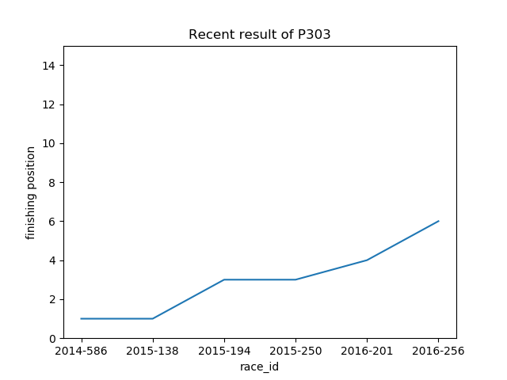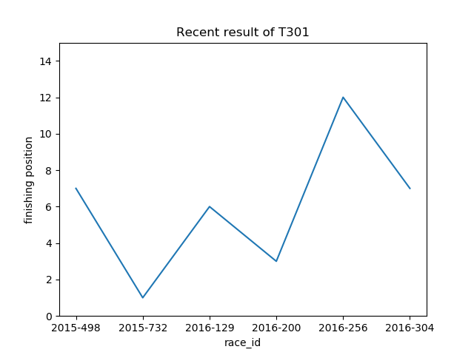

From the plot of horse P303, it has an increasing trend in ranking, which means the performance of this horse is worsening.

From the plot of horse T301, the line going up and down, which means the horse’s performance is fluctuating.

6.2

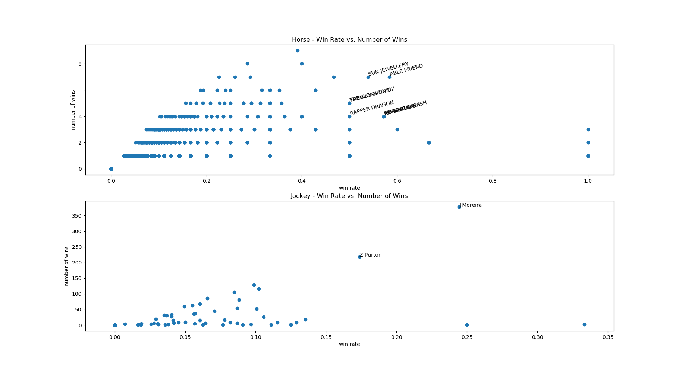

Best horse: Able Friend. Although there are other horses having win rate of 100%, these horses only join a few races (<4 races), which is hardly to determine if these horses will continue the performance afterward. Therefore, for all horse having more than 4 races, Able Friend have win rate > 50% and it’s win rate also the highest, so it is the best currently.

Best jockey: J Moreira. He has the highest number of wins. Although there are jockeys having higher win rate, these jockeys only participate in very few races, so they should not be classified as best jockey at the moment.

6.3

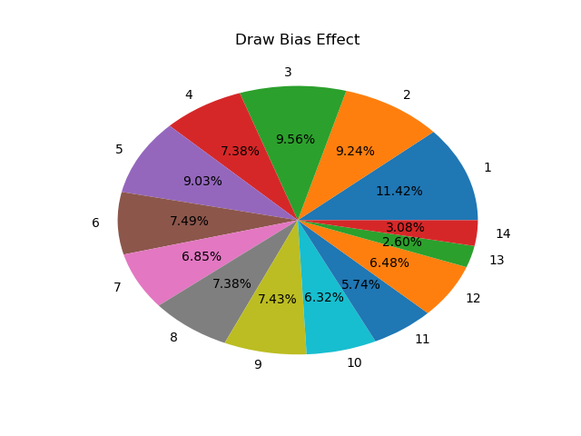

The plot shows that the draw 1 has a highest chance of winning, and the winning chance tends to decrease as the draw number increase. Note that the draw 13 and draw 14 have a relatively low percentage just because not all races have 14 horses, some of them only have 12 horses. The lower draw number has a considerable advantage to win, when comparing draw 1 and draw 11, draw 1 has doubled the win rate. Although the increase is only a few percentage, that’s because there are much more factor affecting the winning rate.

6.4

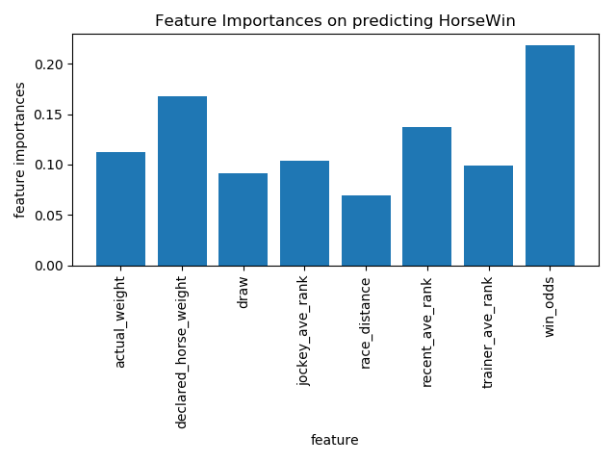

The plot shows that the feature “win_odds” have the highest importance on predicting the winning horse, which is reasonable as people usually bet on the horse that have a higher chance to win. The feature “race_distance” have the lowest importance, which is because the distance is the same for all record in the same race, so it can’t have a large importance. It is interesting to find that the “declared_horse_weight” have a relatively higher importance, when compare to the “actual_weight”, since the “actual_weight” should be related to the horse’s previous performance.

6.5

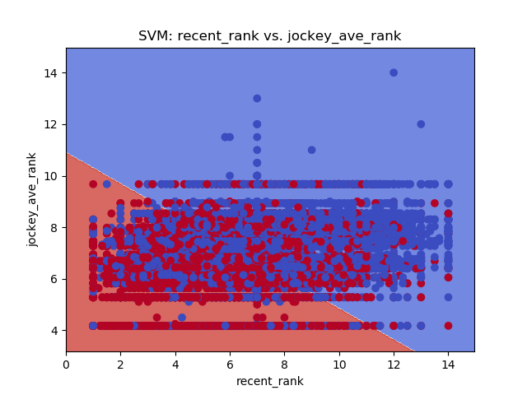

This plot shows that higher recent_rank or higher jockey_ave_rank does have a higher chance to rank higher. SVM does try to find a best line to separate 2 classes, although they can’t be totally separated. As we can see that the blue plane has more blue points on it while the red plane has more red points on it. The line seems to pass through the point (7,7), which is the mean point, but have a lower y-intercept than x-intercept, which may show that the jockey_ave_rank is more important.