Exception:
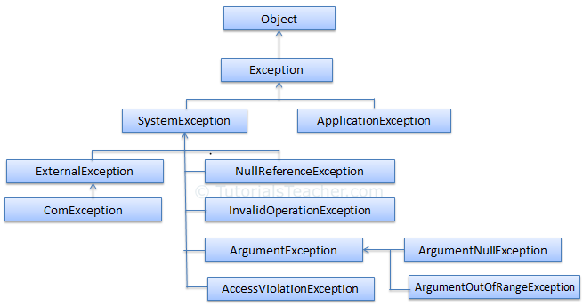
Exception -> SystemException -> Build-in Exceptions
Exception Class | Description
ArgumentException | Raised when a non-null argument that is passed to a method is invalid.
ArgumentNullException | Raised when null argument is passed to a method.
ArgumentOutOfRangeException | Raised when the value of an argument is outside the range of valid values.
DivideByZeroException | Raised when an integer value is divide by zero.
FileNotFoundException | Raised when a physical file does not exist at the specified location.
FormatException | Raised when a value is not in an appropriate format to be converted from a string by a conversion method such as Parse.
IndexOutOfRangeException | Raised when an array index is outside the lower or upper bounds of an array or collection.
InvalidOperationException | Raised when a method call is invalid in an object's current state.
KeyNotFoundException | Raised when the specified key for accessing a member in a collection is not exists.
NotSupportedException | Raised when a method or operation is not supported.
NullReferenceException | Raised when program access members of null object.
OverflowException | Raised when an arithmetic, casting, or conversion operation results in an overflow.
OutOfMemoryException | Raised when a program does not get enough memory to execute the code.
StackOverflowException | Raised when a stack in memory overflows.
TimeoutException | The time interval allotted to an operation has expired. | TimeoutException(String, Exception)

Exception Handling
try block: Any suspected code that may raise exceptions should be put inside a try{ } block. During the execution, if an exception occurs, the flow of the control jumps to the first matching catch block.
catch block: The catch block is an exception handler block where you can perform some action such as logging and auditing an exception. The catch block takes a parameter of an exception type using which you can get the details of an exception.
finally block: The finally block will always be executed whether an exception raised or not. Usually, a finally block should be used to release resources, e.g., to close any stream or file objects that were opened in the try block.

