# Supplement Materials

Food4healthKG: Knowledge Graphs for Food Recommendations Based on Gut Microbiota and Mental Health

Content

Supplement Materials 1

Figures 2

Figure 1 2

Figure 2 3

Tables 4

Table 1 4

SPARQL query 6

Query 1: 6

Query 2: 6

Query 3: 7

## Figures

### Figure 1

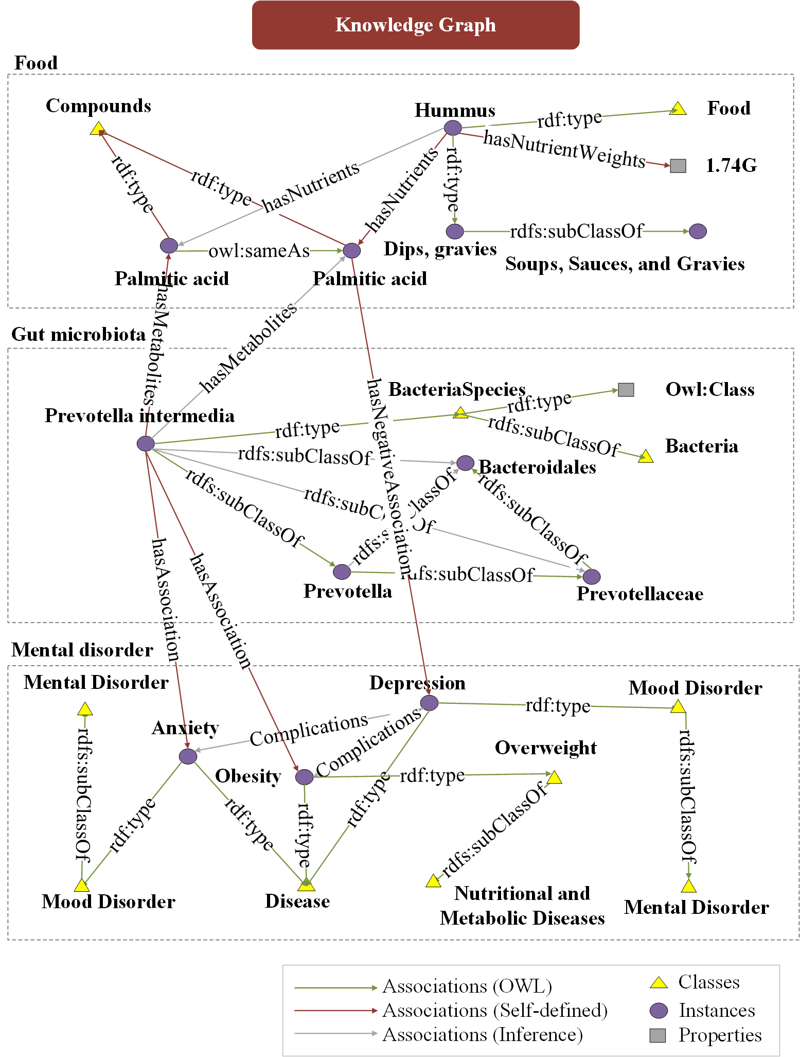

Fig 1. An example of the graph structure in Food4healthKG. The ontologies concern food, gut microbiota, and disorders. Associations are mainly from OWL (well-defined general relations), self-defined relations, and inference (implicit relations that are inferred from knowledge reasoning). Food4healthKG also includes multiple entities as classes, instances, and properties. This figure shows a comprehensive example of how food could affect complicated disorders through the gut microbial metabolisms.

### Figure 2

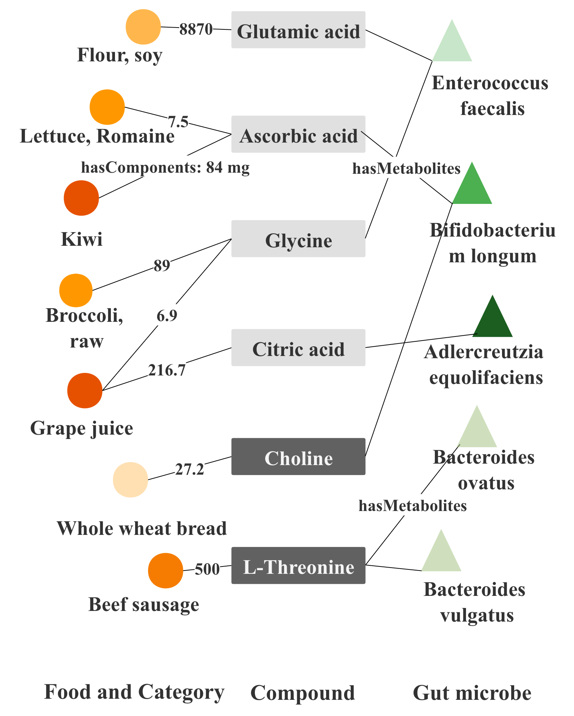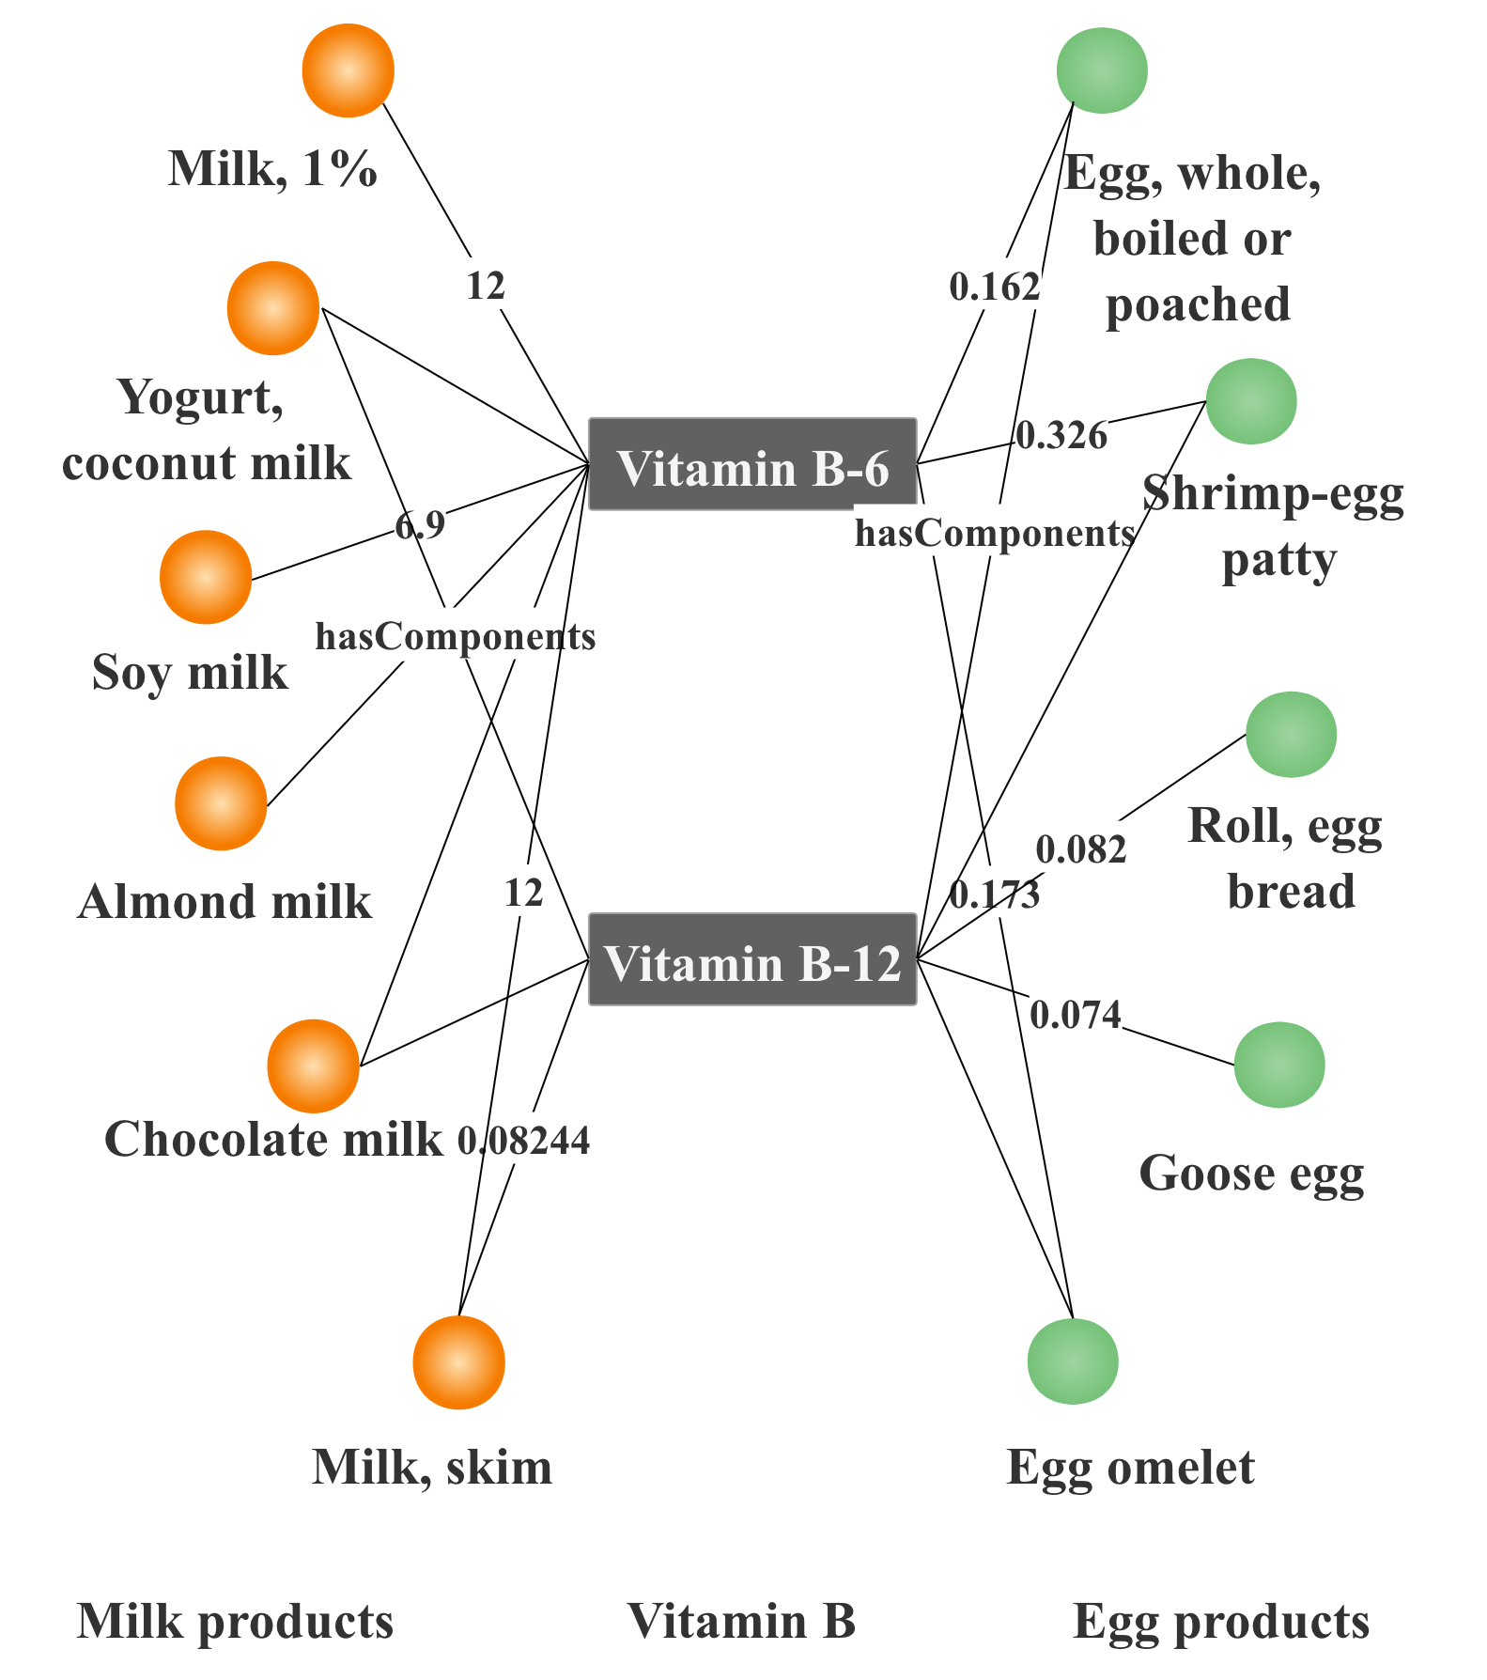

1. The effects of food on the human gut. (b) The effects of food on mental disorder.

Fig 2. The visualization of results from query type 1 and 2. In both figures, the circles are food. The square boxes are nutrients, as well as the gut metabolites. The triangles are the gut microbiota. The various colors of the food represent the categories, colors of gut microbiota represent different genus. The links between them are associations.

## **Tables**

### Table 1

|  |  |  |  |  |  |  |
| --- | --- | --- | --- | --- | --- | --- |
| No | Questions | Attributes | Food4healthKG | V0 | V1 | V2 |
| 0 | Lists of fruits which contains Lysine | food categories | Melons, oranges, strawberries, etc | 1 | 1 | 1 |
| 1 | The food categories of the cola | food categories | Soft drinks, beverages | 1 | 1 | 1 |
| 2 | The food categories of the soy milk | food categories | Milk substitutes, beverages | 1 | 1 | 1 |
| 3 | The lists of baby food | food categories | Carrots(baby food), plums(baby food), etc | 1 | 1 | 1 |
| 4 | The weight of folate that peach pie can provides in gut | compounds in food and gut | 0.046mg/100g | 1 | 1 | 1 |
| 5 | The difference of retinol between milk and yogurt | compounds in food and gut | 0.127mg/100g milk, 0.702mg/100g yogurt | 1 | 1 | 1 |
| 6 | The weight of citric acid can Adlercreutzia equolifaciens taken from grape juice | compounds in food and gut | 309mg/100g | 1 | 1 | 1 |
| 7 | The weight of ascorbic acid can Bifidobacterium longum taken from lettuce | compounds in food and gut | 15mg/100g | 1 | 1 | 1 |
| 8 | The rank of Potassium weight in food | weight calculation | Beans, Egg whites, Almonds, etc | 1 | 1 | 1 |
| 9 | The weight of Vitamin B12 in mixed diet orange and sausage | weight calculation | 0.072mg/200g | 1 | 1 | 1 |
| 10 | The weight of Vitamin B6 in egg and whole milk | weight calculation | 6.591mg/200g | 1 | 1 | 1 |
| 11 | The microbial related mental disorders | disease classification | Autistic disorder, developmental disorder, etc | 1 | 1 | 1 |
| 12 | The difference between depression and autistic disorder | disease classification | Depression(Mood disorder)  Autistic disorder(developmental disorder) | 1 | 1 | 0 |
| 13 | The list of diseases in mental disorders | disease classification | Eating disorder, bipolar disorder, etc | 1 | 1 | 1 |
| 14 | The vitamins may have effects on depression | compounds categories | Vitamin B1-B5, VC, VE, etc | 0 | 1 | 1 |
| 15 | The alkaloids involved from food | compounds categories | Caffeine, theobromine, etc | 1 | 0 | 1 |
| 16 | The categories of biological compounds | compounds categories | Peptides, alkaloids, etc | 1 | 1 | 1 |
| 17 | The Bacteroides may have effects on depression | bacteria taxonomy | Bacteroides ovatus, vulgatus, fragilis | 1 | 1 | 1 |
| 18 | The taxonomy tree of Escherichia coli | bacteria taxonomy | Escherichia, Enterobacteriaceae, etc | 1 | 1 | 1 |
| 19 | The top 3 genus of bacteria related to disease | bacteria taxonomy | Streptococcus, Bacteroides, Prevotella | 1 | 0 | 1 |

## SPARQL query

Query 1:

###### How much Vitamin B can be absorbed from a mixed meal of milk and egg products?

select distinct ?Eggname?Milkname?Nutrientname((?eggweight + ?milkweight) AS ?Weight)

where

{

{?egg pq:hasNutrients ?nutrient;

pq:hasNutrientWeights ?eggunit;

rdf:type ?eggclass;

rdfs:label ?eggname.}

{?milk pq:hasNutrients ?nutrient;

rdfs:label ?milkname.}

?eggclass rdfs:label ?eggclassname.

{?nutrient rdfs:label ?nutrientname;

pq:hasNutrientWeights ?eggunit;

pq:hasNutrientWeights ?milkunit.}

?eggunit rdf:value ?eggweight.

?milkunit rdf:value ?milkweight.

filter regex(?nutrientname,"Vitamin B","i")

filter regex(?eggname,"Egg","i")

filter regex(?milkname,"Milk","i")

}

Query 2:

###### **Which gut metabolism pathway could have effect on food and depression?**

select distinct ?foodname?foodclassname?compoundname?weight?bacname

where {

?depression npq:hasNegativeAssociation ?compound;

rdfs:label ?depressionname.

?compound rdfs:label ?compoundname.

?nutrition owl:sameAs ?compound;

pq:hasNutrientWeights ?unit.

{?food pq:hasNutrients ?nutrient;

pq:hasNutrientWeights ?unit;

rdfs:label ?foodname.}

?unit rdf:value ?weight.

?food rdf:type ?foodclass.

?foodclass rdfs:label ?foodclassname.

?depression npq:hasPositiveAssociation ?bac.

?bac npq:hasMetabolites ?compound.

?bac rdfs:label ?bacname.

filter regex(?depressionname,"depression | depressive | depressed","i")

}

### Query 3:

###### How does food affect on both depression and its complication through the gut microbiota?

select distinct ?food?compound?bacteria?disease

where {

{?depression npq:hasNegativeAssociation ?compound;

rdfs:label ?depressionname.}

?nutrition owl:sameAs ?compound.

?compound rdfs:label ?compoundname;

rdf:type entity:Compounds

{?food pq:hasNutrients ?nutrient;

rdfs:label ?foodname.}

{?bacteria npq:hasMetabolites ?compound;

rdfs:label ?bacterianame;

npq:hasAssociation ?disease.}

?dissnomed owl:sameAs ?disease;

wasp:hasEnglishLabel ?disname;

rdfs:subClassOf ?disclass.

?disclass wasp:hasEnglishLabel ?disclassname.

filter regex(?disclassname,``mental disorder",``i")

filter regex(?depressionname,``depression| depressive | depressed",``i")

}