Report

Eric R. Scott

2022-07-11

## My analysis

I modeled the relationship between height and shoots two ways: 1) by log-transforming the response and 2) with log-normal errors. Here I compare the two approaches:

tar_load(summary_table)  
summary_table %>% arrange(AIC)

## df AIC  
## log_lm 2 322.3481  
## log_link_glm 3 486.1629

As you can see, model 1 (with log-transformed response) has a lower AIC but I don’t know if these are comparable because the two models are fit to different data!!!

Instead, let’s look at model diagnostics

#### Log-transformed:

plot(tar_read(log_lm), c(1,2))

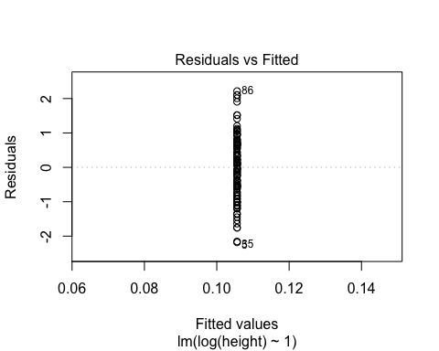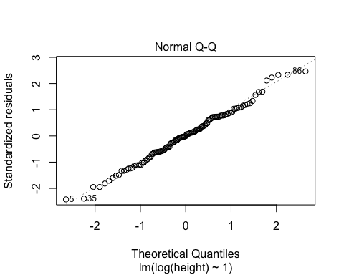

#### Log-normal

plot(tar_read(log_link_glm), c(1,2))

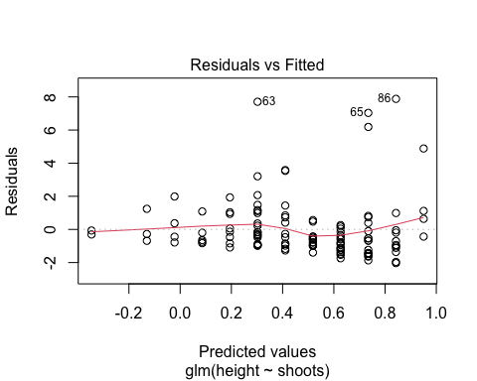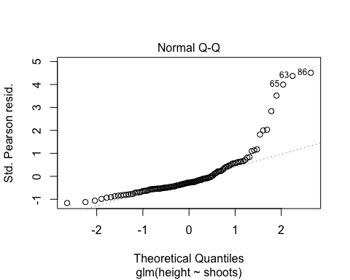

The log transformed response model also has better behaved residuals.