Individual variation in natural or manipulated corticosterone is not related to variation in circulating glucose in a wild bird.

Conor C. Taff1,2*, Cedric Zimmer1, Thomas A. Ryan1, David Chang van Oordt1, Maren Vitousek1,2

1 Department of Ecology & Evolutionary Biology, Cornell University

2 Lab of Ornithology, Cornell University

* Correspondence: Conor C. Taff, [cct63@cornell.edu](mailto:cct63@cornell.edu) 518-332-3983

Other people who helped:

* General field work for multiple years and multiple sites worth of field crews. Not sure any single person from those years really needs to be added on this particular paper though.
* Currently I have the population comparison in here. I’m on the fence about whether to leave that in or take it out and just make it a bit simpler, though it fits in fine. If we do leave it in, would we want to add authors from the other populations?

Open questions:

* I originally had dex in here as well, but I realized in preparing this that it doesn’t actually fit all that well because even though dex should decrease cort, dex itself should be triggering a similar glucose increase through it’s actions at GC receptors. That might be interesting in a similar way as Cortrosyn, but since we can’t measure actual concentrations of cort + dex, there isn’t any real way to do the between individual covariation that the rest of the paper focuses on. The results aren’t really changed by adding dex, but I think it’s probably simpler to just keep it out.

**ABSTRACT**

We sought to address the question of whether between-individual variation in either absolute levels or upregulation of corticosterone directly predicted variation in glucose regulation.

Total of 2,673 measurements of circulating glucose from four populations observational birds and an additional 483 following either dex or cortrosyn injection from four populations including both adults and nestlings All are coupled with simultaneous corticosterone measurements.

At a group level, our study provides compelling evidence that glucose reliably increases during a stress response induced by capture and handling. This result is robust across four populations in adults but was not observed in 12-day old nestlings. However, there was very little evidence that between-individual differences in circulating corticosterone levels or in the magnitude of corticosterone change predicted between-individual differences in glucose regulation. In adults, but not nestlings, experimentally increasing the corticosterone response with synthetic ACTH resulted in increased glucose, but once again the magnitude of hormone increase did not predict the magnitude of glucose increase. Experimentally decreasing corticosterone with dexamethasone injection did not alter glucose regulation in either age group. Our results highlight the fact that a strong response in one aspect of the coordinated acute stress response (corticosterone increase) does not necessarily indicate that an individual is a strong responder overall. These results have important implications for understanding both how individuals differ in their response to challenges and for studying how the full stress-response system is likely to respond to selection.

Population differences in glucose regulation that might reflect plastic response to climate or local adaptation.

3,154 samples from 776 individual birds adults and nestlings four populations.

Cannot be assumed that a strong corticosterone response indicates a strong response in glucose, or other physiological mediators without investigating between- and within-individual variation.

Should dexamethasone actually be decreasing glucose since it is still having cort effects? (see Horner et al. 1987 cited in MacDougall-Shackleton).

***Keywords:*** *stress response, glucose regulation, evolutionary endocrinology*

**INTRODUCTION**

Wild animals live in capricious environments where sudden challenges are encountered regularly. Successfully navigating these challenges requires an integrated physiological and behavioral response (cite). In vertebrates, acute challenges trigger both the catecholamine regulated ‘fight-or-flight’ response and the glucocorticoid mediated acute stress response (cite). When rapidly elevated, glucocorticoids organize a variety of physiological and behavioral changes that facilitate the successful response to an acute challenge along with recovery and preparation for subsequent challenges (cite). In the past fifteen years, attention has shifted from describing the general response to investigating how individuals differ and what consequences this variation may have for fitness and the evolution of physiological systems (Bonier et al., 2009; Breuner et al., 2008). While some patterns have emerged (Schoenle et al., 2021), the lack of consistent links between fitness and corticosterone, coupled with substantial within-individual variation in components of the stress response across time, contexts, or even different tissues in one animal has led to some debate about how to interpret studies that seek to link fitness with corticosterone without measuring other aspects of the multifaceted stress response (Gormally et al., 2020; Lattin et al., 2015; Romero and Gormally, 2019). Addressing these critiques will require more studies of how different aspects of the stress response system covary within and between individuals.

One of the primary actions of glucocorticoids during an acute stress response is to alter glucose homeostasis and increase the availability of glucose (cite). Regulation is accomplished through multiple routes; first, glucocorticoids act antagonistically to insulin in peripheral tissue and decrease glucose uptake across cell membranes, thereby increasing circulating glucose availability (Horner et al., 1987; Remage-Healey and Romero, 2001). At the same time, glucocorticoids promote gluconeogenesis in the liver and alter glucose homeostasis through a variety of other indirect pathways (Kuo et al., 2015). In the context of the acute vertebrate stress response, glucocorticoids are thought to increase the availability of glucose for use by the brain and to allow animals to cope with and recover from an acute challenge (Kuo et al., 2015; Remage-Healey and Romero, 2001).

Although the general pattern of acute challenges increasing glucose availability has been demonstrated many times (cite), there is a great deal of variation and context dependence in this response both within and between species (cite). For example, in captive European starlings (*Sturnus vulgaris*), handling stress increases both corticosterone and glucose, but only in samples taken during or shortly after nighttime (Remage-Healey and Romero, 2000). In a wild population of Rufous-winged sparrows (*Peucaea capalis*), glucose either increases, decreases, or stays the same in response to handling stress, depending on the life history stage (Deviche et al., 2016a). Thus, the magnitude of a glucose response to a stressor—and whether a response occurs at all—may differ with season, time of day, and nutrition. A small number of studies published to date demonstrate that baseline glucose can be moderately repeatable and associated with individual performance (Montoya et al., 2018; Montoya et al., 2020). Across many more species, baseline and stress-induced glucocorticoid levels are also moderately repeatable within individuals (Taff et al., 2018), but repeatability of each trait does not necessarily imply covariation within or between individuals.

Despite the mechanistic link between glucocorticoids and glucose, relatively few studies have investigated changes in both measures simultaneously in wild birds (but see Deviche et al., 2016a; Deviche et al., 2016b). Even fewer studies have investigated whether between-individual variation in the absolute value or magnitude of change in glucocorticoids during an acute stress response predicts the degree of change in glucose availability. In a recent study of Wandering gartersnakes (*Thamnophis elegans vagrans*), Neuman-Lee et al. (2020) used both observational and experimental data to show that while glucose did increase with an acute stress response, individual differences in the amount of glucocorticoid change did not predict the magnitude of change in circulating glucose (see also Gangloff et al., 2017). The generality of this lack of relationship has important implications for understanding how selection operates on variation in the physiological stress response. There is an assumption—often implicit—in evolutionary physiology that a stronger glucocorticoid response to a stressor will result in a similarly stronger change in downstream regulation, including a larger increase in glucose (Romero and Gormally, 2019). However, this assumption is rarely directly tested and if substantial regulation occurs in other components of the system (e.g., in tissue specific receptor density; Lattin et al., 2015) then a similar glucose response might require different levels of corticosterone in two different animals. Moreover, individuals may differ in their degree of within-individual variation (how tightly linked corticosterone and glucose are within the same individual when measured multiple times). Even if corticosterone and glucose are tightly coupled within-individuals, there is no guarantee that within-individual trait correlations will scale to between-individual covariation (Agrawal, 2020).

Here, we studied between- and within-individual covariation in glucose and corticosterone regulation during an acute stress response in the breeding season of wild tree swallows (*Tachycineta bicolor*). We measured glucose and corticosterone repeatedly at baseline and stress-induced levels for adults from four populations with different climate variability along with nestlings from one population. In the main population, we also coupled observational data with experimental manipulations that directly increased circulating corticosterone in adults and nestlings to determine whether there was a causal effect of additional corticosterone on subsequent glucose levels.

We first predicted that glucose and corticosterone would be relatively low in baseline samples, elevated in stress-induced samples, and highest in samples where corticosterone was experimentally elevated. Next, we predicted that if variation in corticosterone levels is the direct cause of glucose elevation, then individual variation in circulating corticosterone and in the magnitude of the natural or experimental increase in corticosterone would be correlated with glucose levels or the increase in glucose levels over the same time period. Alternatively, if glucose and corticosterone regulation do not covary, it would suggest that these two aspects of the acute stress response can be regulated relatively independently or that their link depends critical on additional unmeasured traits (e.g., nutritional state). Finally, using a subset of individuals that were measured multiple times, we assessed the degree to which corticosterone and glucose covaried within-individuals.

**METHODS**

*General Field Methods*

We studied tree swallows breeding near Ithaca, New York, USA (42.4°N, 76.5°W) from 2016-2019. In each year, we monitored nest boxes using established protocols for this population (Winkler et al., 2020). Adult females were captured at the nest box up to three times each breeding season (1-2 times during incubation and 1-2 times after nestlings had hatched). Adult males were typically captured once per year 3-8 days after nestlings had hatched. Nestlings were sampled on days 12 and 15 after hatching. All adults were captured between 6 a.m. and 10 a.m. and nestlings were sampled between 12 p.m. and 3 p.m. to limit variation in physiological measurements associated with circadian patterns.

At each capture, we took a measurement of individual mass to the nearest 0.25 grams and added a unique USGS aluminum band to any individual that was not previously banded. For most captures, we took a series of blood samples by brachial venipuncture to measure corticosterone and glucose. First, we collected a baseline sample within 2 minutes of disturbance (< 70 μl). After 30 minutes, we collected a stress-induced blood sample (< 30 μl). For a subset of adults, immediately after the stress-induced sample, we manipulated the course of the stress-response by injecting Cortrosyn and collected a final blood sample 30 minutes later (< 30 μl; see details below). We performed the same manipulation on nestlings, except in the case of nestlings the Cortrosyn sample was collected on a separate day from the baseline and stress-induced sample (see below).

We measured glucose from baseline, stress-induced, and post-Cortrosyn blood samples at the time of collection using a handheld glucose meter and test strips (FreeStyle, Abbott Diabetes Care, Alameda, CA, USA). Similar devices have been used in previous studies of wild birds (Clinchy et al., 2004; Malisch et al., 2018), and this device was previously validated to provide repeatable measures of glucose in this population of tree swallows (Taff et al., 2019c). The remaining blood sample was stored on ice in the field for <3 hours. Plasma was then separated by centrifugation and stored frozen until corticosterone was measured with an ELISA kit that was previously validated in this population (Arbor Assays K014-H5; Taff et al., 2019a).

During these years, adult females in the population were subjected to a variety of manipulative experiments (Taff et al., 2018; Taff et al., 2019b; Zimmer et al., 2019). In this study, we excluded samples from individuals that had been subject to direct manipulations of corticosterone, but we included samples from treatments that manipulated flight costs, perceived predator presence, or plumage coloration. Males did not receive any direct manipulation and we include all male samples. In the one year that nestling glucose was measured (2019), adult females had received plumage dulling or simulated predation treatments prior to nestling sampling. However, these treatments only targeted adult females and we included all nestling samples. As part of the adult experiments during this year, eggs at most nests were cross fostered prior to the onset of incubation so that each nest typically included eggs from multiple females; we included nest identity as a random effect in all of our models but did not specifically investigate any effects of cross-fostering.

*Comparative Population Study*

In parallel with the study described above in New York, we collected similar data from adult tree swallows breeding in McCarthy, Alaska (2016-2017; 61.4°N, 143.3°W), Burgess Junction, Wyoming (2018; 44.5°N, 107.3°W), and Chattanooga, Tennessee (2018; 35.1°N, 85.2°W). Sampling schedules and details of sampling in each location were identical to those described above for New York. Full descriptions of these study locations can be found in Zimmer et al. (2020). Inclusion criteria were the same as described above from the New York population. Physiological measurements from the other populations were not available for adult males, so analyses comparing the four populations are restricted only to adult females. We did not collect glucose measurements from nestlings in these populations and we do not report data from any post-injection measures in these additional populations. Baseline and stress-induced samples were collected exactly as described above.

*Manipulating the Corticosterone Response*

In the New York population only, we used manipulations to artificially increase the magnitude of the corticosterone response to handling stress in 2019 to determine if there was a direct causal effect of continued corticosterone release on circulating glucose levels. Most adults and nestlings in 2019 received an injection of Cortrosyn (a synthetic version of adrenocorticotropic hormone). Because we had not used this injection previously, we also conducted a validation experiment with a separate set of birds, which confirmed that Cortrosyn injection produced a reliable increase in circulating corticosterone compared to saline injection in both adults and nestlings (supplemental methods; Figure S1-S2; Table S1).

For nestlings, the time course of sampling differed slightly from adults. For all nestlings, we collected a series of samples on day 12 that included a baseline and stress-induced sample as described above for adults. On day 15, we returned to each nestling and collected a post-Cortrosyn sample at a single time point. For this last sample, nestlings were injected immediately after removal from the nest and then a single blood sample was collected 30 minutes later.

*Data Analysis*

Using a subset of adult samples where multiple measures were available, we first evaluated overall unadjusted repeatability in baseline, stress-induced, and induced minus baseline glucose and corticosterone in a linear mixed model fit with the ‘rptR’ package in R (Stoffel et al., 2017). We next sought to determine whether glucose and corticosterone differed at a group level for the three different sample types (baseline, induced, and post-Cortrosyn). We fit a single linear mixed model separately for adults and nestlings to address this question with glucose or corticosterone as the response variable and sample type as a categorical predictor. The adult model included an additional fixed effect for sex and a random effect of bird identity to account for repeated sampling from the same individual. The nestling model included random effects for individual identity and for nest to account for the fact that nestlings sampled from the same nest are not independent.

We next asked whether between individual variation in circulating corticosterone predicted variation in glucose levels. For these analyses, we fit a set of three models separately for adults and nestlings with baseline glucose or change in glucose (base to stress-induced or induced to post-Cortrosyn) as the response variable. Predictor variables included baseline corticosterone or the change in corticosterone over the same sampling interval. The adult model included a random effect for individual identity to account for repeated sampling and the nestling model included a random effect for nest identity to account for non-independence. The adult post-Cortrosyn model did not include any repeat sampling, so it was fit as a simple linear model with no random effects. In these models, we also included mass and an interaction between mass and the corticosterone predictor to test whether corticosterone and glucose were more tightly linked under conditions of food limitation. If there was no support for the mass by corticosterone interaction, we removed this effect from the final model for simplicity.

To determine whether there were population differences in glucose regulation, we fit three linear mixed models with baseline, stress-induced, or induced minus baseline glucose as the response variable and population as a categorical predictor. These analyses included only baseline and stress-induced sample types in adult females. Next, we fit models similar to those describe above with either baseline or induced minus baseline glucose as the response and with corticosterone over the same interval, mass, and a corticosterone by mass interaction as predictors. These models were fit separately for each population and included female identity as a random effect.

Finally, we assessed whether there was any evidence for within-individual covariation between glucose and corticosterone using a subset of individuals that had four or more sampling events. Using this subset, we centered and standardized both glucose and corticosterone within each individual and then fit models with baseline, induced, or the change in glucose as the response variable and with corticosterone over the same time period as the response. By centering within individuals, we used these models to ask whether an increase in corticosterone—relative to an individual’s own mean corticosterone level over all observations—was associated with an increase in glucose relative to their own mean glucose level across observations (see discussion of within-individual mean centering in Westneat et al., 2020).

All linear mixed models except for repeatability estimates were fit using the ‘lme4’ package version 1.1-26 (Bates et al., 2015, 4). For all linear mixed models with categorical comparisons, we extracted means and 95% confidence intervals for each group using the ‘emmeans’ package in R with the Satterthwaite approximation (Lenth, 2020). We interpret groups whose confidence intervals do not overlap to be significantly different. In cases where an interaction was supported, we illustrated the interaction by calculating confidence intervals across a range of predictor values by drawing 1,000,000 samples from the multivariate normal distribution of the fit model using the ‘mvrnorm’ function in R package MASS version 7.5-53 (Ripley et al., 2013) and then calculating the highest posterior density interval with default settings (‘HPDI’ function) using package ‘rethinking’ version 2.01 in R (McElreath, 2020) All figures and analyses were produced in R version 4.0.2 (R Core Development Team, 2020). Complete raw data and the full set of code required to reproduce all of the analyses and figures presented here is publicly available on GitHub and will be permanently archived upon acceptance (<https://github.com/cct663/glucose_cort>).

**RESULTS**

In total, our New York analyses included corticosterone and glucose samples from 331 adults with 776 baseline, 586 stress-induced, and 45 post-Cortrosyn samples. For nestlings, we included samples from 187 nestlings in 43 nests. The population comparison also included baseline and stress-induced corticosterone and glucose measurements from 71, 75, and 112 adult females from Alaska, Tennessee, and Wyoming, respectively. A full table of sample sizes by age, location, year, and sample type is included in the supplementary material (Table S2).

Baseline, stress-induced, and the change in glucose levels had low, but significant repeatability (baseline r = 0.11, CI = 0.02 to 0.20, likelihood ratio test P = 0.02; stress-induced r = 0.21, CI = 0.12 to 0.30, P < 0.001; change in glucose r = 0.11, CI = 0.02 to 0.20, P = 0.01). Baseline corticosterone was not repeatable in this sample (baseline corticosterone r = 0.01, CI = 0 to 0.10, P = 0.42). Stress-induced corticosterone and the change in corticosterone had the highest repeatability (stress-induced corticosterone r = 0.32, CI = 0.23 to 0.41, P < 0.001; corticosterone response r = 0.25, CI = 0.16 to 0.35, P < 0.001). Note that repeatability estimates for corticosterone, but not glucose, in a subset of these birds were previously reported with similar effect sizes (see Table 5 in Vitousek et al., 2018).

*Overall Changes in Glucose and Corticosterone*

In adults, mean corticosterone levels differed significantly for all three sample types, although there was substantial overlap in the distribution of individual corticosterone measures (Figure 1A; Table S3). Corticosterone was lowest in the baseline sample (‘emmeans’ estimated mean from mixed model = 6.4 ng/μl; 95% CI = 4.9 to 7.8) and increased substantially by the stress-induced sample (32.1 ng/μl; CI = 30.6 to 33.6). Injection with Cortrosyn resulted in a further increase of corticosterone (43.9 ng/μl; CI = 39.7 to 48.2).

Overall, glucose concentrations showed a similar pattern of variation between sample types to corticosterone (Figure 1B; Table S3). Glucose was lowest in the initial sample (mean = 209.3 mg/dl; CI = 205.7 to 212.8) and increased by the stress-induced sample (240.0 mg/dl; CI = 236.3 to 243.7). Cortrosyn injection resulted in a further increase in circulating glucose levels (270.0 mg/dl; CI = 259.8 to 280.2).

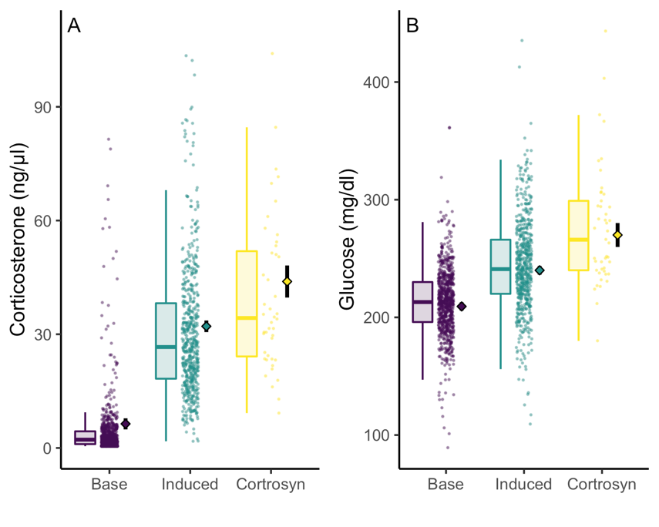

**Figure 1.** Corticosterone (A) and glucose (B) levels for adult tree swallows in the New York population by sample type. Boxes and whiskers show the interquartile range and largest value within 1.5 times the IQR, respectively. Small points show raw data. Solid diamonds and solid black lines show the point estimate and 95% confidence interval for each group mean as calculated by ‘emmeans’ and the linear mixed model described in text.

In nestlings, corticosterone increased from the initial to stress induced sample (Figure 2A; initial mean = 6.3 ng/μl; 95% CI = 3.1 to 9.4; stress-induced = 25.0; CI = 21.8 to 28.1). Cortrosyn injection resulted in the highest corticosterone levels, although the confidence interval for post-cortrosyn samples overlapped that for stress-induced samples (29.2; CI = 26.0 to 32.5).

In contrast to adults and despite clear variation in corticosterone levels, the confidence intervals for glucose concentrations overlapped across all three sample types (Figure 2B). Although they did not differ significantly, glucose levels were lowest in the initial sample (mean = 204.2 mg/dl; CI = 194.6 to 213.8) and increased at the stress-induced sample (222.2; CI = 212.5 to 231.9). Glucose did not increase further after Cortrosyn injection (219.0; CI = 209.1 to 228.9).

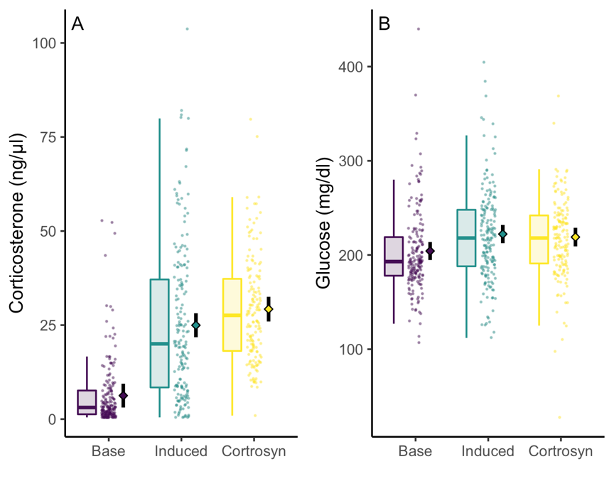

**Figure 2.** Corticosterone (A) and glucose (B) levels for nestling tree swallows in the New York population by sample type. Boxes and whiskers show the interquartile range and largest value within 1.5 times the IQR, respectively. Small points show raw data. Solid diamonds and solid black lines show the point estimate and 95% confidence interval for each group mean as calculated by ‘emmeans’ and the linear mixed model described in text.

*Between-Individual Covariation in Glucose and Corticosterone*

For adults and nestlings in New York, there was no relationship between baseline corticosterone and baseline glucose, although nestlings with higher baseline corticosterone tended to have lower glucose levels (Figure 3A; Table S4 & S5; adult β = 1.7; CI = -0.4 to 3.7; nestling β = -3.6; CI = -10.7 to 3.5). Among nestlings, a greater increase in corticosterone from baseline to stress-induced samples was associated with a smaller increase in glucose during the same period (Figure 3B; β = -5.5; CI = -11.0 to -0.1).

In contrast, among adults there was an interaction between mass and the change in corticosterone from baseline to stress-induced samples (Figure 3B; corticosterone by mass interaction β = 4.3; CI = 0.7 to 8.0). Adults that were below average mass had a positive relationship between corticosterone increase and glucose increase during this period, while adults that were above average mass had a negative relationship (Figure 4). However, this model only explained a small amount of variation in the glucose response (full model marginal R2 = 0.03; Table S4). Neither mass nor the change in corticosterone from stress-induced to post-Cortrosyn measurements were related to the change in glucose in adults or nestlings (Figure 3C-D; Table S4 & S5).

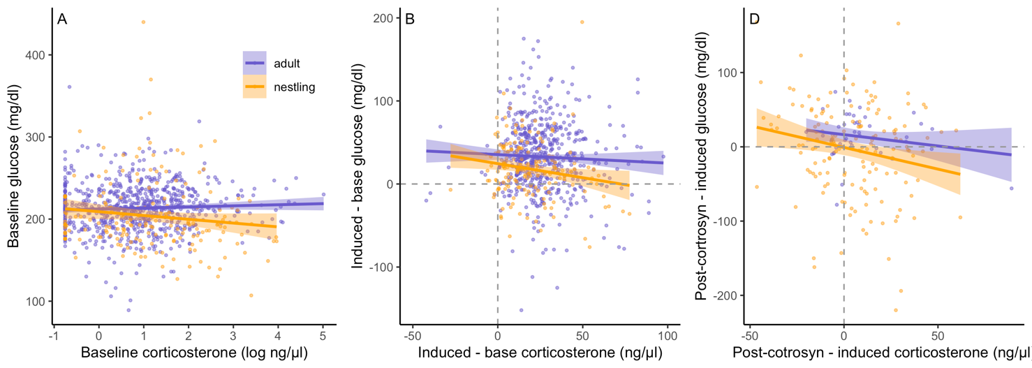

**Figure 3.** Covariation in between-individual variation in corticosterone and glucose for adults (blue) and nestlings (orange) in the New York population. Panel A shows baseline corticosterone measures versus baseline glucose (note baseline corticosterone is log transformed for easier visualization). Panel B shows the change in corticosterone from baseline to induced samples versus the change in glucose over the same period. Panel C shows the change in both measures from stress-induced to post-cortrosyn samples. In panels B & C, dashed lines indicate positive changes in corticosterone (right of the vertical line) and glucose (above the horizontal line).

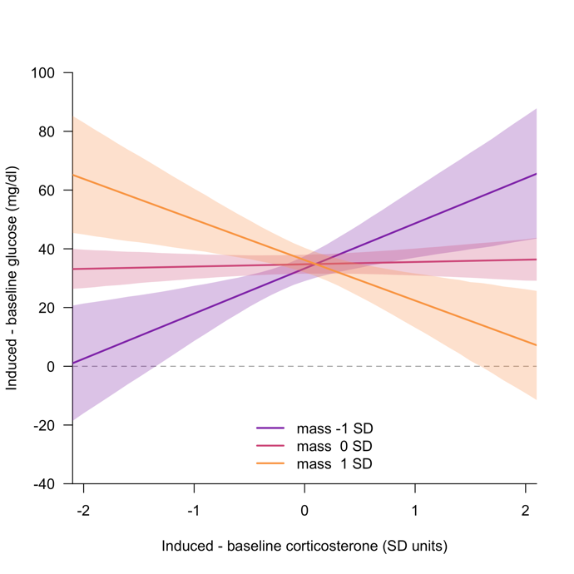

**Figure 4.** Illustration of the interaction between adult mass and the change in corticosterone from baseline to stress-induced samples as a predictor of the change in glucose concentration over the same time period. Solid lines and shaded regions show the maximum likelihood estimate and 95% confidence interval for the relationship among adults 1 SD below the mean (purple), at the mean mass (red), or 1 SD above the mean (orange). Confidence intervals were computed based on sampling from the fit model (see text).

*Population Comparison*

When comparing population baseline glucose levels, the NY population had a higher circulating level than the AK and WY populations, but the confidence intervals for all other two-way comparisons overlapped (Figure 5A; ‘emmeans’ estimate for AK = 206.4, CI = 202.6 to 210.2; NY = 212.6, CI = 210.4 to 214.8; TN = 208.2, CI = 204.3 to 212.1; WY = 198.9, CI = 195.1 to 202.6). For stress-induced glucose, the NY population had higher levels than the AK and TN populations, but the other two-way comparisons had overlapping confidence intervals (Figure 5B; AK = 230.8, CI = 224.4 to 237.3; NY = 242.1, CI = 238.4 to 245.8; TN = 228.1, CI = 221.6 to 234.6; WY = 239.3, CI = 232.8 to 245.8).

All four populations increased in mean glucose levels between baseline and stress-induced samples (Figure 5C). However, the WY population showed a greater increase over this period than AK or TN, while the other two-way comparisons did not differ (mean change in glucose AK = 28.0, CI = 21.8 to 34.2; NY = 32.4, CI = 28.7 to 36.0; TN = 23.1, CI = 16.8 to 29.5, WY = 42.2, CI = 35.8 to 48.6).

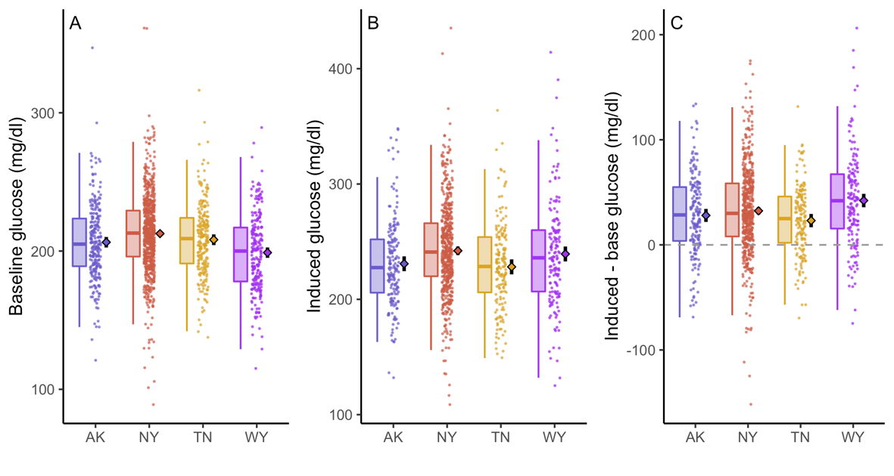

**Figure 5.** Population comparison among adult females of baseline (A), stress-induced (B), and stress-induced - baseline glucose (C). Boxplots show the interquartile interval and points < 1.5 times IQR. Points include all raw data. Filled diamond and black lines show the estimated mean and 95% CI of the mean as estimated by the ‘emmeans’ package in R.

For baseline glucose, there was no evidence that between-individual variation in adult female corticosterone was related to variation in circulating glucose in any of the four populations (Table S6; coefficient estimate for baseline corticosterone AK β = 1.5, CI = -2.4 to 5.5; NY β = 1.5, CI = -0.7 to 3.7; TN β = -2.2, CI = -6.6 to 2.3; WY β = -2.2, CI = -7.3 to 2.9). Mass was negatively associated with baseline glucose levels in all four populations, although the confidence interval crossed zero in the TN population (Table S6; estimate for mass AK β = -4.1, CI = -8.0 to -0.1; NY β = -3.0, CI = -5.2 to -0.8, TN β = -3.2, CI = -7.2 to 0.8; WY β = -4.8, CI = -9.1 to -0.4). There was no support for an interaction between mass and baseline corticosterone on baseline glucose in any population (Table S6). For the change in glucose from baseline to induced measures, there was no support for either a direct effect of the change in corticosterone, for mass alone, or for an interaction between corticosterone and mass in any population other than NY (Table S7). The NY population had a similar effect size for the corticosterone by mass interaction to that described above, although the confidence interval was wider in this subset of data with males excluded (see above).

*Within-Individual Glucose and Corticosterone Covariation*

For both baseline and stress induced glucose, there was no evidence that deviations from the observed within-individual average corticosterone level were associated with similar deviations in the within-individual average glucose level (Figure 6A-B; overall baseline β = 0.1, CI = -0.1 to 0.3; overall stress-induced β = -0.01, CI = -0.2 to 0.2). For the induced minus baseline measures, there was a tendency for higher within-individual corticosterone stress responses to be associated with stronger within-individual glucose responses, though the confidence interval for this effect included zero (Figure 6C; overall response β = 0.2, CI = 0.0 to 0.4).

**Figure 6.** Covariation between baseline (A), stress-induced (B), and induced – base (C) corticosterone and glucose with both measures standardized within-individual. Points show raw data, blue lines are regressions for each individual sampled at least 4 separate times, red line and confidence interval show the overall relationship across all birds. The black dashed line is included as a reference of no effect. By definition, each individual’s regression passes through the origin where both corticosterone and glucose are at the mean value observed for that bird.

**DISCUSSION**

At the group level, our results fit well with the canonical stress response. In adults, corticosterone and glucose both increased from baseline to stress-induced samples and this result was robust across four widely spread populations. Furthermore, injection with Cortrosyn in the New York population resulted in an additional increase in both measures. However, these group level patterns largely failed to scale down to the between- and within-individual level. Between-individual variation in corticosterone was unrelated to between-individual variation in glucose at any time scale that we measured, except in one case when considered as an interaction with mass. Even in that instance, the corticosterone response explained a very small amount of variation in the glucose response, suggesting that it is not safe to assume that strong responders in one aspect of the acute stress response will also have strong responses in other components of the response. Furthermore, even at the within-individual level, there was no clear evidence that modulation of the corticosterone response was associated with similar modulation of the glucose response.

Ecological fallacy (Piantadosi et al 1988).

* Why population difference of interaction in NY: could just be an effect of more sampling over wider range of conditions that were captured by having 4 years of data. Suggests that there might only be certain contexts where cort is positively associated with glucose, making it hard to generalize covariance (non-linear).
* Adult vs. nestling difference: note that we measured at different times of day for logistical reasons, but could be an explanation for some of the difference in adults vs. nestlings.
* Romero et al. 2015. Understanding stress in the healthy animal: points out ridiculousness of measuring stress from blood samples and need to have on animal sensor/data-loggers that could record more continuously (also use this for my cort flexibility paper).
* Does this mean that variation in the response system is not important for evolution? In contrast, suggests that there may be multiple ways to achieve the same outcomes. The same downstream modulations (such as glucose) might be accomplished in some individuals with the different levels of primary mediators (corticosterone). Does mean that it is very hard to determine the functioning of the system with single measures or few timepoints (point has been made many times). Also suggests that more nuanced understanding of flexibility in the full system is likely to be important (within-individual reaction norm papers). Real need for better methods to measure multiple components in more real time: sensors, data-loggers. Also, in the meantime, much more to be done with theory and modeling to understand coupling of different aspects of stress-response system.
* Remage-Healey & Romero 2000: captive starlings, stress-induced increase in glucose was only observed in the dark phase, not in the light phase. Also put in discussion: we measured adults in the morning at a time of day when they saw increases, but nestlings measured in mid-day: possible explanation for no increase then.
* No estimates of glucose response repeatability or even of variation in species level glucose response? Are some comparative analyses of baseline glucose variation.

Results to address

* Repeatability: small but significant, relatively little published on this. May be lower than the ZEFI study that was done in captivity because of increased environmental variation associated with wild populations.
* General characterization of the stress response
  + Clear support! Acute stress results in coordinated increase in both corticosterone and glucose with cortrosyn increasing both even further. Confirms that there really is a causal role of corticosterone increasing glucose at the group level.
  + This result is seen across four populations: robust
  + Not seen in nestlings. Why? Possibly because of developmental stage or because of time of day? Maybe adults sampled over a wider range of conditions with multiple years and times, not enough nestling variation.
* Despite that clear general pattern, little evidence that there is any between-individual covariation in glucose and cort. Often an implicit assumption in evolutionary physiology that group level differences (e.g. cort = more glucose) will scale to individuals, but this is the ecological phallacy. Increasing interest in understand when the covariation in functional traits will scale across levels of organization (within-individual, between, population, species) and recognition that demonstrating covariation at any one of these levels is no guarantee of patterns at another level (Agrawal). Similar approach is needed for understanding covariance in physiological traits and implications for evolutionary physiology. Particularly challenging with flexible traits because of need to measure many times within individuals.
* Population
  + Mass and base was a consistent pattern
  + Although general patterns (increase, and mass) were robust, there were population differences in overall regulation. Suggests that there could be local adaptation in glucose regulation or plastic response: promise for comparative studies.
  + In birds, recent studies have examined comparative variation in baseline glucose (tomasek) finding xyz. Similar comparative studies on base & stress corticosterone (hormonebase) but no widespread comparative data on the magnitude of glucose increase and how this might relate to life history of different species.
* Within-individual
  + Basically no correlation or at best very weak
  + Big caveat at this point is we only have a small number of samples per individual. Would be much better to have many paird samples across a time series to address within-individual reaction norm type questions with multiple physiological traits. Likely will require improved ability to use physiological loggers that can collect data continuously without need for repeated disruptive captures.
* Evolutionary physiology will need to grapple with these challenges to progress.

**ACKNOWLEDGEMENTS**

We would like to thank many students and collaborators who helped with field season data collection and logistics over the years and locations described here. We also thank members of the Vitousek Lab group for feedback and discussion of this project. Do we want to list all the field crews for each of these years? It’s a lot of people!!

**COMPETING INTERESTS**

The authors declare no competing or financial interests.

**ETHICAL NOTE**

All work described here was approved by the Cornell University Institutional Animal Care & Use Board (IACUC protocol numbers xxx & xxx). Capture and sampling of wild birds was approved by appropriate federal and state agencies (federal permit # xxx, AK permit # xx, NY permit # xx, TN permit # xx, WY permit #). Maren, can you also fill this in. Not sure if we also want to list who each permit was to. I checked in the Sci Reports paper but all the permits aren’t listed.

**AUTHOR CONTRIBUTIONS**

All authors contributed to field data collection and study conceptualization. CCT and CZ performed the lab work for corticosterone measurement. CCT analyzed the data and wrote the first draft of the manuscript. All authors contributed to revisions of the final manuscript.

**FUNDING**

The work was funded by xxx [MAREN: can you fill this in?]

**REFERENCES**

**Agrawal, A. A.** (2020). A scale‐dependent framework for trade‐offs, syndromes, and specialization in organismal biology. *Ecology* **101**,.

**Bates, D., Maechler, M., Bolker, B. and Walker, S.** (2015). Fitting linear mixed-effects models using lme4. *Journal of Statistical Software* **67**, 1–48.

**Bonier, F., Martin, P. R., Moore, I. T. and Wingfield, J. C.** (2009). Do baseline glucocorticoids predict fitness? *TREE* **24**, 634–642.

**Breuner, C. W., Patterson, S. H. and Hahn, T. P.** (2008). In search of relationships between the acute adrenocortical response and fitness. *Gen Comp Endocrinol* **157**, 288–295.

**Clinchy, M., Zanette, L., Boonstra, R., Wingfield, J. C. and Smith, J. N.** (2004). Balancing food and predator pressure induces chronic stress in songbirds. *Proc Biol Sci* **271**, 2473–9.

**Deviche, P., Valle, S., Gao, S., Davies, S., Bittner, S. and Carpentier, E.** (2016a). The seasonal glucocorticoid response of male Rufous-winged Sparrows to acute stress correlates with changes in plasma uric acid, but neither glucose nor testosterone. *Gen Comp Endocrinol* **235**, 78–88.

**Deviche, P., Bittner, S., Davies, S., Valle, S., Gao, S. and Carpentier, E.** (2016b). Endocrine, metabolic, and behavioral effects of and recovery from acute stress in a free-ranging bird. *Gen Comp Endocrinol*.

**Gangloff, E. J., Sparkman, A. M., Holden, K. G., Corwin, C. J., Topf, M. and Bronikowski, A. M.** (2017). Geographic variation and within-individual correlations of physiological stress markers in a widespread reptile, the common garter snake (Thamnophis sirtalis). *Comparative Biochemistry and Physiology Part A: Molecular & Integrative Physiology* **205**, 68–76.

**Gormally, B. M. G., Estrada, R., McVey, M. and Romero, L. M.** (2020). Beyond corticosterone: The acute stress response increases DNA damage in house sparrows. *Journal of Experimental Zoology Part A: Ecological and Integrative Physiology* **333**, 595–606.

**Horner, H. C., Munck, A. and Lienhard, G. E.** (1987). Dexamethasone causes translocation of glucose transporters from the plasma membrane to an intracellular site in human fibroblasts. *Journal of Biological Chemistry* **262**, 17696–17702.

**Kuo, T., McQueen, A., Chen, T.-C. and Wang, J.-C.** (2015). Regulation of Glucose Homeostasis by Glucocorticoids. *Adv Exp Med Biol* **872**, 99–126.

**Lattin, C. R., Keniston, D. E., Reed, J. M. and Romero, L. M.** (2015). Are Receptor Concentrations Correlated Across Tissues Within Individuals? A Case Study Examining Glucocorticoid and Mineralocorticoid Receptor Binding. *Endocrinology* **156**, 1354–1361.

**Lenth, R. V.** (2020). emmeans: Estimated Marginal Means, aka Least-Squares Means. *R package version 1.5.3*.

**Malisch, J. L., Bennett, D. J., Davidson, B. A., Wenker, E. E., Suzich, R. N. and Johnson, E. E.** (2018). Stress-Induced Hyperglycemia in White-Throated and White-Crowned Sparrows: A New Technique for Rapid Glucose Measurement in the Field. *Physiol Biochem Zool* **91**, 943–949.

**McElreath, R.** (2020). *Statistical Rethinking: A Bayesian Course with Examples in R and STAN*. CRC Press.

**Montoya, B., Briga, M., Jimeno, B., Moonen, S. and Verhulst, S.** (2018). Baseline glucose level is an individual trait that is negatively associated with lifespan and increases due to adverse environmental conditions during development and adulthood. *J Comp Physiol B* **188**, 517–526.

**Montoya, B., Briga, M., Jimeno, B. and Verhulst, S.** (2020). Glucose regulation is a repeatable trait affected by successive handling in zebra finches. *J Comp Physiol B* **190**, 455–464.

**Neuman-Lee, L. A., Hudson, S. B., Webb, A. C. and French, S. S.** (2020). Investigating the relationship between corticosterone and glucose in a reptile. *Journal of Experimental Biology* **223**,.

**R Core Development Team** (2020). R: A language and environment for statistical computing, Vienna, Austria.

**Remage-Healey, L. and Romero, L. M.** (2000). Daily and Seasonal Variation in Response to Stress in Captive Starlings (Sturnus Vulgaris): Glucose. *General and Comparative Endocrinology* **119**, 60–68.

**Remage-Healey, L. and Romero, L. M.** (2001). Corticosterone and insulin interact to regulate glucose and triglyceride levels during stress in a bird. *American Journal of Physiology-Regulatory, Integrative and Comparative Physiology* **281**, 994–1003.

**Ripley, B., Venables, B., Bates, D. M., Hornik, K., Gebhardt, A., Firth, D. and Ripley, M. B.** (2013). Package “MASS.”

**Romero, L. M. and Gormally, B. M. G.** (2019). How Truly Conserved Is the “Well-Conserved” Vertebrate Stress Response? *Integr Comp Biol* **59**, 273–281.

**Schoenle, L. A., Zimmer, C., Miller, E. T. and Vitousek, M. N.** (2021). Does variation in glucocorticoid concentrations predict fitness? A phylogenetic meta-analysis. *General and Comparative Endocrinology* **300**, 113611.

**Stoffel, M. A., Nakagawa, S. and Schielzeth, H.** (2017). rptR: Repeatability estimation and variance decomposition by generalized linear mixed-effects models. *Methods in Ecology and Evolution* **8**, 1639–1644.

**Taff, C. C., Schoenle, L. A. and Vitousek, M. N.** (2018). The repeatability of glucocorticoids: A review and meta-analysis. *General and Comparative Endocrinology* **260**, 136–145.

**Taff, C. C., Zimmer, C. and Vitousek, M. N.** (2018). Efficacy of negative feedback in the HPA axis predicts recovery from acute challenges. *Biology Letters* **14**, 20180131.

**Taff, C. C., Zimmer, C. and Vitousek, M. N.** (2019a). Achromatic plumage brightness predicts stress resilience and social interactions in tree swallows (Tachycineta bicolor). *Behav Ecol* **30**, 733–745.

**Taff, C. C., Campagna, L. and Vitousek, M. N.** (2019b). Genome-wide variation in DNA methylation is associated with stress resilience and plumage brightness in a wild bird. *Molecular Ecology* **28**, 3722–3737.

**Taff, C. C., Zimmer, C., Scheck, D., Ryan, T. A., Houtz, J. L., Smee, M. R., Hendry, T. A. and Vitousek, M. N.** (2019c). Plumage manipulation alters the integration of social behavior, physiology, internal microbiome, and fitness. *bioRxiv* 826719.

**Vitousek, M. N., Taff, C. C., Hallinger, K. K., Zimmer, C. and Winkler, D. W.** (2018). Hormones and fitness: Evidence for trade-offs in glucocorticoid regulation across contexts. *Frontiers in Ecology and Evolution* **6**, 1–14.

**Westneat, D. F., Araya‐Ajoy, Y. G., Allegue, H., Class, B., Dingemanse, N., Dochtermann, N. A., Garamszegi, L. Z., Martin, J. G. A., Nakagawa, S., Réale, D., et al.** (2020). Collision between biological process and statistical analysis revealed by mean centring. *Journal of Animal Ecology* **89**, 2813–2824.

**Winkler, D. W., Hallinger, K. K., Pegan, T. M., Taff, C. C., Verhoeven, M. A., Oordt, D. C. van, Stager, M., Uehling, J. J., Vitousek, M. N., Andersen, M. J., et al.** (2020). Full lifetime perspectives on the costs and benefits of lay-date variation in tree swallows. *Ecology* **101**, e03109.

**Zimmer, C., Taff, C. C., Ardia, D. R., Winkler, D. W. and Vitousek, M. N.** (2019). On again, off again: acute stress response and negative feedback together predict resilience to experimental stressors. *Functional Ecology* **33**, 619–628.

**Zimmer, C., Taff, C. C., Ardia, D. R., Rose, A. P., Aborn, D. A., Johnson, L. S. and Vitousek, M. N.** (2020). Environmental unpredictability shapes glucocorticoid regulation across populations of tree swallows. *Scientific Reports* **10**, 13682.