Corticosterone induced priming linked with changes to DNA methylation in the tree swallow (*Tachycineta bicolor*).

Conor C. Taff

Sabrina M. McNew

Leonardo Campagna

Maren N. Vitousek

## ABSTRACT (250 words)

In many organisms prior experiences influence the hormone mediated response to challenges. While repeated stressors may generate costs, conceptual models also suggest that activation of the stress response could prime increased performance. Relatively little is known about priming in wild animals or about the mechanisms that facilitate active calibration of the stress response. One mechanism that might play a role is changes to DNA methylation that encode prior experiences and alter subsequent physiological responses. We used non-invasive dosing to simulate spikes of corticosterone in female tree swallows (*Tachycineta bicolor*) and monitored priming effects one year after treatment along with DNA methylation during the treatment year and a full year later. In partial support of the priming hypothesis, we found that experimental females had stronger negative feedback and initiated breeding earlier; these traits are associated with higher performance in our population. We also found that natural variation in corticosterone was correlated with patterns of DNA methylation and that dosing causally influenced methylation on short (1-2 weeks) and long (1 year) time scales. Stress-induced corticosterone was associated with methylation of the MC2R gene, which encodes the adrenocorticotropic hormone receptor, but most changes we identified did not have clear links to functional regulation of the stress response. Taken together, our results are consistent with priming from corticosterone spikes and support DNA methylation as a potential mechanism underpinning these effects. Uncovering the mechanism(s) underlying endocrine flexibility has implications for understanding when and how individuals can adjust the stress response to cope with changing conditions.

*Keywords: reduced representation bisulfite sequencing, stress, endocrinology, carryover effects, tree swallow*

## INTRODUCTION

Wild organisms regularly encounter challenging conditions that require rapid behavioral and physiological responses. In vertebrates, the glucocorticoid mediated stress response plays an essential role in allowing animals to successfully avoid or tolerate stressors (Sapolsky, Romero, & Munck, 2000; Wingfield et al., 1998). While an appropriate response is beneficial (Wingfield et al., 1998), an inappropriate or prolonged elevation of glucocorticoids can result in a variety of well described costs (Korte, Koolhaas, Wingfield, & McEwen, 2005). Accordingly, the dominant paradigm in behavioral ecology and endocrinology is that the immediate benefits of the stress response are balanced by long-term costs.

But are the long term effects of a physiological stress response always costly? Some conceptual models propose that activating the stress response system–even in adulthood–primes more effective responses to future challenges (Del Giudice et al., 2018; Hilker et al., 2016). These models predict that initiating a response calibrates the stress response system, increasing organismal resilience or robustness. Because physiological priming results from activating the stress response system rather than from learning, it could occur even in the absence of exposure to an identifiable external threat. Physiological studies have provided some evidence that stressor priming can occur, including outside of critical developmental periods (Andrade-Linares, Lehmann, & Rillig, 2016; Marasco, Boner, Heidinger, Griffiths, & Monaghan, 2015). However, we know little about the degree to which stressor priming operates in natural populations, affecting later life behavior, physiology, and fitness. Similarly, the mechanism(s) that link activation of the stress response to physiological regulation of subsequent responses are not well understood.

One mechanism that could play a role in the calibration of stress response systems is altered DNA methylation in response to prior challenges. Epigenetic modification by DNA methylation can alter phenotypes by making genes or promoters more or less accessible for transcription (Anastasiadi, Esteve-Codina, & Piferrer, 2018; Lea et al., 2018; Sepers et al., 2019). Early life experiences can have profound programming effects on DNA methylation patterns that often persist throughout the individuals’ lifetime (e.g., McGowan et al., 2009). For example, classic work in lab rodents demonstrates that early life experiences regulate methylation of the gene producing the glucocorticoid receptor, which results in lifelong changes to glucocorticoid secretion in response to challenges (Liu et al., 1997; Weaver et al., 2004). A growing number of studies also demonstrate early life programming of DNA methylation patterns in wild populations resulting from dominance hierarchies (Laubach et al., 2019), brood size (Jimeno, Hau, Gómez-Díaz, & Verhulst, 2019; Sheldon, Schrey, Ragsdale, & Griffith, 2018), temperature and weather (Metzger & Schulte, 2017; Rubenstein et al., 2016), or landscape features (Kartzinel, Oers, Verhoeven, Ouyang, et al., 2022).

While they are less well documented, experiences during adulthood can also result in changes to DNA methylation and these adjustments can occur rapidly (Bentz et al., 2021; Metzger & Schulte, 2017). For example, brief periods of experimental competition and aggression in tree swallows (*Tachycineta bicolor*) resulted in altered DNA methylation of brain regions associated with hormone signaling, suggesting a priming effect in preparation for future aggression (Bentz et al., 2021). Conceptual models of the stress response have long recognized that the sequence, frequency, duration, and intensity of stressors should change the optimal behavioral and physiological response (Romero, Dickens, & Cyr, 2009; Zimmer, Woods, & Martin, 2022). Yet it is often unclear how the experience of challenges during adulthood would be biologically encoded to alter responses to future challenges. Altered DNA methylation is a promising mechanism because i) it can change rapidly even during adulthood, ii) it can persist over moderate to long time scales, iii) it has been shown to change with challenging experiences, and iv) it may play a direct role in physiological responses to future challenges. It has not yet been demonstrated, however, whether brief increases in corticosterone as an adult causally influence methylation patterns.

We experimentally simulated a series of acute corticosterone spikes using a non-invasive dosing procedure (Vitousek et al., 2018) and monitored both potential priming effects and changes to DNA methylation. In this population we previously found that brief increases in corticosterone have lingering effects on behavior and performance within a breeding season (Taff, Zimmer, & Vitousek, 2018; Vitousek et al., 2018) and that genome wide methylation predicts resilience to experimental challenges (Taff, Campagna, & Vitousek, 2019). Here, we extended those results to ask whether brief increases in corticosterone altered regulation of the stress response and breeding decisions a full year later. We coupled this approach with reduced representation bisulfite sequencing (RRBS) and a newly improved reference genome assembled for this study to examine genome wide patterns of DNA methylation at high resolution. Using RRBS, we assessed covariation between methylation and natural variation in corticosterone regulation during an acute stress response. Next, we compared DNA methylation in corticosterone treated females to controls to determine whether brief increases in corticosterone resulted in altered DNA methylation at either short (1-2 weeks) or long (1 year) timescales.

If activation of the stress response machinery has long term priming effects on coping ability (Del Giudice et al., 2018; Hilker et al., 2016), we expected that experimentally treated females would exhibit phenotypes associated with higher seasonal fitness in the following year. Specifically, we predicted that females would initiate breeding earlier and have low baseline corticosterone, a robust stress-induced increase, and strong negative feedback (Winkler et al., 2020; Zimmer et al., 2019). Given previous work demonstrating a correlation between coping ability and both genome-wide methylation (Taff et al., 2019) and natural variation in rapid corticosterone regulation (Vitousek, Taff, Hallinger, Zimmer, & Winkler, 2018), we also predicted that natural variation in corticosterone (baseline, stress-induced increase, and efficacy of negative feedback) would be associated with DNA methylation. However, a correlation here could arise through early life programming, prior activation of the acute corticosterone response, or any conditions that impact the regulation of both methylation and corticosterone (e.g., body condition). In contrast, for the experimental manipulation we predicted that differences in DNA methylation between control and treatment groups would only be present if brief increases in corticosterone have a causal effect on altering methylation patterns. We assessed the time course and persistence of any such changes using comparisons 1-2 weeks after treatments and 1 year after treatments. If methylation changes play a role in altering future corticosterone secretion then we expected to find more differences near genes and promoters associated with endocrine regulation.

## METHODS

We studied tree swallows breeding at field sites in and around Ithaca, New York, U.S.A. from April to July 2014 to 2017. This population of tree swallows has been continuously studied since 1986 and we followed well established monitoring protocols (for details see Winkler et al., 2020). Adult females were captured on day 6 to 7 after the beginning of incubation and again on day 3 to 7 after eggs had hatched. In the year after treatment, any returning females were captured on day 6 to 7 of incubation. At each capture we collected blood samples (< 70l each) to measure baseline (< 3 minutes) and stress induced (30 minutes) corticosterone (Vitousek et al., 2018). Immediately after the second blood sample was taken, females were injected with 4.5 l/g of dexamethasone in the pectoralis muscle, which stimulates strong negative feedback (Mylan 4mg ml-1 dexamethasone sodium phosphate; previously validated in Zimmer et al., 2019). A final blood sample was collected 30 minutes after injection to measure the efficacy of negative feedback. We also collected a set of standardized morphological measurements and monitored reproductive success (Vitousek et al., 2018). All birds received a unique USGS aluminum band and passive integrated transponder (PIT) tag if they were not previously banded.

Between the first and second capture in year one, females were randomly assigned to either a control or experimental treatment group (experiment schematic and samples sizes at each stage are shown in Figure 1). In the experimental group, we simulated a brief spike in corticosterone once per day on five days between the two captures. To accomplish this, we applied two 60 l doses of corticosterone dissolved in DMSO gel one hour apart to a fake egg anchored in the nest cup at a randomly chosen time during the day when females were absent from the nest. Upon returning, females incubated the clutch and absorbed the corticosterone across the skin on their brood patch. For the purposes of this study, we considered females as part of the corticosterone treatment group if they received any of the three dose concentrations described in Vitousek et al. 2018 (high = 4 mg ml -1 corticosterone once plus sham once per day; low = 2 mg ml -1 once plus sham once per day; long = 2 mg ml -1 twice per day).

We previously validated that this dosing method results in a brief (< 180 minutes) increase in corticosterone within the range of natural acute corticosterone responses (Vitousek et al., 2018). Control nests received either no manipulation or a sham control in which they were dosed as described above but with DMSO gel only with no corticosterone added. We previously found no difference in physiology, behavior, reproductive success, or survival between control and sham control birds receiving this treatment (Taff et al., 2018; Vitousek et al., 2018) and we combined both control groups in the analyses described here.

For methylation analyses, we focused on the set of females manipulated in 2015 and–if they returned–recaptured in 2016. In analyses focused on between year effects of treatments on later corticosterone regulation and breeding decisions, we also included a smaller number of females observed from 2014 to 2015 and from 2016 to 2017. These additional samples included slight variants on corticosterone dosing that we considered part of the corticosterone treatment group (six doses or three doses of 4 mg ml -1 corticosterone once per day during incubation, Taff et al., 2018). In the year after dosing, we only considered potential carryover effects of dosing on corticosterone regulation at the first capture and on the timing of clutch initiation because some females were subsequently entered into unrelated experiments that could have influenced later season measures.

*Tree swallow reference genome assembly*

For this study, we improved upon a previously published reference genome sequenced from a female belonging to this study population (Taff et al., 2019) by first extracting high molecular weight DNA from this same individual. We performed a phenol-chloroform extraction followed by an ethanol precipitation and finally a bead cleanup. The Duke Center for Genomic and Computational Biology core facility used the DNA to produce a large insert library (15 to 20 kb), which was subsequently sequenced on 3 cells of a Pacific Biosciences RSII instrument. This produced a total of 9.6 Gbp of data with an average read length of 12,053 bp and an N50 subread length of 15,643 bp. We used bamtools version 2.5.1 (Barnett, Garrison, Quinlan, Strömberg, & Marth, 2011) to merge the reads from the difference cells and retain only those that were longer than 4,500 bp (47.6% of the original raw reads). We improved our first assembly with the PBJelly2 module of PBSuite version 15.8.24 (English et al., 2012), which uses long reads to fill or reduce gaps. This pipeline produced an assembly which was moderately improved from the previous version (Taff et al., 2019). The total length of the assembly was 1.22 Gb (previously 1.14 Gb) and was contained in 49,278 scaffolds (previously 92,148), with an N50 of 82.9 kb (originally 34 kb) and 1.9% Ns (vs. 5.8%). Finally, we annotated the genome following the pipeline described in Taff et al. (2019). The assembly generated for this project is deposited on GenBank (BioProject ID PRJNA553513).

*Sample processing*

Blood samples collected in the field were immediately stored on ice in a cooler and processed in the lab within 3 hours of capture. Red blood cells were separated from plasma by centrifugation and added to 1 mL of ice cold cryopreservation buffer (90% newborn calf serum, 10% DMSO, Haussmann & Mauck, 2008). Samples were then frozen at a constant cooling rate in a Mr. Frosty container with isopropyl alcohol and stored at -80 C until further processing. Cryopreserved blood samples were thawed and DNA was extracted using the DNeasy Blood & Tissue spin column extraction kits according to the manufacturer’s protocol (Qiagen Sciences Incorporated).

*Corticosterone and breeding timing data analysis*

We used general linear models to compare corticosterone and the timing of breeding between control and experimental females one year after dosing manipulations. We fit four models in total with either the date of clutch initiation or corticosterone (baseline, stress-induced, or post-dexamethasone injection) as the response variable. Predictors included treatment and year as a categorical fixed effect. The model for stress-induced corticosterone also included baseline corticosterone as a predictor and the mdoel for post-dexamethasone corticosterone also included stress-induced corticosterone as a predictor.

*Reduced representation bisulfite sequencing*

We prepared our samples for reduced representation bisulfite sequencing (RRBS) using the Diagenode Premium RRBS Kit and closely following the manufacturer’s protocol (Veillard, Datlinger, Laczik, Squazzo, & Bock, 2016). Briefly, samples were diluted to 3.85 ng/l and 26 l of diluted sample was used for library preparation. The process included enzymatic digestion with Mspl and size selection to increase coverage of CpG-rich regions, such as CpG islands and enhancers. Individual samples received one of twenty-four unique barcodes and were pooled in randomized groups of 8 before bisulfite conversion. We also included a methylated and unmethylated spike in control with each sample to confirm the efficiency of bisulfite conversion.

From the available samples, we selected 120 samples to process from 61 unique birds (three samples per bird n = 14, two samples n = 31, one sample n = 16). Prior to RRBS processing, these 120 samples were randomly sorted to account for any batch effects. Libraries were prepared with the Diagenode kit in two batches (one set of 24 and one of 96). Prepared libraries were checked for the expected size distribution by digital PCR prior to sequencing. Sequencing was performed at the Cornell BRC using NextSeq 1x75 with 20% PhiX and 85% of the normal cluster density. In total, we ran our samples on five sequencing lanes with 24 samples per lane.

Raw sequence data were first processed with Trim Galore! using the default RRBS settings. Visual inspection of FastQC files confirmed high quality reads for all samples. Next, we used Bismark to align each sequence to the prepared genome and extract the methylation status for each CpG, CpH, or CHH site (Krueger & Andrews, 2011). As expected, global methylation at CpH and CHH sites was extremely low (1.0% and 0.6%, respectively, Figure S1) and we only considered methylation at CpG sites in our subsequent analyses. We also used Bismark to determine the methylation conversion efficiency for each sample based on methylated and unmethylated spike in controls and following the instructions in the Diagenode RRBS kit (Krueger & Andrews, 2011; Veillard et al., 2016).

*RRBS Data Analysis*

Output data from the sequence processing described above was analyzed in R version 4.1.1 (R Core Team, 2020). We processed the aligned sequence data using MethylKit (Akalin et al., 2012). Using MethylKit, we extracted the number of total aligned reads and number of methylated or unmethylated reads for each CpG site.

For analyses of corticosterone and treatment associations, we filtered these CpGs to include only those that met the following criteria: First, we required a minimum coverage of 10 reads per sample to retain data for that sample at a given CpG. We further filtered the dataset to remove any CpGs that were mostly invariant (i.e., more than half of samples had methylation percentage of 0 or 100%) as well as CpGs that had extremely low variation (SD less than 5% across all samples, Husby, 2022; Lundregan et al., 2022). For models comparing treatment effects, we required that females have data at a given CpG from both pre and post treatment sampling points to be included. For basic descriptions of methylation patterns, we used all CpGs that had 10 reads or more in the pre-treatment samples.

The built in differential methylation techniques in MethylKit are designed for two group comparisons with limited flexibility in modeling options. Because we had repeated measures before and after treatments for both groups, we could not specify the necessary models within MethylKit itself. Therefore, we exported and combined the filtered CpG records for all groups so that we could fit generalized linear mixed models (GLMMs) for each CpG site (as in Lindner et al., 2021) using the glmer function in R package lme4 (Bates, Mächler, Bolker, & Walker, 2014). We fit a separate set of models for natural corticosterone variation (baseline, stress-induced, or post-dexamethasone), within-year treatments, and between-year treatments. Each of these datasets were constructed separately since they included different subsets of both individual birds and of CpGs that met the criteria described above.

For natural variation in corticosterone, we included only the pre-treatment samples. Using these samples, we fit a GLMM for each CpG with the number of methylated and unmethylated reads as the binomial response variable. We fit this set of models separately with baseline, stress-induced, or post-dexamethasone corticosterone as the single continuous predictor variable. The models included a random effect for female identity to account for repeated sequencing of the same CpG sites within each female. We excluded the results for any models that failed to converge because we could not reliably estimate effects in those cases.

For within year and between year comparisons after treatments, we fit a single GLMM for each included CpG with the number of methylated and unmethylated reads as the binomial response variable. Predictors included pre-treatment methylation percentage at the CpG being modeled, a fixed effect of treatment (control vs. corticosterone), and a random effect for female identity. In each model, significance of the comparison between control and corticosterone treated birds was assessed using the emmeans package in R (Lenth, 2019). We also evaluated the stability of methylation within individuals in these models by summarizing the regression coefficient of pre-treatment methylation on post-treatment methylation.

We accounted for multiple comparisons in each of these analyses by adjusting all p-values using the q-value approach implemented by the qvalue package in R with the false discovery rate set at 0.05 (Storey, Bass, Dabney, & Robinson, 2019). We only report and interpret estimates with q-values < 0.05.

*Annotation of differentially methylated CpGs*

After identifying CpGs that were significantly associated with either natural corticosterone or experimental treatment with corticosterone, we identified genes associated with each CpG. We used the bedtoolsr package to select genes that had a significant CpG either within the gene body or within 2 kb upstream of the transcription start site (Patwardhan, Wenger, Davis, & Phanstiel, 2019). We generated separate lists of genes associated with CpGs for baseline corticosterone, stress-induced corticosterone, post-dexamethasone corticosterone, within-year treatment effects, and between-year treatment effects. For each of these comparisons we also generated a complete list of genes associated with all of the CpGs that passed the filtering criteria described above to be used as a null background list (see below).

Starting with the list of genes associated with each comparison set, we used the DAVID functional annotation tool (Huang et al., 2007) to test whether our genes were enriched in any molecular functions or biological processes in the Gene Ontology knowledgebase (Ashburner et al., 2000; Consortium, 2021). For each comparison we used the custom background list generated above. This background list is important for interpretation because we were only able to test CpGs near a subset of genes in each comparison (number of genes included in testing for baseline corticosterone = 4,143; stress-induced corticosterone = 4,146; post-dexamethasone corticosterone = 3,863; within-year treatment = 2,913; between-year treatment = 452).

Using DAVID we identified a set of GO terms associated with biological processes or molecular functions that were over represented in the list of significant CpGs compared to the background list for that comparison (Consortium, 2021). We filtered this list to include only GO terms with p-values < 0.05 after applying a false discovery rate correction. We initially visualized the GO terms for each comparison using REVIGO (Supek, Bošnjak, Škunca, & Šmuc, 2011); however, our study identified a relatively small number of GO terms and no clearly identifiable clusters of terms were identified in REVIGO. Therefore, we report the complete list of genes and GO terms associated with CpGs in each comparison.

*Data and code availability*

The complete set of bioinformatic processing scripts, R code, and sample data is available on GitHub for review and will be publicly archived to Zenodo upon acceptance (www.github.com/cct663/tres_rrbs). Raw sequence data from RRBS is available on GenBank (BioProject ID PRJNA953597).

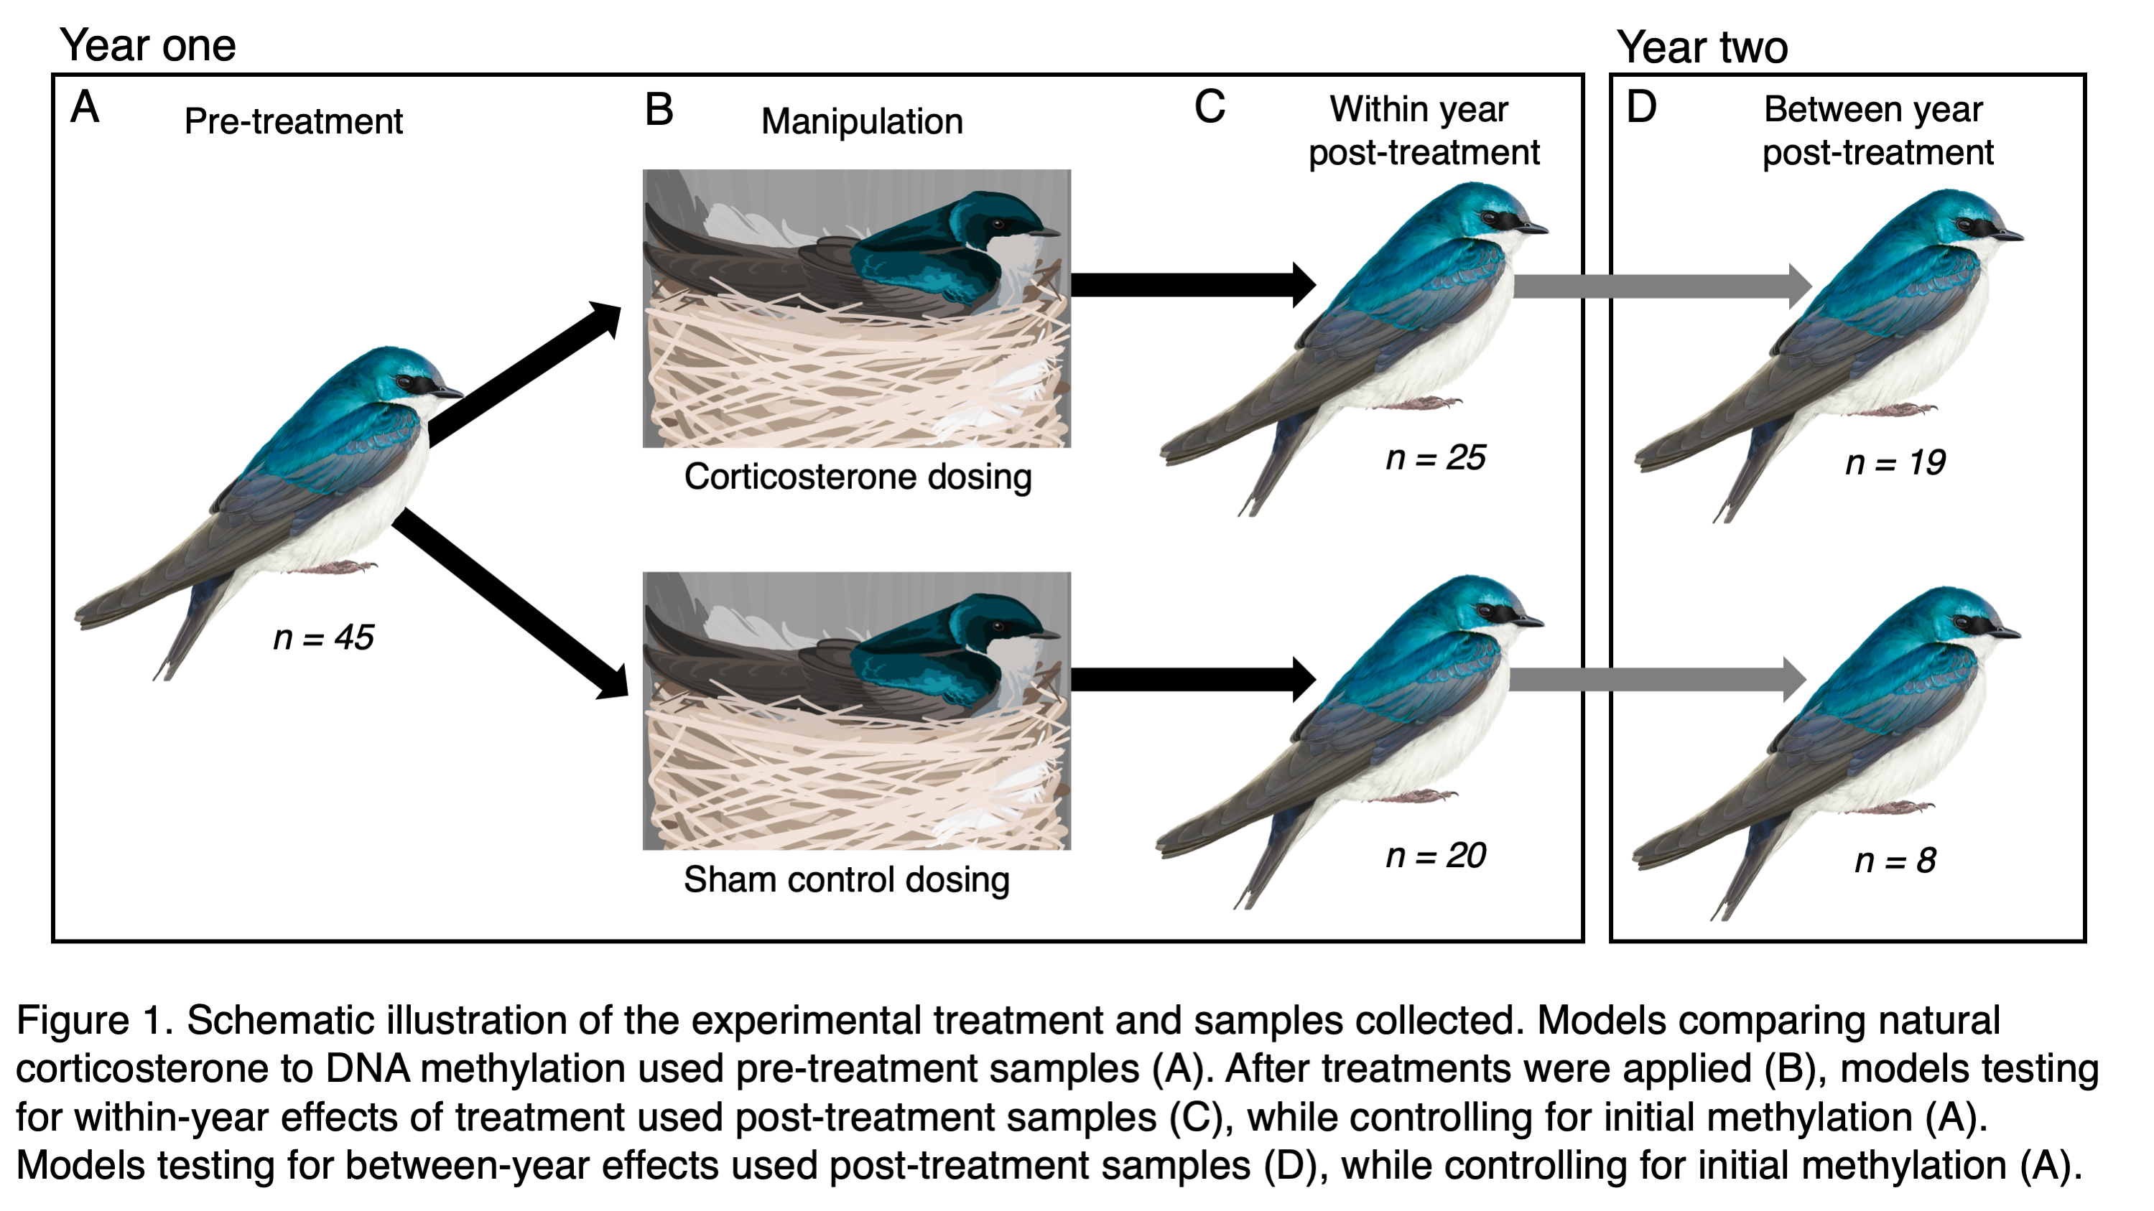

Figure 1: Schematic illustration of the experimental treatment and samples collected for RRBS. Models comparing natural corticosterone to DNA methylation used pre-treatment samples (A). After treatments were applied (B), models testing for within-year effects of treatment used post-treatment samples (C), while controlling for initial methylation (A). Models testing for between-year effects used post-treatment samples (D), while controlling for initial methylation (A). See text for description of birds included in treatment and control groups and additional samples used for analyses not focused on methylation.

## RESULTS

*Corticosterone and breeding timing*

Among females that returned to be sampled at the field site one year after treatments had ended, we found that previously corticosterone treated birds had higher baseline corticosterone (corticosterone dosing = 3.34; 95% confidence interval = 1.43 to 5.24; Figure 2A; Table S1). Prior year treatment was not related to stress-induced corticosterone (Table S1), but females that had previously received corticosterone dosing had lower post-dexamethasone corticosterone, indicating more robust negative feedback ( = -4.86; 95% confidence interval = -9.01 to -0.70; Figure 2B; Table S1). Finally, females that recieved corticosterone dosing initiated their nesting attempt earlier in the following year ( = -2.34; 95% confidence interval = -4.49 to -0.20; Figure 2C; Table S1).

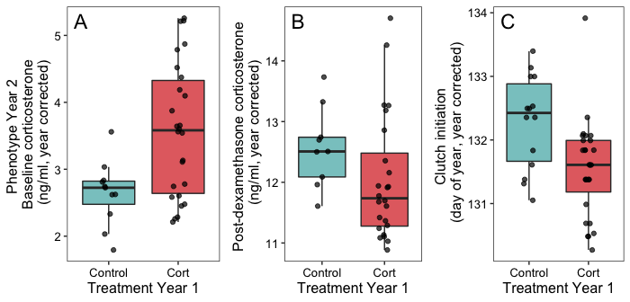

Figure 2: Effect of corticosterone treatment in one year on measures of baseline corticosterone (A), post-dexamethasone corticosterone (B), and clutch initiation date (C) in the following year. Points are partial residuals of raw data collected for average year effects. Boxes and whiskers show the median, interquartile range, and 1.5 times IQR.

*General methylation patterns*

Our process resulted in 9.8 4.3 million (SD) total reads per sample (Figure S1). Across all samples, we were able to align 51.1% of the total reads produced, which is comparable to several recent studies in wild birds (e.g., Mäkinen et al., 2019; Watson, Powell, Salmón, Jacobs, & Isaksson, 2021). Spiked controls in each sample indicated that our bisulfite conversion worked efficiently and within the recommended kit parameters (conversion of methylated control sites = 1.9% 1.4; conversion of unmethylated control sites = 99.5% 0.6).

Among 45 pre-treatment samples, we had sufficient coverage to estimate methylation at 148,167 CpGs. In total, the average percentage methylation across all sites was 35.5% 34.0 with a wide distribution (Figure S2A). After assigning CpGs hierarchically to promoter (within 2kb upstream of a TSS) > exon > intron, we found that 12.1% of sites were in promoters, 7.9% in exons, 11.8% in introns, and 68.1% in intergenic regions. At the level of genomic features, promoters had the lowest methylation (median = 5.3%, mean SEM = 20.5% 0.5), introns had intermediate methylation (median = 43.5%, mean SEM = 41.0% 0.5), and exons had the highest methylation (median = 54.3%, mean SEM = 46.7% 0.7). However, each of these features had a wide distribution of methylation percentages across different genes (Figure S2B).

*Association between natural or experimental corticosterone and methylation*

Using pre-treatment samples, we found that methylation percentage at 116 CpGs out of 78,143 tested was associated with baseline corticosterone after FDR correction (Figure 3A; Table 1). For stress-induced corticosterone, we found a similar association at 356 out of 78,027 CpGs that were tested (Figure 3B; Table 1). For post-dexamethasone injection samples, we found an association between corticosterone and methylation at 735 out of 69,189 CpGs tested (Figure 3C; Table 1).

In models examining the causal effect of corticosterone treatment, we found that for samples collected within the same breeding season 1-2 weeks after treatment, 111 out of 48,070 CpGs tested showed evidence of differential methylation after FDR correction (Figure 3D; Table 1). We had fewer individuals and fewer CpGs that passed filtering for comparisons one year after treatment, but we found that 49 out of 6,787 CpGs tested were differentially methylated between treatment and control groups after one year (Figure 3E; Table 1). Although we were primarily interested in treatment effects, these models also showed that pre-treatment methylation at a given CpG site generally predicted post-treatment methylation both within a year (Figure S3A) and for samples collected one year later (Figure S3B).

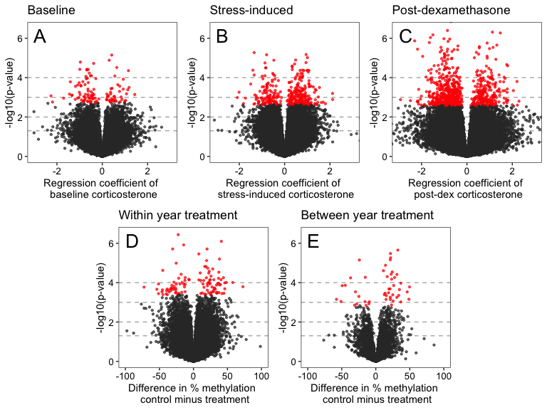

Figure 3: Association between DNA methylation and corticosterone from GLMMs based on observational and experimental study components. Panel A and B show the pre-treatment regression coefficient for baseline corticosterone and stress-induced corticosterone on methylation percentage, respectively. Panel C and D show the difference in methylation for control vs. treatment groups after accounting for pre-treatment methylation percentage for samples 1-2 weeks after treatment (C) and 1 year after treatment (D). In all plots, -log base 10 p-values are shown on the y axis with red points indicating CpGs that were significantly associated with corticosterone after applying the false discovery rate correction. Horizontal dashed lines indicate p-values of 0.05, 0.01, 0.001, and 0.0001 moving from the bottom to top of each plot to aid in interpretation.

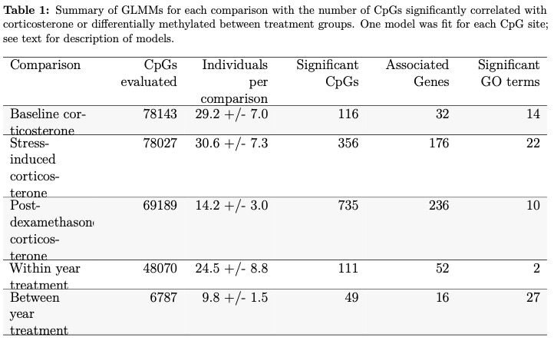

*Association between differentially methylated CpGs and genes*

We found that CpGs that were significantly associated with baseline corticosterone, stress-induced corticosterone, and post-dexamethasone corticosterone were located in or near a total of of 32, 176, and 236 identifiable genes, respectively (Table S2). When comparing differentially methylated CpGs after treatment effects, within-year and between year CpGs were located in or near 52 and 16 genes, respectively (Table S2). A subset of these genes were identified in two or three different comparisons (Figure 4). Because of our filtering process many genes were not tested in each comparison (i.e., the background set of possible genes tested differed for each comparison).

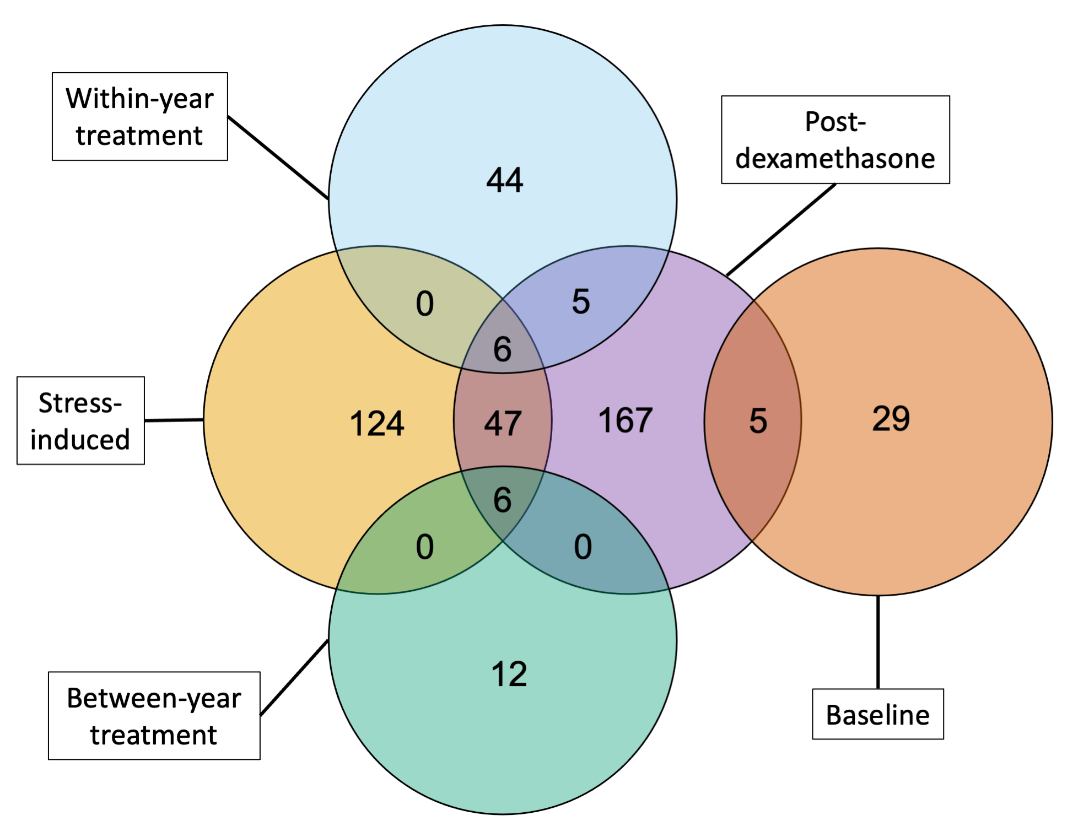

Figure 4: Number of genes near CpGs that were significantly associated with natural variation in corticosterone (baseline, stress-induced, and post-dexamethasone) or with corticosterone dosing (within-year and between-year).

In examining the function of genes identified in this process, only one was obviously directly connected to regulation of the hypothalamic-pituitary-adrenal (HPA) axis. We found that individuals with higher stress-induced corticosterone in the observational dataset had higher methylation at a CpG associated with the MC2R gene, which is responsible for making the ACTH receptor (Figure 5). Unfortunately, several other genes known to be associated with the HPA axis (e.g., CRH, CRHR1, FKBP5) did not have any CpGs near them in the background set, so we could not test for differences associated with these genes.

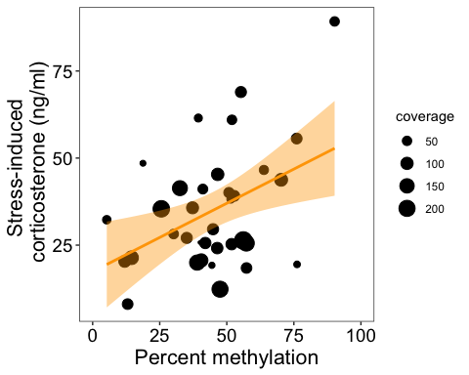

Figure 5: Percent methylation in relation to stress-induced corticosterone at the CpG near the MC2R gene that was significantly associated with corticosterone. Size of circles indicates sequence coverage for each sample. Trendline and confidence interval is shown for illustration but significance was assessed in the binomial GLMM described in the text.

*GO term analysis*

Using the gene lists from Table S2 as input, we identified GO terms that were significantly associated with each comparison. With the false discovery rate set at 0.05, we identified 14 GO terms associated with baseline corticosterone, 22 terms associated with stress-induced corticosterone, 10 terms associated with post-dexamethasone corticosterone, 2 terms for the within-year treatment effect, and 27 terms for the between-year treatment effect (Table S3). None of these lists resulted in any clear clustering of processes using the REVIGO visualization tool and many terms were repetitive and attributable to the same few gene associations.

Baseline corticosterone was associated with photoreceptor activity and response to light, which was primarily driven by opsin and rhodopsin gene associations (OPN1SW, RHO, LWS). Stress-induced corticosterone was associated with a wider range of processes connected to a larger set of genes. These included a variety of cell signaling and receptor pathways, such as the ACTH association described above (MC2R). Post-dexamethasone corticosterone was primarily associated with signaling receptor activity driven by a relatively large number of associated genes (Table S3).

Differentially methylated CpGs for within-year corticosterone treatment were only related to two GO terms associated with structural cell components and attributable to genes of unknown function. Between-year corticosterone treatment was associated with a variety of GO terms having to do primarily with transmembrane receptor signaling, but nearly all of these terms were selected from the same set of gene associations (BMPR1A and B, ACVR1, and TGFBR1).

## DISCUSSION

We found that experimental increases in corticosterone induced priming effects that resulted in females having stronger corticosterone negative feedback and breeding earlier in the subsequent year; these characteristics are typically associated with high stress resilience and reproductive success in this population. Furthermore, natural variation in corticosterone was correlated with DNA methylation and experimental treatments altered DNA methylation patterns. Importantly, regulation of DNA methylation in response to corticosterone occurred rapidly in adults and resulted in detectable changes at least one year after treatment, paralleling the changes in physiological and behavioral phenotypes. Taken together, these results support the idea that activation of the stress-response machinery may prime subsequent performance and that DNA methylation could act as an important mechanism linking the prior experience of stressors–both during development and adulthood–to subsequent coping ability. Rapid endocrine flexibility and adaptive calibration of the stress response have emerged as key determinants of resilience to challenges (Grindstaff, Beaty, Ambardar, & Luttbeg, 2022; Hau & Goymann, 2015; Taff & Vitousek, 2016) and understanding the mechanistic basis of these patterns is an important step in predicting when flexibility is adequate or insufficient to cope with changing conditions.

The changes in phenotype that we detected one year after corticosterone dosing partially matched our predictions if dosing resulted in a beneficial priming effect. We found that, compared to controls, experimental females initiated breeding earlier and had stronger negative feedback in the subsequent year. In tree swallows, clutch initiation date is a strong predictor of both seasonal and lifetime reproductive success and is often considered a proxy for individual quality or condition (Winkler et al., 2020). Similarly, the strength of negative feedback is consistently the best physiological predictor of coping ability and reproductive success both under natural conditions and after imposing experimental challenges (Taff et al., 2018; Zimmer et al., 2019). However, we also found that corticosterone dosed females had higher baseline corticosterone and no difference in stress-induced corticosterone one year after treatment. Because baseline corticosterone is often associated with increased energetic demands of reproduction (the cort-adaptation hypothesis, Bonier, Moore, & Robertson, 2011), these results might reflect an increased allocation to breeding in subsequent years in corticosterone treated females. For example, female European starlings (*Sturnus vulgaris*) with experimentally increased parental care demands also increased their baseline corticosterone (Love, Madliger, Bourgeon, Semeniuk, & Williams, 2014). Thus, our results might represent a combination of long term priming effects coupled with the immediate energetic demands of breeding earlier.

Our study also adds to the growing recognition of bi-directional links between coping ability and DNA methylation. While this relationship is well known in laboratory based model systems (Liu et al., 1997; Weaver et al., 2004) the potential importance of methylation changes due to environmental stressors and subsequent coping ability as a consequence of methylation have only recently been explored in wild animals. In wild mammals, early results suggest patterns similar to those seen in laboratory rodents. For example, early life maternal care and social connections in spotted hyenas (*Crocuta crocuta*) predict DNA methylation and glucocorticoid regulation as an adult (Laubach et al., 2019, 2021). Similar effects can play out in adulthood; for example, in savannah baboons (*Papio cynocephalus*) high social status as an adult is associated with more rapid changes to DNA methylation (epigenetic aging) as a consequence of the social stress that accompanies high status (Anderson et al., 2021). Our results are consistent with the results derived from lab rodents, wild mammals, and a growing number of studies in wild birds (Lindner et al., 2021; Rubenstein et al., 2016), suggesting that flexible adjustment of methylation may be a general mechanism by which prior experiences of stressors are encoded in order to modulate future responses to challenges.

While there has been a rapid increase in studies of methylation in wild birds in recent years (e.g., Kartzinel et al., 2022; Mäkinen et al., 2019; Rubenstein et al., 2016), relatively few studies have sampled the same individuals multiple times as adults. Our study design allowed us to assess the stability of genome wide DNA methylation within individuals. We found that many CpGs that we interrogated had large between individual differences in methylation and that those differences were typically stable even in samples collected one year apart. Compared to these individual differences, flexible changes in methylation were relatively smaller and detectable at fewer CpGs. The stable individual differences that we detected might represent the consequences of early life conditions (Jimeno et al., 2019; e.g., Laubach et al., 2019; Sheldon et al., 2018). For example, early life climate conditions are related to lifelong methylation of the glucocorticoid receptor gene in superb starlings (*Lamprotornis superbus*, Rubenstein et al., 2016). We could not assess the possibility of a similar pattern in our study because we did not have any information on early life conditions for our birds. Regardless of the source of these initial differences, our results clearly demonstrate that detecting subtle adjustments of methylation in adulthood to any treatment of interest will often require accounting for pre-treatment methylation.

At this point, it is somewhat unclear what functional consequences most of the specific methylation changes that we detected might have. We did find that stress-induced corticosterone was correlated with methylation of a CpG associated with the MC2R gene, which encodes the ACTH receptor. Individuals with a more robust stress response had higher methylation at this CpG. Higher methylation is expected to be associated with lower gene expression (Anastasiadi et al., 2018; Lea et al., 2018), suggesting that individuals with a more robust corticosterone response might have lower ACTH receptor expression. It isn’t clear why lower ACTH receptor expression would result in higher stress-induced corticosterone, but because regulation of the HPA axis can occur at multiple levels with bi-directional feedback, the result may instead reflect a downregulation of ACTH receptor expression in response to robust activation of other components of the HPA axis. Pairing RRBS with gene expression measurements and comparisons in different tissues would be helpful to understand these patterns (e.g., Hukkanen et al., 2023).

In contrast to stress-induced corticosterone, none of the genes or GO terms associated with baseline-corticosterone, post-dexamethasone corticosterone, or treatments had clear connections to HPA axis regulation. We previously found that non-specific, genome-wide methylation predicts stress resilience to experimental challenges in this population (Taff et al., 2019). Thus, the differences that we detected might reflect large scale regulation of methylation rather than targeted regulation of sites with specific functional consequences. Alternatively, some of the changes that we detected might have functional effects on stress response calibration that are not obvious from the known effects of those genes. In support of this idea, we did find some overlap between the genes identified in association with natural variation in corticosterone and with changes in corticosterone as a consequence of our experimental treatment. In particular, post-dexamethasone corticosterone, which is a strong predictor of stress resilience in tree swallows (Taff et al., 2018; Zimmer et al., 2019), had the most extensive correlations between methylation and identified genes and some of these genes were shared with the other corticosterone measures and with treatment effects.

Another reason that we failed to find clear links between changes in DNA methylation and genes associated with the stress response may have to do with limitations of our approach. An advantage of RRBS is that it does not rely on pre-selecting candidate genes, but a disadvantage is that not all relevant genes are necessarily tested. After filtering our data, many of the genes with known roles in the HPA axis were not included in comparisons or had coverage at only a few CpG sites. Thus we did not directly test for methylation differences for many key genes. It is possible that deeper sequencing of our libraries would have improved our ability to detect functional differences. Studying DNA methylation in non-model systems is a rapidly developing field and many recent papers outline the pros and cons of various approaches (Beck, Ben Maamar, & Skinner, 2022; Laine et al., 2022; Sepers et al., 2019). One particularly promising approach that may strike a balance between a focus on candidate genes and the ability to detect genome wide associations is to combine RRBS with probes that enrich sequences at a potentially large number of target genes (target-enriched enzymatic methyl sequencing, Rubenstein & Solomon, 2023).

Regardless of the functional consequences of the changes we detected, we found that brief increases in corticosterone have effects on subsequent corticosterone regulation, breeding decisions, and methylation even a full year after dosing ended. At least some of the phenotypic changes we detected support a hormone priming effect in which activation of the stress response machinery improves later performance. The fact that these changes in phenotype are coupled with changes in methylation patterns implicates the regulation of DNA methylation as a potentially key mechanism that plays a role in the flexible adjustment of the stress response system based on prior experiences. Understanding the mechanism(s) that integrate experience with future stress responsiveness has important consequences for predicting how and when individuals can cope with repeated exposure to challenges. Conceptual models of the stress response suggest that while repeated challenges can sometimes generate long term costs (McEwen & Wingfield, 2003; e.g., Romero et al., 2009), activation of the stress response at other times may prime more effective responses to future challenges (e.g., Del Giudice, Ellis, & Shirtcliff, 2011; Hilker et al., 2016). Studying the mechanisms by which stress exposure is encoded biologically will help to differentiate these possibilities and shed light on when and how individuals succeed or fail through flexible regulation of the physiological response to challenges.

## ACKNOWLEDGMENTS

We would like to thank the members of the tree swallow research team for assistance with fieldwork. Bronwyn Butcher and the Lovette Lab provided input on lab methods and members of the Vitousek Lab provided feedback on earlier versions of the manuscript. Charlotte Holden produced the tree swallow illustrations. **MAREN: I’ve been lately trying to list all names of field assistants who helped, but I’m not sure about names of the 2015 field crew.** 2016 Ithaca crew: Lyra Liu, Garret Levesque, Avram Pinals, Joe Colcombe, Vanesa Rodriguez-Arcilla, David Scheck, Cedric Zimmer, Tom Ryan

## AUTHOR CONTRIBUTIONS

CCT and MNV conducted the field based data collection. CCT and MNV conceived the study. CCT and SMM conducted the lab work for RRBS. CCT and LC conducted the lab work for creating the reference genome and LC carried out the bioinformatics for genome assembly and annotation. CCT analyzed and visualized the data with assistance from SMM and LC. CCT drafted the paper with input from all authors.

## ETHICAL NOTE

All methods were approved by Cornell IACUC and sampling was conducted with appropriate state and federal permits.

## FUNDING

Research was supported by NSF-IOS grants 1457251 and 2128337 and by DARPA D17AP00033. The views, opinions and/or findings expressed are those of the authors and should not be interpreted as representing the official views or policies of the Department of Defense or the U.S. Government. CCT and SMM were supported by the Rose Postdoctoral program at the Cornell Lab of Ornithology. **MAREN: can you check funding do we want to list all these grants? Sort of a weird project since samples go back to 2015 but effort extends over various years/funding so not sure what grants we want to list.**

## REFERENCES

Akalin, A., Kormaksson, M., Li, S., Garrett-Bakelman, F. E., Figueroa, M. E., Melnick, A., & Mason, C. E. (2012). methylKit: A comprehensive r package for the analysis of genome-wide DNA methylation profiles. *Genome Biology*, *13*(10), 1–9.

Anastasiadi, D., Esteve-Codina, A., & Piferrer, F. (2018). Consistent inverse correlation between DNA methylation of the first intron and gene expression across tissues and species. *Epigenetics & Chromatin*, *11*(1), 1–17.

Anderson, J. A., Johnston, R. A., Lea, A. J., Campos, F. A., Voyles, T. N., Akinyi, M. Y., … Tung, J. (2021). High social status males experience accelerated epigenetic aging in wild baboons. *Elife*, *10*, e66128.

Andrade-Linares, D. R., Lehmann, A., & Rillig, M. C. (2016). Microbial stress priming: A meta-analysis. *Environmental Microbiology*, *18*(4), 1277–1288.

Ashburner, M., Ball, C. A., Blake, J. A., Botstein, D., Butler, H., Cherry, J. M., … others. (2000). Gene ontology: Tool for the unification of biology. *Nature Genetics*, *25*(1), 25–29.

Barnett, D. W., Garrison, E. K., Quinlan, A. R., Strömberg, M. P., & Marth, G. T. (2011). BamTools: A c++ API and toolkit for analyzing and managing BAM files. *Bioinformatics*, *27*(12), 1691–1692.

Bates, D., Mächler, M., Bolker, B., & Walker, S. (2014). Fitting linear mixed-effects models using lme4. *arXiv Preprint arXiv:1406.5823*.

Beck, D., Ben Maamar, M., & Skinner, M. K. (2022). Genome-wide CpG density and DNA methylation analysis method (MeDIP, RRBS, and WGBS) comparisons. *Epigenetics*, *17*(5), 518–530.

Bentz, A. B., George, E. M., Wolf, S. E., Rusch, D. B., Podicheti, R., Buechlein, A., … Rosvall, K. A. (2021). Experimental competition induces immediate and lasting effects on the neurogenome in free-living female birds. *Proceedings of the National Academy of Sciences*, *118*(13).

Bonier, F., Moore, I. T., & Robertson, R. J. (2011). The stress of parenthood? Increased glucocorticoids in birds with experimentally enlarged broods. *Biology Letters*, *7*(6), 944–946.

Consortium, G. O. (2021). The gene ontology resource: Enriching a GOld mine. *Nucleic Acids Research*, *49*(D1), D325–D334.

Del Giudice, M., Buck, C. L., Chaby, L. E., Gormally, B. M., Taff, C. C., Thawley, C. J., … Wada, H. (2018). What is stress? A systems perspective. *Integrative and Comparative Biology*, *58*(6), 1019–1032.

Del Giudice, M., Ellis, B. J., & Shirtcliff, E. A. (2011). The adaptive calibration model of stress responsivity. *Neuroscience & Biobehavioral Reviews*, *35*(7), 1562–1592.

English, A. C., Richards, S., Han, Y., Wang, M., Vee, V., Qu, J., … others. (2012). Mind the gap: Upgrading genomes with pacific biosciences RS long-read sequencing technology. *PloS One*, *7*(11), e47768.

Grindstaff, J. L., Beaty, L. E., Ambardar, M., & Luttbeg, B. (2022). Integrating theoretical and empirical approaches for a robust understanding of endocrine flexibility. *Journal of Experimental Biology*, *225*(Suppl_1), jeb243408.

Hau, M., & Goymann, W. (2015). Endocrine mechanisms, behavioral phenotypes and plasticity: Known relationships and open questions. *Frontiers in Zoology*, *12*(1), 1–15.

Haussmann, M. F., & Mauck, R. A. (2008). New strategies for telomere-based age estimation. *Molecular Ecology Resources*, *8*(2), 264–274.

Hilker, M., Schwachtje, J., Baier, M., Balazadeh, S., Bäurle, I., Geiselhardt, S., … others. (2016). Priming and memory of stress responses in organisms lacking a nervous system. *Biological Reviews*, *91*(4), 1118–1133.

Huang, D. W., Sherman, B. T., Tan, Q., Collins, J. R., Alvord, W. G., Roayaei, J., … Lempicki, R. A. (2007). The DAVID gene functional classification tool: A novel biological module-centric algorithm to functionally analyze large gene lists. *Genome Biology*, *8*(9), 1–16.

Hukkanen, M., Hsu, B.-Y., Cossin-Sevrin, N., Crombecque, M., Delaunay, A., Hollmen, L., … others. (2023). From maternal glucocorticoid and thyroid hormones to epigenetic regulation of gene expression: An experimental study in a wild bird species. *bioRxiv*, 2023–2003.

Husby, A. (2022). Wild epigenetics: Insights from epigenetic studies on natural populations. *Proceedings of the Royal Society B*, *289*(1968), 20211633.

Jimeno, B., Hau, M., Gómez-Díaz, E., & Verhulst, S. (2019). Developmental conditions modulate DNA methylation at the glucocorticoid receptor gene with cascading effects on expression and corticosterone levels in zebra finches. *Scientific Reports*, *9*(1), 1–11.

Kartzinel, R., Oers, K. van, Verhoeven, K., Ouyang, J.others. (2022). Changes in the rearing environment cause reorganization of molecular networks associated with DNA methylation. *The Journal of Animal Ecology*.

Korte, S. M., Koolhaas, J. M., Wingfield, J. C., & McEwen, B. S. (2005). The darwinian concept of stress: Benefits of allostasis and costs of allostatic load and the trade-offs in health and disease. *Neuroscience & Biobehavioral Reviews*, *29*(1), 3–38.

Krueger, F., & Andrews, S. R. (2011). Bismark: A flexible aligner and methylation caller for bisulfite-seq applications. *Bioinformatics*, *27*(11), 1571–1572.

Laine, V. N., Sepers, B., Lindner, M., Gawehns, F., Ruuskanen, S., & Oers, K. van. (2022). An ecologist’s guide for studying DNA methylation variation in wild vertebrates. *Molecular Ecology Resources*.

Laubach, Z. M., Faulk, C. D., Dolinoy, D. C., Montrose, L., Jones, T. R., Ray, D., … Holekamp, K. E. (2019). Early life social and ecological determinants of global DNA methylation in wild spotted hyenas. *Molecular Ecology*, *28*(16), 3799–3812.

Laubach, Z. M., Greenberg, J. R., Turner, J. W., Montgomery, T. M., Pioon, M. O., Sawdy, M. A., … others. (2021). Early-life social experience affects offspring DNA methylation and later life stress phenotype. *Nature Communications*, *12*(1), 4398.

Lea, A. J., Vockley, C. M., Johnston, R. A., Del Carpio, C. A., Barreiro, L. B., Reddy, T. E., & Tung, J. (2018). Genome-wide quantification of the effects of DNA methylation on human gene regulation. *Elife*, *7*, e37513.

Lenth, R. (2019). *Emmeans: Estimated marginal means, aka least-squares means*. Retrieved from <https://CRAN.R-project.org/package=emmeans>

Lindner, M., Laine, V. N., Verhagen, I., Viitaniemi, H. M., Visser, M. E., Oers, K. van, & Husby, A. (2021). Rapid changes in DNA methylation associated with the initiation of reproduction in a small songbird. *Molecular Ecology*, *30*(15), 3645–3659.

Liu, D., Diorio, J., Tannenbaum, B., Caldji, C., Francis, D., Freedman, A., … Meaney, M. J. (1997). Maternal care, hippocampal glucocorticoid receptors, and hypothalamic-pituitary-adrenal responses to stress. *Science*, *277*(5332), 1659–1662.

Love, O. P., Madliger, C. L., Bourgeon, S., Semeniuk, C. A., & Williams, T. D. (2014). Evidence for baseline glucocorticoids as mediators of reproductive investment in a wild bird. *General and Comparative Endocrinology*, *199*, 65–69.

Lundregan, S. L., Mäkinen, H., Buer, A., Holand, H., Jensen, H., & Husby, A. (2022). Infection by a helminth parasite is associated with changes in DNA methylation in the house sparrow. *Ecology and Evolution*, *12*(11), e9539.

Mäkinen, H., Viitaniemi, H. M., Visser, M. E., Verhagen, I., Oers, K. van, & Husby, A. (2019). Temporally replicated DNA methylation patterns in great tit using reduced representation bisulfite sequencing. *Scientific Data*, *6*(1), 136.

Marasco, V., Boner, W., Heidinger, B., Griffiths, K., & Monaghan, P. (2015). Repeated exposure to stressful conditions can have beneficial effects on survival. *Experimental Gerontology*, *69*, 170–175.

McEwen, B. S., & Wingfield, J. C. (2003). The concept of allostasis in biology and biomedicine. *Hormones and Behavior*, *43*(1), 2–15.

McGowan, P. O., Sasaki, A., D’alessio, A. C., Dymov, S., Labonté, B., Szyf, M., … Meaney, M. J. (2009). Epigenetic regulation of the glucocorticoid receptor in human brain associates with childhood abuse. *Nature Neuroscience*, *12*(3), 342–348.

Metzger, D. C., & Schulte, P. M. (2017). Persistent and plastic effects of temperature on DNA methylation across the genome of threespine stickleback (gasterosteus aculeatus). *Proceedings of the Royal Society B: Biological Sciences*, *284*(1864), 20171667.

Patwardhan, M. N., Wenger, C. D., Davis, E. S., & Phanstiel, D. H. (2019). Bedtoolsr: An r package for genomic data analysis and manipulation. *Journal of Open Source Software*, *4*(44).

R Core Team. (2020). *R: A language and environment for statistical computing*. Vienna, Austria: R Foundation for Statistical Computing. Retrieved from <https://www.R-project.org/>

Romero, L. M., Dickens, M. J., & Cyr, N. E. (2009). The reactive scope model—a new model integrating homeostasis, allostasis, and stress. *Hormones and Behavior*, *55*(3), 375–389.

Rubenstein, D. R., Skolnik, H., Berrio, A., Champagne, F. A., Phelps, S., & Solomon, J. (2016). Sex-specific fitness effects of unpredictable early life conditions are associated with DNA methylation in the avian glucocorticoid receptor. *Molecular Ecology*, *25*(8), 1714–1728.

Rubenstein, D. R., & Solomon, J. (2023). Target-enriched enzymatic methyl sequencing: Flexible, scalable and inexpensive hybridization capture for quantifying DNA methylation. *Plos One*, *18*(3), e0282672.

Sapolsky, R. M., Romero, L. M., & Munck, A. U. (2000). How do glucocorticoids influence stress responses? Integrating permissive, suppressive, stimulatory, and preparative actions. *Endocrine Reviews*, *21*(1), 55–89.

Sepers, B., Heuvel, K. van den, Lindner, M., Viitaniemi, H., Husby, A., & Oers, K. van. (2019). Avian ecological epigenetics: Pitfalls and promises. *Journal of Ornithology*, *160*, 1183–1203.

Sheldon, E. L., Schrey, A. W., Ragsdale, A. K., & Griffith, S. C. (2018). Brood size influences patterns of DNA methylation in wild zebra finches (taeniopygia guttata). *The Auk: Ornithological Advances*, *135*(4), 1113–1122.

Storey, J. D., Bass, A. J., Dabney, A., & Robinson, D. (2019). *Qvalue: Q-value estimation for false discovery rate control*. Retrieved from <http://github.com/jdstorey/qvalue>

Supek, F., Bošnjak, M., Škunca, N., & Šmuc, T. (2011). REVIGO summarizes and visualizes long lists of gene ontology terms. *PloS One*, *6*(7), e21800.

Taff, C. C., Campagna, L., & Vitousek, M. N. (2019). Genome-wide variation in DNA methylation is associated with stress resilience and plumage brightness in a wild bird. *Molecular Ecology*, *28*(16), 3722–3737.

Taff, C. C., & Vitousek, M. N. (2016). Endocrine flexibility: Optimizing phenotypes in a dynamic world? *Trends in Ecology & Evolution*, *31*(6), 476–488.

Taff, C. C., Zimmer, C., & Vitousek, M. N. (2018). Efficacy of negative feedback in the HPA axis predicts recovery from acute challenges. *Biology Letters*, *14*(7), 20180131.

Veillard, A.-C., Datlinger, P., Laczik, M., Squazzo, S., & Bock, C. (2016). Diagenode premium RRBS technology: Cost-effective DNA methylation mapping with superior coverage. *Nature Methods*, *13*(2), i–ii.

Vitousek, M. N., Taff, C. C., Ardia, D. R., Stedman, J. M., Zimmer, C., Salzman, T. C., & Winkler, D. W. (2018). The lingering impact of stress: Brief acute glucocorticoid exposure has sustained, dose-dependent effects on reproduction. *Proceedings of the Royal Society B: Biological Sciences*, *285*(1882), 20180722.

Vitousek, M. N., Taff, C. C., Hallinger, K. K., Zimmer, C., & Winkler, D. W. (2018). Hormones and fitness: Evidence for trade-offs in glucocorticoid regulation across contexts. *Frontiers in Ecology and Evolution*, *6*, 42.

Watson, H., Powell, D., Salmón, P., Jacobs, A., & Isaksson, C. (2021). Urbanization is associated with modifications in DNA methylation in a small passerine bird. *Evolutionary Applications*, *14*(1), 85–98.

Weaver, I. C., Cervoni, N., Champagne, F. A., D’Alessio, A. C., Sharma, S., Seckl, J. R., … Meaney, M. J. (2004). Epigenetic programming by maternal behavior. *Nature Neuroscience*, *7*(8), 847–854.

Wingfield, J. C., Maney, D. L., Breuner, C. W., Jacobs, J. D., Lynn, S., Ramenofsky, M., & Richardson, R. D. (1998). Ecological bases of hormone—behavior interactions: The “emergency life history stage.” *American Zoologist*, *38*(1), 191–206.

Winkler, D. W., Hallinger, K. K., Pegan, T. M., Taff, C. C., Verhoeven, M. A., Chang van Oordt, D., … others. (2020). Full lifetime perspectives on the costs and benefits of lay-date variation in tree swallows. *Ecology*, *101*(9), e03109.

Zimmer, C., Taff, C. C., Ardia, D. R., Ryan, T. A., Winkler, D. W., & Vitousek, M. N. (2019). On again, off again: Acute stress response and negative feedback together predict resilience to experimental challenges. *Functional Ecology*, *33*(4), 619–628.

Zimmer, C., Woods, H. A., & Martin, L. B. (2022). Information theory in vertebrate stress physiology. *Trends in Endocrinology & Metabolism*, *33*(1), 8–17.

## SUPPLEMENTARY FIGURES

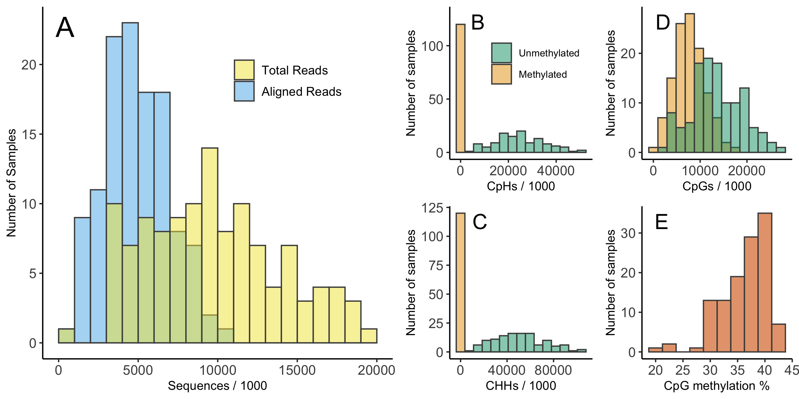

Figure S1: Summary of sequencing and methylation call results from raw sequence data. Panel A shows the distribution of the total number of sequences for each sample and number of sequences that aligned to the tree swallow genome. Panel B shows the number of CpH sites that were methylated or unmethylated for each sample. Panel C shows the number of CHH sites that were methylated or unmethylated for each sample. Panel D shows the number of CpG sites that were methylated or unmethylated for each sample. Panel E shows the percentage of total CpG reads that were methylated by sample. Note that these histograms are based on raw sequencing results that do not account for differential coverage between samples or locations in the genome and are included for illustration only.

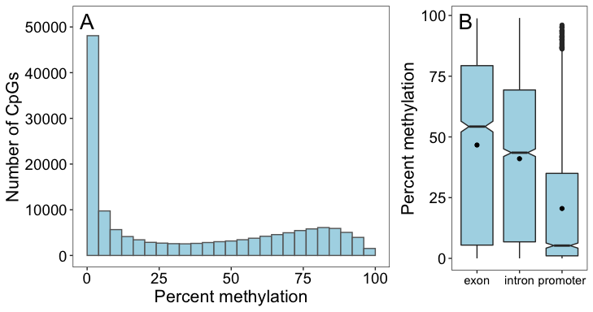

Figure S2: Distribution of methylation percentage across all CpGs and for different genomic features. Panel A shows entire distribution of methylation percentage for all 148,167 CpGs from pre-treatment samples before any filtering. Panel B shows the methylation percentage for exons, introns, and promoters that had CpGs identified within them. Horizontal lines, boxes, and whiskers show the median, interquartile range, and 1.5 times IQR respectively. The black circle within each box is the mean for that feature.

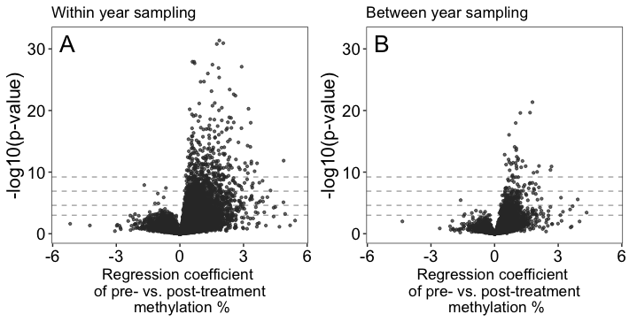

Figure S3: Association between pre-treatment methylation percentage and post-treatment methylation at each CpG for samples collected within a breeding season (panel A) and for samples collected one year apart (panel B). To help with interpretation, horizontal dashed lines indicate p-values of 0.05, 0.01, 0.001, and 0.0001 moving from the bottom to top of the plots.

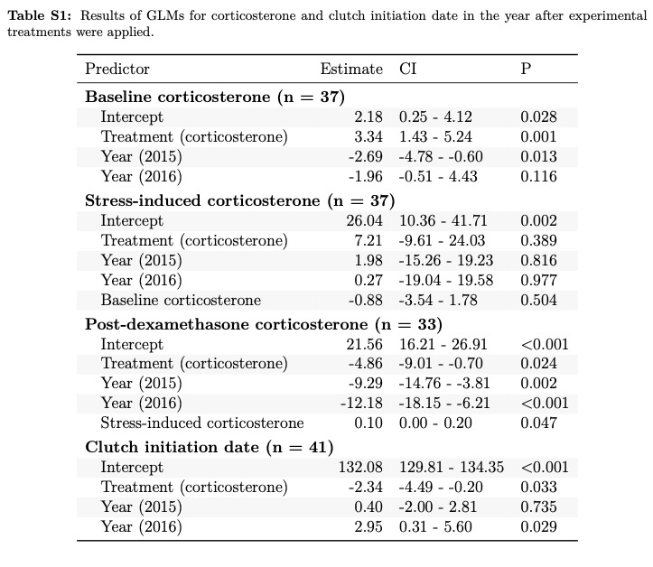

Table S2: List of genes with differentially methylated CpGs in exons, introns, or within 2kb upstream of the gene.

Comparison

Genes

Baseline corticosterone

ABHD8; CBX2; CCDC15; CLP1; HELZ; HMGA1; LIG3; LOC100220428; LOC100221958; LOC100223410; LOC100228079; LOC751972; LWS; MAST3; NFASC; NRCAM; OPN1SW; PCBP2; PCBP3; PCBP4; PCMT1; PUS3; RHO; SESN1; SESN3; STAMBPL1; STMN1; STMN2; STMN3; TAF6L; TMIE; ZFYVE19

Stress-induced corticosterone

ACVR1; ACVR1B; ACVRL1; ADGRB1; ADGRB2; ADGRB3; AKT1; AKT3; ALPK1; ALX1; ARHGEF11; ARID3A; ARID3B; ARID3C; ASB3; AXIN1; AXIN2; BMPR1A; BMPR1B; CLDN1; CLDN14; CLDN5; COPA; DCLK1; DCX; ESRRG; FOSL2; FOXJ1; GALM; GATA4; GATA5; GATA6; GPR171; HID1; HNF4A; HNF4G; HOXA3; HOXB3; HSPA13; HSPA14; HSPA2; HSPA5; HSPA8; HSPA9; IER5L; IGHMBP2; IGSF9B; IKZF1; IKZF2; IKZF3; ITGA11; KIF1A; KIF1B; KLHL12; KLHL17; KLHL18; KLHL2; KLHL20; KLHL5; LAMB1; LAMB2; LAMB3; LDLRAP1; LECT2; LOC100217876; LOC100219031; LOC100220115; LOC100221543; LOC100222291; LOC100222941; LOC100223643; LOC100224585; LOC100224644; LOC100224843; LOC100225871; LOC100226582; LOC100226815; LOC100227201; LOC100227468; LOC100227703; LOC100229020; LOC100229354; LOC100229528; LOC100229609; LOC100229630; LOC100230278; LOC100230328; LOC100230362; LOC100231693; LOC100231893; LOC100232259; LOC101233849; LOC105758838; LOC105759110; LOC105759301; LOC105759399; LOC105759510; LOC105759937; LOC115491093; LOC115491353; LOC115491354; LOC115491358; LOC115491417; LOC115491512; LOC115494566; LOC115494567; LOC115496063; LOC115496268; LOC115497065; LOC115497066; LOC115497067; LOC115497068; LOC115497095; LOC115497281; LOC115498367; LOC116807418; LOC116807419; LOC121468018; MAPK1IP1L; MC1R; MC2R; MC3R; MC4R; MC5R; MEX3A; MEX3B; MEX3D; MITF; MNX1; MOB1B; MOB3C; MYO1D; NCOA5; NCOR2; NKX3-2; NR2E1; NR2E3; NR2F1; NR2F2; NR2F6; NR5A2; P2RY12; P2RY13; P2RY14; PCDH10; PCDH12; PCDH8; PIM1; PIM3; PKNOX1; PKNOX2; PLEKHA6; PLEKHO1; PTCH1; PTK7; RAX; RAX2; RXRA; SGK1; SGK2; SIX6; SLC25A10; SLC66A1; SRSF3; SYNPO; TFEB; TFEC; TGFBR1; TIMM8A; TNRC18; UBALD1; UBALD2; UBXN7; WDR7; ZCCHC14; ZDHHC23

Post-dexamethasone corticosterone

ACVR1; ACVR1B; ACVRL1; ADORA1; ADORA2A; ADORA2B; ADRA1B; AK8; ATOH7; BMPR1A; BMPR1B; C18H17orf58; CBX2; CCM2; CCNA1; CHGB; CHL1; CHST11; CHST12; CHST13; CLIP1; COPA; CORO2A; CORO2B; CRTC2; CRYBB1; CTRL; CTXN1; CTXN2; DENND4C; DNAJB13; DNMT3B; DOCK7; DOCK8; EMX2; ERICH3; ESRRG; EVA1B; FAM83A; FGF18; FGF8; FZD1; FZD10; FZD2; FZD3; FZD4; FZD5; FZD6; FZD7; FZD8; GAD1; GAD2; GATA2; GATA3; GNPTG; GPR171; GPR26; GPR78; GPR83; GRB2; HID1; HNF4A; HNF4G; ID=cds-NP_001232480.1; ID=cds-NP_001232635.1; ID=cds-NP_001243137.1; ID=cds-NP_001243138.1; ID=cds-XP_030112754.3; ID=cds-XP_030134736.2; ID=cds-XP_032603585.2; IGHMBP2; IKZF1; IKZF2; IKZF3; ILF3; IP6K1; IP6K2; IP6K3; ITGA11; KATNAL2; KCNA10; KCNA2; KCNA4; KCNA5; KDM5A; KHDRBS1; LOC100190025; LOC100218025; LOC100219450; LOC100220115; LOC100221543; LOC100221838; LOC100221958; LOC100223460; LOC100224073; LOC100225784; LOC100225871; LOC100226496; LOC100226582; LOC100226723; LOC100227201; LOC100227464; LOC100227703; LOC100229528; LOC100229609; LOC100229630; LOC100229947; LOC100230362; LOC100231785; LOC100232259; LOC101232904; LOC101232979; LOC101233511; LOC105758604; LOC105758698; LOC105758845; LOC105758859; LOC105759399; LOC105759510; LOC115490659; LOC115492615; LOC115494788; LOC115496018; LOC115496268; LOC115496876; LOC115497044; LOC115497045; LOC115497065; LOC115497066; LOC115497067; LOC115497068; LOC115497095; LOC115498277; LOC115498450; LOC115498504; LOC115498524; LOC116806919; LOC116807124; LOC116807173; LOC116807372; LOC116807374; LOC116807475; LOC116807566; LOC116807567; LOC116807569; LOC116807570; LOC116807571; LOC116807574; LOC116807590; LOC116809047; LOC116809297; MEIS1; MEIS2; MEX3A; MEX3B; MEX3D; MGAT5; MNX1; MOV10; MYH10; MYH11; MYH9; MYO5A; NANOS3; NEUROG1; NEUROG2; NFASC; NKX6-1; NKX6-2; NR2E1; NR2E3; NR2F1; NR2F2; NR2F6; NR5A2; NRCAM; NUAK1; NUAK2; P2RY12; P2RY13; P2RY14; PALB2; PAN2; PAPSS1; PAPSS2; PATL1; PCDH10; PCDH12; PCDH18; PCDH8; PCMT1; PFKL; PI15; PIK3C2B; PIM1; PIM3; PLEKHA6; PTCH1; QRFPR; R3HDML; RPL13A; RXRA; S100A11; SAMD11; SEC16A; SEPTIN11; SEPTIN2; SEPTIN3; SEPTIN5; SEPTIN6; SEPTIN8; SH3GL2; SH3GL3; SLC2A6; SLC38A10; SMARCC1; SPOPL; STX8; SYNGR3; SYT7; TAL2; TCF7L2; TGFBR1; TRPM2; TWF1; TWF2; VIPR1; VPS26A; VPS26B; VWCE; WIPI1; WIPI2; WWP2; ZDHHC5; ZDHHC8; ZNF598

Treatment within year

ACTA1; ACTA2; ACTB; ACTC1; ACTG1; ACTG2; ACTR1A; ASS1; ESPN; GALNT3; GALNT6; GMPS; GPR27; GPR85; INHBB; IRF7; ITGA11; KCNG1; KCNG2; KCNG4; LOC100190135; LOC100218246; LOC100218887; LOC100220115; LOC100220137; LOC100227878; LOC105758845; LOC105758846; LOC105758847; LOC105758850; LOC105758859; LOC105760754; LOC115494114; LOC115496608; LOC115497065; LOC115497066; LOC115497067; LOC115497068; LOC115497975; LOC115498396; LOC115498513; LOC115498523; LOC116809297; NTN1; NTN3; NUAK1; NUAK2; PCDH15; RIMS3; TMPRSS6; VDAC1; VDAC2

Treatment between years

ACVR1B; ACVR1; ACVRL1; BMP1; BMPR1A; BMPR1B; LOC115495659; LOC115495665; LOC115495661; LOC115490544; MMADHC; NETO1; TBKBP1; TGFBR1; TLL2; TLL1

Table S3: GO terms identified using DAVID after correction to a false discovery rate of 0.05 for each comparison set.

