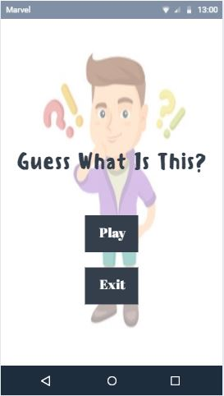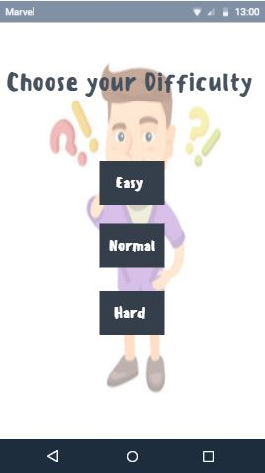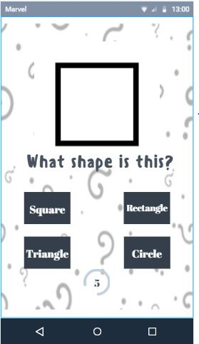

This Is the title screen where user will direct here upon launching the app

This is a choosing screen where the user will choose what kind of shape is that.

This Is the Difficulty screen, the user will choose difficulty between easy, normal, and hard

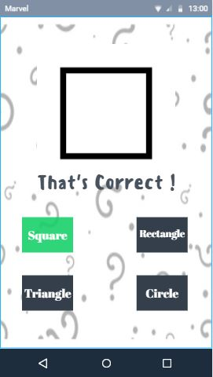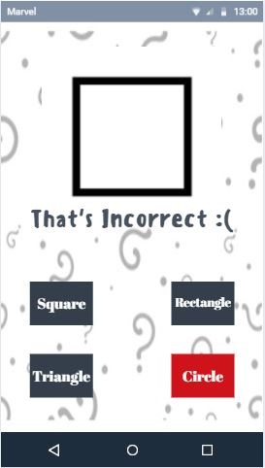

This is the correct screen the user will direct here if he/she get an right answer.

This is the Incorrect Screen the user will direct here if he/she will get an incorrect answer.